Quick reference guide: Request access to the NDIS Worker Screening Database (NWSD)
Unregistered provider

Contents
Contents 1
Overview 1
Online form 3
Use of information and the system 3
Business details 4
Our key contacts 5
Confirm details 7
The primary contact 7
Participation in the disability sector 9
Summary and declaration 10
Submission received 10
PRODA Account 11

Overview
- The NDIS Worker Screening Database (NWSD) is a national database which stores NDIS Worker Screening Check information about workers who deliver NDIS supports and services.
- Unregistered NDIS providers can decide whether they will require their workers to have a NDIS Worker Screening Check. More information about this can be found on our website - Unregistered providers.
- When a worker applies for an NDIS Worker Screening Check they must nominate an employer/s to verify their application. Once verified, the worker will be linked to the employer. The employer can then view and receive upates about the worker’s NDIS Worker Screening Check status e.g. whether they have an NDIS Worker Screening Clearance and when that clearance is due to expire.
- For a worker to be able to nominate an employer/s, the employer must have registered for access to the NWSD. Each employer must only make one application for access to the NWSD, after which they can manage the access of their employees by using the self-service functions (refer to Quick Reference Guide – Unregistered Provider – Manage NWSD access & email preferences).

- This quick reference guide provides information for unregistered providers about how to register for NWSD access.
For further information please refer to the NDIS Quality and Safeguards website - Unregistered providers. Alternatively, contact the NDIS Quality and Safeguards Commission on
1800 035 544 or by email nwsd@ndiscommission.gov.au

Online form
- To request access to the NWSD, begin the online form – Register for Worker Screening.
- Enter your email address and select ‘Save and continue’.
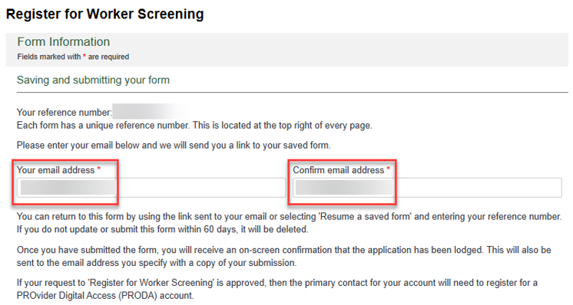
- There are a number of pages on the form which are indicated by the headings on the left hand side of the screen. You can navigate back to a pervious page by using the ‘Back’ button or selecting the page you want to go to. When you have completed a page, select ‘Save and continue’.
Tip 1 – You can exit the form at anytime. You will receive an email with a link to the partially completed form. You must submit the form within 60 days or it will be deleted.

Use of information and the system
- Read through the information on the ‘Use of information and the system’ page and select the checkbox if you agree.
- Select the radio button next to ‘I am the authorised representative of an organisation in the disability sector’ if you are an unregistered provider. Select ‘Save and continue’.
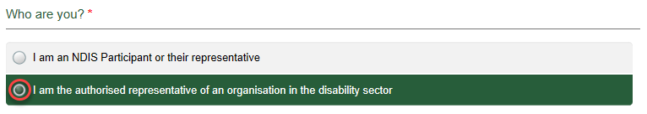

Business details
- On the ‘Business details’ page enter the required fields. Select ‘Save and continue’.
Tip 2 – You will need to enter a valid ABN and Business Address and select ‘Validate ABN’ / ’Validate’. If you cannot validate the Business Address select the ‘Unable to validate’ check box and continue.
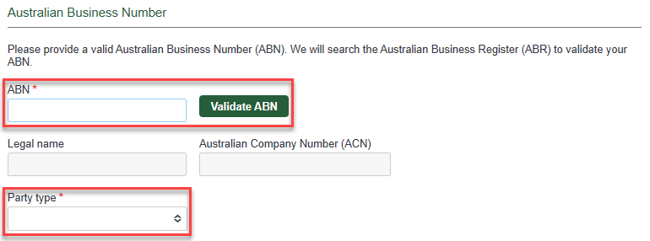

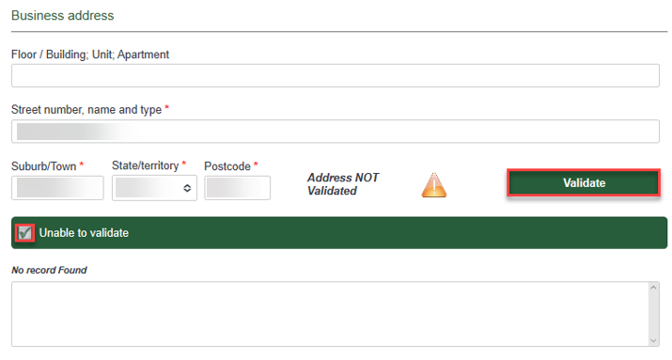
Tip 3 – In the ‘Business Name’ field enter a business name that is registered to your ABN as it appears on the Australia Business Register - https://abr.business.gov.au/
  - For example ABN = 00 000 000 000. Entity Name/Legal Name = Example Pty Ltd. Business Name = Example Shop. The business name entered should be ‘Example Shop’. Any variation to that name will result in delays in processing your application.
  - This is the business name that workers will use to find your business on their application for an NDIS Worker Screening Check.

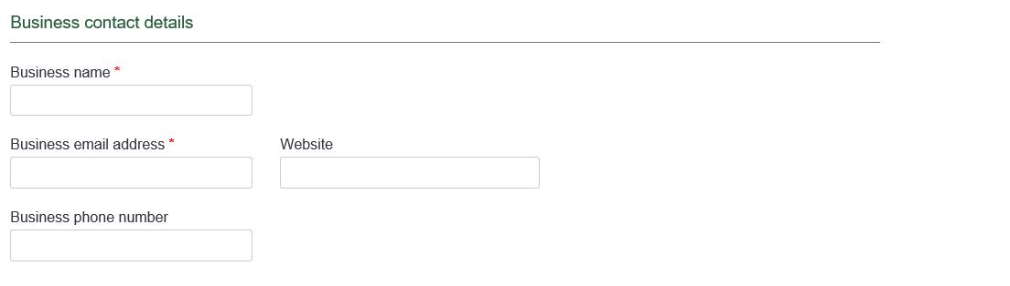

Our key contacts
- On the ‘Our key contacts’ page select ‘Add a contact’. You must add the contact details of at least one key contact. The contact can be the same person that is making the application for access to the NWSD.
- To add more the one key contact, select ‘Add contact’. To remove a contact, select ‘Remove contact’.
Tip 4 – The key contacts are people who the NDIS Commission may contact to discuss various matters.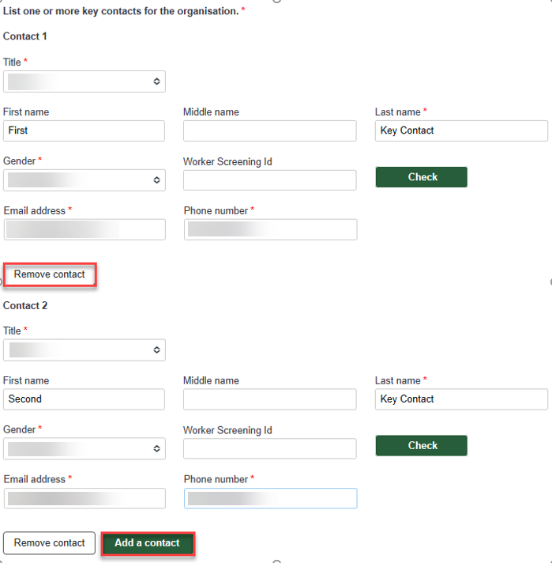
- If you want to add a Worker Screening ID for a Key Contact you will need to validate the Worker Screening ID by selecting ‘Check’.
Tip 5 – Once validated the Worker Screening ID is not editable. If you have made an error select ‘Add a contact’, you will then be presented with the option to ‘Remove contact’ so that you can remove the incorrect Worker Screening ID entry.
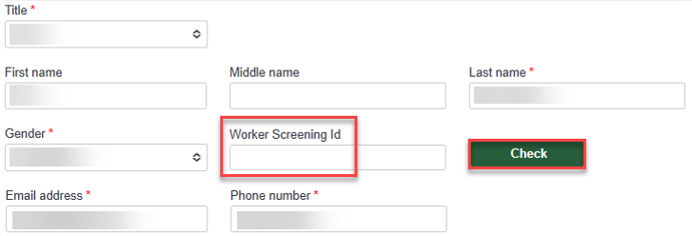
- Enter the key contact details and select ‘Save and continue’.

Confirm details
- On the ‘Confirm details’ page check that the information you entered on the ‘Our key contacts’ page is the correct current legal name and correct email address for each person.
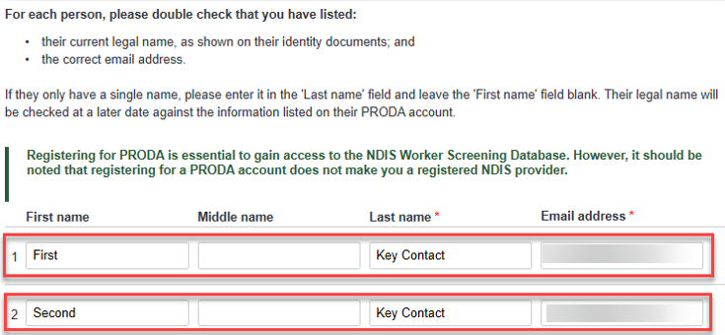
The primary contact
- Select one primary contact from the list of key contacts you have entered, then select ‘Save and continue’.
Tip 6 – The primary contact will receive email notifications about workers linked to the organisation, such as the status of a worker’s NDIS Worker Screening Clearance and requests to verify a worker’s NDIS Worker Screening Check application, and will also be the Authorised Access Delegate who can manage user access to the NWSD on behalf of the organisation.
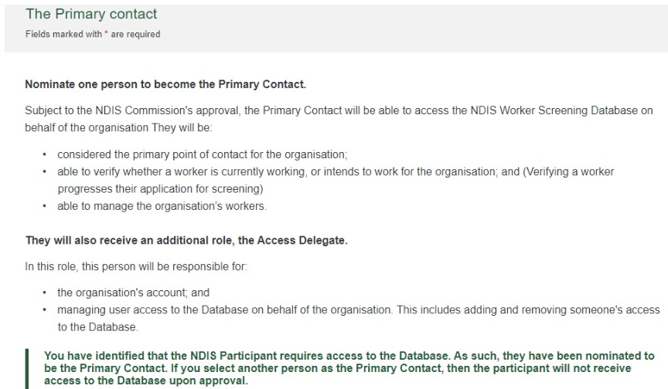
Participation in the disability sector
- On the ‘Participation in the disability sector’ page, select the check box/es that apply and provide a summary of the disability supports and services that your organisation provides. Select ‘Save and continue’.
Tip 7 - Please include the following details:
  - type of services and supports;
  - the environment in which they are delivered e.g. in the home of people with disability;
  - the type and frequency of contact with NDIS participants the organisation will have; and
  - any other information that you think might be relevant.

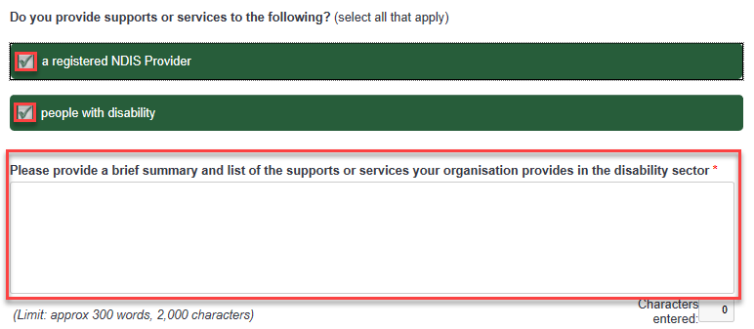Workers
- On the ‘Workers’ page, select ‘Add a worker’ if your organisation is intending to engage any workers that have applied for or have made an application for an NDIS Worker Screening Check application.
If you do not want to add a worker, select ‘Save and continue’ and skip to step 21 below.
- Enter the worker’s ‘Worker’s last name’ and either ‘Application ID’ or ‘Worker Screening ID’ and select ‘Check’. The worker must be verified before you can progress.
Tip 8 – The worker’s application ID is the reference number they received when they made their NDIS Worker Screening Check application. If the worker already has a worker screening clearance, they will have a Worker Screening ID.
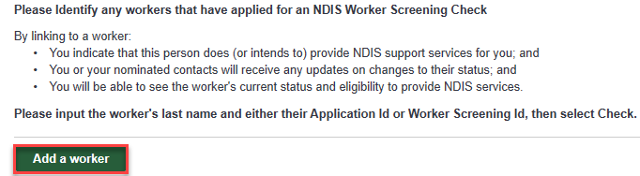
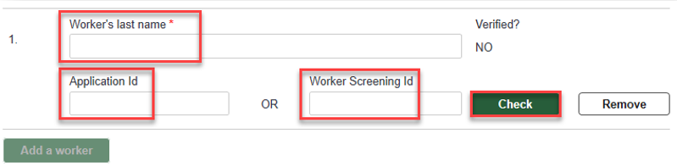

Summary and declaration
- On the ‘Summary and declaration’ page check the details you have entered into the application, enter your name in the ‘My full name’ field and tick the two check box declarations if you agree, then select ‘Submit’.
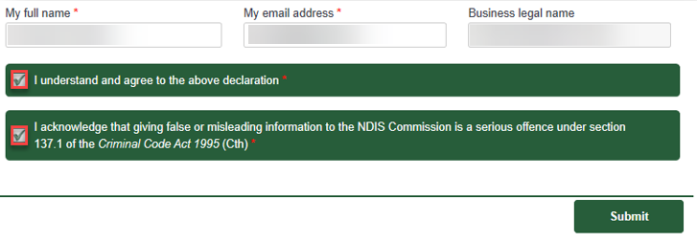

Submission received
- Once the application is submitted you will receive a confirmation email with a copy of your application, and be taken to a confirmation screen.
- From the confirmation screen you can also choose to email a copy of the completed application to a different email address or download a copy of the application to save.
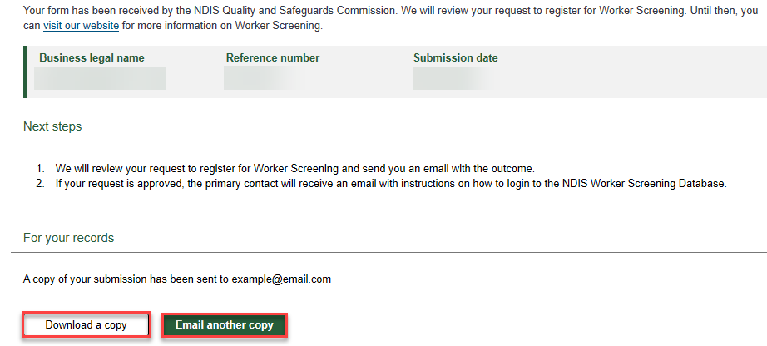

PRODA Account
- If your request for access to the NWSD is approved, you will receive an email prompting you to complete the access request.
- Follow the link provided in the email which will take you to a PRODA sign in page. If you already have a PRODA account, log in. If you do no have a PRODA account register by following the link.
Tip 9 – Please ensure that the primary key contact email address you include in your application matches the email address you use to register for PRODA. You can change the primary key contact email address once your access is finalised – refer to the Quick Reference Guide – Manage NDIS Worker Screening Database access and email preferences.
Tip 10 –If you are having trouble registering for PRODA contact the PRODA Helpdesk on 1800 700 199.
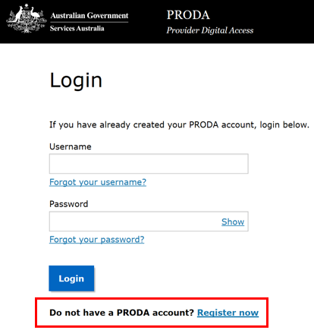
- Once you log in to PRODA read the ‘Portal access – terms and conditions’ and select the check box in the ‘Acknowledgement’ section if you agree.
- On the ‘Portal entry point’ screen, select the correct ‘Provider name’ and ‘Role’. Choose the ‘Worker Screening for Organisations’ to go directly to the NWSD.
Tip 11 – There may be multiple options under ‘Provider name’ if you are associated with multiple organisations that provide NDIS supports and services. Select the appropriate option.

