Renewal of a registration
Quick Reference Guide (Registration)

Providers can submit a formal renewal in the final 6 months of their registration using the NDIS Commission Portal.

Renewal of a registration
- Click on Portal- select Registered NDIS Provider.
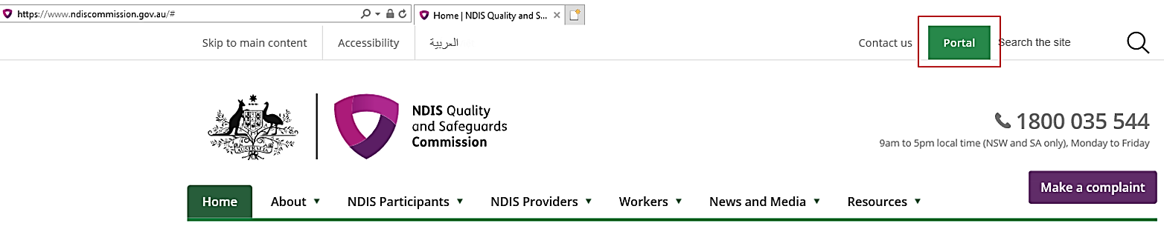
- Login with PRODA.
- You will need the following details to enter the portal, once entered select Continue:
  - Provider name: XXXXXX
  - Ensure your Role is: Registrant
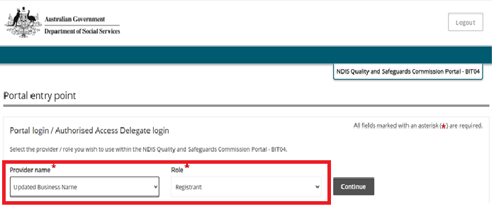
Only users with access to the 'Registrant' role can start and submit a renewal application for the provider. Visit the NDIS Commission website for more information on applying for renewal of your registration and how to start and submit your application in the NDIS Commission Portal.

If you don't have access to the Registrant role for this provider:
- Login to the NDIS Commission Portal with your PRODA account (if you do not have a PRODA account you will be prompted to create one).
- Select 'Request/update my access' and follow instructions- further guidance can be found in the Getting access to NDIS Commission Portal Quick reference guide
- Once you see the Login on to the NDIS Commission Portal- select I agree
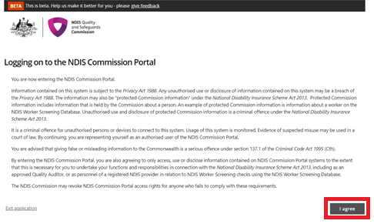
- If you are eligible to start your Renewal in the My Applications box you will see Commence a formal renewal by xx/xx/xxxx.
If this is not showing you are not able to commence your renewal yet- it will appear 6 months out from your renewal date.
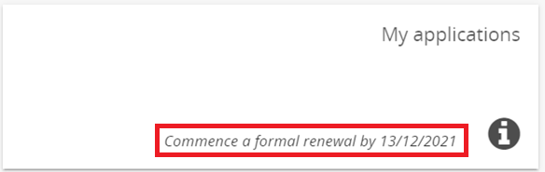
- When you are ready to commence your renewal select My applications.
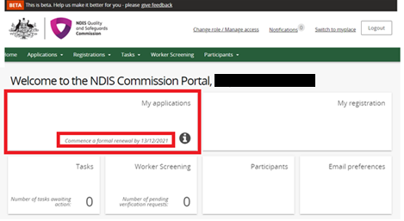
- The banner below will appear. If you wish to commence your renewal select start application.
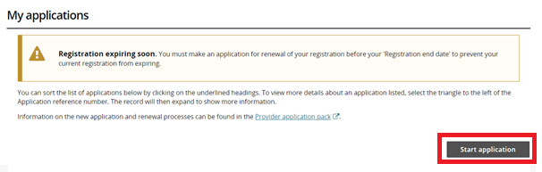
- A prompt will appear to ask you if you wish to create a renewal. Click Confirm.
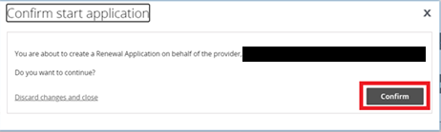
- Start to complete the renewal process by working through each of the different sections in the left hand menu and update each screen ensuring the correct details are captured.
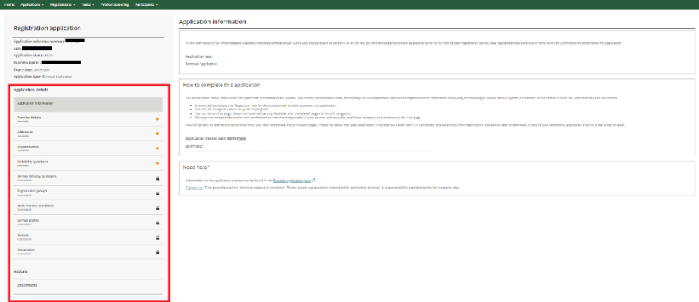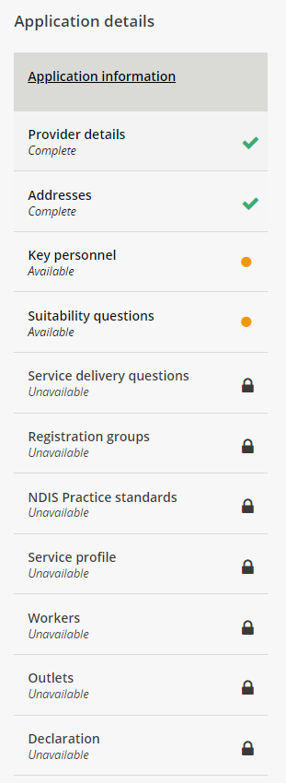
You will be able to submit the application once you have completed and a green tick shows for all the relevant pages. Please be aware that your application is considered draft until it is completed and submitted.
After you’ve commenced this application, you may return to it at any time by going to My applications and viewing your renewal application.
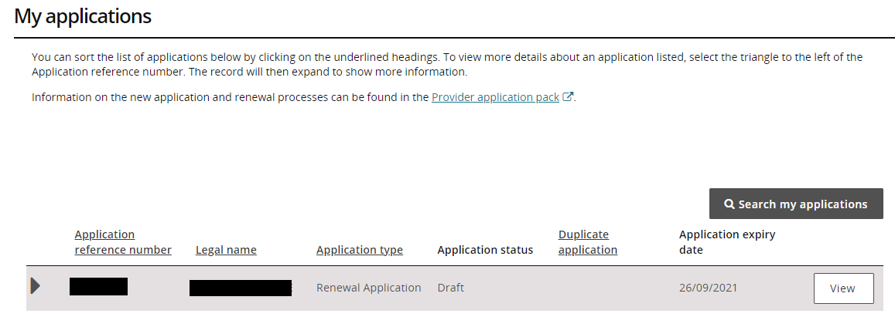
Once you have submitted your application a scope of audit will be generated. Use this document to obtain quotes from approved quality auditors, Approved quality auditors as at 20/08/2021 | NDIS Quality and Safeguards Commission (ndiscommission.gov.au)

Please Note: There is a further Quick Reference Guide available to assist with assigning a selected auditor.

