Unauthorised uses of restrictive practices in the National Disability Insurance Scheme
Unauthorised uses of restrictive practices reported to the NDIS Quality and Safeguards Commission

NDIS Quality and Safeguards Commission
January 2022

The NDIS Quality and Safeguards Commission regulates the use of regulated restrictive practices by NDIS providers in relation to NDIS participants.
The NDIS Commission does not regulate the use of restrictive practices outside the NDIS, even if the restrictive practices are being used in relation to NDIS participants. For example, the NDIS Commission does not regulate the use of restrictive practices:
- in health, education or forensic settings (unless they are used by NDIS providers in those settings)
- by family members or other people who provide informal supports to participants.
Regulated restrictive practices are restrictive practices that involve:
- seclusion
- chemical restraint
- mechanical restraint
- physical restraint
- environmental restraint
Chemical restraint, the most commonly used restrictive practice, is the use of medication for the primary purpose of influencing a person’s behaviour. Chemical restraint does not include the use of medication prescribed by a medical practitioner for the treatment of, or to enable the treatment of, a diagnosed mental disorder, a physical illness or a physical condition.

Introduction

Purpose of this report
On 2 September 2021, the Acting Commissioner of the NDIS Quality and Safeguards Commission (NDIS Commission) released the NDIS Commission’s Activity Report for the 12 months to 30 June 2021. That Activity Report showed that NDIS providers had notified the NDIS Commission of more than 1,000,000 unauthorised uses of restrictive practices (URPs) in relation to NDIS participants.
The Acting Commissioner undertook to publish an analysis of the NDIS Commission’s data relating to the use of restrictive practices and behaviour support plan activity by the end of 2021.
This report provides that analysis.

Data Remediation
During the course of undertaking this analysis the NDIS Commission identified data quality issues in the reported number of URPs in 2020-21. This exercise has resulted in an adjustment to the total number of Reportable Incidents of URPs in the 2020-21 period from 1,032,064 to 994,595.
The adjustment relates to the introduction of automated upload of weekly reporting of URPs for routine restrictive practices and issues with the initial manual upload of that data. This adjustment is attributed to:
- providers creating erroneous or duplicate records for the same Reportable Incident;
- NDIS Commission data processing errors in moving form a manual to an automated reporting process; and
- providers entering incorrect URP usage numbers in weekly reports of URPs.
These issues have been rectified and will not appear in future reporting.
The analysis in this report aligns with the publically reported figure of 1,035,064 reportable incidents which were URPs. The number for 2020-21 will be adjusted in future reporting to reflect the revised number of 994,595.

Regulation of restrictive practices
The National Disability Insurance Act 2013 gives effect to Australia’s obligations under the Convention of the Right of People with Disabilities (CRPD). The CRPD is the first binding international human rights treaty to recognise the rights of all people with disability. Australia signed the CRPD in 2008. The NDIS Commission is committed to promoting, protecting and ensuring the full and equal enjoyment of all human rights and fundamental freedoms by people with disability and promoting respect for their inherent dignity.
The NDIS Commission regulates NDIS providers’ use of regulated restrictive practices in relation to persons with disability for the purposes of reducing and eliminating the use of restrictive practices.
A restrictive practice means any practice or intervention that has the effect of restricting the rights or freedom of movement of a person with disability. Under the National Disability Insurance Scheme (Restrictive Practices and Behaviour Support) Rules 2018 (Restrictive Practices and Behaviour Support Rules) certain restrictive practices are subject to regulation. A restrictive practice is a regulated restrictive practice if it is or involves seclusion, chemical restraint, mechanical restraint, physical restraint and environmental restraint.
The use of a restrictive practice is ‘unauthorised’ if its use has not been authorised in accordance with any applicable state or territory requirements for authorisation and/or it is not used in accordance with a behaviour support plan for the participant. Providers must report every instance of a restrictive practice, including each individual use, until evidence of authorisation (if required) and the behaviour support plan are lodged with the NDIS Commission.
Restrictive practices should:
- be used only as a last resort in response to risk of harm to the person with disability or others, and after the NDIS provider has explored and applied evidence-based, person-centred and proactive strategies;
- be the least restrictive response possible in the circumstances to ensure the safety of the person with disability or others;
- reduce the risk of harm to the person with disability or others;
- be in proportion to the potential negative consequence or risk of harm; and
- be used for the shortest possible time to ensure the safety of the person with disability or others.
These requirements are met through the development of a behaviour support plan for the participant, which includes requirements that a specialist behaviour support provider:
- undertakes a behaviour support assessment, including a functional behavioural assessment, of the participant;
- makes changes within the environment of the participant that may reduce or remove the need for the use of restrictive practices;
- identifies opportunities for the participant to participate in community activities and develop new skills that have the potential to reduce or eliminate the need for restrictive practices in the future; and
- consults with the participant and the participant’s family, carers, guardian or other relevant person.
The NDIS Commission regulates NDIS providers’ use of regulated restrictive practices through two mechanisms:
- Behaviour support function: Where the use of the restrictive practice has been authorised (if required) and is included in a behaviour support plan for the participant, evidence of authorisation and the behaviour support plan are lodged with the NDIS Commission and the NDIS provider must report to the NDIS Commission on its usage of the restrictive practice in relation to the participant every month.
- Reportable incidents function:
  - Where the use of the restrictive practice is a single, emergency use the NDIS provider must notify the NDIS Commission of the use as a reportable incident.
  - Where the use of the restrictive practice is ongoing but it has not yet been authorised (if required) or it is not included in a behaviour support plan for the participant, the NDIS provider must notify the NDIS Commission of each use as a reportable incident.
The NDIS Commission’s Activity Report for the 12 months to 30 June 2021 showed that NDIS providers had notified the NDIS Commission of 1,032,064 URPs in relation to 7,862 NDIS participants during the period 1 July 2020 to 30 June 2021 (2020-21).
This report analyses data the NDIS Commission holds in relation to URPs and identifies priorities for work to reduce the number of URPs.

Number of URPs since July 2018
The number of URPs reported to the NDIS Commission has grown significantly in each 6-month reporting period since the NDIS Commission commenced operating in New South Wales and South Australia on 1 July 2018.
Figure 1 - Instances of URPs by State and Territory since July 2018
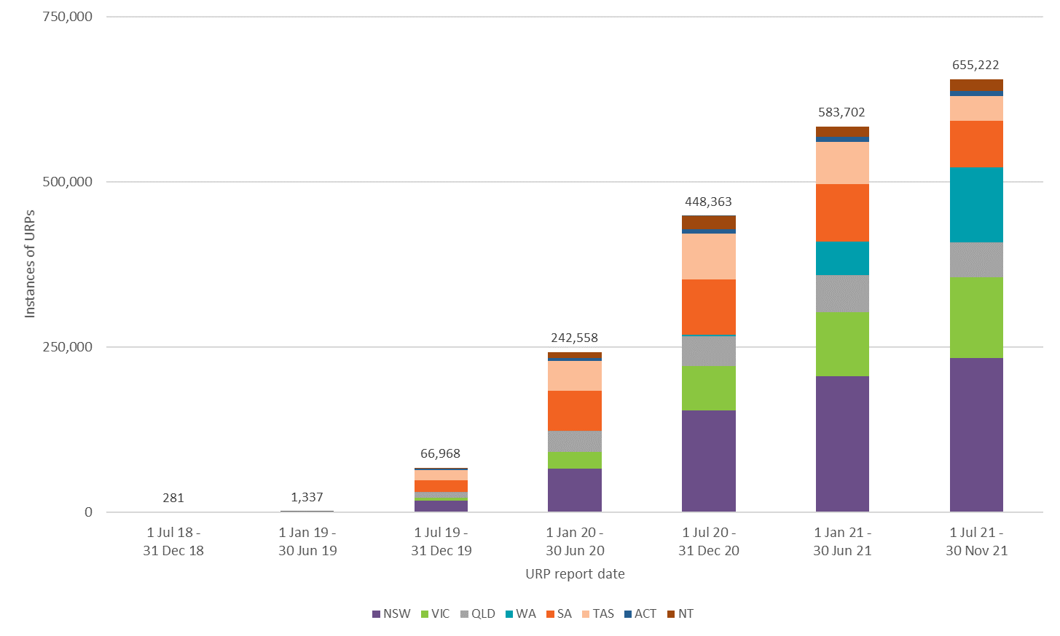
In 2018-19, the NDIS Commission operating in New South Wales and South Australia only and few URPs were reported during this period. The number of URPs reported in the six-month period from 1 July to 31 December 2019 grew significantly as the NDIS Commission began operations in Victoria, Queensland, Tasmania, the Australian Capital Territory and the Northern Territory, introduced online reporting of all reportable incidents from 1 July 2019, and introduced a streamlined reporting mechanism for URPs from late 2019.
A sharp increase in notifications of URPs in the subsequent six-month period from 1 January 2020 to 30 June 2020, and the subsequent increases in reporting in the 2020-21 period reflect a range of factors including:
- expiry of transitional arrangements under the Restrictive Practices and Behaviour Support Rules, described further below;
- the growth in the number of participants accessing the NDIS;
- increased understanding of compliance obligations following extensive education campaigns by the Commission;
- full implementation of the streamlined reporting mechanism for URPs introduced in late 2019, which allowed providers to move to a weekly reporting system for reporting of each instance of the use of a chemical or environment URP that is ongoing for a participant until authorised or within a BSP;
- in 2020-21, the NDIS Commission’s targeted compliance action in relation to URPs which had the effect of further improving providers’ awareness of their obligations in relation to authorisation and behaviour support plans and reporting URPs;
- in December 2020, the expansion of the NDIS Commission’s jurisdiction to Western Australia on 1 December 2020;
- in December 2020, the expansion of the NDIS Commission’s jurisdiction in relation to Residential Aged Care (RAC) providers that support NDIS participants, which had the effect of requiring RAC providers to register with the NDIS Commission and commence reporting all URPs in relation to NDIS participants to the NDIS Commission from 1 December 2020; and
- through to 2021, the completion of the transition of state and territory disability service systems into the NDIS including the cessation of in-kind arrangements; for example, in-kind supported accommodation for around 2500 NDIS participants ended in early 2021 in Victoria.
The number of URPs reported to the NDIS Commission started to stabilise during the period 1 July 2020 to 30 November 2020. During this period the NDIS Commission was notified of an average of 75,174 URPs per month.
During the period 1 December 2020 to 30 June 2021, the average number of URPs reported each month increased to 93,742. A significant component of this increase is attributable to the expansion of the NDIS Commission’s jurisdiction in Western Australia and in relation to RAC providers.
Under the Restrictive Practices and Behaviour Support Rules, there were special transitional arrangements for registered NDIS providers who transitioned to the jurisdiction of the NDIS Commission. These arrangements allowed time for:
- the National Disability Insurance Agency (NDIA) to add funding for behaviour support to participants’ plans where required;
- specialist behaviour support providers to develop behaviour support plans for participants; and
- providers who use restrictive practices regulated restrictive practices to obtain state or territory authorisation for the use of those restrictive practices, if required.
The application of these transitional arrangements in each jurisdiction means that the full extent of URPs has only become evident in the 2020-21 reporting period. Some Western Australian providers and RAC providers are still transitioning to the full reporting requirements and so numbers of reports of URPs may continue to grow in the 2021-22 reporting period.

Number of participants subject to URPs since July 2018
The number of NDIS participants subject to URPs notified to the NDIS Commission has also increased since July 2018, consistently with reporting trends in the number of URPs notified to the NDIS Commission.
Figure 2 - Count of participants subject to URPs by State and Territory since July 2018
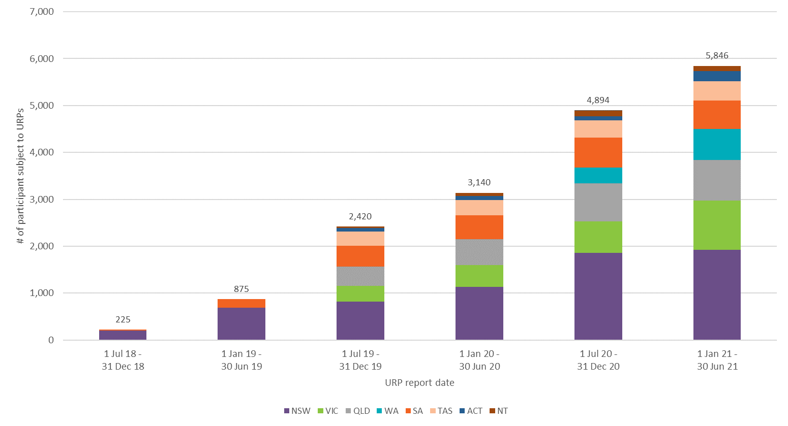
Some participants are counted in more than one six-monthly reporting period. For example, the total number of participants subject to URPs in 2020-21 was 7,862 participants, which means that 2,878 participants were included in the counts for both 1 July 2020 - 31 December 2020 and 1 January 2021 - 30 June 2021.

Intensity of use of URPs
One of the important considerations in relation to URPs is the number of URPs to which an individual participant is subject.
Figure 3 below groups participants by the number of URPs to which they were subject in each six-month reporting period. In each period, approximately half of the participants subject to URPs were subject to 10 or fewer URPs. Fewer than 5 percent of participants subject to URPs were subject to more than 500 URPs in a six-month reporting period.
Figure 3 Count of participants subject to URPs since July 2018 by number of URPs in half year
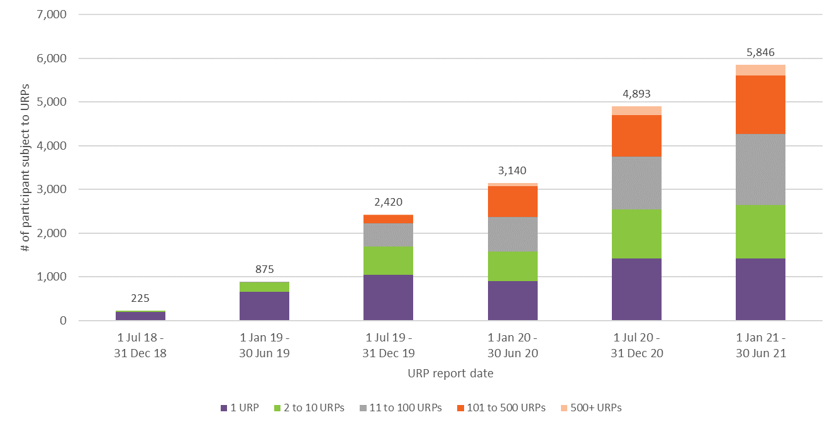
The Activity Report for 2020-21 reported that, for the participants subject to URPs in 2020-21:
- 27% were subject to only one URP during the reporting period;
- 72% were subject to 100 or fewer URPs during the reporting period; and
- the median number of URPs was 15.
A similar analysis for the six month period from 1 January 2021 to 30 June 2021 shows that, for the participants subject to URPs in the second half of 2020-21:
- 24% of participants subject to URPs were subject to a single URP;
- 73% of participants subject to URPs were subject to 100 or fewer URPs; and
- the median number of URPs per participant subject to URPs was 17.
The relatively consistent proportion of participants subject to a single URP suggests that the reporting of URPs is correctly picking up the use of restrictive practices as single, emergency uses as intended under the NDIS Quality and Safeguarding Framework. Single, emergency uses of restrictive practices are also likely to account for a number of the URPs for those participants who were subject to 10 or fewer URPs, where a restrictive practice might have been used a few times during a reporting period, on each occasion as a single, emergency use.
Turning from the participants subject to the fewest URPs to the participants subject to the most URPs, for the six-month period from 1 January 2021 to 30 June 2021, 57 % of the URPs were used in relation to only 10 % (570) of participants subject to URPs.
In each of 2019-2020 and 2020-2021, more than half of all URPs reported to the NDIS Commission were used in relation to the 10 % of participants subject to the most URPs.
Figure 4 Instances of URPs used in relation to the 10% of participants subject to the most URPs
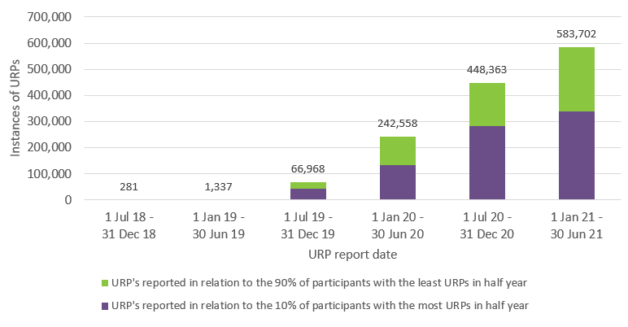
This analysis shows that a relatively small proportion of the participants who are subject to URPs are subject to most of the URPs notified to the NDIS Commission.
The high proportion of URPs (57% in January - June 2021) used in relation to a relatively small number of participants (570 or 10% of participants subject to URPs) suggests that only a relative small number of participants are subject to high numbers of ongoing URPs. It is to these participants that the NDIS Commission’s attention is most appropriately directed to ensure that the providers who use URPs in relation to these participants, and the providers that provide specialist behaviour support to these participants, comply with their obligations to obtain authorisation, if required, and develop and implement behaviour support plans for these participants.

Some characteristics of participants subject to URPs
For the purposes of this report, the NDIS Commission sought the assistance of the NDIA to conduct further analyses of demographic and other characteristics of the participants subject to URPs in 2020-21.
The data set out below analyses the number of participants subject to URPs in 2020-21 by:
- State and territory and as a percentage of the total number of ‘active’ participants in the state or territory;
- age band and as a percentage of the total number of active participants in the relevant age band;
- primary disability and as a percentage of the total number of active participants with the relevant primary disability;
- whether they receive funding for supported independent living (SIL) supports and as a percentage of the total number of active participants who do or do not receive funding for SIL supports.
Because these analyses rely on matching NDIS Commission URP notifications with NDIA participant records, they have been conducted only in relation to the participants subject to URPs in 2020-21 whose identities have been fully verified against NDIA participant records. The NDIS Commission’s operating system was enhanced in 2021 to enable the NDIS Commission to verify participant details in reportable incident notifications against NDIA participant records. This verification process commenced during 2020-21; however, not all URP notifications in 2020-21 were fully verified. The data set out below analyses the demographic and other characteristics of the 6,622 participants subject to URPs in 2020-21 who have been fully verified against NDIA participant records, and not all of the 7,862 participants who were subject to URPs in 2020-21.

Participants subject to URPs by state and territory
Table 1 below analyses the number of participants subject to URPs in 2020-21 by state and territory and as a percentage of the total number of ‘active’ participants in the state or territory.
The number of participants subject to URPs in Western Australia is likely to be an understatement as the NDIS Commission only commenced jurisdiction in Western Australia on 1 December 2020 and the transitional arrangements under the Restrictive Practices and Behaviour Support Rules applied in Western Australia following transition. Some Western Australian providers are still transitioning to the full reporting requirements and so the number of reports of URPs and the number of participants subject to URPs in Western Australia may continue to grow in the 2021-21 reporting period.
Excluding the data for Western Australia, the lowest rate of active participants subject to URPs in 2020-21 was 1.0% in Victoria, followed by 1.2% in the Australian Capital Territory. The highest rate of active participants subject to URPs in 2020-21 was 4.4% in Tasmania. The number of participants subject to URPs in Victoria may be affected by the fact that in-kind supported accommodation for around 2,300 NDIS participants in Victoria did not transition to the NDIS Commission until 2021.
Table 1 - Participants subject to URPs in 2020-21 by state and territory
Jurisdiction | Active participants | Number of participants subject to URPs |  | Percentage of active participants subject to URPs
NSW | 144,890 | 2,604 |  | 1.8%
VIC | 124,501 | 1,246 |  | 1.0%
QLD | 92,742 | 1,175 |  | 1.3%
WA | 39,951 | 89 |  | 0.2%
SA | 41,034 | 786 |  | 1.9%
TAS | 10,657 | 465 |  | 4.4%
ACT | 8,586 | 106 |  | 1.2%
NT | 4,196 | 151 |  | 3.6%
OT | 41 | 0 |  | 0.0%
Missing | 12
Total | 466,619 | 6,622 |  | 1.4%

Participants subject to URPs by age band
Table 2 below analyses the number of participants subject to URPs in 2020-21 by age band and as a percentage of the total number of active participants in the relevant age band.
Table 2 - Participants subject to restrictive practices in 2020-21 by age band
Participant Age | Active participants | Number of participants subject to URPs | Percentage of active participants subject to URPs
0 to 6 | 72,258 | 50 | 0.1%
7 to 14 | 120,612 | 511 | 0.4%
15 to 18 | 35,821 | 496 | 1.4%
19 to 24 | 38,392 | 1,008 | 2.6%
25 to 34 | 41,565 | 1,216 | 2.9%
35 to 44 | 38,558 | 902 | 2.3%
45 to 54 | 47,263 | 1,078 | 2.3%
55 to 64 | 55,569 | 1,028 | 1.8%
65+ | 16,581 | 333 | 2.0%
Total | 466,619 | 6,622 | 1.4%

The lowest rates of active participants subject to URPs in 2020-21 were for participants who were 14 years of age or younger (0.1% for 0 to 6 years of age and 0.4% for 7 to 14 years of age). The highest rate of active participants subject to URPs in 2020-21 was for participants who were 25 to 34 years of age.

Participants subject to URPs by primary disability
Table 3 below analyses the number of participants subject to URPs in 2020-21 by primary disability and as a percentage of the total number of active participants with the relevant primary disability.
Table 3 - Participants subject to URPs in 2020-21 by primary disability
Primary Disability | Active participants | Participants subject to URPs
 |  | # | %
Acquired brain injury | 14,920 | 387 | 2.6%
Autism | 151,433 | 1,777 | 1.2%
Cerebral Palsy | 16,572 | 360 | 2.2%
Developmental delay | 37,677 | 8 | 0.0%
Global developmental delay | 9,556 | 4 | 0.0%
Hearing Impairment | 22,363 | 0 | 0.0%
Intellectual Disability | 91,311 | 3,166 | 3.5%
Multiple Sclerosis | 8,528 | 23 | 0.3%
Other | 3,760 | 21 | 0.6%
Other Neurological | 19,498 | 302 | 1.5%
Other Physical | 18,617 | 38 | 0.2%
Other Sensory/Speech | 2,778 | 0 | 0.0%
Psychosocial disability | 48,460 | 444 | 0.9%
Spinal Cord Injury | 5,134 | 26 | 0.5%
Stroke | 6,955 | 55 | 0.8%
Visual Impairment | 9,057 | 11 | 0.1%
Total | 466,619 | 6,622 | 1.4%

The majority of participants subject to URPs are those with the primary disability of intellectual disability or autism, representing 75% of participants subject to URPs.
Of the 6,620 participants subject to URPs in 2020-2021, 47% had a primary disability of intellectual disability and 27% had a primary disability of autism. However, it should also be noted that only 3.4% of active participants who had a primary disability of intellectual disability were subject to URPs, and only 1.1% of active participants who had a primary disability of autism were subject to URPs.
A higher percentage of active participants who had a primary disability of acquired brain injury or cerebral palsy were subject to URPs (2.5% for acquired brain injury and 2.1% for cerebral palsy) than the percentage of active participants who had a primary disability of autism (1.1%). However, there are considerably fewer participants with a primary disability of acquired brain injury or cerebral palsy subject to URPs (384 with acquired brain injury and 356 with cerebral palsy) than participants with a primary disability of autism (1,777).

Participants subject to URPs by receipt of SIL funding
Table 4 below analyses the number of participants subject to URPs in 2020-21 by whether they receive funding for SIL supports and as a percentage of the total number of active participants who do or do not receive funding for SIL supports.
Supported independent living (SIL) is a type of support for participants with higher support needs who need some level of help at home all the time. SIL includes help or supervision with daily tasks, like personal care or cooking meals, and it helps participants live as independently as possible, while building their skills. SIL supports are commonly provided for participants who live in group or shared living arrangements.
Table 4 - Participants subject to restrictive practices in 2020-21 by SIL funding
SIL funding | Active participants | Participants subject to URPs
 |  | # | %
SIL | 22,485 | 3,821 | 17.0%
Non-SIL | 444,134 | 2,801 | 0.6%
Total | 466,619 | 6,622 | 1.4%

The majority of participants subject to URPs receive funding for SIL supports.
As SIL is a type of support for participants with higher support needs, relatively few of the total number of active participants receive funding for SIL supports. In 2020-21, 4.8% of active participants received funding for SIL supports. However, a majority of participants who were subject to URPs in 2020-21 were participants who received funding for SIL supports.
Of the 6,662 participants subject to URPs in 2020-21, 58% received funding for SIL supports. However, it should also be noted that most participants who receive funding for SIL supports are not subject to URPs. Of the 22,485 active participants who received funding for SIL in 2020-21, 17% were subject to URPs.

Participants subject to URPs by receipt of behaviour support funding
Table 5 below analyses the number of participants subject to URPs in 2020-21 by whether they receive funding for behaviour supports.
Dependent on the participant’s circumstance, NDIS funded support workers may require individualised training specific to the participant to maintain consistency and positive behaviour supports. Practitioners may provide training plans for the support worker or therapy assistant in the development of social skills identified as required due to behaviours of concern. Participants may also receive funding to implement their behaviour support plan and address any behavioural complexities in their current life situation. Collectively these are funded Behaviour Supports. Participants who are subject to ongoing restrictive practices are likely to require behaviour support funding to fund the preparation of their behaviour support plan. They may also receiving NDIS funding for implementation of their behaviour support plan; for example, funding may be required for the behaviour support practitioner who prepared the participant’s behaviour support plan to train the support workers who will be required to implement the positive behaviour support strategies in the plan. The NDIS also provides behaviour support funding to some participants who are not subject to restrictive practices if this is considered reasonable and necessary support for the participant.
Table 5 - Participants subject to restrictive practices in 2020-21 by behaviour support funding
Behaviour support Funding | Active participants | Participants subject to URPs
 |  | # | %
Behaviour support | 44,576 | 5,172 | 78.1%
No behaviour support | 422,043 | 1,450 | 21.9%
Total | 466,619 | 6,622 | 100.0%

As Behaviour Supports is a type of support for participants with behaviours of concern, relatively few of the total number of active participants receive funding for Behaviour Supports. In 2020-21, 9.6% of active participants received funding for Behaviour Supports. However, a majority of participants who were subject to URPs in 2020-21 were participants who received funding for Behaviour Supports.
The majority of participants subject to URPs receive behaviour support funding. Participants who are subject only to a single, emergency use of a restrictive practice may not require behaviour support or behaviour support funding. Any participants who are subject to ongoing URPs and do not yet have behaviour support funding included in their NDIS plans should seek to have that funding added to their plans.
Of the 6,662 participants subject to URPs in 2020-21, 78% received funding for behaviour supports. However, it should also be noted that most participants who receive funding for behaviour supports are not subject to URPs. Of the 44,476 active participants who received funding for behaviour supports in 2020-21, 12% were subject to URPs.

Some analyses of types of URPs in 2020-21

Types of restrictive practices in URPs in 2020-21
The Activity Report for 2020-21 reported the numbers of URPs by state and territory and by type of restrictive practice as follows:
Figure 5 - Number of URPs by state/territory and type
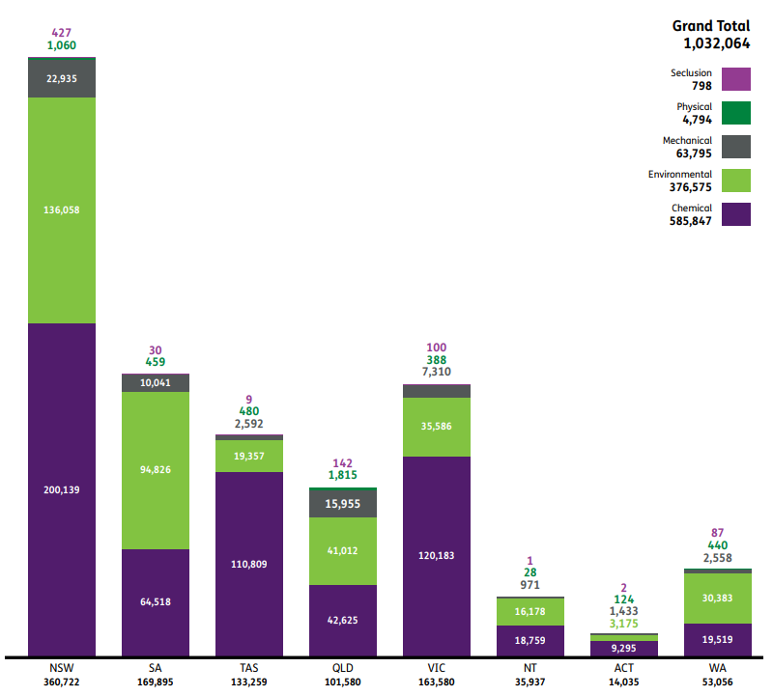
Figure 6 and Table 6 below show the number of URPs in 2020-21 by type of restrictive practice and by month.
Figure 6 - Number of instances of URPs in 2020-21 by type of restrictive practice by month

Table 6 - Number of instances of URPs in 2020-21 by type of restrictive practice by month
URP Type | Jul-20 | Aug-20 | Sep-20 | Oct-20 | Nov-20 | Dec-20 | Jan-21 | Feb-21 | Mar-21 | Apr-21 | May-21 | Jun-21
Chemical | 41,971 | 45,857 | 45,066 | 51,350 | 46,596 | 39,174 | 43,662 | 49,440 | 59,695 | 48,601 | 54,049 | 60,386
Environmental | 23,714 | 23,855 | 22,279 | 24,911 | 26,042 | 28,824 | 26,826 | 30,585 | 43,521 | 36,925 | 42,930 | 46,163
Mechanical | 3,356 | 3,962 | 5,484 | 5,010 | 4,462 | 3,959 | 4,414 | 5,244 | 8,588 | 6,452 | 6,303 | 6,561
Physical | 249 | 264 | 277 | 321 | 456 | 458 | 422 | 433 | 470 | 438 | 570 | 437
Seclusion | 53 | 71 | 82 | 60 | 65 | 43 | 29 | 55 | 40 | 117 | 99 | 84
Not classified | 15 | 16 | 7 | 5 | 14 | 35 | 9 | 16 | 19 | 19 | 21 | 79
Total | 69,358 | 74,025 | 73,195 | 81,657 | 77,635 | 72,493 | 75,362 | 85,773 | 112,333 | 92,552 | 103,972 | 113,710

Although the monthly numbers vary, the vast majority of URPs in each month involve the use of chemical restraints and environmental restraints.
Chemical restraints involve the use of medication or chemical substance for the primary purpose of influencing a person’s behaviour. Chemical restraints do not include the use of medication prescribed for the treatment of, or to enable treatment of, a diagnosed mental disorder, a physical illness or a physical condition.
Environmental restraints restrict a person’s free access to all parts of their environment, for example by locking doors or restricting access to knives and other sharps.

Chemical restraints in URPs in 2020-21
Chemical restraints are the most frequently used restrictive practices in URPs.
All chemical restraints have been prescribed for the participant by the participant’s health practitioner. In contrast to the other categories of regulated restrictive practices, chemical restraints are in a sense subject to an additional threshold requirement outside of state and territory authorisation requirements and NDIS Commission behaviour support requirements. That is, regardless of whether the use of a chemical restraint is authorised or unauthorised, it will have been prescribed for the participant by a medical practitioner with authority to prescribe the particular medication or chemical substance.
For the purposes of this report, the NDIS Commission analysed notifications of URPs in 2020-21 involving chemical restraint where the medication or chemical substance was named.
Table 7 below shows the number of participants who were subject to URPs involving chemical restraint where the medication or chemical substance was named by the number of medications to which the participant was subject and by the age group of the participant (18 years of age or younger, or 19 years of age or older). Although participants aged 18 are adults, in this report they are grouped with younger participants to be consistent with analysis applied by the NDIA in areas of analysis, participation in school which may affect the reporting of restrictive practices where they are administered in the school setting, and may be subsequently administered by an NDIS provider when a participant leaves secondary education.
Table 7 - Number of participants subject to unauthorised use of chemical restraint in 2020-21 by number of medications and age group
Number of medications | Age 0 to 18 | Age 19+ | Total | Percent (%)
1 | 297 | 1,960 | 2,257 | 54%
2 | 145 | 872 | 1,017 | 24%
3 | 71 | 398 | 469 | 11%
4 | 34 | 185 | 219 | 5%
5 | 15 | 96 | 111 | 3%
6 | 10 | 45 | 55 | 1%
7 | 6 | 18 | 24 | 1%
8 | 0 | 9 | 9 | 0%
9 | 0 | 2 | 2 | 0%
10+ | 0 | 0 | 0 | 0%
Total number of participants receiving a specified unauthorised chemical restraint | 578 | 3,585 | 4,163 | 100%

A majority of participants (54%) who were subject to the unauthorised use of a chemical restraint in 2020-21 where the medication or chemical substance was named were subject to only one medication or chemical substance used as a chemical restraint. 90% of the participants who were subject to the unauthorised use of a chemical restraint in 2020-21 where the medication or chemical substance was named were subject to three or fewer medications or chemical substances used as chemical restraints.
86% of the participants who were subject to the unauthorised use of a chemical restraint in 2020-21 where the medication or chemical substance was named were 19 years of age or older. However, notifications of URPs received by the NDIS Commission may understate the comparable use of chemical restraints in relation to children if chemical restraints are more often administered to child participants by persons other than NDIS providers (for example, parents or other family members or within the education system) than occurs in relation to older participants.
Table 8 below shows the types of medication reported as unauthorised chemical restraints in 2020-21 by medication class, showing both the number of instances of use of each type of medication and the number of participants in respect of whom the type of medication was used.

Table 8 - Types of medication reported as unauthorised chemical restraint in 2020-21
Medication class | Number of instances | Number of participants
Antipsychotic | 281,440 | 2,590
Anticonvulsant | 107,359 | 769
Antidepressant | 78,801 | 1,029
Benzodiazepine | 34,238 | 753
Antihypertensive | 27,588 | 412
Hormone treatment | 11,954 | 252
Anti-Parkinsonian | 7,407 | 54
Contraceptive | 7,161 | 93
Stimulant | 6,121 | 188
Bipolar disorder treatment | 5,743 | 51
Antiandrogen | 3,555 | 37
Other | 14,480 | 312

The most frequently used medications, both in terms of the number of times they were used and the number of participants in relation to whom they were used, were antipsychotics. The next most frequently used medications in terms of the number of times they were used were anticonvulsants; however, antidepressants were used with more participants (1,029) than anticonvulsants (769).
The Senior Practitioner is undertaking work to assist NDIS providers to engage with, and obtain clarification from prescribers, where required, about the purpose for which the medication is prescribed, thereby enabling the provider to determine whether the use of the medication should be reported to the NDIS Commission as a chemical restraint, or contained in a behaviour support plan.

NDIS providers that notified URPs
Table 9 below shows:
- the number of providers in each state and territory that reported URPs in 2020-21;
- the number of individual instances of URPs in 2020-21;
- the number of individual instances of URPs in 2020-21 that were notified by the 10 providers who notified the highest numbers of URPs in 2020-21 in the relevant state or territory or nationally (the ‘top 10 providers’, noting that the group of top 10 providers will be different in each State or Territory and nationally);
- the percentage of URPs in 2020-21 that were notified by the relevant group of top 10 providers (for each state, or nationally).
Table 9 - providers reporting URPs in 2020-21 by state and territory and by highest usage
Jurisdiction | # of providers | # Instances of unauthorised restrictive practices implemented | # Instances of unauthorised restrictive practices implemented by top 10 providers | % of unauthorised restrictive practices implemented by the top 10 providers
NSW | 243 | 360,722 | 221,558 | 61%
VIC | 161 | 163,580 | 106,840 | 65%
QLD | 222 | 101,580 | 66,992 | 66%
WA | 72 | 53,056 | 42,825 | 81%
SA | 102 | 169,895 | 124,816 | 73%
TAS | 44 | 133,259 | 109,259 | 82%
ACT | 61 | 14,035 | 11,070 | 79%
NT | 25 | 35,937 | 33,357 | 93%
National | 792 | 1,032,064 | 380,654 | 37%

In 2020-21, 792 registered NDIS providers notified the NDIS Commission of reportable incidents involving URPs in relation to the participants they support.
The number of URPs reported in Western Australia is likely to be an understatement as the NDIS Commission only commenced jurisdiction in Western Australia on 1 December 2020 and the transitional arrangements under the Restrictive Practices and Behaviour Support Rules applied in Western Australia following transition. Some Western Australian providers are still transitioning to the full reporting requirements and so the number of reports of URPs in Western Australia may continue to grow in the 2021-21 reporting period
The NDIS Commission analysed URPs reported in 2020-21 to identify the 10 providers that notified the most URPs in 2020-21. The NDIS Commission then analysed the proportion of total URPs that were used by the top 10 providers. These analyses show that a small number of providers (10) used most of the URPs notified in 2020-21 (69%). Excluding Western Australia, the proportion of URPs used by the top 10 providers ranged from 61% to 66% in the larger states (New South Wales, Victoria and Queensland) and from 73% to 93% in the smaller jurisdictions (South Australia, Tasmania, the Australian Capital Territory and the Northern Territory).

Reducing URPs

How the regulatory requirements are intended to work
Ideally, only single, emergency uses of restrictive practices by NDIS providers will be notified as reportable incidents, while all ongoing uses of restrictive practices by NDIS providers will be authorised (if required) and will occur in accordance with a behaviour support plan for the participant. Authorisation and behaviour support planning are the best way to uphold the human rights of affected participants and reduce and eliminate the use of restrictive practices.
However, there are circumstances in which ongoing uses of restrictive practices will need to be notified as reportable incidents:
- when an NDIS provider starts using restrictive practices in relation to a participant, each use will need to be notified as a reportable incident until the restrictive practice is authorised (if required) and a behaviour support plan is prepared – this could occur when a person with disability first becomes a participant, when an NDIS provider first decides that it needs to use a restrictive practice in relation to a participant, or when a participant moves from being supported in the family home (where they are subject to restrictive practices used by family members) to supported accommodation (where the restrictive practices are used by an NDIS provider);
- when the restrictive practices being used in relation to a participant change so that a new restrictive practice is used – this could occur if the participant’s prescribing health practitioner changes the participant’s medication to a different medication or a different dosage or adds an additional medication, or if an additional type of environmental restraint is used in relation to the participant; and
- when the authorisation (if required) for the use of the restrictive practice or the behaviour support plan for the participant expire or are no longer current – the NDIS provider will need to report each use of the previously authorised restrictive practice as a reportable incident until authorisation (if required) and a current behaviour support plan for the participant are in place.
In these circumstances, the NDIS Commission’s objective as regulator is to require the use of the restrictive practice to be authorised (if required) and for a behaviour support plan for the participant covering the use of the restrictive practice to be prepared and submitted to the NDIS Commission as soon as possible.
Obtaining authorisation (if required) and a behaviour support plan for a participant involves two different NDIS providers and an NDIS behaviour support practitioner as follows:
(a) Implementing provider: This is the NDIS provider who uses a restrictive practice in relation to a participant in the course of providing NDIS supports and services to the participant. It is the implementing provider that is required to notify the NDIS Commission of any URP as a reportable incident.
(b) Specialist behaviour support provider: This is the NDIS provider who is responsible for the development of behaviour support plans for participants. Specialist behaviour support providers must comply with particular requirements under the NDIS Practice Standards to be registered to provide specialist behaviour support services.
(c) NDIS behaviour support practitioner: This is the individual who undertakes the behaviour support assessment, including the functional behavioural assessment, and develops the behaviour support plan for the participant. A person can be an NDIS behaviour support practitioner only if the NDIS Commissioner considers the person to be suitable to undertake behaviour support assessments and to develop behaviour support plans that may contain the use of restrictive practices.
In addition to notifying the NDIS Commission of any URPs, the implementing provider is also obliged to obtain authorisation (if required) for the ongoing use of any regulated restrictive practice and to take all reasonable steps to facilitate the development of an interim behaviour support plan and then a comprehensive behaviour support plan for the participant. Authorisation (if required) cannot usually be obtained under state or territory requirements until a behaviour support plan has been prepared.
The specialist behaviour support provider is obliged to develop an interim behaviour support plan within one month after being engaged to develop the plan and a comprehensive behaviour support plan within six months after being engaged to develop the plan. The specialist behaviour support provider must engage and NDIS behaviour practitioner to develop the behaviour support plans.
Moving from the unauthorised use of a restrictive practice to use of a restrictive practice that is authorised (if required) and in accordance with a behaviour support plan for the participant typically will require:
- the participant or their nominee, with any necessary assistance from the implementing provider, to choose and engage a specialist behaviour support provider or NDIS behaviour support practitioner
- the NDIS behaviour support practitioner and the participant to be available for the NDIS behaviour support practitioner to undertake the behaviour support assessment, including the functional behavioural assessment
- the NDIS behaviour support practitioner to develop the behaviour support plan
- the implementing provider to use the behaviour support plan and any other necessary inputs to obtain authorisation
- the specialist behaviour support provider to lodge the behaviour support plan with the NDIS Commission
- the implementing provider to accept the behaviour support plan and lodging evidence of authorisation (if required) with the NDIS Commission.
The time that it takes a specialist behaviour support provider to lodge a behaviour support plan is influenced by a number of factors already described in this report. The NDIS Commission will be undertaking further analysis of these trends as part of a further analysis of restrictive practices in the NDIS, both authorised and unauthorised.
Figure 7 - comprehensive BSP lodgement timeframe by month of first use of restrictive practice
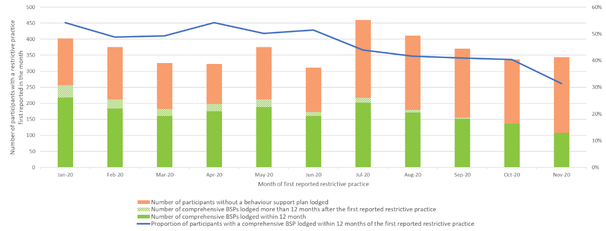
Figure 7 provides a view of behaviour support lodgements over the period 1 January to 30 November 2020 as an example of lodgement trends:
- the number of participants with a restrictive practice reported in each month;
- the number of participants with a restrictive practice reported in each month without a behaviour support plan (BSP) lodged;
- the number of participants with a restrictive practice reported in each month with a BSP lodged within 12 months of the first reported restrictive practice
- the number of participants with a restrictive practice reported in each month with a BSP lodged more than 12 months after the first reported restrictive practice.
By 30 November 2021, comprehensive BSPs had been lodged with the NDIS Commission for 44% of the participants with their first restrictive practice reported between 1 January 2020 and 30 November 2020. BSPs are not required for single emergency uses of restrictive practices. However, single emergency uses would not account for the relatively large number of participants for whom a comprehensive BSP has not been lodged. Where a comprehensive BSP was lodged, 92% were lodged within 12 months of the first reported restrictive practice. The NDIS Commission is targeting both the preparation and the timeliness of the preparation of BSPs in its compliance action.

How the regulatory requirements are working
The data on URPs in 2020-21 suggests that single, emergency uses of restrictive practices are being notified to the NDIS Commission as reportable incidents. 27% of participants who were subject to URPs in 2020-21 were subject to only one URP. Where participants were subject to only a few URPs throughout the year, these may also be single, emergency uses of restrictive practices which are not required to be authorised (if required) or used in accordance with a behaviour support plan.
However, the high number of URPs in 2020-21 (1,032,064) shows that authorisation (if required) is not being obtained and behaviour support plans are not being prepared and submitted to the NDIS Commission as quickly as they should be for some participants. The reasons for this could include:
- decisions to be taken by an NDIS participant or their supporters about a behaviours support provider to prepare a plan, or a chosen behaviour support provider not being available;
- authorisation processes involving more complex steps for some participants such as applications to administrative tribunals;
- authorisations expiring during the development of a comprehensive behaviour support plan;
- failure of an implementing provider, or a behaviour support provider to comply with their obligations to take all reasonable steps to obtain authorisation or develop a behaviour support plan.
The NDIS Commission’s compliance action in 2019-20 required providers to provide information about URPs notified over the period July 2019 to September 2020 and demonstrate compliance with regulatory requirements in relation to a number of those URPs. That compliance action provides important information on the factors that contribute to the growing number of URPs at that time, with the main reason being action required by providers to be compliant.
The data on URPs in 2020-21 shows that:
- a relatively small number of participants (776 or 10% of participants subject to URPs) are subject to high numbers of ongoing URPs (62% of total URPs)
- a relatively small number of providers (10) report a large proportion of URPs (37% of total URPs).
These analyses demonstrate that, in taking action to bring the use of regulated restrictive practices into compliance with the regulatory requirements to promote and protect the human rights of affected participants and to reduce and eliminate the use of restrictive practices, the NDIS Commission’s attention is properly focused on the small number of participants subject to high numbers of ongoing URPs, and on the providers who use the most URPs. This attention is directed at ensuring that providers that use URPs, and providers that provide specialist behaviour support, comply with their obligations to obtain authorisation, if required, and develop and implement behaviour support plans for participants subject to ongoing uses of regulated restrictive practices.

Priority actions
The NDIS Commission has identified the following priority actions.
- Continue to target the current compliance activity on participant outcomes
The NDIS Commission will continue to focus the compliance action commenced in 2021-22 on the participants who are subject to the highest number of URPs, targeting the NDIS providers who are using those restrictive practices and the specialist behaviour support providers who have been engaged to prepare the participant’s behaviour support plan. In doing so the NDIS Commission will draw on extensive information obtained through compliance action undertaken in 2019-20 on the factors contributing to the ongoing use of URPs.
- Increase focus on compliance as soon as notifications of URPs are received
The NDIS Commission continue work commenced in 2021-22 to identify early URPs that are likely to be ongoing when they are first notified; engaging with the NDIS provider who notified the use; following up on compliance with the more detailed guidance on what taking all reasonable steps to facilitate the development of an interim or comprehensive behaviour support plan requires; identify and seeking to address early any problems that are likely to cause delay; and engaging with the specialist behaviour support provider to ensure timeframes for behaviour support plans are understood and met.
- Continue engagement with States and Territories on authorisation processes
The NDIS Commission continues to work with all states and territories to apply shared principles to achieve national consistency in authorisation for the use of restrictive practices, and the reduction and ultimately elimination of such practices consistent with the National Framework for Reducing and Eliminating the Use of Restrictive Practices in the Disability Service Sector (National Framework) endorsed by all governments in 2014. States and territories have plans in place to move to national consistency with the principles, the implementation of which are monitored Disability Ministers.
- Increase the number and competence of behaviour support practitioners
The NDIS Commission will continue to implement an extensive program of work, in collaboration with states and territories, to build the capability of behaviour support practitioners, and to attract new practitioners to the NDIS market, participating in areas where there is a need to develop this market. There is a national plan in place to guide this work.
- Reviewing the interaction of the regulatory requirements in relation to behaviour support and reportable incidents
Once the current compliance activity is completed, the NDIS Commission will reconsider the regulatory requirements to prevent the oversight of uses of restrictive practices in relation to a participant being split between reportable incidents and behaviour support.
This will give better ongoing oversight of what is happening for a participant who is subject to restrictive practices, whether authorised or unauthorised or both. It will enable the NDIS Commission, through the behaviour support function to monitor in a single view, the circumstances of a participant, once they have an initial behaviour support plan and there is at least initial authorisation of the restrictive practices to which they are subject. If the restrictive practices change, or the behaviour support plan or authorisation expire, uses of restrictive practices for that participant could continue to be reported to and overseen through the behaviour support function, which would also require the relevant NDIS providers to obtain further authorisation and review the participant’s behaviour support plan or develop a new plan. This would give better continuity of oversight of the participant’s experiences in relation to restrictive practices.
It would also enable the Commission’s reportable incident function to focus on those participants who are subject to ongoing uses of restrictive practices for the first time in the NDIS, and who have not yet had a behaviour support plan or authorisation, and on single, emergency uses of restrictive practices.
- Building the capability of the workforce implementing restrictive practices
The NDIS Commission will embark on an education program for providers and workers who implement restrictive practices in the course of supporting a participant. This may include the development of a Worker Orientation Module that guides workers through their obligations, with a focus on participant experience and outcomes, building a culture of rights-based supports and reinforcing the objective of reducing and eliminating the use of restrictive practices in the NDIS.

Appendices

Additional summaries
Figure 8 - Instances of URPs by state and territory since July 2019 - NSW
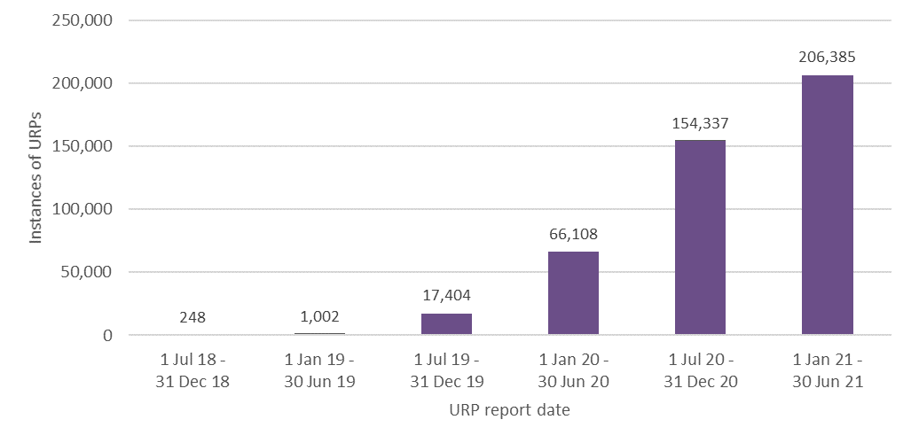
Figure 9 - Instances of URPs by state and territory since July 2019 - VIC
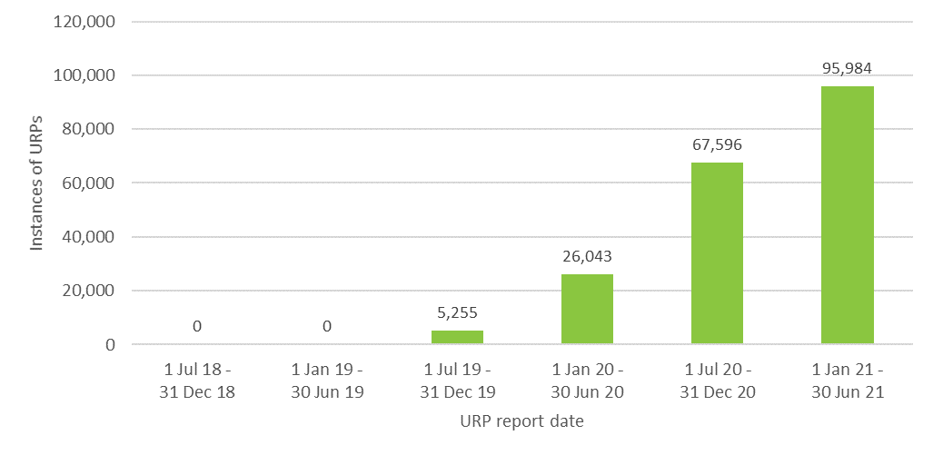
Figure 10 - Instances of URPs by state and territory since July 2019 - QLD
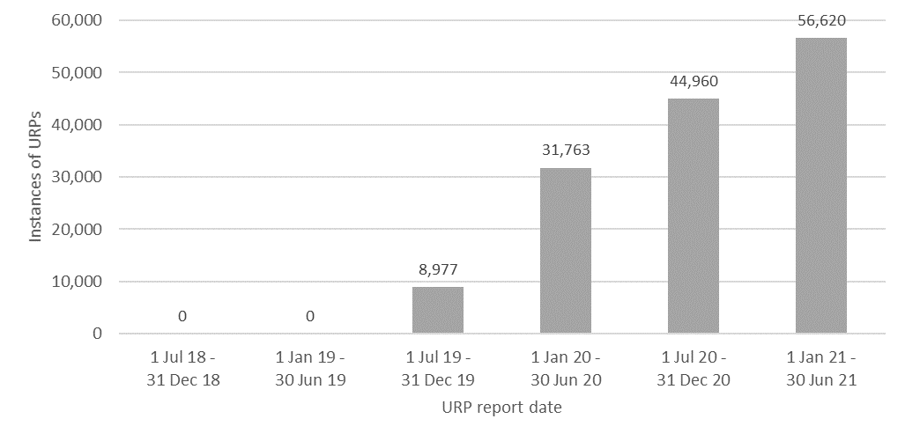
Figure 11 - Instances of URPs by state and territory since July 2019 - WA
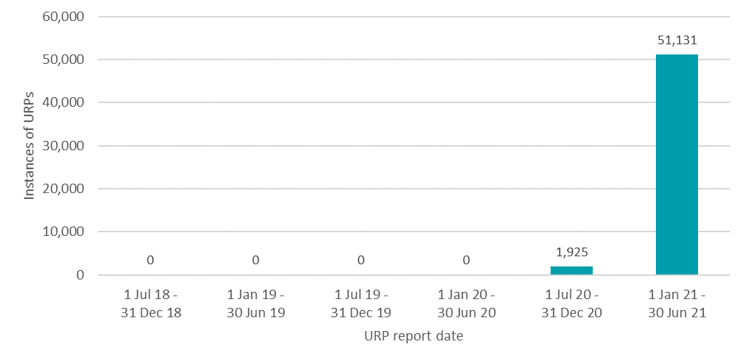

Figure 12 - Instances of URPs by state and territory since July 2019 - SA
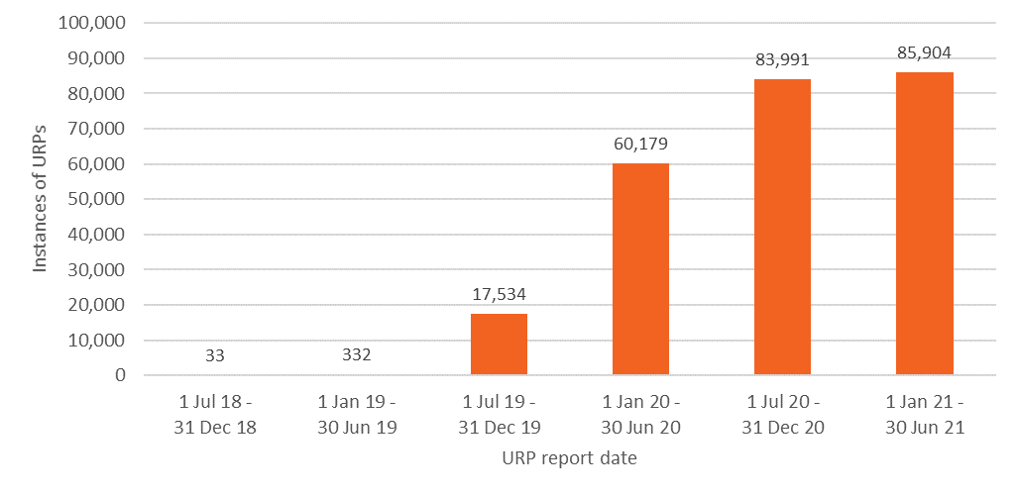
Figure 13 - Instances of URPs by state and territory since July 2019 - TAS
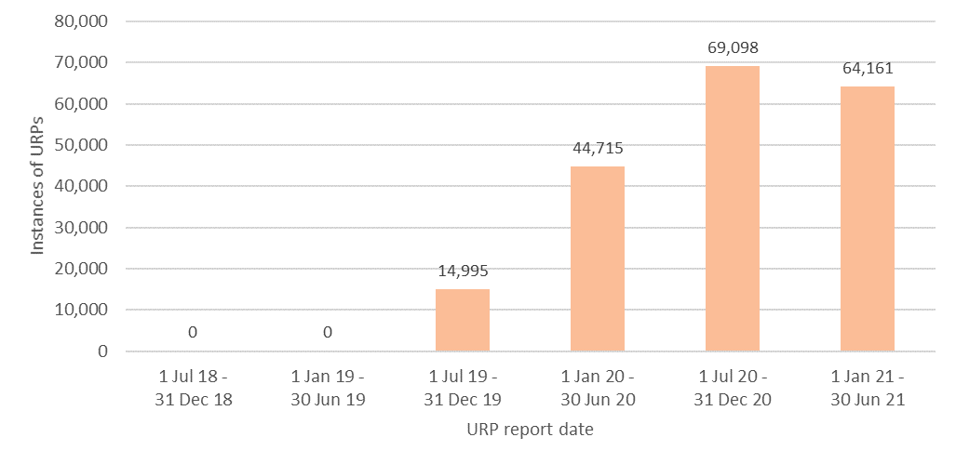
Figure 14 - instances of URPs by state and territory since July 2019 - ACT
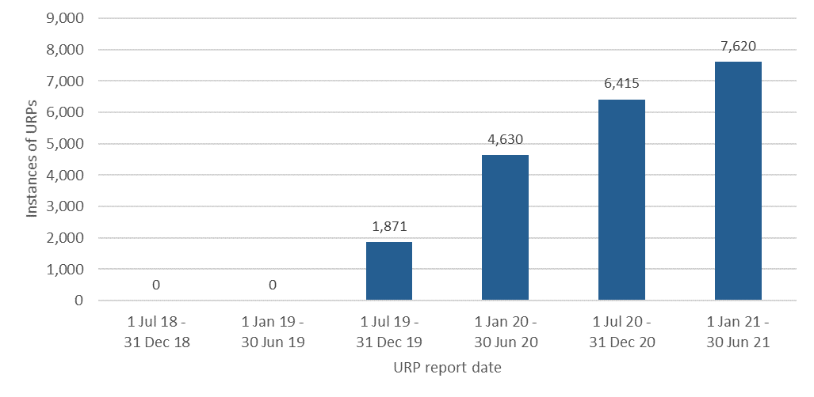
Figure 15 - Instances of URPs by state and territory since July 2019 - NT
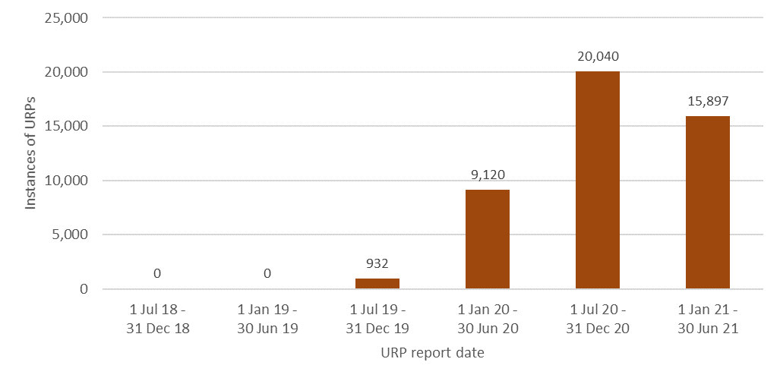
Figure 16 - Instances of URPs used in relation to the 10% of participants subject to the most URPs - NSW
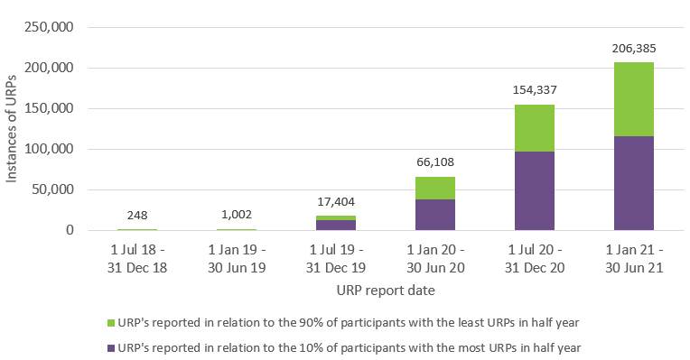
Figure 17 - Instances of URPs used in relation to the 10% of participants subject to the most URPs - VIC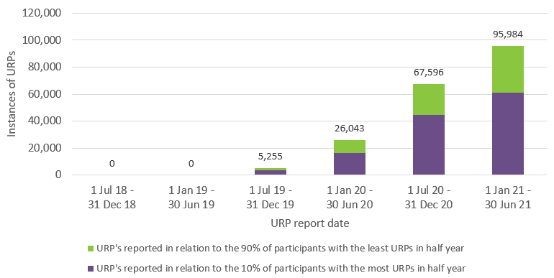
Figure 18 - Instances of URPs used in relation to the 10% of participants subject to the most URPs - QLD
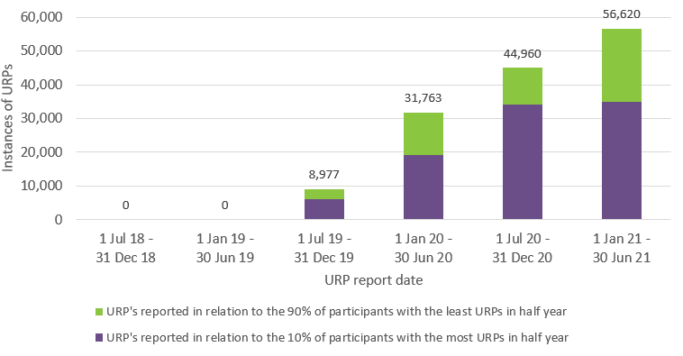
Figure 19 - Instances of URPs used in relation to the 10% of participants subject to the most URPs - WA
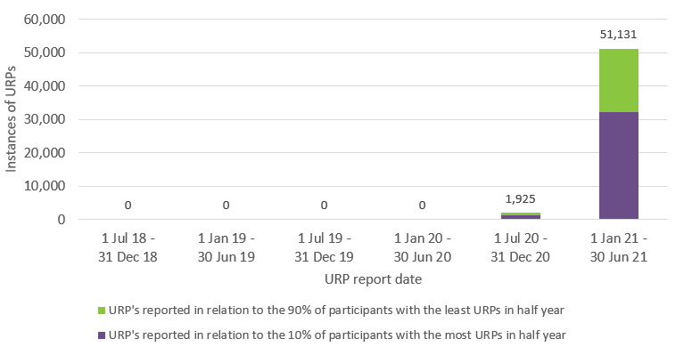
Figure 20 - Instances of URPs used in relation to the 10% of participants subject to the most URPs - SA
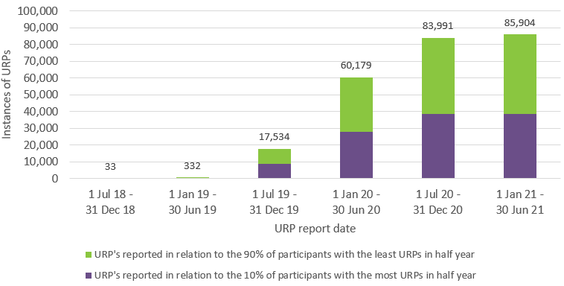
Figure 21 - Instances of URPs used in relation to the 10% of participants subject to the most URPs - TAS
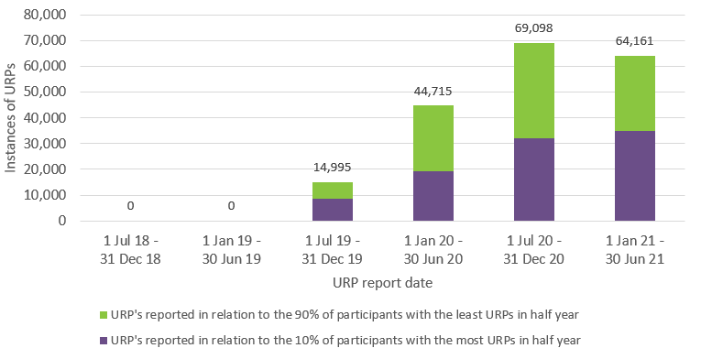
Figure 22 - Instances of URPs used in relation to the 10% of participants subject to the most URPs - ACT
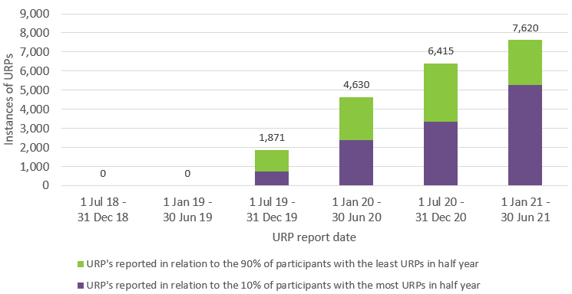
Figure 23 - Instances of URPs used in relation to the 10% of participants subject to the most URPs - TAS
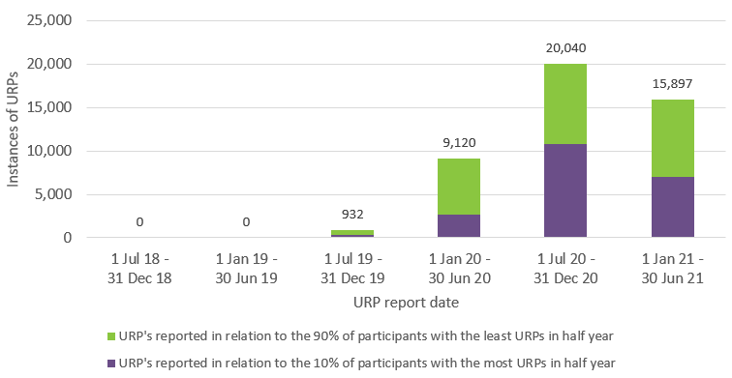
Figure 24 - Count of participants subject to URPs since July 2018 - NSW
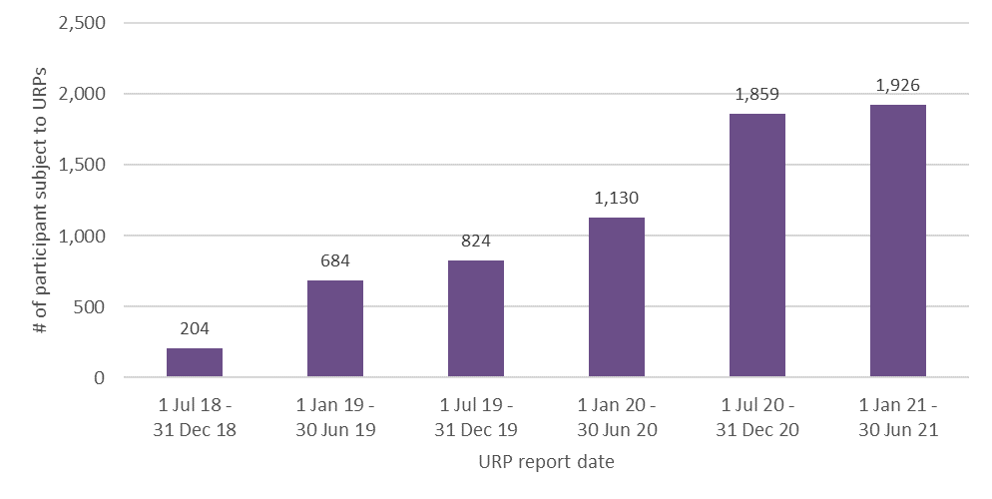
Figure 25 - Count of participants subject to URPs since July 2018 - VIC
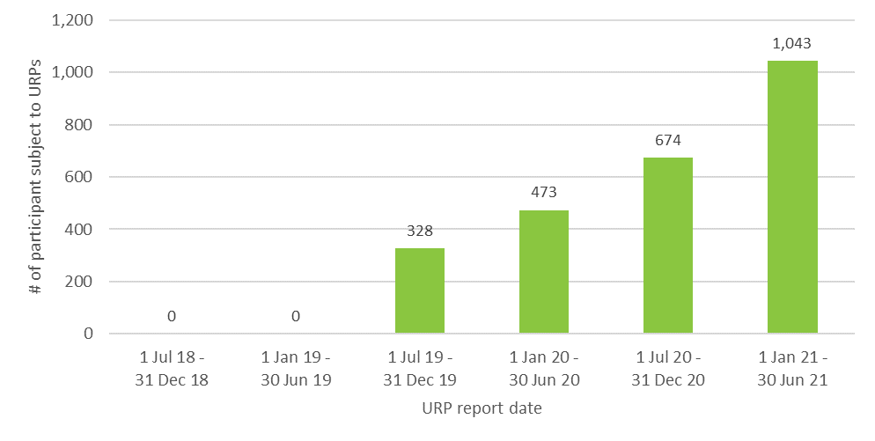
Figure 26 - Count of participants subject to URPs since July 2018 - QLD
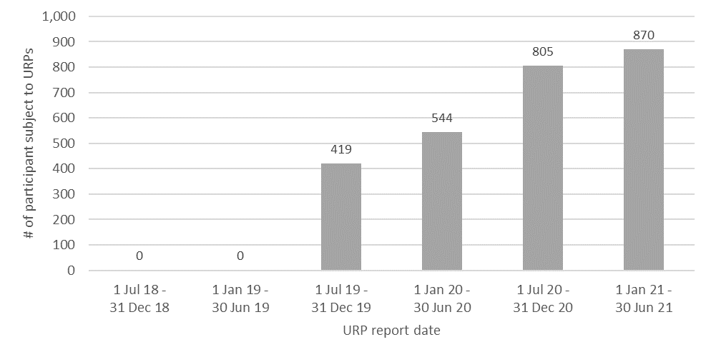Figure 27 - Count of participants subject to URPs since July 2018 - WA
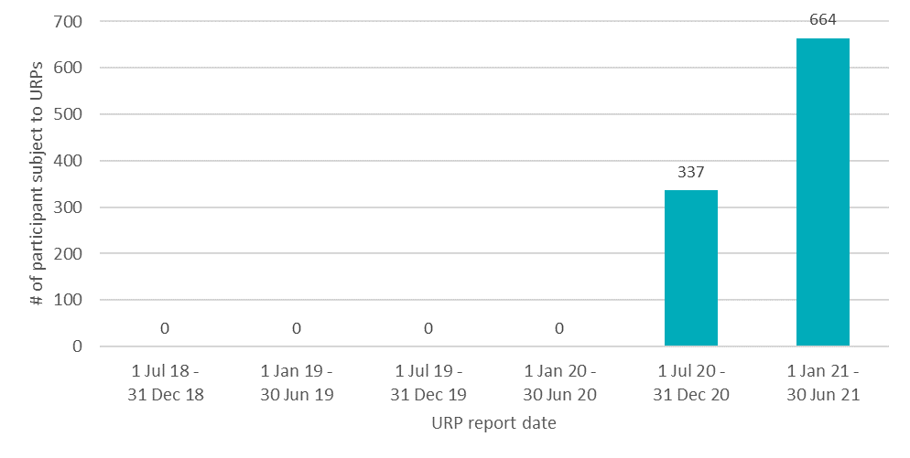
Figure 28 - Count of participants subject to URPs since July 2018 - SA
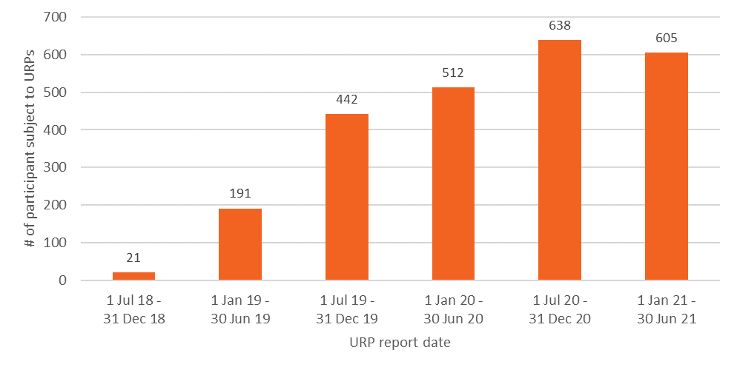
Figure 29 - Count of participants subject to URPs since July 2018 - TAS
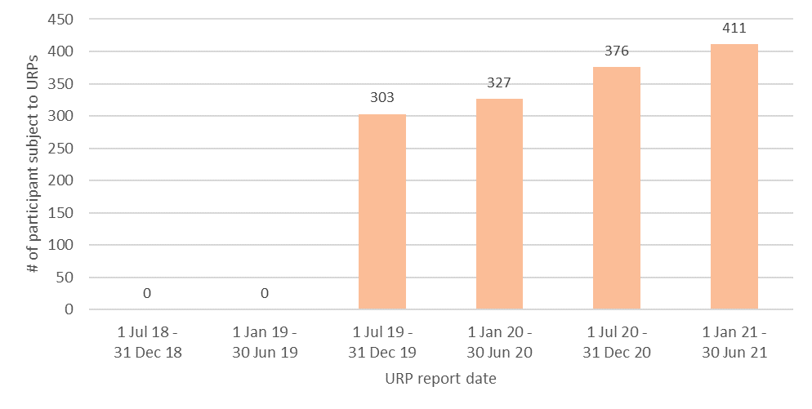
Figure 30 - Count of participants subject to URPs since July 2018 - ACT
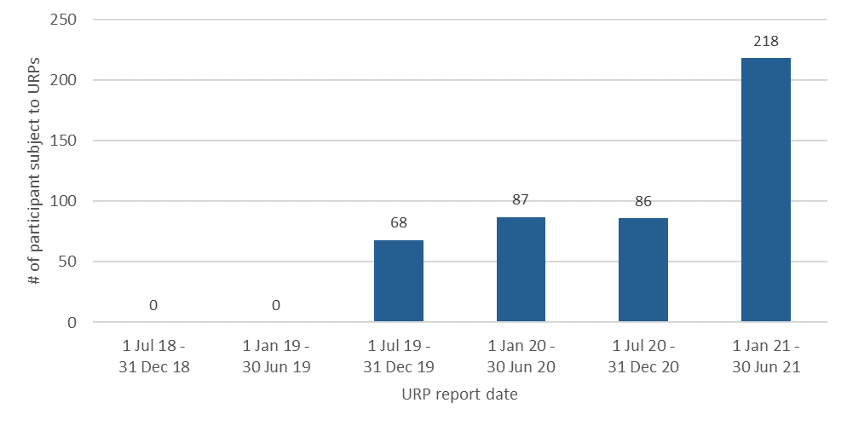Figure 31 - Count of participants subject to URPs since July 2018 - NT
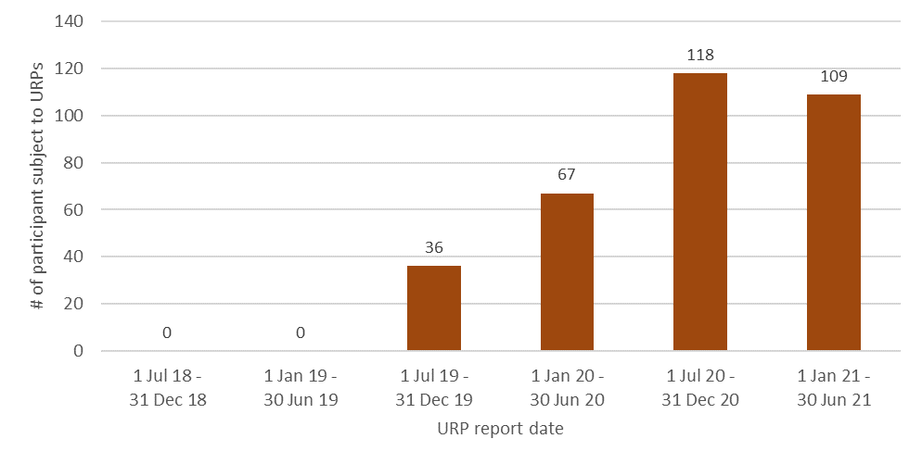

Figure 32 - Count of participants subject to URPs since July 2019 by number of URPs experienced in half year - NSW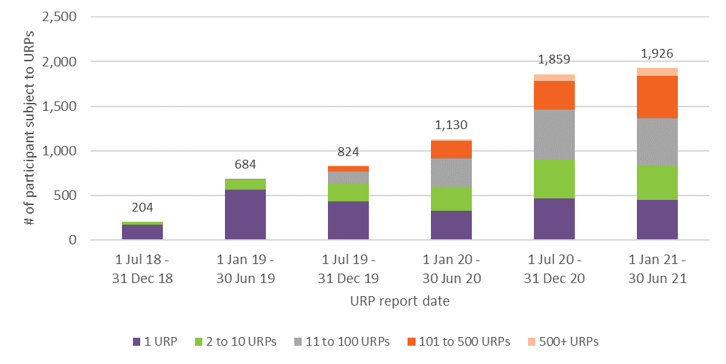
Figure 33 - Count of participants subject to URPs since July 2019 by number of URPs experienced in half year - VIC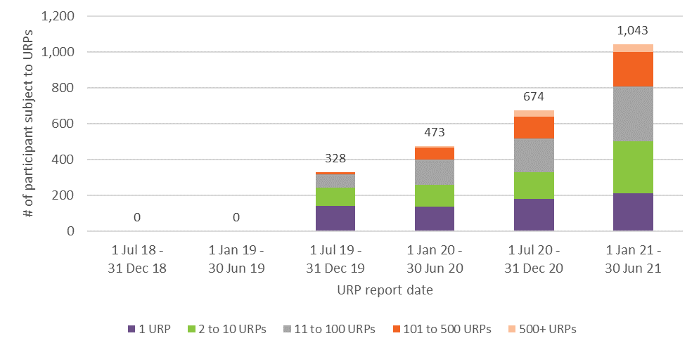
Figure 34 - count of participants subject to URPs since July 2019 by number of URPs experienced in half year - QLD
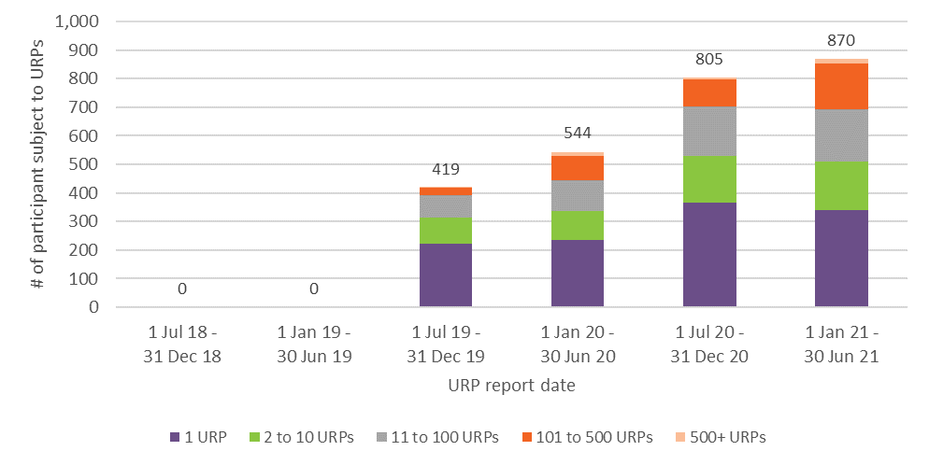
Figure 35 - count of participants subject to URPs since July 2019 by number of URPs experienced in half year - WA
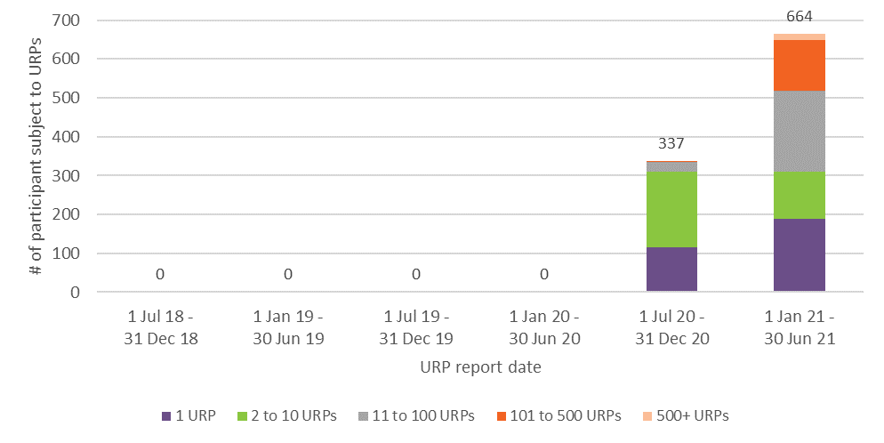
Figure 36 - Count of participants subject to URPs since July 2019 by number of URPs experienced in half year - SA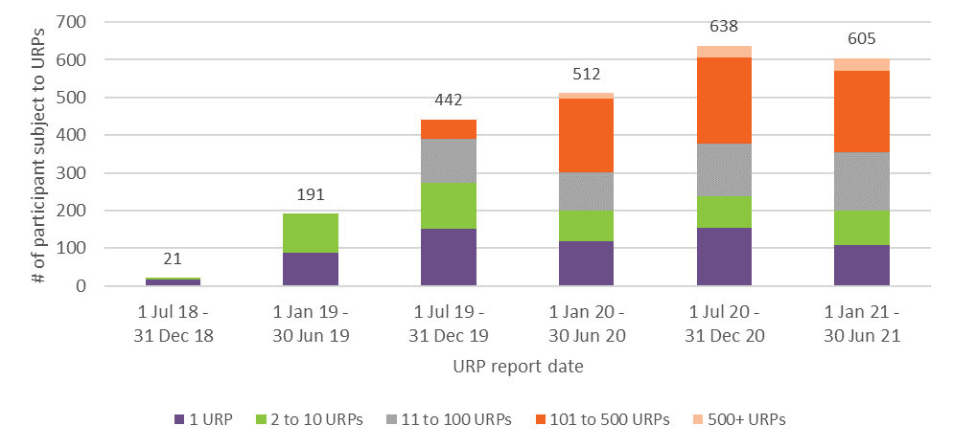
Figure 37 - Count of participants subject to URPs since July 2019 by number of URPs experienced in half year - TAS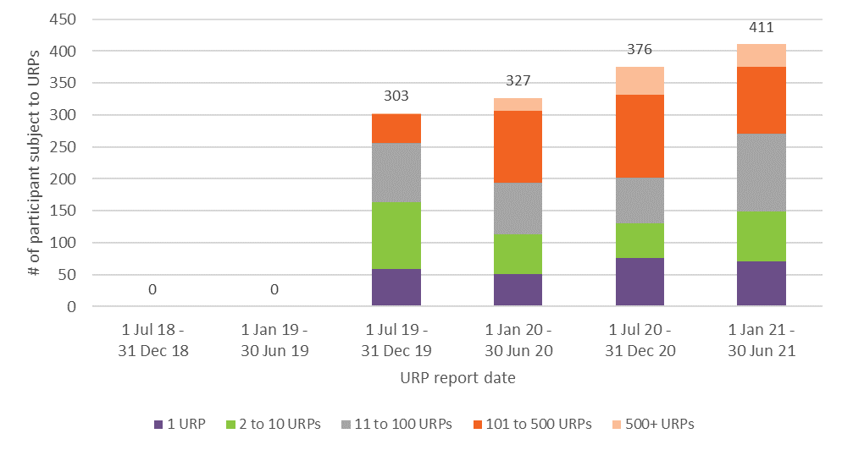
Figure 38 - Count of participants subject to URPs since July 2019 by number of URPs experienced in half year - ACT
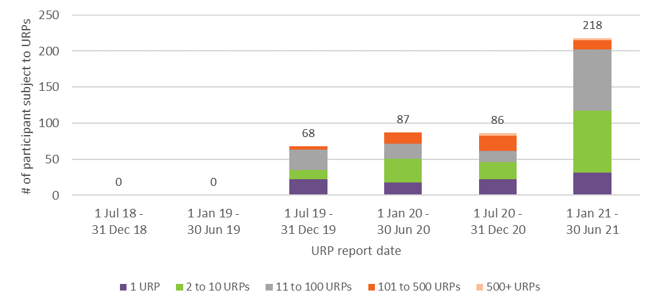
Figure 39 - Count of participants subject to URPs since July 2019 by number of URPs experienced in half year - NT

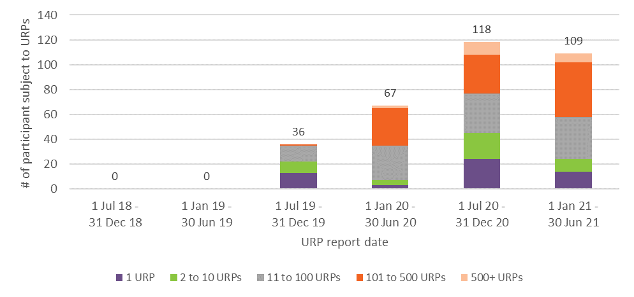
Table 10 - Participants subject to restrictive practices in 2020-21 by behaviour support funding and age band
Participant Age | Participants subject to URPs | Participants with behaviour support funding and subjected to URP's
 |  | # | %
0 to 6 | 50 | 11 | 1.6%
7 to 14 | 511 | 383 | 3.2%
15 to 18 | 496 | 400 | 7.5%
19 to 24 | 1,008 | 845 | 16.9%
25 to 34 | 1,216 | 1,000 | 18.0%
35 to 44 | 902 | 731 | 16.1%
45 to 54 | 1,078 | 836 | 16.9%
55 to 64 | 1,028 | 749 | 14.9%
65+ | 333 | 217 | 13.9%
Total | 6,622 | 5,172 | 11.6%

Table 11 - Participants subject to restrictive practices in 2020-21 by behaviour support funding and primary disability
Primary Disability | Participants subject to URPs | Participants with behaviour support funding and subjected to URP's
 |  | # | %
ABI | 387 | 301 | 77.8%
Autism | 1,777 | 1,504 | 84.6%
Cerebral Palsy | 360 | 216 | 60.0%
Developmental delay | 8 | 2 | 25.0%
Global developmental delay | 4 | 1 | 25.0%
Hearing Impairment | 0 | 0
Intellectual Disability | 3,166 | 2,526 | 79.8%
Multiple Sclerosis | 23 | 10 | 43.5%
Other | 21 | 16 | 76.2%
Other Neurological | 302 | 186 | 61.6%
Other Physical | 38 | 19 | 50.0%
Other Sensory/Speech | 0 | 0
Psychosocial disability | 444 | 344 | 77.5%
Spinal Cord Injury | 26 | 9 | 34.6%
Stroke | 55 | 33 | 60.0%
Visual Impairment | 11 | 5 | 45.5%
Total | 6,622 | 5,172 | 78.1%

Table 12 - Participants subject to restrictive practices in 2020-21 by behaviour support funding and state/territory
Jurisdiction | Participants subject to URPs | Participants with behaviour support funding and subjected to URP's
 |  | # | %
NSW | 2,604 | 2,127 | 81.7%
VIC | 1,246 | 995 | 79.9%
QLD | 1,175 | 794 | 67.6%
WA | 89 | 56 | 62.9%
SA | 786 | 660 | 84.0%
TAS | 465 | 324 | 69.7%
ACT | 106 | 91 | 85.8%
NT | 151 | 125 | 82.8%
Total | 6,622 | 5,172 | 78.1%

Background

About the NDIS Commission
The NDIS Quality and Safeguards Commission is an independent Commonwealth agency established to improve the quality and safety of NDIS supports and services.
The NDIS Commission works with NDIS participants, service providers, workers and the community to implement a new nationally consistent approach so participants can access services and supports that promote choice, control and dignity.
The NDIS Commission regulates the quality and safety of NDIS services and supports. The Commission’s activities include: upholding the rights, health and safety of people with disability; development of a nationally consistent approach to managing quality and safeguards; registration of providers; education activities and provision of information; complaints management, including, assessment, investigation, conciliation and resolution of complaints; oversight of a provider’s responses to reportable incidents and taking action as appropriate; behaviour support leadership and oversight; compliance and enforcement, including investigations; market oversight; and supporting providers to meet their NDIS worker screening obligations.
The NDIS Commission began operations in New South Wales and South Australia on 1 July 2018. Operations expanded to Victoria, Queensland, Tasmania, the Northern Territory, and the Australian Capital Territory on 1 July 2019. Operations began in Western Australia and residential aged care facilities on 1 December 2020.

The Policy Framework
Consistent with the UN Convention on the Rights of Persons with Disabilities, the Commonwealth, State and Territory Governments established a National Framework for Reducing and Eliminating the Use of Restrictive Practices in the Disability Services Sector (2014) (National Framework). This framework emphasises that restrictive practices should only be use where they are proportionate and justified in order to protect the rights or safety of the person or others. Recording, reporting, and monitoring on restrictive practices is critical to ensuring accountability and awareness.
The NDIS Quality and Safeguarding Framework contextualises the need for regulation of restrictive practices, particularly that:
- Such practices would apply to a small proportion of the NDIS participant population, specifically those who require supports to address behaviours which pose a risk to themselves or others;
- Restrictive practices have been used as a first line of response for people with behaviours of concern but are now understood to represent serious human rights infringements
- There is clear evidence that the use of restrictive practices to control individuals’ behaviour has often been harmful and exacerbated the behaviours they were intended to control.
- For most people subject to restrictive practices it should be possible to eliminate the use by understanding and responding to underlying behaviours, but for a small number of people it may not be possible to fully eliminate the use of restrictive practices for example.
- The goal should always be to move to a reduction or elimination. However there might be some emergency of extenuating circumstances where a restriction might be the most appropriate response.
- The NDIS should move toward a system in which the use of restrictive practices in response to behaviours of concern occurs by exception and is underpinned by a positive behaviour support framework

Types of restrictive practices in the NDIS
The NDIS (Restrictive Practice and Behaviour Support) Rules 2018 identify five types of regulated restrictive practice. The rules require NDIS providers to report where these regulated restrictive practices have been used on NDIS participants. The five types of regulated restrictive practice are:
- seclusion, which is the sole confinement of a person with disability in a room or a physical space at any hour of the day or night where voluntary exit is prevented, or not facilitated, or it is implied that voluntary exit is not permitted;
- chemical restraint, which is the use of medication or chemical substance for the primary purpose of influencing a person’s behaviour. It does not include the use of medication prescribed by a medical practitioner for the treatment of, or to enable treatment of, a diagnosed mental disorder, a physical illness or a physical condition;
- mechanical restraint, which is the use of a device to prevent, restrict, or subdue a person’s movement for the primary purpose of influencing a person’s behaviour but does not include the use of devices for therapeutic or non-behavioural purposes;
- physical restraint, which is the use or action of physical force to prevent, restrict or subdue movement of a person’s body, or part of their body, for the primary purpose of influencing their behaviour. Physical restraint does not include the use of a hands-on technique in a reflexive way to guide or redirect a person away from potential harm/injury, consistent with what could reasonably be considered the exercise of care towards a person.
- environmental restraint, which restrict a person’s free access to all parts of their environment, including items or activities.

What is required of providers
Where an NDIS participant’s behaviours of concern place themselves or others at risk of harm, and subsequently a regulated restrictive practice required, a behaviour support plan must be developed and lodged with the NDIS Commission by a specialist behaviour support provider. An interim behaviour support plan must be lodged within one month and a comprehensive plan lodged within six months.
An implementing provider who uses regulated restrictive practices needs to provide monthly reports to the NDIS Commission on the use of these practices. Unplanned or unauthorised use of a regulated restrictive practice must be reported to the NDIS Commission through the reportable incident process.
As the NDIS Commission commenced in each jurisdiction, there was a transitional period where providers did not need to report these practices.

Oversight and analysis of restrictive practices
The NDIS Commission monitors the use of restrictive practices and educates providers and participants about behaviour support strategies, with the aim of reducing and eliminating restrictive practices.
The NDIS Commission’s first line of oversight of restrictive practices is the registration of implementing providers and behaviour support providers. Both implementing providers and behaviour support providers are required to abide by the NDIS Code of Conduct.
Behaviour support providers are also required to register with the NDIS Commission for specialist behaviour support. Assessment against the Positive Behaviour Support Capability Framework forms the basis for determining suitability as an NDIS behaviour support practitioner.
The NDIS Commission’s second line of oversight of restrictive practices is the review of behaviour support plans. The NDIS Commission’s behaviour support teams regularly review behaviour support plans to ensure they are compliant with restrictive practice and behaviour support legislation. The behaviour support teams also assist NDIS providers to deliver quality behaviour supports and reduce restrictive practice by developing and sharing research on best practice.
The NDIS Commission’s third line of oversight of restrictive practices is the investigation of complaints from the public regarding behaviour of concern, safety of persons with disability and restrictive practices. Where these restrictive practices are unauthorised the NDIS Commission will work with the participant, provider, and relevant State / Territory authorities to develop a behaviour support plan and report any authorised restrictive practices.
The NDIS does not regulate medical practitioners or their prescribing practices. The use of chemical restraint is a concern that needs to be dealt with primarily at the level of medical practitioner and prescribing practices. The Senior Practitioner has noted that there is increasing evidence that there is insufficient evidence for the use of medicine to ‘treat’ behaviours of concern.

See s21(3), National Disability Insurance Scheme (Restrictive Practices and Behaviour Support) Rules 2018.
See ss20(3), 21(3) and 21(4), National Disability Insurance Scheme (Restrictive Practices and Behaviour Support) Rules 2018.
NDIS providers are required to report every single use of a restrictive practice until that practice is authorised by a state or territory, and a behaviour support plan is put in place for the participant. For example, if a participant was given a prescribed medication as a chemical restraint three times per day, it
NDIS providers are required to report every use of a restrictive practice until that practice is authorised by a state or territory. For example, if a participant was given a prescribed medication as a chemical restraint three times a day, it would be counted as 1095 reportable incidents over a year, or three reportable incidents per day until the use of the restrictive practice was authorised (if required) and a behaviour support plan was lodged.
Active participants are those who have been determined eligible and have an approved plan. (There are also cases where a participant’s plan has expired and a new plan has not formally commenced, but they have not exited the Scheme. These individuals are also counted as active participants).
Number of different types of medications received by individuals as an unauthorised chemical restraint during 2020-21.
Where a specific name for the chemical restraint used was provided.
Individuals may be reported as receiving more than one class of medication in the period. Where this happens, they are counted once for each type of medication received.
The count of providers of unauthorised restrictive practices nationally is less than the sum of the provider counts in each State and/or Territory because providers may operate in multiple States/Territories.
The top largest providers by number of URPs reported are identified through separate calculations for each state, territory and nationally. Some providers that are one of the 10 largest in a particular state or territory may not be one of the 10 largest providers nationally.
An NDIS provider may be both an implementing provider and a specialist behaviour support provider, but participants may choose to obtain their specialist behaviour support from a different provider, even if the provider of their other supports could also provide their specialist behaviour support.
If the specialist behaviour support provider is a natural person and they are also an NDIS behaviour support practitioner, they can develop the behaviour support plans.
National Framework for Reducing and Eliminating the Use of Restrictive Practices in the Disability Service Sector | Department of Social Services, Australian Government (dss.gov.au)
National Disability Insurance Scheme (Restrictive Practices and Behaviour Support) Rules 2018 (legislation.gov.au)
National Disability Insurance Scheme (Incident Management and Reportable Incidents) Rules 2018 (legislation.gov.au)

