  - What is the NDIS Quality and Safeguards Commission and what is its role?

About the NDIS Quality and Safeguards Commission
You have the right to feel safe and receive good quality service from your service providers. We will work with you, service providers, workers, advocates and other people in the community to improve the quality and safety of support and services you receive.
The NDIS Quality and Safeguards Commission (the NDIS Commission) is an Australian Government agency within the Social Services portfolio. We uphold the rights of, and promote the health, safety and wellbeing, of people with disability receiving NDIS supports or services. We are the dedicated national regulator of providers of NDIS supports and services.

What does the NDIS Commission do?
We work to:
- ensure providers and workers know and follow the rules for quality and safety
- assist with, and respond to concerns, complaints and serious incidents
- register and regulate NDIS providers Australia-wide
- educate and inform NDIS service providers, workers, participants and people in the community about the NDIS Commissions’ requirements for quality and safety.

Your rights
We support your rights including your right to dignity, respect and to live free from abuse, exploitation, and violence. If you feel unsafe or unhappy with the NDIS services or supports you are receiving, it’s important to know that you can speak up about your concerns. It’s always okay to speak up.
The NDIS Code of Conduct and NDIS Practice Standards for providers and workers provide clear and enforceable standards for the quality and safety of services and supports in the NDIS.
The NDIS Commission will respond to concerns, complaints and incidents, including allegations of abuse and neglect of NDIS participants. We have powers to take action to protect the safety of people with disability who are NDIS participants.
If you are at immediate risk of harm, or have concerns about a person’s wellbeing, call 000 immediately.

How to contact the NDIS Commission
If you have a question or want to know more, contact us:
- Phone 1800 035 544 (free call from landlines)
- Text Telephone TTY 133 677
- Translating and Interpreting Service 131 450
- National Relay Service and ask for 1800 035 544
- Submit the online complaint contact form
- Mail: PO Box 210, Penrith NSW 2750.

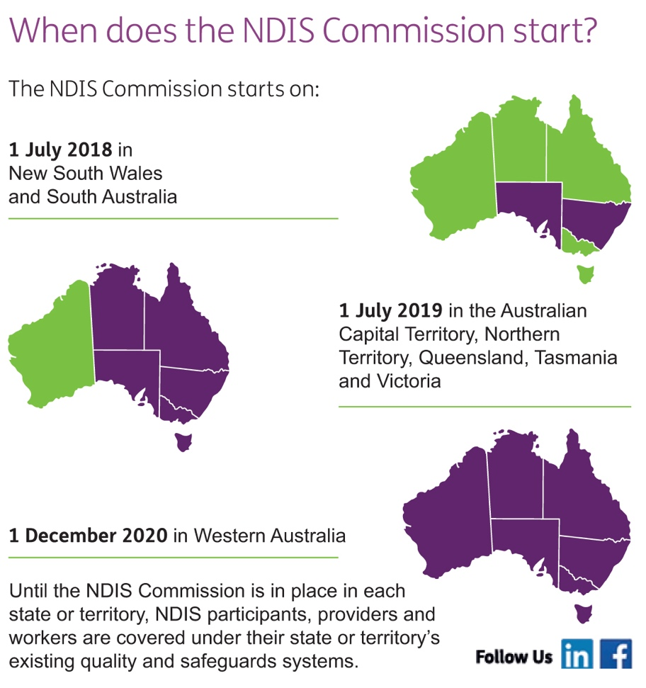

  - Choosing quality and safe supports

A service provider is a person, business or organisation that delivers your supports. It is important to choose service providers that will help you reach your goals.
You have the right to feel safe and to receive quality services and supports from your providers, regardless of which service provider you use. Remember, you can change service providers if necessary.
Some service providers are registered with the NDIS Quality and Safeguards Commission. We refer to them as registered providers. Other businesses/organisations choose not to register with the NDIS Commission; they are unregistered providers. Regardless of whether they are registered or unregistered, all service providers must:
- comply with the requirements of the NDIS Code of Conduct
- listen and respond appropriately to complaints.
If you feel unsafe or unhappy with the services you are receiving from a registered or unregistered provider, it’s always okay to speak up.

What is different about a registered provider?
Registered providers have additional obligations.
These obligations include:
- complying with the NDIS Practice Standards
- complying with new worker screening obligations as they are rolled out
- ensuring that employees successfully complete the online Worker Orientation Module
- maintaining their registration with the NDIS Commission
- reporting incidents to the NDIS Commission.

What is the NDIS Code of Conduct?
The NDIS Code of Conduct sets out the minimum standards and obligations that NDIS participants and all Australians can expect of providers and workers delivering NDIS supports and services.
It must be upheld by:

- registered service providers
- unregistered service providers
- workers of service providers
- community partners under the NDIS such as Local Area Coordinators and Early Childhood Early Intervention Partners.

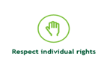

Safeguards when using service providers
You (or someone on your behalf) can make a complaint if you have concerns about the quality or safety of NDIS supports or services provided to you.
You can make a complaint directly to the relevant service provider.
You can also make a complaint to the NDIS Commission. Our complaints service is independent and free, and you can let us know your preferred method of communication. Complaints can be made anonymously. Where appropriate, we will seek to resolve the complaint.
The NDIS Commission has a range of powers we can use to respond to matters. These include powers of investigation and imposing penalties such as revoking registration, and banning workers and service providers.
If you are at immediate risk of harm, or have concerns about a person’s wellbeing, call 000 immediately.

Choosing a service provider
You can visit the NDIS website for lists of registered service providers in each state and territory.
When finding a service provider that is right for you, you may wish to seek advice from people such as:

- advocates and advocacy groups
- family
- friends
- Early Childhood (EC) Partners
- Local Area Coordinator (LAC) and/or NDIA Planner.

How do I know which service providers have been banned?
In the most serious cases, the NDIS Commission can make a banning order that stops a service provider or worker from providing supports or services in the NDIS market.
If the NDIS Commission bans a service provider from providing supports or services, we will update our NDIS Provider Register, which is available on our website.
We encourage you to look at our information on registered providers regularly.

  - NDIS plan management

Your approved NDIS plan gives you choice in which services you will use to help achieve your goals.
Depending on how your NDIS funding is managed, you may be able to use registered providers, unregistered providers, or even directly employ your own staff to help you reach your goals. Services may come from a person, business or organisation.
There are different ways to manage your NDIS funding. The different options are:
1. NDIA managed (also called Agency managed)
2. Plan-managed
3. Self-managed
4. A combination of the above three management types.
Regardless of how you choose to manage your funding, the NDIS Quality and Safeguards Commission is working to ensure you receive quality and safe supports. We support your rights including your right to dignity, respect and to live free from abuse, exploitation, and violence. If you feel unsafe or unhappy with your services, it’s always okay to speak up.
Regardless of how your plan is managed, you:
- will be protected by the NDIS Code of Conduct
- can raise a concern or make a complaint to the NDIS Commission
- have the right to feel safe when working with your NDIS providers
- have the right to receive quality service and support from your NDIS providers
- can access information about which providers have restrictions or bans placed on them by the Commission
- can speak up if you have concerns about the quality or safety of the services from your providers.
For information about how to manage your plan, please visit the NDIS website.

  - Making a complaint about your NDIS provider

You have the right to feel safe and to receive quality service and support from your providers. All providers must uphold the Code of Conduct, which supports these rights. If there is a problem with the safety or quality of services that you are receiving from a provider, it is always okay to speak up.

Why speak up?
The NDIS Commission’s role is to promote the health, safety and wellbeing of people with disability receiving NDIS supports or services. We want you to be safe and to receive quality service and support from providers.
If you speak up, you can help create better services, better communications and improvements to the way services are delivered. This means that by speaking up, you can help other people with a disability too.
It is always okay to speak up.

How do I speak up?
We recommend the first step you take is to speak to the NDIS service provider about your concerns/complaint. This could be done by you, or by someone on your behalf (such as an advocate, family member, carer). Visit the NDIS Commission website to download or print postcard-sized handouts with information on the Code of Conduct. These postcards and other useful resources are also available for order on the NDIS Commission website, which you may wish to give providers to start a conversation about your rights.
If you are unhappy with the response from your service provider or feel uncomfortable about raising your concern directly with them, you are encouraged to use the NDIS Commission complaints service.
The NDIS Commission complaints service is independent and free. Anyone can make a complaint about the quality or safety of any NDIS provider’s services, or their response to a complaint. You can let us know your preferred method of communication. You can also withdraw your complaint at any time.
If you (or someone making a complaint on your behalf) is concerned about the consequences of making a complaint (such as how you may be treated), you can ask the NDIS Commission to keep your identity confidential. This may impact the actions the NDIS Commission can take in response to your complaint.

How to complain to the NDIS Commission
Anyone can make a complaint to the NDIS Commission about a NDIS service provider. This includes a NDIS participant, their family members/friends, their NDIA appointed nominee, advocates, guardians or any other person who wishes to make a complaint.

Call us
1800 035 544
Online complaint form
www.ndiscommission.gov.au
Text Telephone (TTY)
133 677
National Relay Service
https://internet-relay.nrscall.gov.au/and then ask for 1800 035 544
Translating and Interpreting Service
131 450

Your family, friends, advocates, Local Area Coordinator, Support Coordinator, EC Partner, and NDIA Planner may also be able to assist you and provide support in voicing your concern. If you need an advocate to help you make a complaint, you can use the Disability Advocacy Finder to locate an advocate close to you:
Where required, the NDIS Quality and Safeguards Commission can arrange for interpreters in your language. There is no cost for this.

What the NDIS Commission will do
Our goal is to resolve your complaint quickly and simply.
When the NDIS Commission receives a complaint, a complaints officer will:
- communicate with the person making the complaint
- assess the complaint and decide whether we will take further action
- confirm your issues raised and the outcome you want in writing
- with your consent, contact the NDIS service provider
- talk to you about the information we receive from the NDIS service provider.
A complaints officer may:
- ask for further documentation and/or information
- talk to other NDIS participants that are affected by the complaint
- talk to or visit the service provider.
There are a number of ways that complaints can be resolved. Sometimes complaints can be resolved with a discussion between you, your NDIS service provider and us. Our involvement might make it easier to clarify issues and bring them to the attention of the people involved.
Where there are serious concerns and risks to NDIS participants such as abuse, assault or neglect, we may use our powers of investigation and enforcement. Unlawful and criminal matters will also be referred to police.

Who else can you contact?
If your complaint is about the National Disability Insurance Agency (NDIA), your eligibility for NDIS funding or your NDIS plan, you should contact the NDIA directly. www.ndis.gov.au/participants
The Commonwealth Ombudsman’s office can also help people with a disability who are NDIS participants resolve problems with government agencies and their partners.
If you are unsure about who to contact or what to do to about an issue, we can give you advice or help you find the right place to go.
If you are at immediate risk of harm, or have concerns about a person’s wellbeing, call 000 immediately.

  - Do you have questions or need more support?

It’s okay to ask for help. Here are some more ways to get support.
Make contact with:
- family members
- friends
- NDIS Quality and Safeguards Commission
- your NDIA appointed nominee
- your support coordinator
- local area coordinator (LAC) and/or NDIA Planner
- Early Childhood (EC) Partner
- advocates and advocacy groups
- service providers.

To contact the NDIS Commission
We encourage you to ask us questions if you are unclear about any of the information in this booklet.
- General Enquiries
  - Phone 1800 035 544
  - Text Telephone TTY 133 677
  - Translating and Interpreting Service 131 450
  - National Relay Service website and ask for 1800 035 544
  - Mail: PO Box 210, Penrith NSW 2750

- Complaints
  - Phone 1800 035 544
  - NDIS Commission website, complete the online complaint contact form
  - Text Telephone TTY 133 677
  - Translating and Interpreting Service 131 450
  - National Relay Service website and ask for 1800 035 544

