Add or manage key personnel
Quick Reference Guide - Provider

Providers can add or manage their own key personnel in the NDIS Commission Portal.

Add or change key personnel
- Log in to the NDIS Commission’s business application system.
- Select Registration from the menu bar then click Registration details.
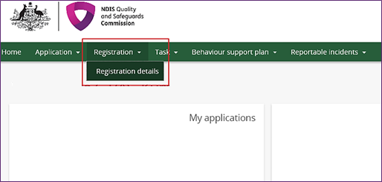
- Select Key personnel from the left hand menu bar.
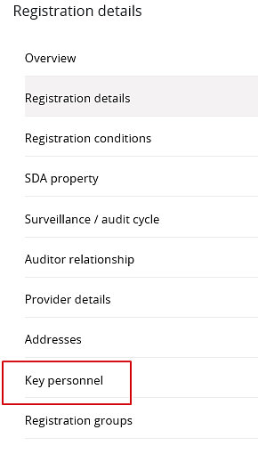

Add Key Personnel
- Click Add.
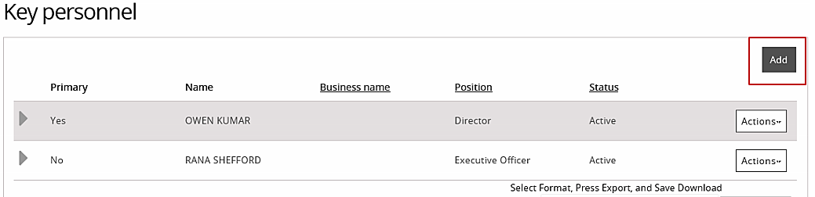
The Key personnel details window opens.
- Type the details of the new key personnel then click Save.
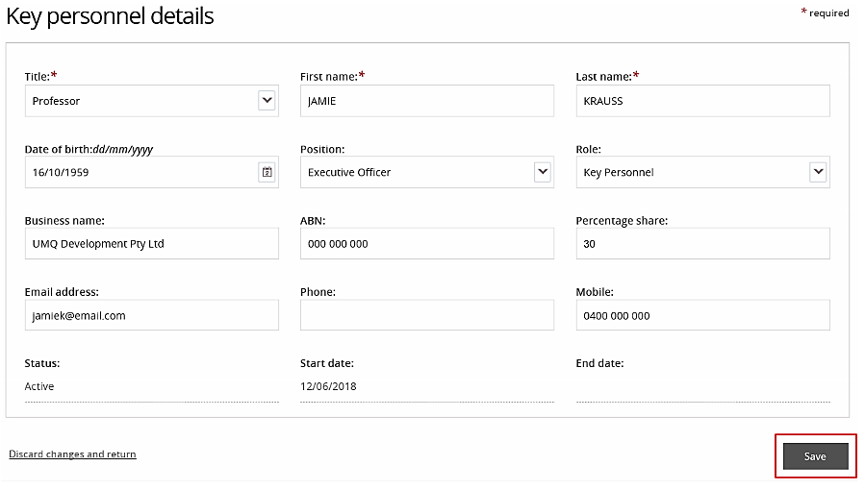
Manage Key Personnel
- Select Actions then select an option from the drop down list. You can view, update, make primary or remove the selected key personnel.
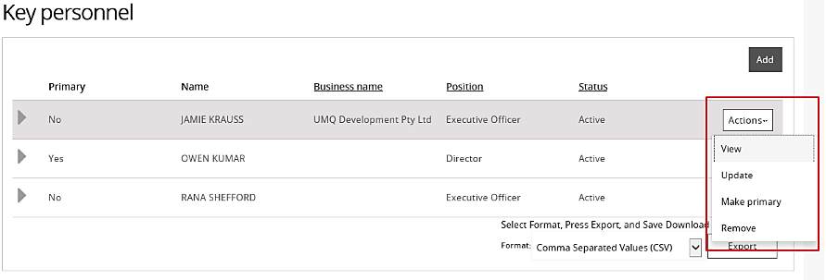
- To view the details of key personnel, click View. The personnel details are displayed.
- To update the details on record for key personnel, click Update.

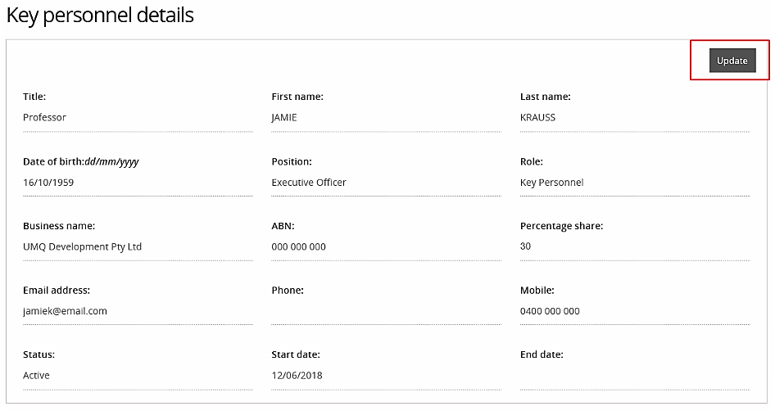

- To make a key personnel the primary contact, select Make primary.
This option only appears if the person selected is not currently a primary contact. You can only have one primary contact.

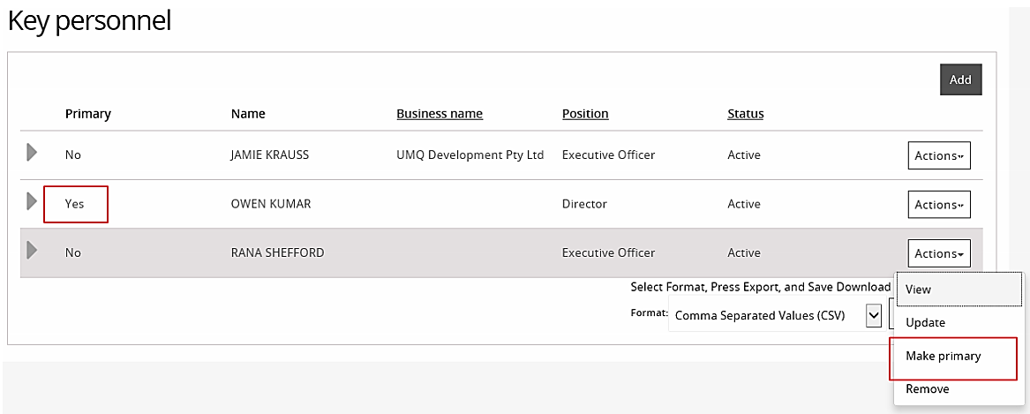

- To make a key personnel inactive, select Remove. Once a person is made inactive, they cannot be made active again. However, they can be added again as a new person.

