Applying to be considered suitable as an NDIS Behaviour Support Practitioner
Quick Reference Guide

This guide outlines how to use the Applications Portal to apply to be considered suitable as an NDIS behaviour support practitioner. See our FAQ page if you have question about applying.
See our other quick reference guides:
- Responding to an information request
- Managing your practitioner profile

Accessing the NDIS Commission Applications Portal
You will need a PRODA account to access both the Applications Portal and the NDIS Commission Portal. You should log into the Applications portal to complete your first application.
If you are considered suitable, you will receive a practitioner profile, which you will access through the NDIS Commission Portal.
Refer to our Quick reference guide: Getting access to the NDIS Commission Applications Portal
When you have logged in, select Apply to become an NDIS Behaviour Support Practitioner.
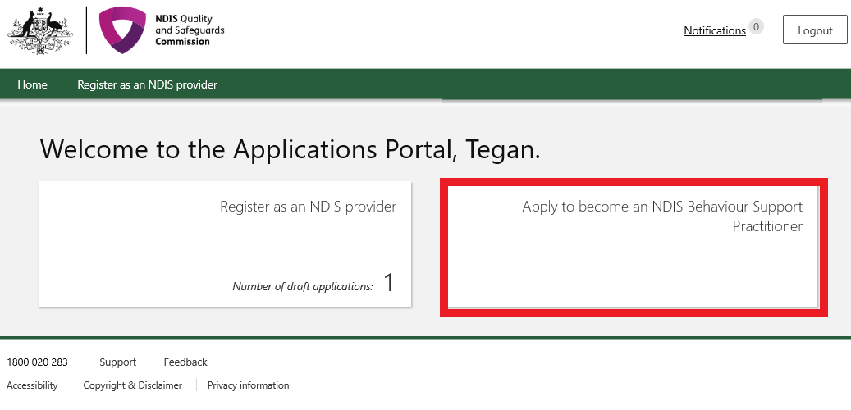

Completing the application in the Portal
- Click Continue to commence your application.
- Enter “Applicant details” then click Save and continue.
Note: Ensure that you enter your legal name on your application. It should be the same name as your PRODA account, otherwise you may have issues accessing your practitioner profile in the future.
- On the Overview page read the information under the heading “Preparing to apply” and “How to complete this application”.
- Click Personal details on the left hand side navigation menu.

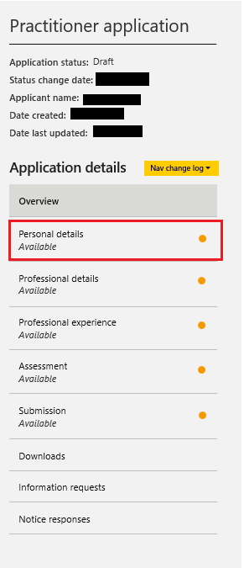

- If any “Personal details” are missing or incorrect, click Update and enter the required information.
- Under “Postal address” title, click Add and enter the required information.
- Click Mark as complete and continue to progress through the application.
- On the Professional details page, click Update under “Practitioner information” and enter the required information.
- Under “Other states and territories worked in”, click Add and enter the required information.
- Practitioners considered suitable can have their name and contact details published on the NDIS Commission website. If you consent to your name and contact details being published on the NDIS Commission website, click Update and enter the details that wish to be published. Then click Mark as complete and continue to progress through the application.
- If you do not consent to publishing your contact details on the NDIS Commission website when considered suitable, click Mark as complete and continue.
- Under “Employment history” click Add and enter any information relevant to behaviour support.
- Under “Behaviour support experience”, click Update and enter the required information.
- Under “Qualifications and training”, click Add and enter the required information relevant to your role as a behaviour support practitioner.
- Under “Professional registrations and associations”, click Add and enter any relevant information.
- Under “Attachments”, click Add attachment and attach a copy of your resume and certified copies of any qualifications stated.

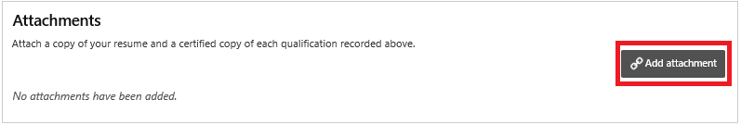

- Click Mark as complete and continue to progress through the application.
- In the Assessment view, select Practitioner Self-Assessment. If you are unable to complete the self-assessment process as outlined in the Self-assessment Resource Guide for the Positive Behaviour Support Capability Framework, contact the national behaviour support team at the NDIS Commission by emailing NDIS Practitioners to discuss further.
- Click Mark as complete and continue to progress through the application.
- If Practitioner Self-Assessment is selected the Practitioner self-assessment view will appear.
- Read the relevant information on the page regarding “Practitioner self-assessment”.
- Start from the Core Practitioner Level under the “Self-assessments” title. Click Actions and click Update.
- Click Action and click Update for each Capability domain. Please ensure all items have been responded to as either Met, Developing or Not met. Once items are completed, enter the relevant information for “Sources of evidence”.
- Click Save and return when a capability domain is completed.
- Once all capability domains are completed, click Back to the “Practitioner self-assessment” page.
- Once the Core Practitioner Level is completed, the Proficient Level will become available. Work through each practitioner level up to the level that you have self-assessed at. Please note that if the Proficient level is met, both Advanced and Specialist levels will become available. You can self-assess at either an Advanced level or a Specialist level (or both) if you have met capability for the Proficient level.
- Under “Supervisor details”, click Update and enter the relevant information for the pop-up. Click Save and close once that is completed.
- Under “Postal address”, click Add and enter the relevant information.
- Under “Supervisor’s endorsement and consent”, click Update and select answers for the pop-up. Click Save and close once that is completed.
- Under “Attachments”, click Add attachment, attach a copy of your supervisor’s endorsement, and consent form. This can be found on the following link: Self-assessment Tools for the PBS Capability Framework | NDIS Quality and Safeguards Commission (ndiscommission.gov.au)
- Once attached click Mark as complete and continue.
- Read the “Declarations”, and click Agree and submit.
- Your application is now complete.

