Associate with registration application
IT Quick Reference Guide – Auditor

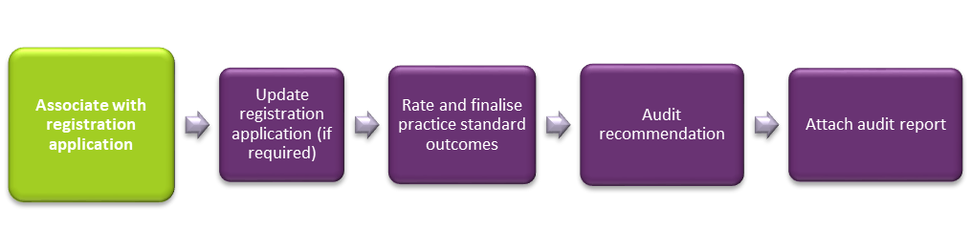This Quick Reference Guide explains how an auditor accepts a registration application for assessment from a provider for the NDIS Quality and Safeguard Commission.

Auditor accepts the registration application
When a provider contacts an auditor to engage them for audit, the auditor must accept the application in the NDIS Commission portal.
Click the Application drop down menu then select Application search.
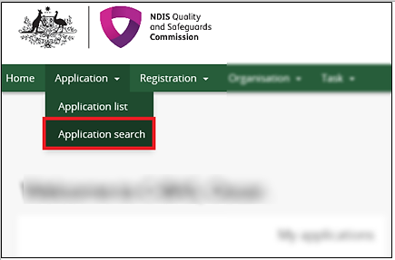
Type Application reference number then click Run search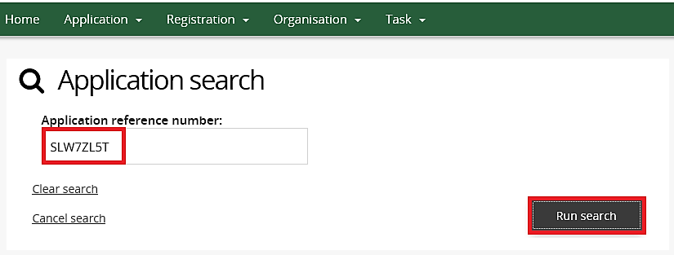
Click the Actions drop down menu and then select Accept application.
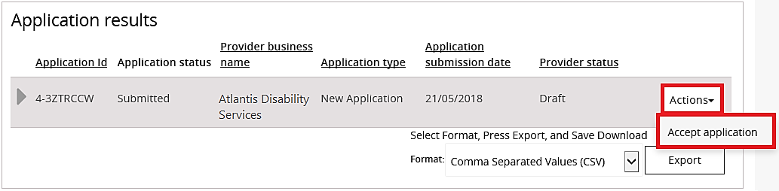
The registration application is now ready for your assessment.

