Quick reference guide: **Log in to the NDIS Worker Screening Database, manage the access of staff & set email preferences**

Registered NDIS Provider

# Contents

Overview 1

Access the NWSD via the NDIS Commission Portal 2

Access the NWSD via PRODA 3

Manage access to the NWSD 4

Update the access of an existing employee 4

Create access for a new employee 6

Employee requests for access 7

Approve or reject a request for access (as the Authorised Access Delegate) 8

Managing email preferences 9

## Overview

1. Registered NDIS providers must ensure that persons (in risk assessed roles), who are employed or otherwise engaged (worker), have an NDIS Worker Screening Check. This is a statutory requirement and a condition of registration as a registered NDIS provider. More information about this can be found on our website - [Worker screening requirements (NDIS registered providers)](https://www.ndiscommission.gov.au/providers/worker-screening).
2. This quick reference guide provides information about how to access the NDIS Worker Screening Database (NWSD) via the NDIS Commission Portal.
3. The representative of an registered NDIS provider who is the ‘Authorised Access Delegate’ will be able to add, remove and vary the access of other members of the organisation (employees) to the NWSD.
4. This quick reference guide also provides information about how to manage email preferences.

**For further information please refer to the NDIS Quality and Safeguards Commission website -** [Worker screening requirements (NDIS registered providers)](https://www.ndiscommission.gov.au/providers/worker-screening)**. Alternatively, contact the NDIS Quality and Safeguards Commission on 1800 035 544 or by email at** [**nwsd@ndiscommission.gov.au**](mailto:nwsd@ndiscommission.gov.au)**.**

## Access the NWSD via the NDIS Commission Portal

1. Go to the [NDIS Commission Website](https://www.ndiscommission.gov.au/) and select the ‘Portals’ button and ‘Registered NDIS providers’ option.

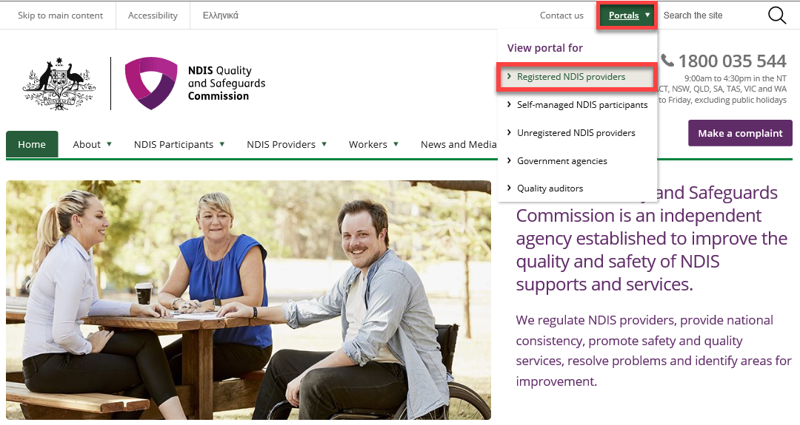

1. Select ‘Login with PRODA’.

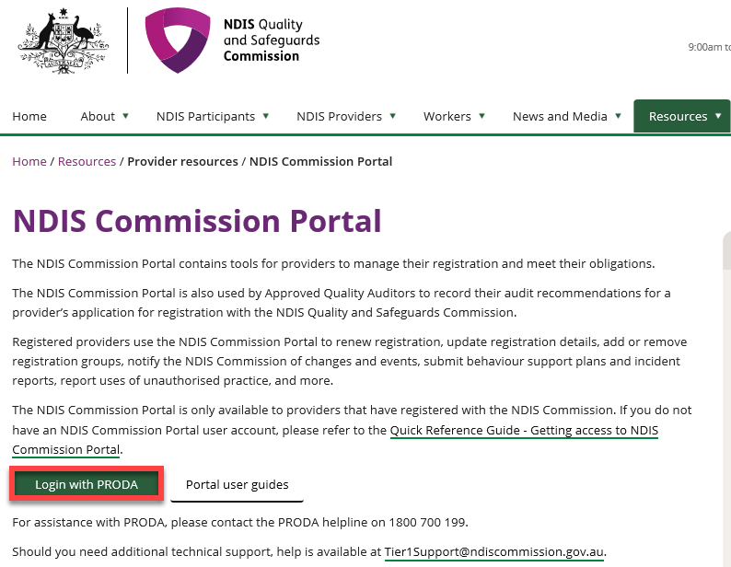

1. At the ‘Portal entry point’ select the ‘Provider name’ of the Registered NDIS provider that you are logging into the Commission Portal on behalf of. Select either ‘**Worker screening officer**’ or ‘**Registrant’** as the ‘Role’.

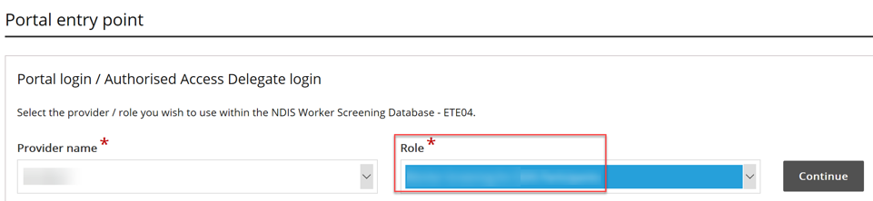

1. Select the Worker Screening tile.

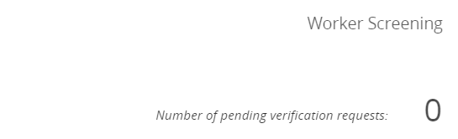

## Access the NWSD via PRODA

1. The preferred method for logging into the NWSD is via the NDIS Commission Portal (refer to the steps above).
2. However, you can also access the NWSD via PRODA by logging in and selecting the ‘NDIS Quality and Safeguards Commission – Provider Portal’ tile.

**Tip 1** - If you are having trouble registering for PRODA contact the PRODA Helpdesk on 1800 700 199.

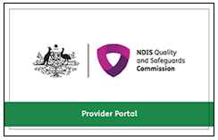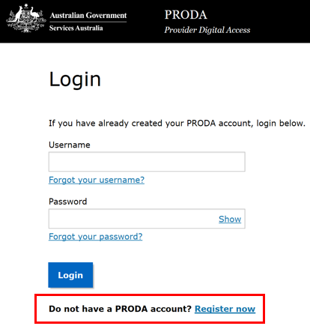

1. At the ‘Portal entry point’ select the ‘Provider name’ of the Registered NDIS Provider that you are logging into the NWSD on behalf of. Select either ‘**Worker screening officer**’ or ‘**Registrant**’ as the ‘Role’.



1. Select the Worker Screening tile.



## Manage access to the NWSD

### Update the access of an existing employee

1. Log into PRODA and select the appropriate ‘Provider name’ and choose the ‘Authorised Access Delegate’ role.

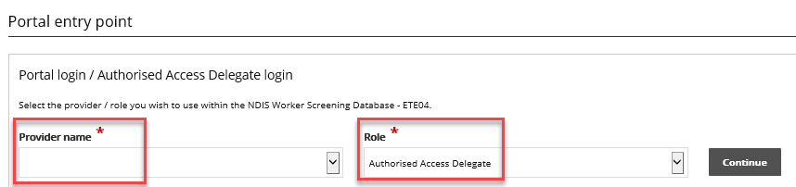

1. Select ‘User access list’ from the side menu and ‘Select’ the employee you want to update the access for.

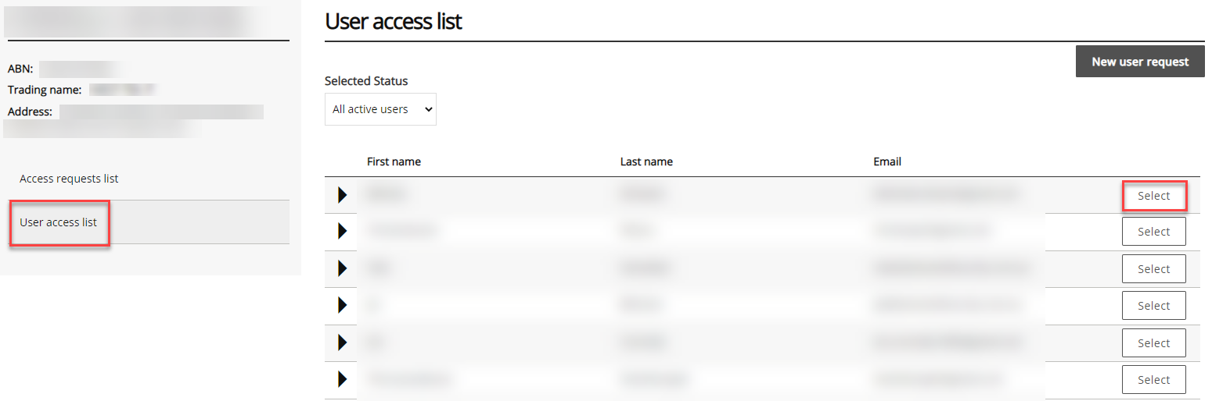

1. To add additional access for the employee, in the ‘Required user role(s)’ section select *all* the user roles you want the employee to have and click ‘Save’.
2. To remove access, in the ‘Required user roles(s)’ section select the user roles you want to be *removed* and select ‘Revoke access’.

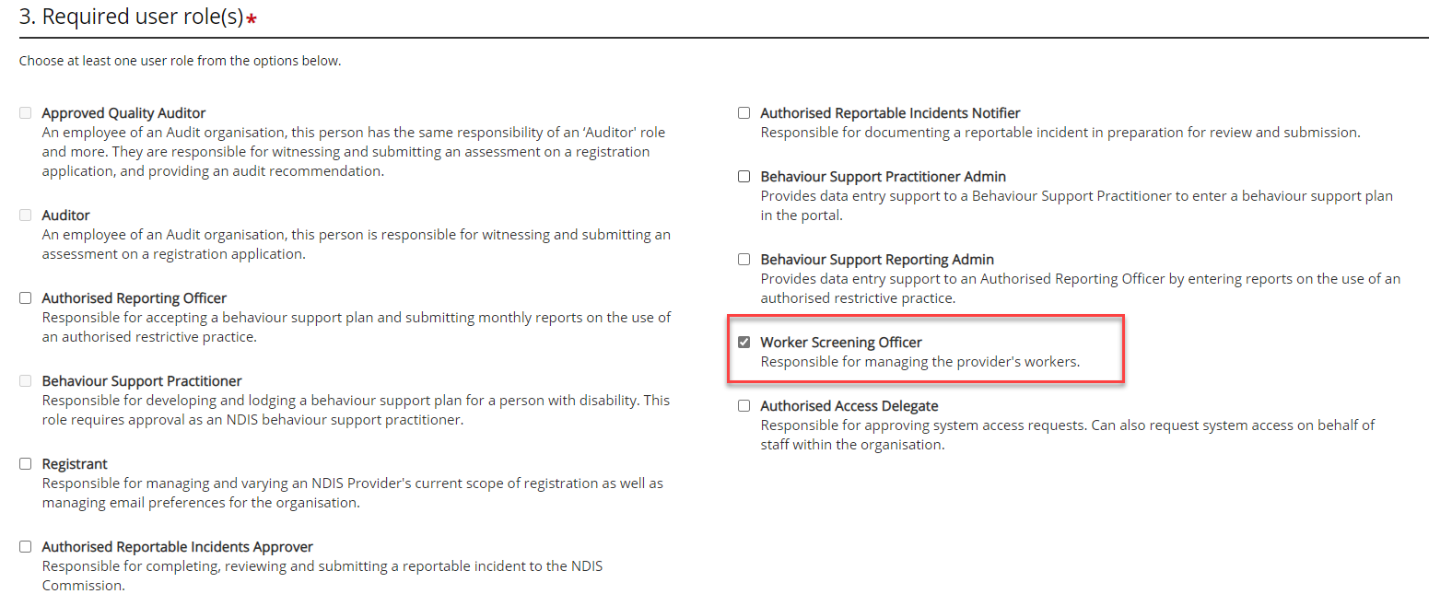

### Create access for a new employee

1. To give a new employee access to the NWSD, log into PRODA, select the appropriate ‘Provider name’ and choose the ‘Authorised Access Delegate’ role.
2. Select ‘User access list’ from the side menu and select ‘New user request’.

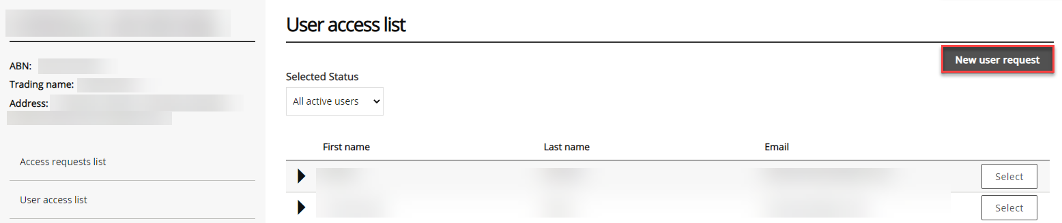

1. Read the information presented and if you are ready to continue select the ‘I’m ready to request access’ button.

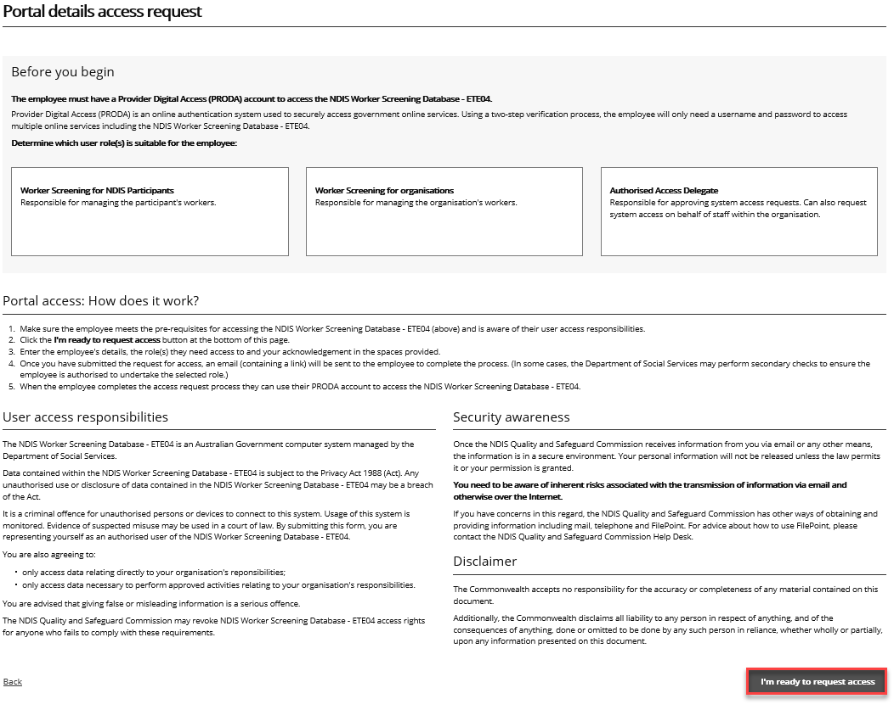

1. Enter the required information and in the ‘Required User Role(s)’ section select:
   1. ‘Worker Screening Officer’ which will provide you with access to the NWSD to verify workers and check the status of a worker’s NDIS Worker Screening Check.

## Employee requests for access

1. If you are an employee seeking access to the NWSD, log into PRODA and select the ‘Request / update my access’ button.

**Tip 2** – You must register for a PRODA account before you can log in. If you are having trouble registering for PRODA contact the PRODA Helpdesk on 1800 700 199.

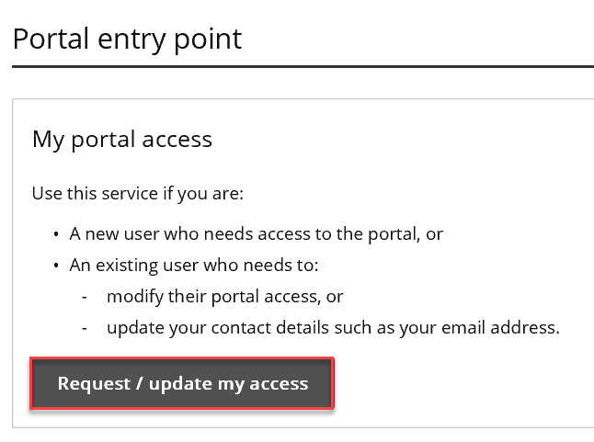

1. Read the information presented and if you are ready to continue select the ‘I’m ready to request access’ button.



1. Enter the required information and in the ‘Required user role(s) section’ select:
   1. ‘Worker Screening officer’ which will provide you with access to the NWSD to verify workers and check the status of a worker’s NDIS Worker Screening Check.
2. On ‘The service provider you work for’ page, enter in the details of the Registered NDIS Provider that you work for.

**Tip 3** – The ‘Authorised Access Delegate’ of this organisation will be the person who considers your request for access to the NWSD.

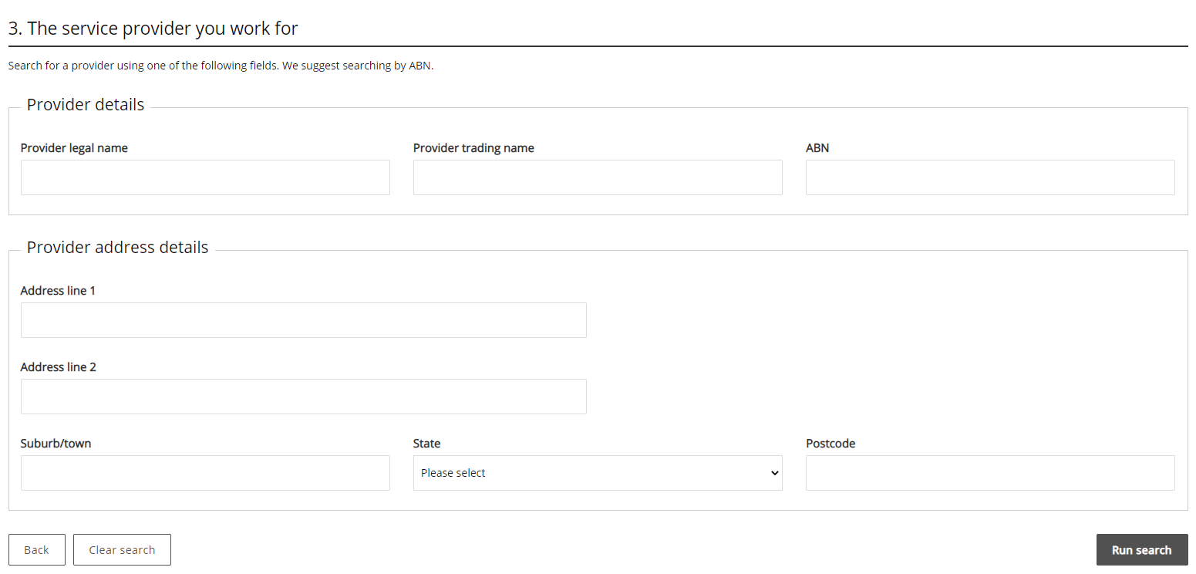

1. Your request will be submitted to the current ‘Authorised Access Delegate’ for consideration. You will receive an email once your request has been approved or rejected.

### Approve or reject a request for access (as the Authorised Access Delegate)

1. When an employee submits a request for access to the NWSD, the ‘Authorised Access Delegate’ will receive an email. Click the link in the email to view the access request.
2. Log into PRODA and select the appropriate ‘Provider name’ and ‘Authorised Access Delegate’ as the ‘Role’. Select ‘Continue’.

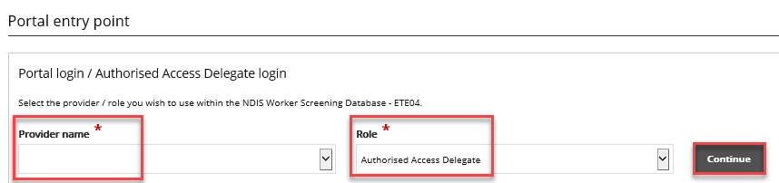

1. Navigate to the ‘Access requests list’ and select ‘View’ next for the application you want to assess.

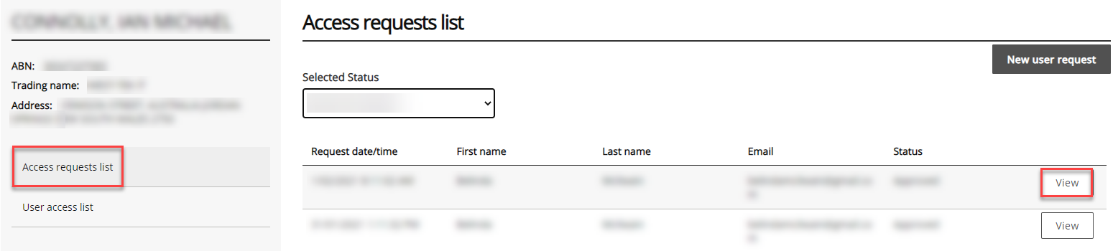

1. Review the ‘Required user role(s)’ that the applicant has selected and ensure the appropriate checkbox is ticked e.g. ‘Worker Screening Officer’ role.
2. Select ‘Reject’ or ‘Approve’. The applicant will receive an email advising them of the outcome.

## Managing email preferences

1. Log into PRODA and select ‘Worker Screening Officer’ or ‘Registrant’ to access the NWSD.

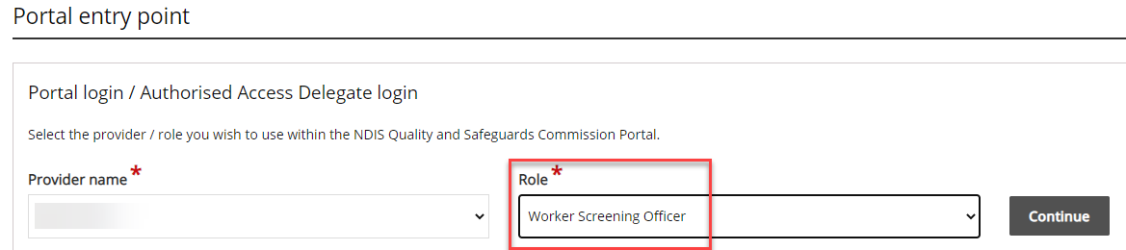

Select the ‘Email preferences’ tile to manage who will receive emails, and what types of emails each person will receive, from the NDIS Quality and Safeguards Commission on behalf of your organisation.

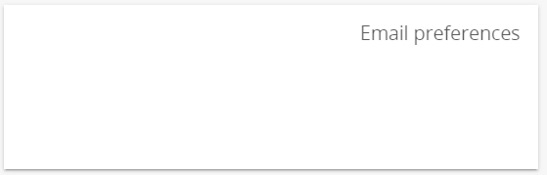

1. A list of category descriptions will display at the top of the screen. This describes the different categories of emails that will be received. For each email contact a category from the list must be selected e.g. these are the types of emails they will receive.

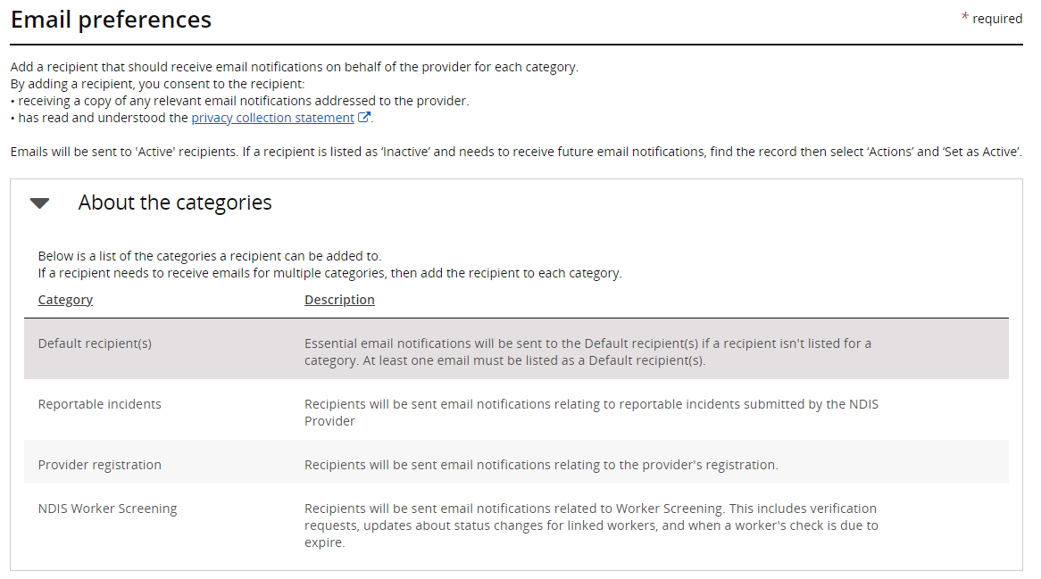

1. To add an email contact to the list, select ‘Add’, enter their details and choose the category of emails they will receive. If they require multiple categories, they will need to be added multiple times.

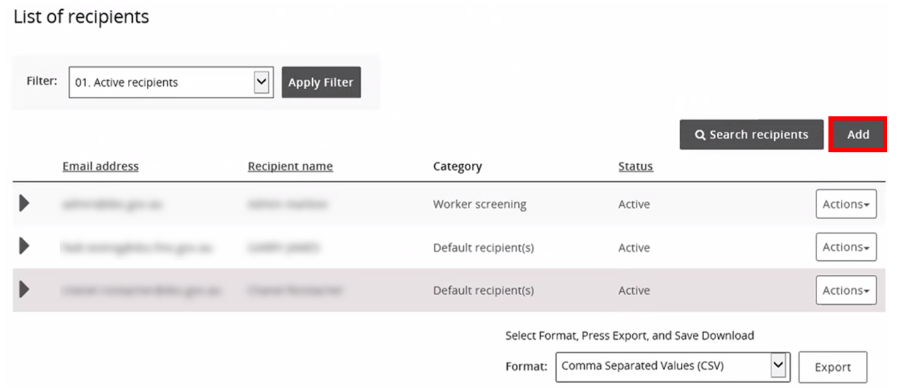

1. To **remove** an email contact, select ‘Action’ and ‘Remove’.
2. To **update** the details of an email contact e.g. change their email category, select ‘Action’ and ‘Update’.

**Tip 4** – If a user doesn’t already have access to the NWSD, updating their email preferences to include the ‘Worker screening’ category will not provide the user with access to the NWSD. You will still need to manage the user’s access by following the steps above.