# Getting access to the NDIS Commission Applications Portal

Quick Reference Guide

The Applications Portal has two functions it gives you the ability to:

* apply to register as a provider
* be considered suitable as an NDIS behaviour support practitioner.

To access the Applications Portal you need a PRODA account.

In this guide:

Getting access to the NDIS Commission Applications Portal 1

Logging in to the Applications Portal through PRODA for the first time 1

Logging in to the Applications Portal through PRODA using an existing PRODA account 10

About PRODA 12

Requirements 12

Learn more and register 12

Help with accessing the NDIS Commission Portal 12

## Logging in to the Applications Portal through PRODA for the first time

This part of the Quick Reference Guide explains the step-by-step process of successfully logging in to the Applications Portal through PRODA for the first time.

Go to the [NDIS Commission website](https://www.ndiscommission.gov.au/resources/application-portal).

Click **Portals select Applications Portal**.

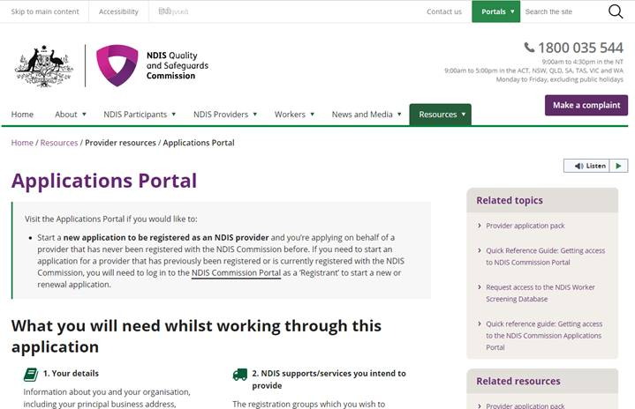

Once you get to the Applications Portal webpage, click **Login with PRODA**.

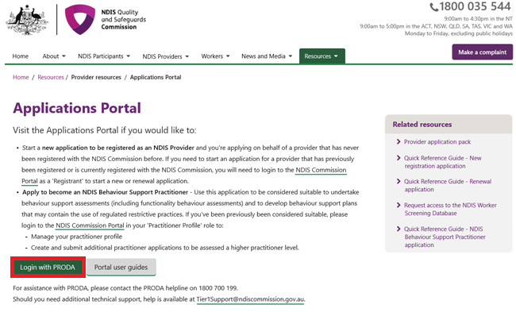

Select **Register Now**.

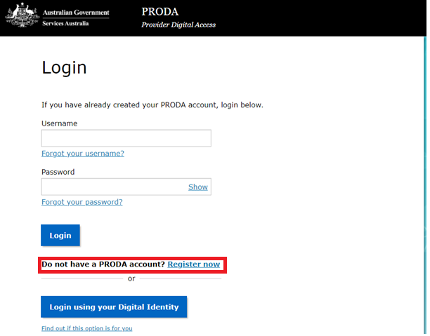

**Follow the steps** within PRODA to create your account.

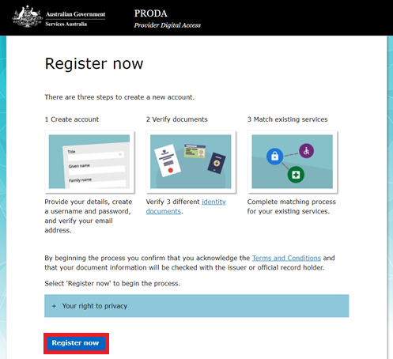

Once you have been through the registration process and your identity has been successfully verified you will see this - click **Next.** 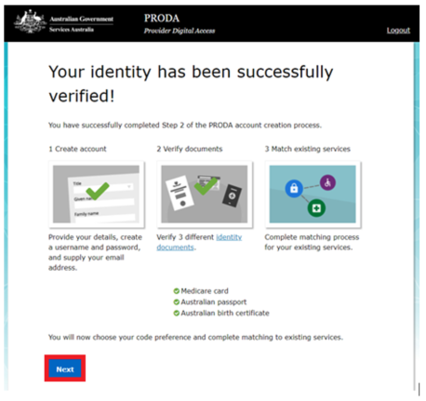

Select your verification code preference,then select **Next.** 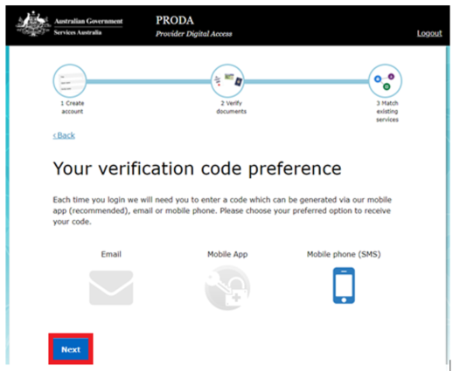

Once you have received your code and entered it via your preferred method click **Next.**

You will then see portals that can be linked to your PRODA account. **Do NOT click on any of these portals.**

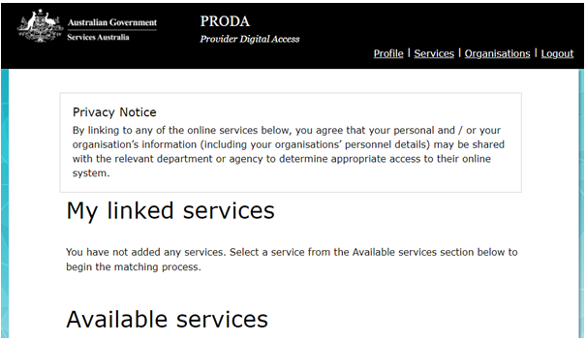

**Please note**

**The Applications Portal is not currently on this list.**

**Follow the steps below**

* Do not enter the NDIS Commission Provider Portal as this is for registered providers only.
* To continue with your application navigate to the NDIS Commission website: [Applications Portal](https://www.ndiscommission.gov.au/resources/application-portal)
* Log in again with your PRODA details if requested.
* You will then be taken to the **New portal** access screen - after you have read the information, click **Begin.**

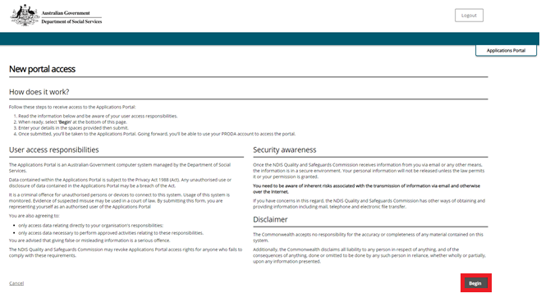

Fill out your details. Once done click **Next.**

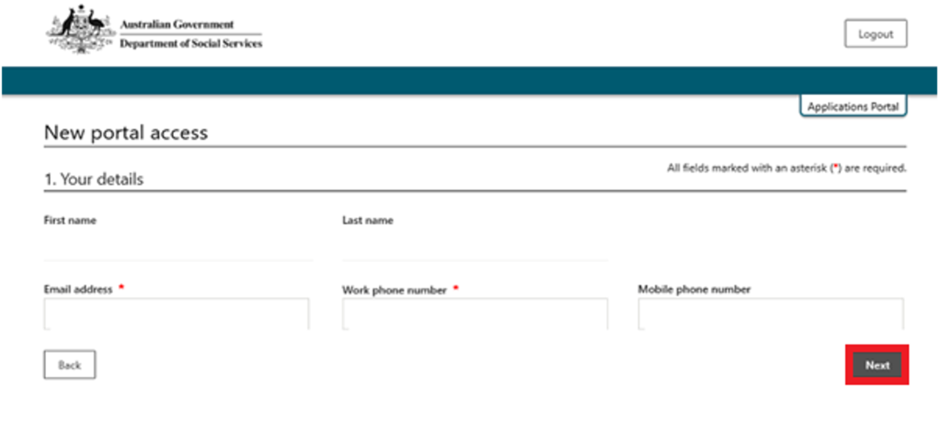

Check if your details are correct. If correct, **tick the acknowledgment and click submit**. If incorrect, select back to correct your details, then repeat this step. 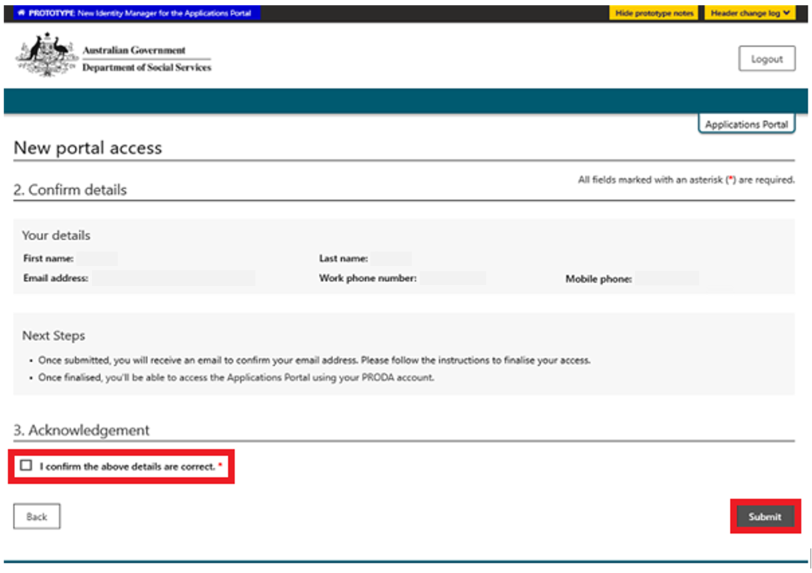

**If all details are correct, select Finish.** 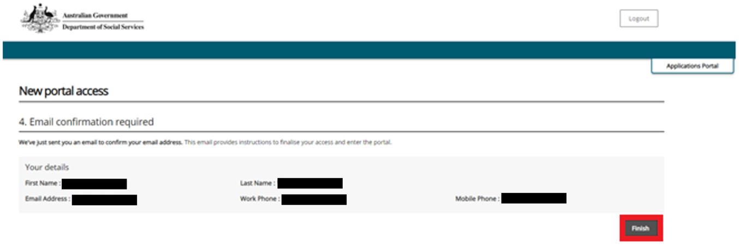

**PRODA will send an email to the email address listed above, access this email and click Confirm my email address.**

**This will take you to the Applications Portal login screen, select I agree.**

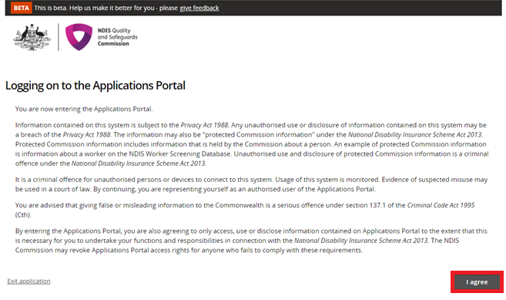

**If you are applying to be a registered Provider select New application to be registered as an NDIS provider.** 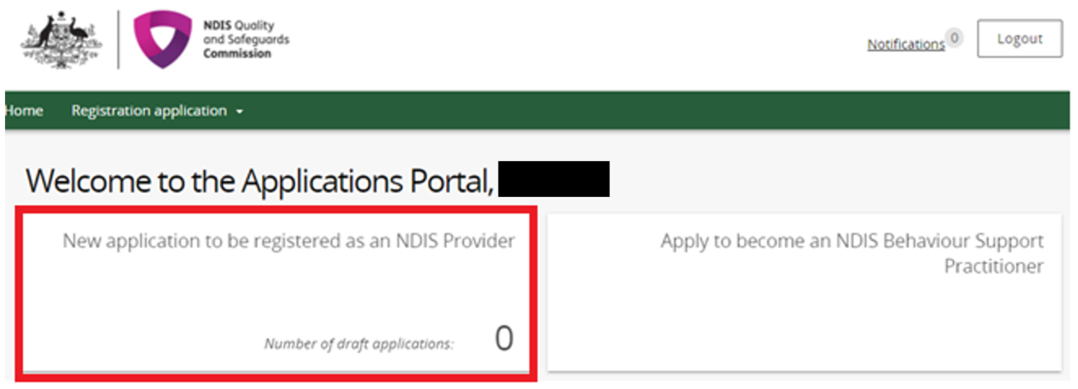

C**lick on Start new application.**

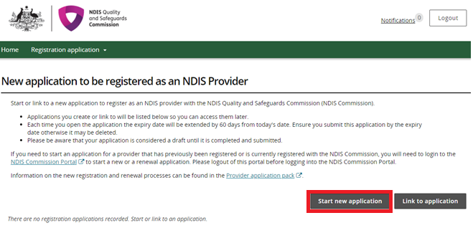

If you are applying to be considered suitable as an NDIS behaviour support practitioner select **Apply to become an NDIS behaviour support practitioner.**

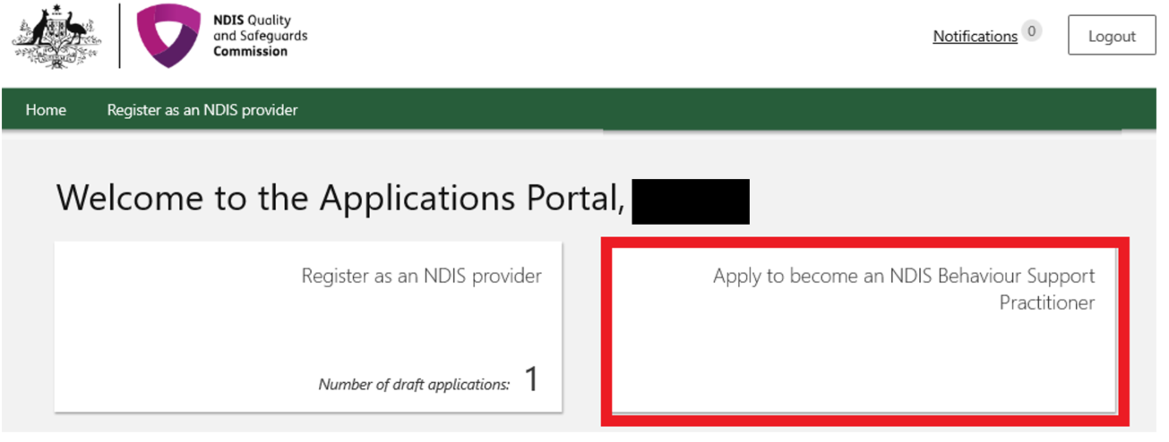

For practitioner applications refer to the quick reference guide: [**Applying to be considered suitable as an NDIS behaviour support practitioner.**](https://www.ndiscommission.gov.au/node/3221)

## Logging in to the Applications Portal through PRODA using an existing PRODA account

Go to the [NDIS Commission website](https://www.ndiscommission.gov.au).

Click **Portals select Applications Portal.**



Once you get to the Applications Portal page, click **Login with PRODA.**



Enter your username and password.

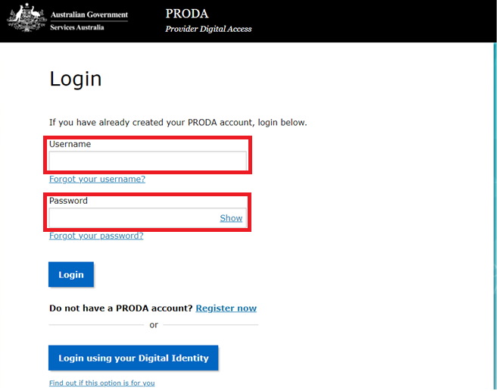

Enter your verification code.

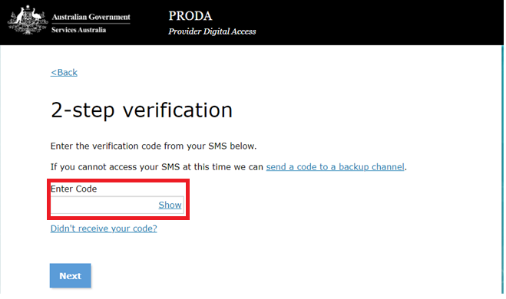

Then follow steps 10 through to 15 in this Quick Reference Guide.

## About PRODA

PRODA is an online authentication system used to securely access government online services.

PRODA is managed by the Department of Human Services.

Most individuals who need access to the NDIS Commission Portal will require a PRODA account.

Once you’ve authenticated your identity with PRODA, your username and password will allow you to access multiple online services including the NDIS Commission Portals.

### Requirements

* An email address which is unique to you (not a shared email address).
* At least three (3) specified and valid Australian Government issued identity documents to verify your identity online. A full list of acceptable documents is available on the [PRODA registration page](https://proda.humanservices.gov.au/pia/pages/public/registration/account/createAccount.jsf).

Also, check you are using the minimum browser version required for the service you are accessing. To access PRODA to set up an account you’ll need one of these minimum browser versions:

* Internet Explorer 9
* Mozilla Firefox 30
* Google Chrome 39
* Safari 5.

### Learn more and register

* [Register for a PRODA account](https://proda.humanservices.gov.au/pia/pages/public/registration/account/createAccount.jsf)
* [Learn more about PRODA](https://www.humanservices.gov.au/organisations/health-professionals/services/medicare/proda#group-130)
* [PRODA eLearning](https://www.humanservices.gov.au/organisations/health-professionals/subjects/provider-digital-access-proda-education-health-professionals).

If you require assistance with your PRODA account, see the [Contact Us section of the PRODA help page](https://www.humanservices.gov.au/organisations/health-professionals/services/medicare/proda#group-130).

## Help with accessing the NDIS Commission Portal

**I do not have a PRODA account, how can I create one?**

See [Register for a PRODA account](https://proda.humanservices.gov.au/pia/pages/public/registration/account/createAccount.jsf) to register and create a new PRODA account.

**I am unable to create a PRODA account, what can I do?**

Please contact the PRODA Help Desk on 1800 700 199 or [by email](mailto:proda@humanservices.gov.au).

**I have a PRODA account but I cannot log on to the NDIS Commission Portals, what can I do?**

If your organisation **is registered** with the NDIS Commission, contact the NDIS Commission Contact Centre on 1800 035 544 or [send us an email](mailto:tier1support@ndiscommission.gov.au).