Getting access to NDIS Commission Portal
Quick Reference Guide

Only NDIS Providers registered with the NDIS Commission can access the NDIS Commission Portal.

In this guide:
- Logging in to the NDIS Commission Portal
- Request new user roles
- About Proda
- Help with accessing the NDIS Commission Portal

Logging in to the NDIS Commission Portal – a step-by-step guide
This part of the Quick Reference Guide explains the step-by-step process of successfully logging in to the NDIS Commission Portal.
- Click Portal.
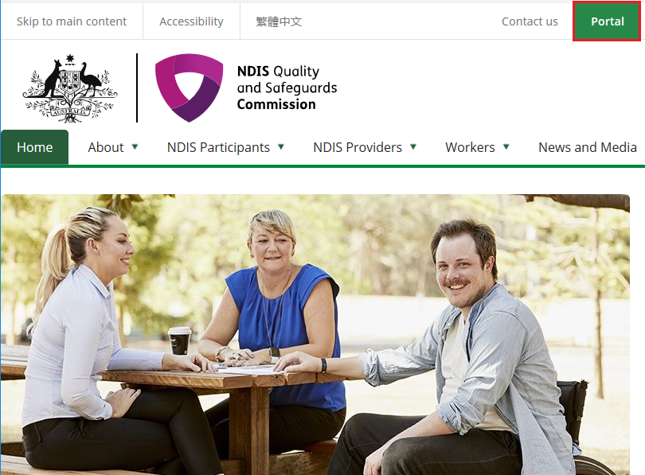
- Click Login with PRODA.
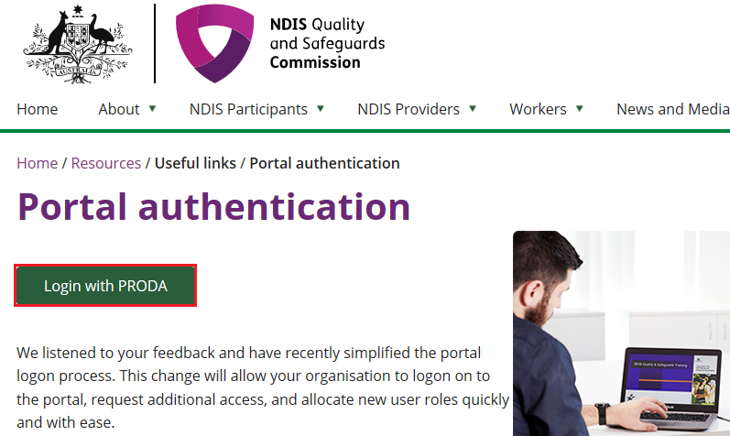

- Type the PRODA Username and Password then click Login.
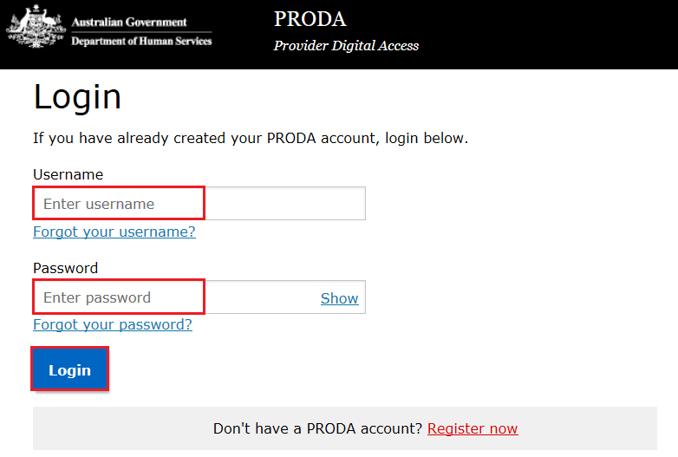

- Enter the PRODA verification Code then click Next.
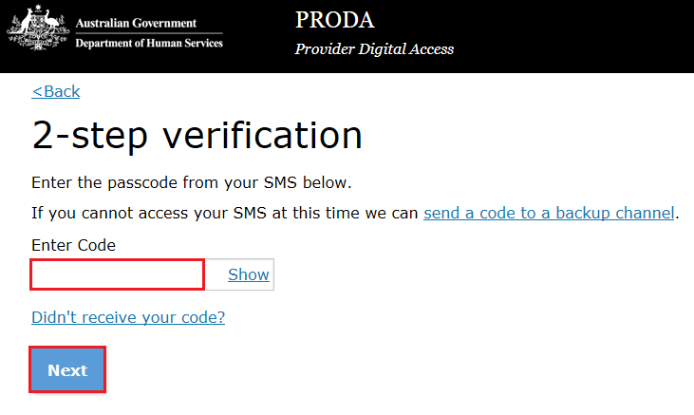
- Select the Provider name and the Role to logon and the click Continue.
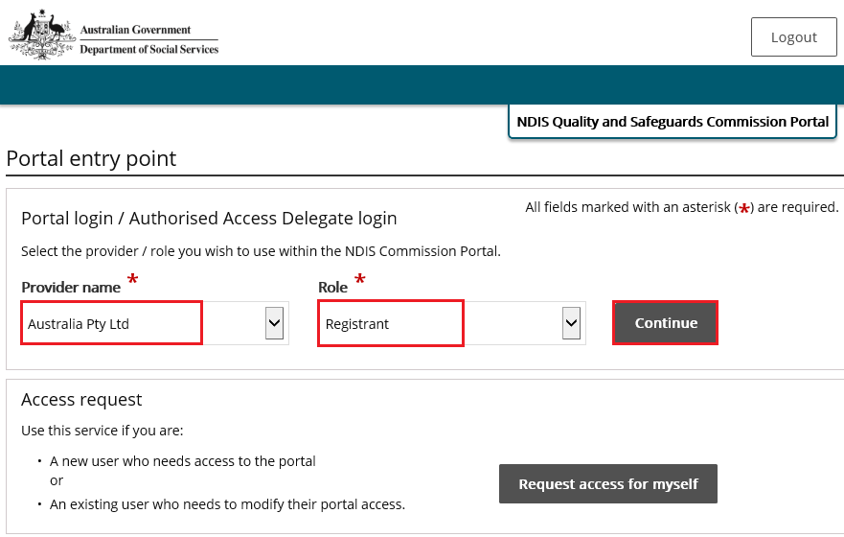

- Click I agree
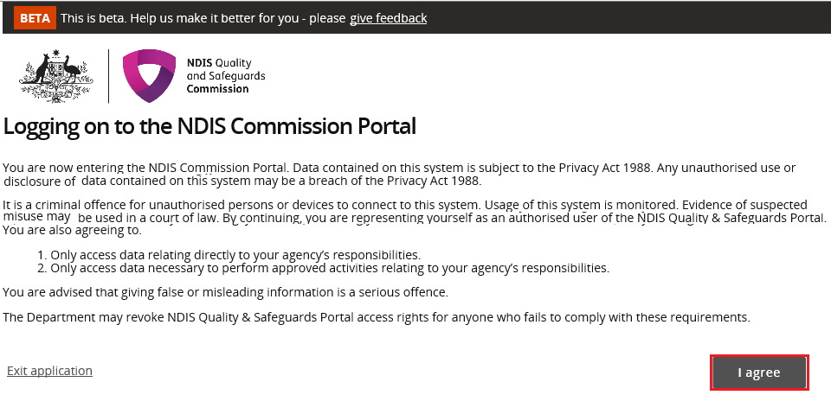
This should Successfully log you on to the Portal.

Request new user roles
A staff member can request a new user role using the Commission Portal, for this the user first needs to successfully login to PRODA.
- After logging in to PRODA, at Portal entry screen, click Request access for myself.
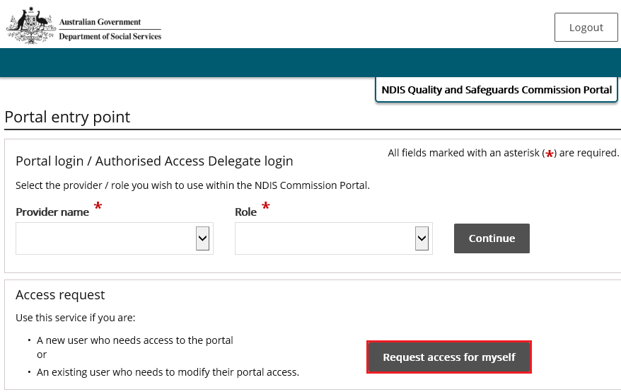

- Click I’m ready to request access.
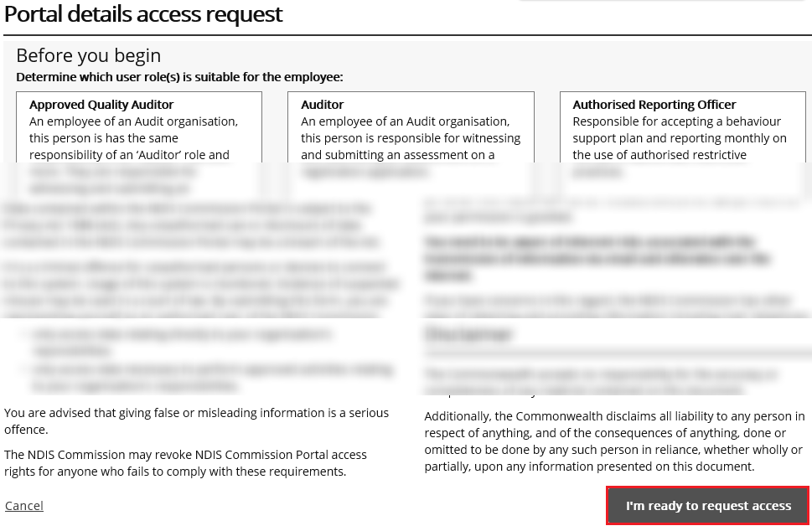

- Select the user roles that are required and click Next.
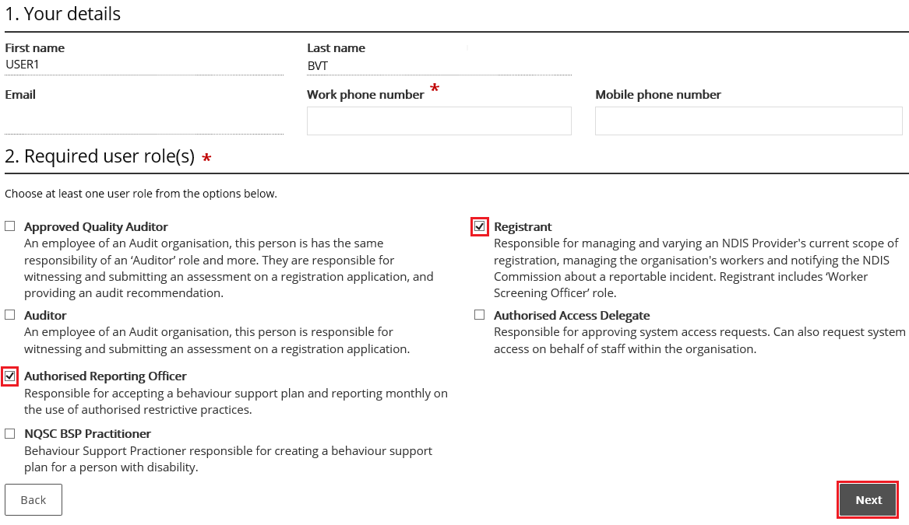

- Enter the related Organisation details for the new user role/s request and click Run search. Please only enter one of the Provider Details (ABN is preferred).
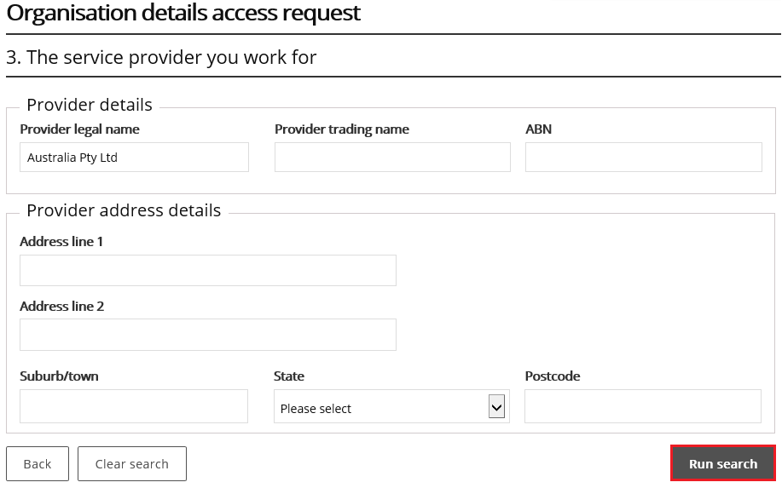

- Review the Summary access request and click Submit.
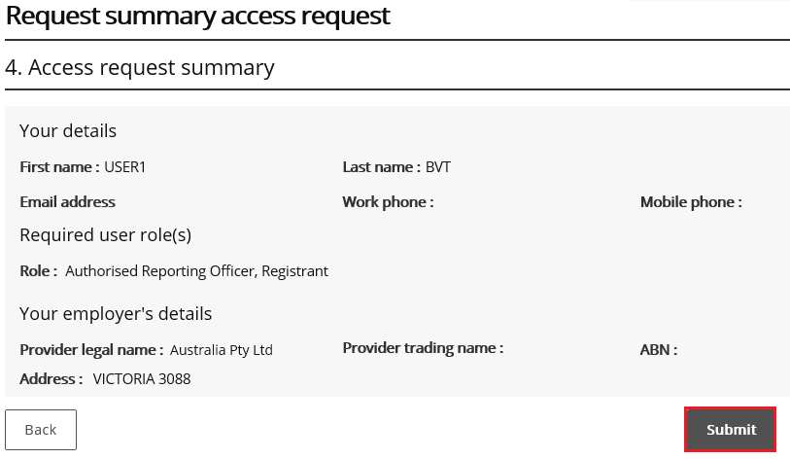

About PRODA
PRODA is an online authentication system used to securely access government online services. PRODA is managed by the Department of Human Services.
Most individuals who need access to the NDIS Commission Portal will require a PRODA account.
Once you’ve authenticated your identity with PRODA, your username and password will allow you to access multiple online services including the NDIS Commission Portal.
Requirements
- An email address which is unique to you (not a shared email address)
- At least 3 specified and valid Australian Government issued identity documents to verify your identity online. A full list of acceptable documents is available on the PRODA registration page.
- Please also check that you are using the minimum browser version required for the service you are accessing through PRODA. To access PRODA to set up an account you’ll need one of these minimum browser versions:
  - Internet Explorer 9
  - Mozilla Firefox 30
  - Google Chrome 39
  - Safari 5
Learn more and register
- Register for a PRODA account
- Learn more about PRODA
- PRODA eLearning.
If you require assistance with your PRODA account, see the Contact Us section of the PRODA help page.

Help with accessing NDIS Commission Portal
The following questions and answers are for Providers who are having difficulties accessing the NDIS Commission Portal.
- I do not have PRODA account, how can I create a PRODA account?
See Register for a PRODA account to register and create a new PRODA account.
- I am unable to create a PRODA account, what can I do?
Please contact the PRODA Help Desk on 1800 700 199 or proda@humanservices.gov.au.
- I have a PRODA account but I cannot log on to the NDIS Commission Portal, what can I do?
- If your organisation is registered with the NDIS Commission, operates in NSW or in SA and you have used Myplace prior to 29th June 2018, contact the NDIS Commission Contact Centre on 1800 035 544 or tier1support@ndiscommission.gov.au.
- If your organisation is not registered with the NDIS Commission and operates in NSW or in SA then your organisation is eligible to register with NDIS Commission. See NDIS Provider registration for more information on registering your organisation with NDIS Commission.
- If your organisation is not registered with the NDIS Commission and operates in states and territories other than NSW and SA, see NDIS Provider Toolkit for more information on registering your organisations with NDIS.

