NDIS Commission Portal
User Guide: How to lodge a behaviour support plan
June 2020

Table of Contents
Accessing the NDIS Commission Portal (the Portal) 2
General tips when lodging a behaviour support plan 3
Getting ready to lodge 3
1. Create behaviour support plan ID 4
2. Add participant details 6
3. Add disability details 9
4. Add address details 10
5. Add key contacts 11
6. Enter details about the behaviour support plan 13
7. Add implementing provider details 14
No implementing provider 14
8. Add a functional behaviour assessment 18
9. Add behaviours of concern 21
10. Add restrictive practices 22
11. Attach the behaviour support plan 25
12. Send draft behaviour support plan to implementing provider(s) 27
13. Fix an error in a plan 29
Draft plans 29
Pending plans 30
Active Plans 31
14. Close a plan 32
Contact us 33

Accessing the NDIS Commission Portal (the Portal)
Step 1: Obtain a PRODA account
To access the Portal, you will need a PRODA account. For instructions, see the Quick Reference Guide: Getting access to NDIS Commission Portal.
Step 2: Are you considered suitable as an NDIS behaviour support practitioner?
Under the NDIS, a specialist behaviour support provider must engage behaviour support practitioners, who are persons that the Commissioner of the NDIS Quality and Safeguards Commission considers suitable to undertake behaviour support assessments and to develop behaviour support plans that may contain the use of restrictive practices. There is information about this requirement on our website.
If you have not been considered suitable as an NDIS behaviour support practitioner, your access request will be rejected.
Step 3 – Self request access role for the Portal
Behaviour Support Practitioner role
Once you have your PRODA account and have been considered suitable as an NDIS behaviour support practitioner, log in to the Portal and request access for ‘Behaviour Support Practitioner’. This role is approved by the NDIS Commission. You will be notified via email if your access has been approved within approximately two business days.
- Tip: if you are requesting multiple user roles, ensure the behaviour support practitioner role is requested separately from any other roles. Do not request multiple roles at the same time as this may result in your request for the behaviour support practitioner role being rejected.
Behaviour Support Practitioner Admin role
An admin staff member or other non-behaviour support practitioner staff can assist in the lodging of behaviour support plans for the specialist behaviour support provider. However, a behaviour support practitioner must be added to the behaviour support plan in the Portal, and remains responsible for the information entered into the Portal and contained in the behaviour support plan. The Behaviour Support Practitioner Admin can complete all steps required for lodgement; however, the behaviour support practitioner must complete the final step of clicking the ‘Send draft’ button.
When is the behaviour lodged?
The behaviour support plan is lodged when the ‘send draft’ button is pressed.

General tips when lodging a behaviour support plan
- Complete mandatory fields when entering information. These are identified by a red asterisk (*). Fields that are not marked with a red asterisk are not essential to complete the lodgement.
- When searching for providers, always use the provider’s ABN only. If you mistype the provider name, the Portal may return zero results, as it looks for an exact match. Using the ABN as the only search term is the most reliable way of finding providers in the Portal quickly.
- Ensure you add the implementing providers’ service location/outlet after adding the implementing provider. This is required to add the behaviours of concern and restrictive practices.

Getting ready to lodge
Prior to lodgement, it is a good idea to have the following items easily available and accessible:
- A completed behaviour support plan in a document that contains at least one regulated restrictive practice. The plan can be written on your own template or on the NDIS Commission template. Note - if there are no restrictive practices in the plan, lodgement is not required.
- Implementing provider details:
  - Each Implementing provider’s ABN
  - Service location outlet ID number or outlet name or outlet address
- Medication details (if chemical restraint is included in the plan) e.g. medication chart with the names of the medications, dosage and frequency.
- A functional behaviour assessment, if a comprehensive behaviour support plan is being lodged, as this must also be attached to the Portal.
- Tip: Select ‘Functional Behaviour Assessment’ as the document type when uploading.
If you have multiple access roles, ensure you are logged in as behaviour support practitioner or Behaviour Support Practitioner Admin role.

1. Create behaviour support plan ID
1.1. Click on the behaviour support plan drop down menu and select Behaviour support plan list.
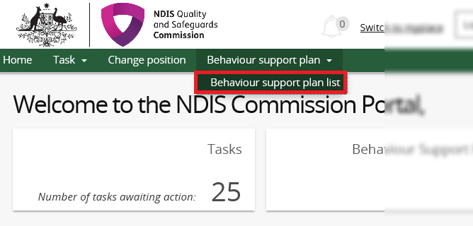
1.2. Click Create plan.
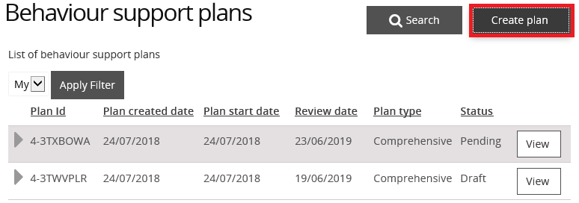

1.3. Select Interim or Comprehensive and then select Save and continue.
Only select Comprehensive if you have a completed a functional assessment ready to upload. Once you select either Interim or Comprehensive, a plan ID is created for this plan type and cannot be changed. If you select the wrong plan type, you will need to go back to step 1.2 and create another plan.
- Tip: Do not select ‘RP record (no BSP)’ plan type. This is only used by implementing providers under certain circumstances. If you are a practitioner uploading a behaviour support plan, then you should only choose between an interim plan or a comprehensive plan.
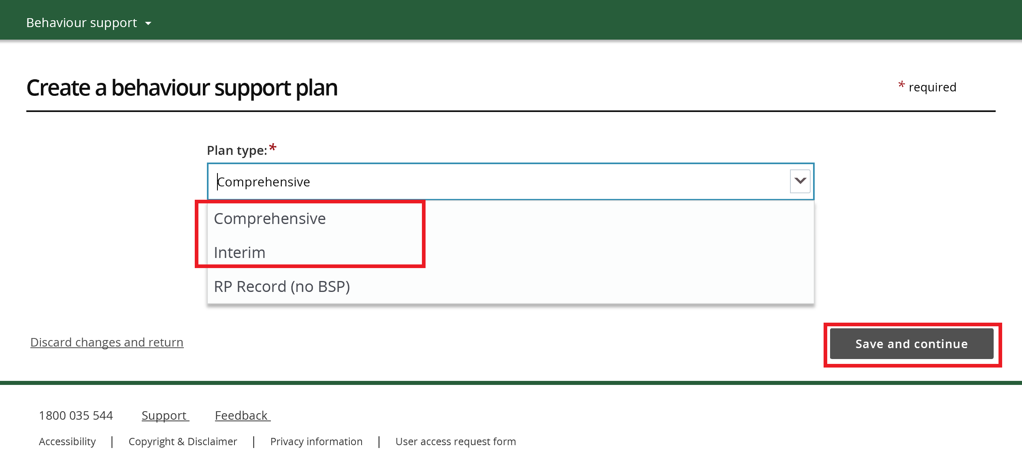
You have now created a draft behaviour support plan in the Portal.
Note: NSW/ACT practitioners need to provide the plan ID to implementing providers for the authorisation submission.
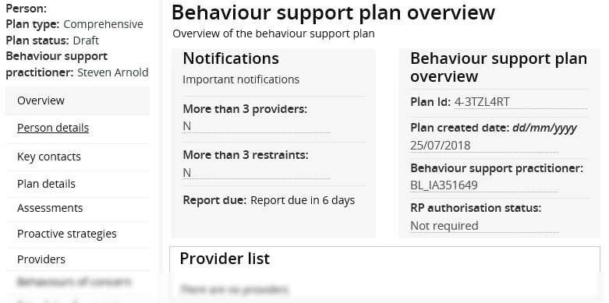
- Tip: The plan ID is located in the ‘Behaviour support plan overview’ section on the right hand side of the screen.

2. Add participant details
2.1. Click the Person details from the left hand side menu then click Select person.
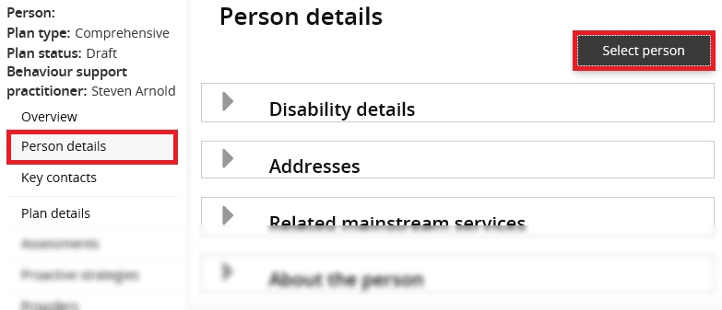
2.2. On the ‘Person with disability’ screen, click Select.
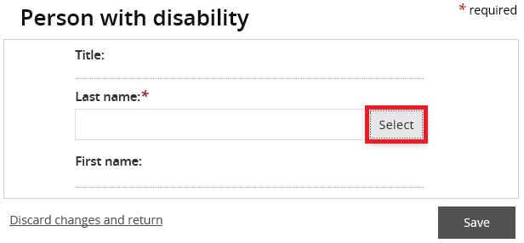
2.3 Type the participant’s details and then click Search.
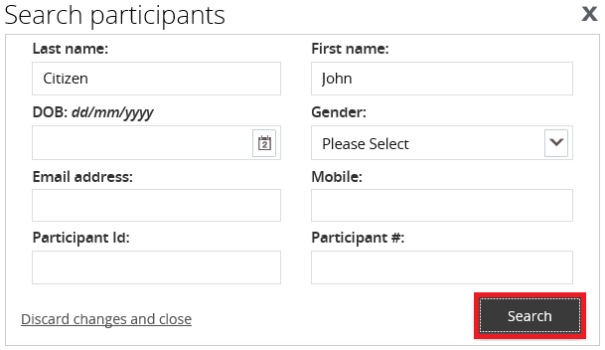
2.4. Select a Participant record to add then click Select and close.
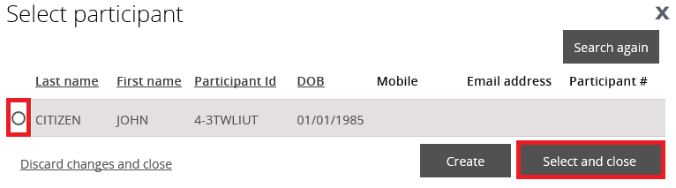
If numerous entries appear, cross check against the DOB on the behaviour support plan and NDIS participant number.
If no participant records appear, click Create and go to step 2.6.
2.5. Check the participant details for accuracy. If they are incorrect, update the person’s details. Click Save. Go to step 3.1.
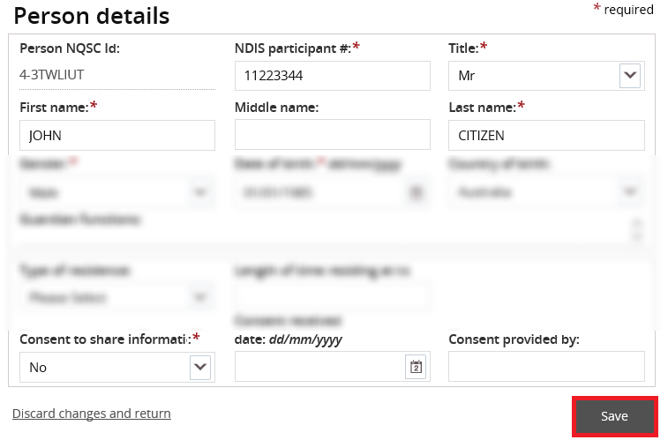
2.6. If no participant records appear after searching, click Create.
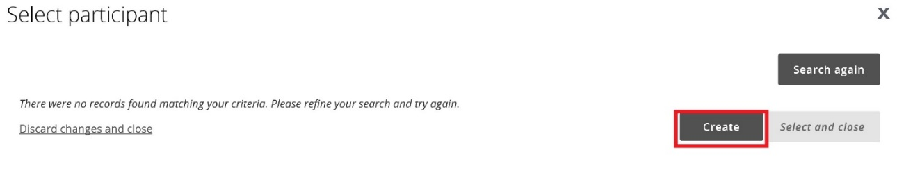
If you select an existing participant, this will auto populate their details, so you can move to the next section.
Once you have created the participant record for the first behaviour support plan, it will be available to use for any subsequent behaviour support plans for that participant.
2.7. Enter the details of the participant. Scroll down and click Save.
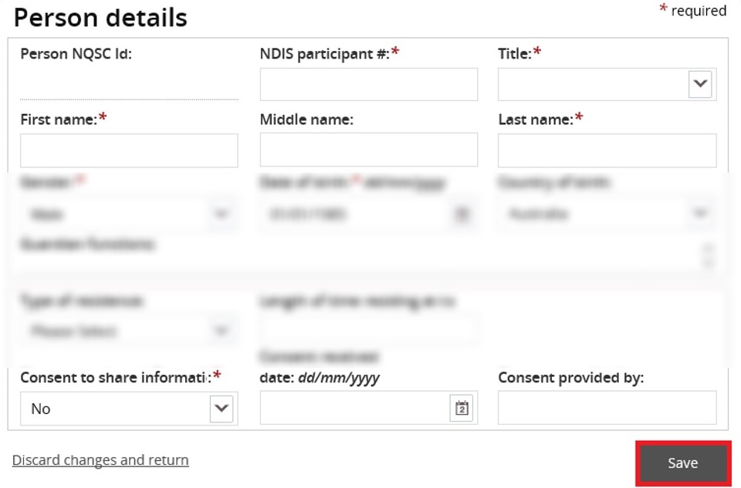

3. Add disability details
3.1. Select the Disability details tile then click Expand button.
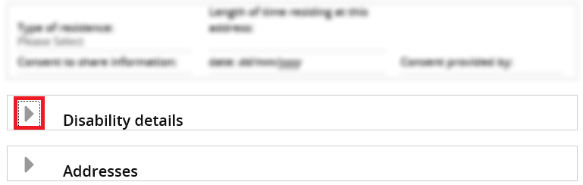
3.2. Click Add.
3.3. Click the Disability type drop down field, select a disability then click Save.
If there are further disabilities to add, repeat steps 3.2 – 3.3.

4. Add address details
4.1. Select the Addresses tile then click Expand button.
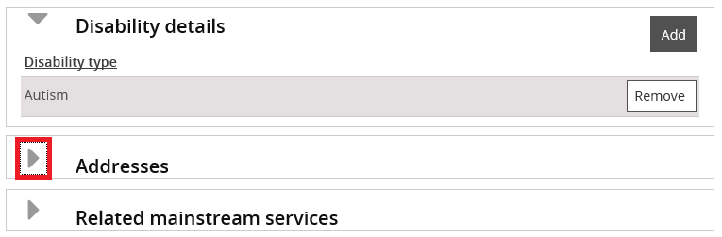
4.2. Click Add address.
4.3. Type the Address details using no punctuation, then click Save.
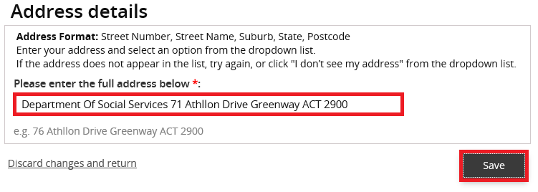

5. Add key contacts
5.1. Click the Key contacts from left hand side menu then click Add.
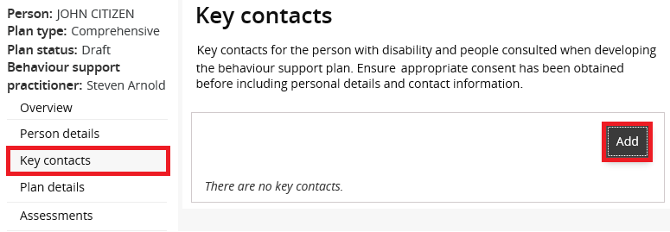
5.2. Click Search.
5.3. Type the key contact’s search details then click Search.
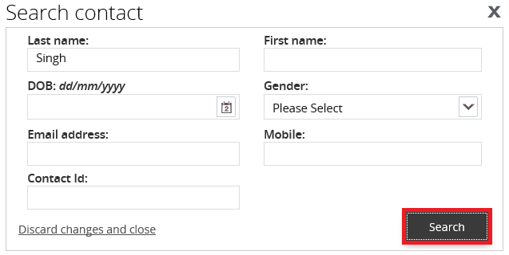

5.4. Select a Key contact record to add then click Select and close.
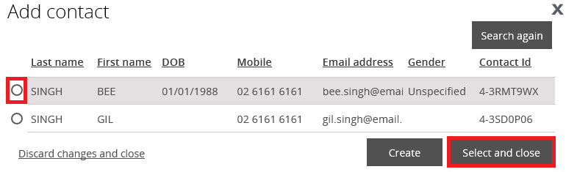
5.5. If the key contact you are searching for is not there, click on the Create button and enter their details.
5.6. Check the Key contact’s details for accuracy.
5.7. Update Key contact’s details if they are incorrect.
5.8. Click Save.
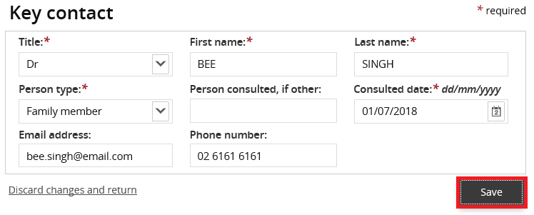

6. Enter details about the behaviour support plan
6.1. Click Update. Click the select button next to the behaviour support practitioner box to select the practitioner that you are uploading the plan for.
6.2. Enter the start date, end date and review date. The review date should be at least one month before the end date.
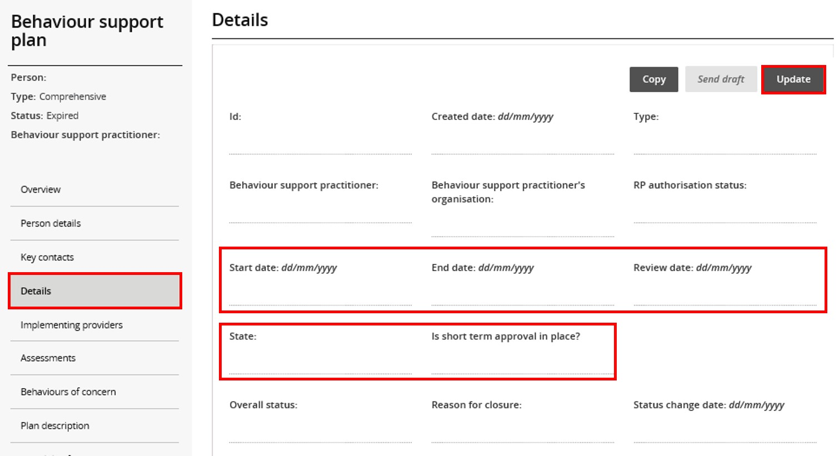
6.2. Enter the State the participant is living in.
6.3. For Queensland only, indicate whether a short-term approval is in place.
- Tip: After saving, check that the dates you have entered are correct. If they are incorrect, update and save again.

7. Add implementing provider details

No implementing provider
When there is no implementing provider (for example only family members are implementing the behaviour support plan) you will be unable to complete behaviours of concern or restricted practices. For these behaviour support plans:
- complete step 8 if it’s a comprehensive plan - adding a functional behaviour assessment
- complete step 11 – attach a copy of the plan
- then go to step 14 and close the plan. Select the appropriate reason for closure e.g. implemented by family or implemented by non-NDIS provider.
For a behaviour support plan that is implemented by an NDIS provider(s), continue to follow each step in this guide.
7.1. Select Implementing providers and click Add.
Only add in Implementing providers who are implementing the restrictive practices. Do not add other providers to this section. Any other providers involved who are not implementing any restrictive practices can be added under Key contacts (see section 5).
Note – you as the practitioner and the specialist behaviour support provider are automatically displayed on the ‘details’ view and do not need to be re-added.
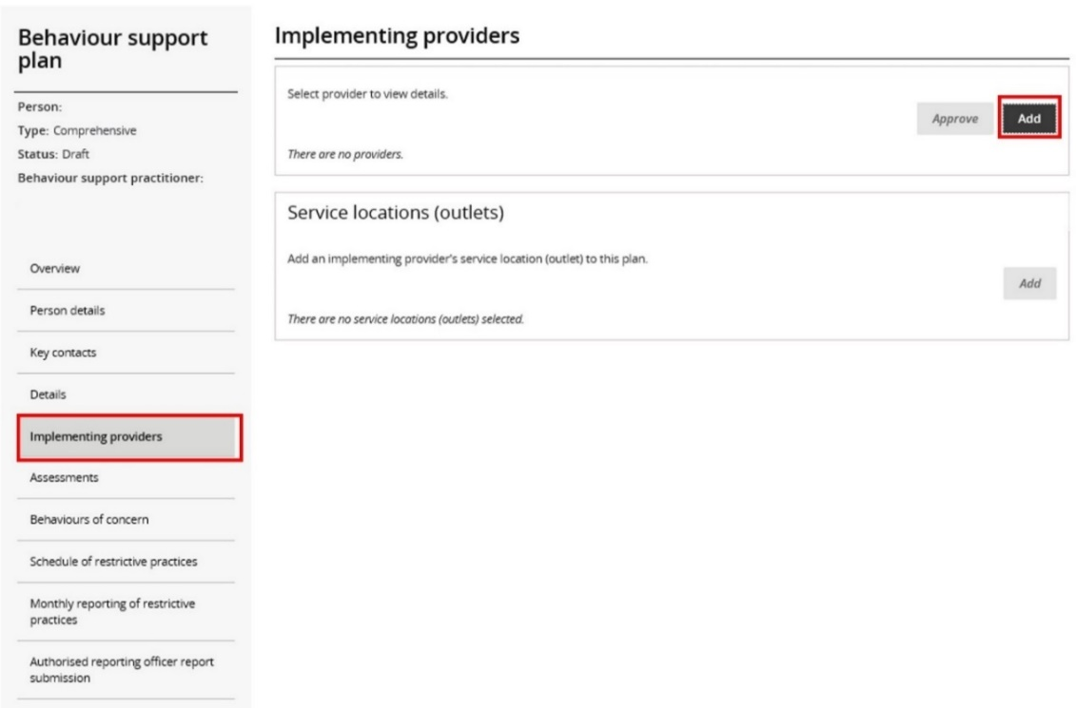
7.2. Type the implementing provider ABN then click Search. You can also search by name, however it is easier to find the correct provider by using the ABN only. You should also verify both the ABN and provider name to ensure you have not selected another provider that is not involved with the participant.
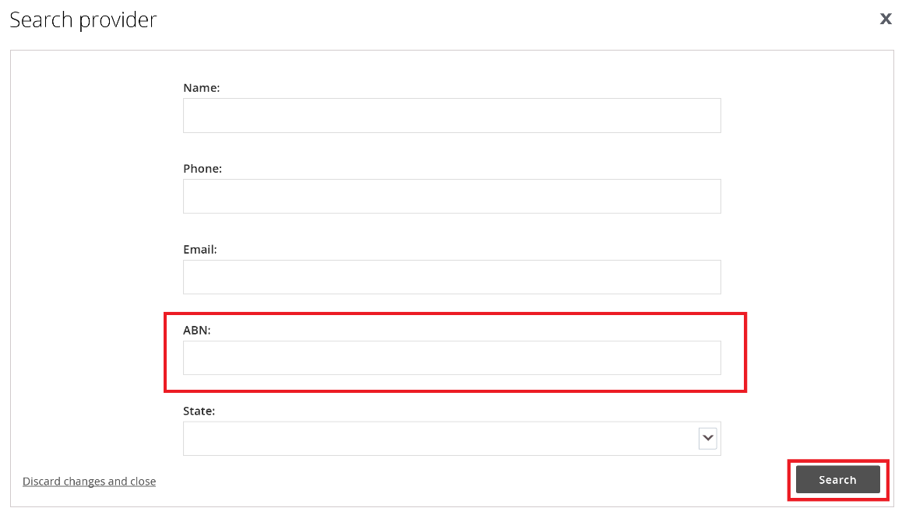
7.3. Select an Implementing provider record to add then click Confirm.
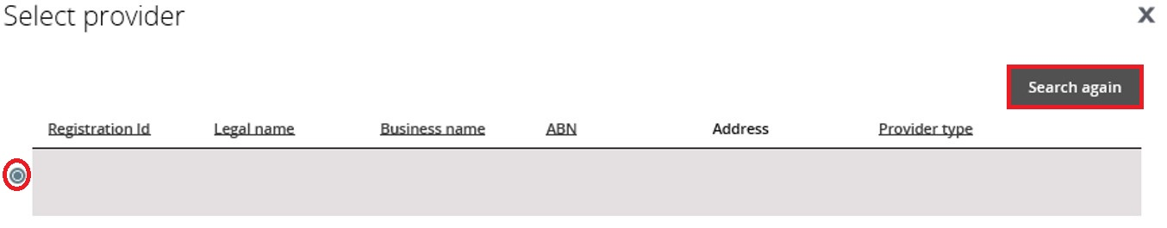
If there are more providers to add, repeat steps 7.1 – 7.3.
7.4. Where there are multiple providers, select a primary provider. This is the provider likely to be using the restrictive practices the most. Click the Actions button to change a primary provider.
Whilst the plan status is in draft, the Remove button is available. If a provider is added in error, ensure it is not the primary provider, click the Actions button and click Remove.
The primary provider can not be removed. Add the correct provider first, make them the primary provider by clicking the make primary button, and then remove the incorrect provider. Note: This will also remove any behaviours of concern or restrictive practices that have been attached to this provider.
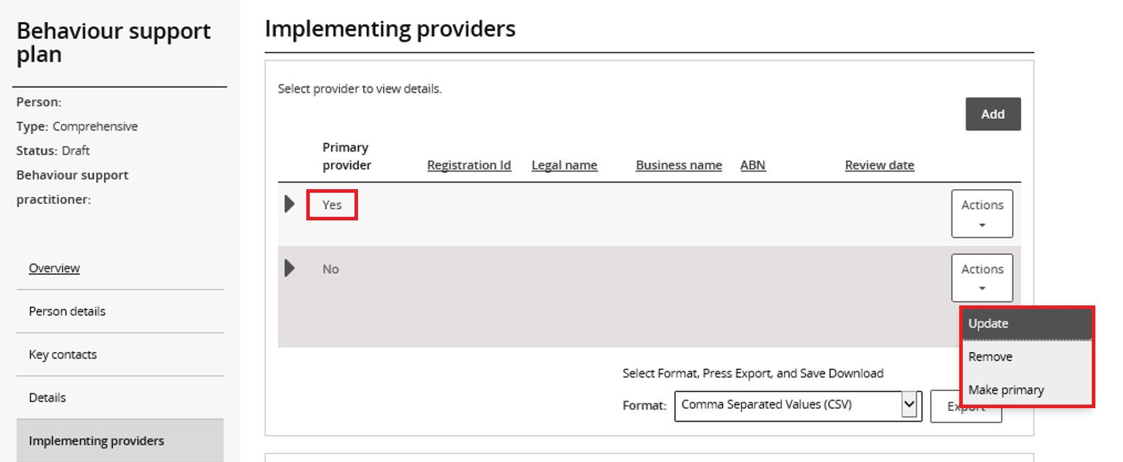
7.5. Click on the Provider name and, on the ‘Service locations (outlets) screen, click Add.
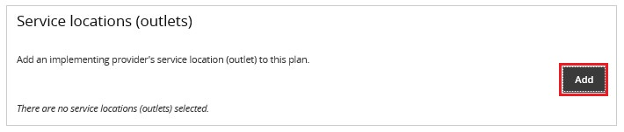

7.6. Type the Service location (outlet) name or ID then click Add.
If you are unsure of what outlet address to add, confirm with the implementing provider. You can also leave the fields blank, and click on the Search locations button. This will bring up a list of all available service locations to select from.
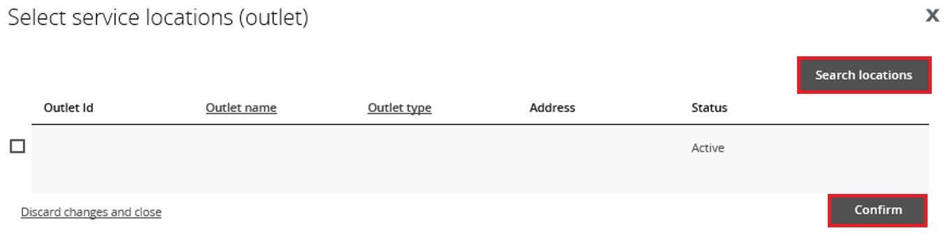
7.7. Select a Service location record to add then click Confirm.
You will not be able to add any behaviours of concern or regulated restrictive practices if a service location is not added.
If there is more than one provider, you need to add a service location for each provider by repeating steps 7.5 – 7.7.

8. Add a functional behaviour assessment
This is a mandatory field for comprehensive behaviour support plans. It is not required for interim plans.
This is a two-step process – first create a record of the assessment by clicking Add. Then upload a copy of the assessment under Attachments.
8.1. Select Assessments and click Add.
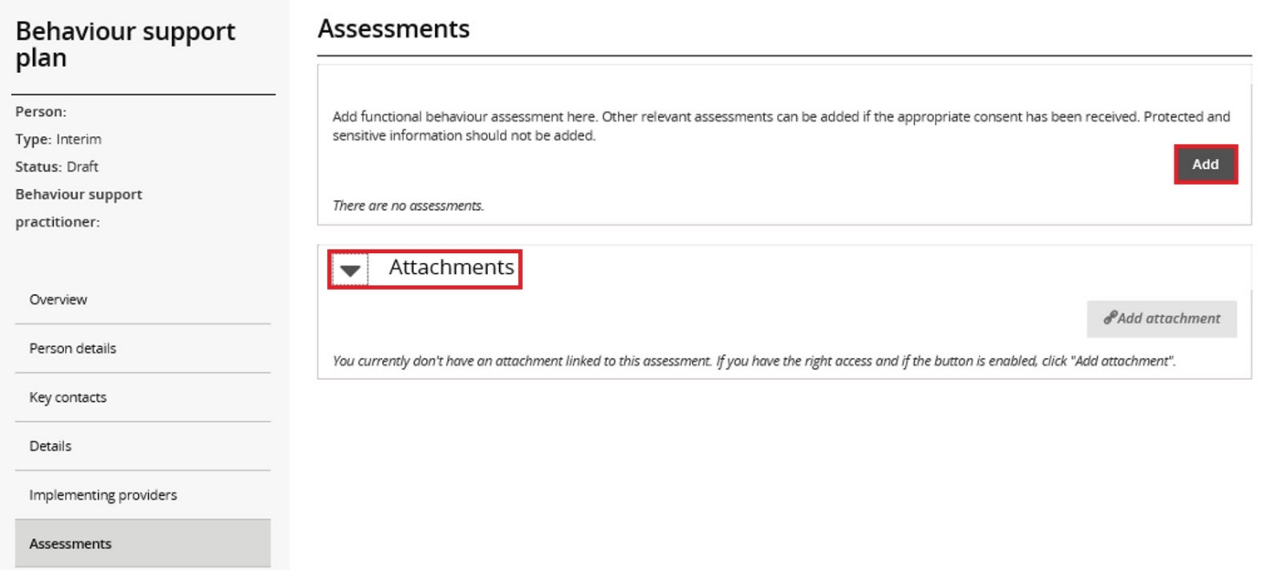
8.2. Enter the assessor’s name and report date, and select Functional Behaviour Assessment then click Save.
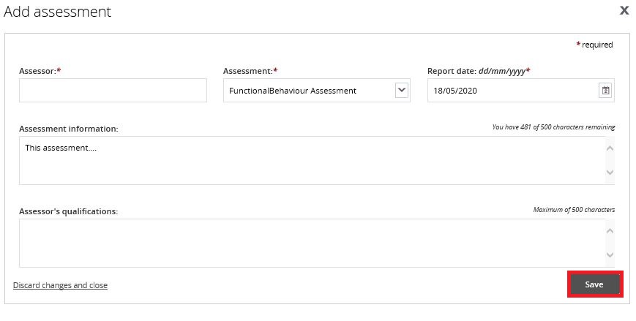
Note: Assessment information and Assessor’s qualifications are not mandatory fields.
Only the functional behaviour assessment is required to be attached. Other assessments do not need to be lodged with the NDIS Commission, but practitioners can attach other reports if useful.

8.3. Click on the name of the assessment, then select the Attachments tile and click Expand.
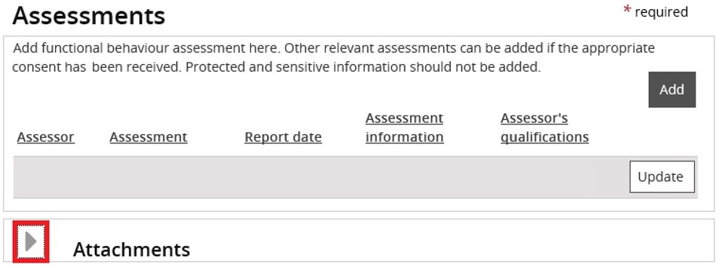
8.4. Click Add attachment.
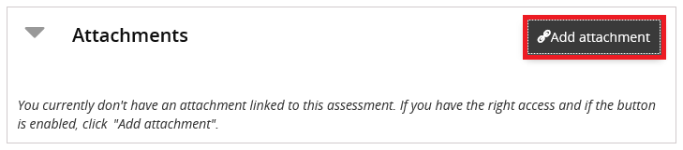
8.5. Choose a File to Upload (attach) then click Open.
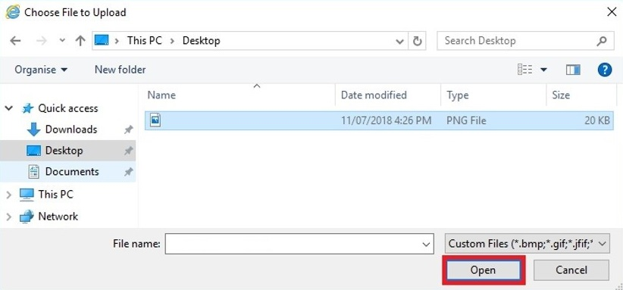

8.6. Select Functional Behaviour Assessment as the Document type then click Save and close.
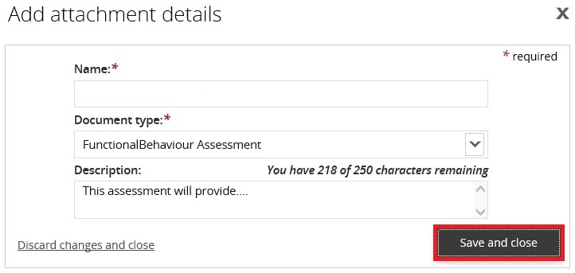
Note – If the functional behaviour assessment is contained within the behaviour support plan, attach the behaviour support plan here as well as attaching it under attachments.
- Tip – ensure that you have Functional Behaviour Assessment showing on the screen in two places, both at the top and underneath Attachments.
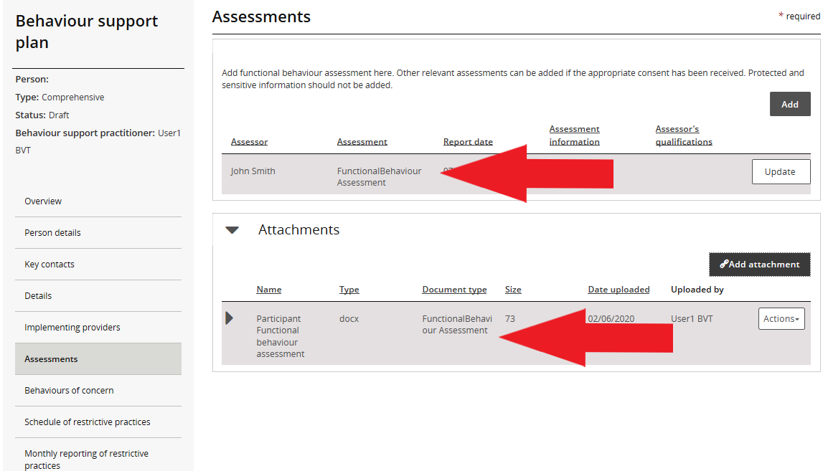

9. Add behaviours of concern
9.1. Click Behaviours of concern from left hand side menu and click Add.
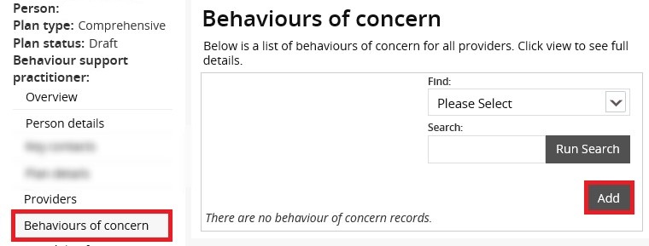
9.2. Select a Behaviour of concern from the Behaviour of concern drop down field then click Next.
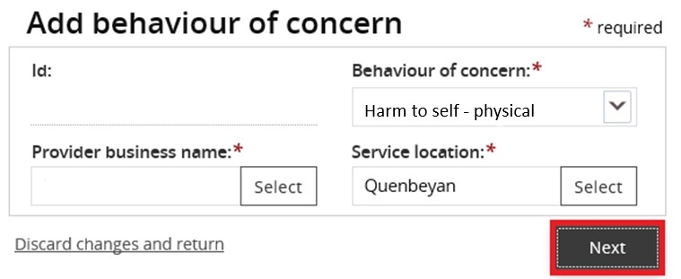
If there are more behaviours of concern to add, repeat steps 9.1 – 9.2.
9.3. If there are multiple providers, the behaviour of concern must be added against each provider where the behaviour occurs. To do this, select the behaviour of concern and click on the copy button. Then change the Provider business name and Service location to reflect the different provider.
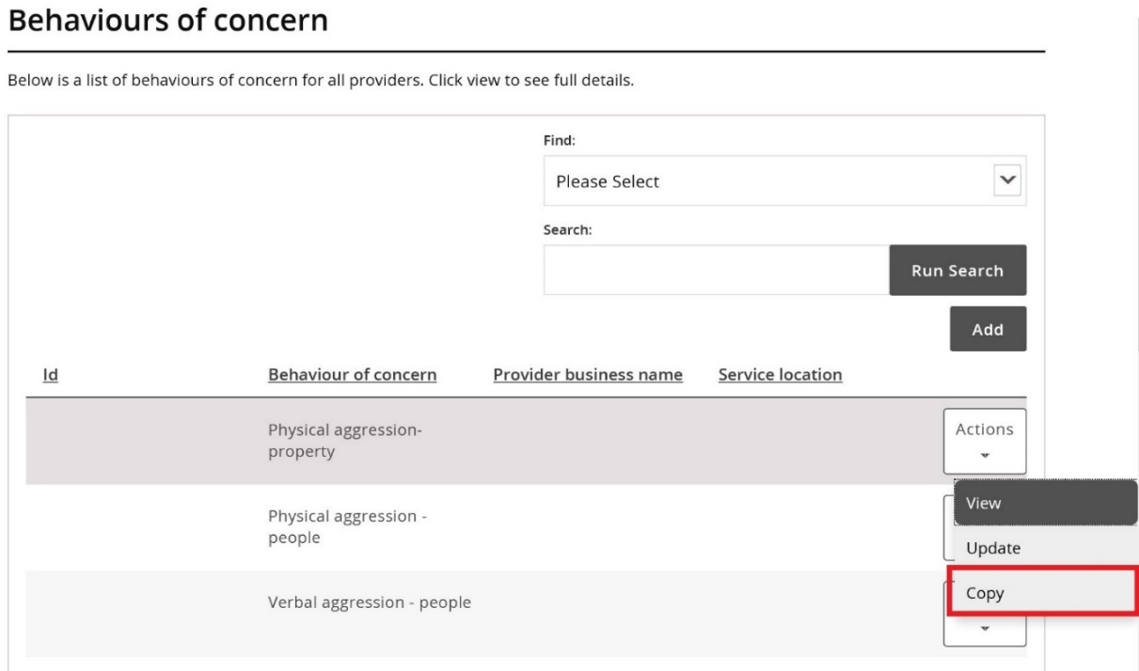

10. Add restrictive practices
10.1. Click Schedule of restrictive practices from the left hand side menu, and then click Add.
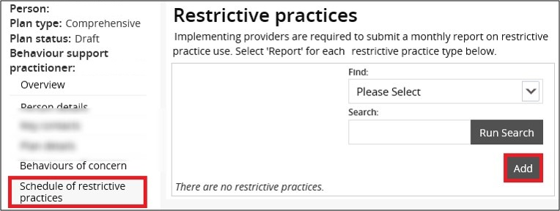
10.2. Complete the restrictive practice information from drop down fields then click Next.
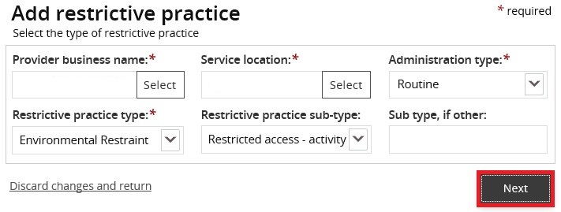
10.3. Enter the restrictive practice authorisation details then click Save.
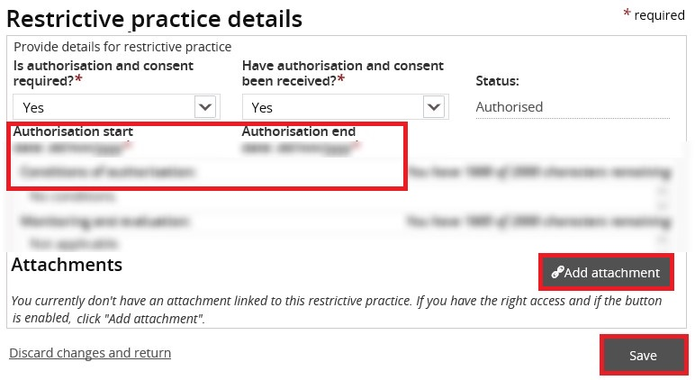
Note – the implementing provider (Authorised Reporting Officer role) can now edit these fields when the behaviour support plan is active. Therefore, if authorisation is not yet obtained, the implementing provider can update this information when they accept the plan and upload the evidence of authorisation (see user guide for implementing providers for additional information).
10.4. For chemical restraint, different dosages or frequencies of the same medication can be combined and entered as a total daily dose. For example, 5mg in the morning and 10mg in the evening of the same medication can be entered in a total daily dose of 15mg. Where the frequency is less than daily, the frequency can be selected from the drop down options.
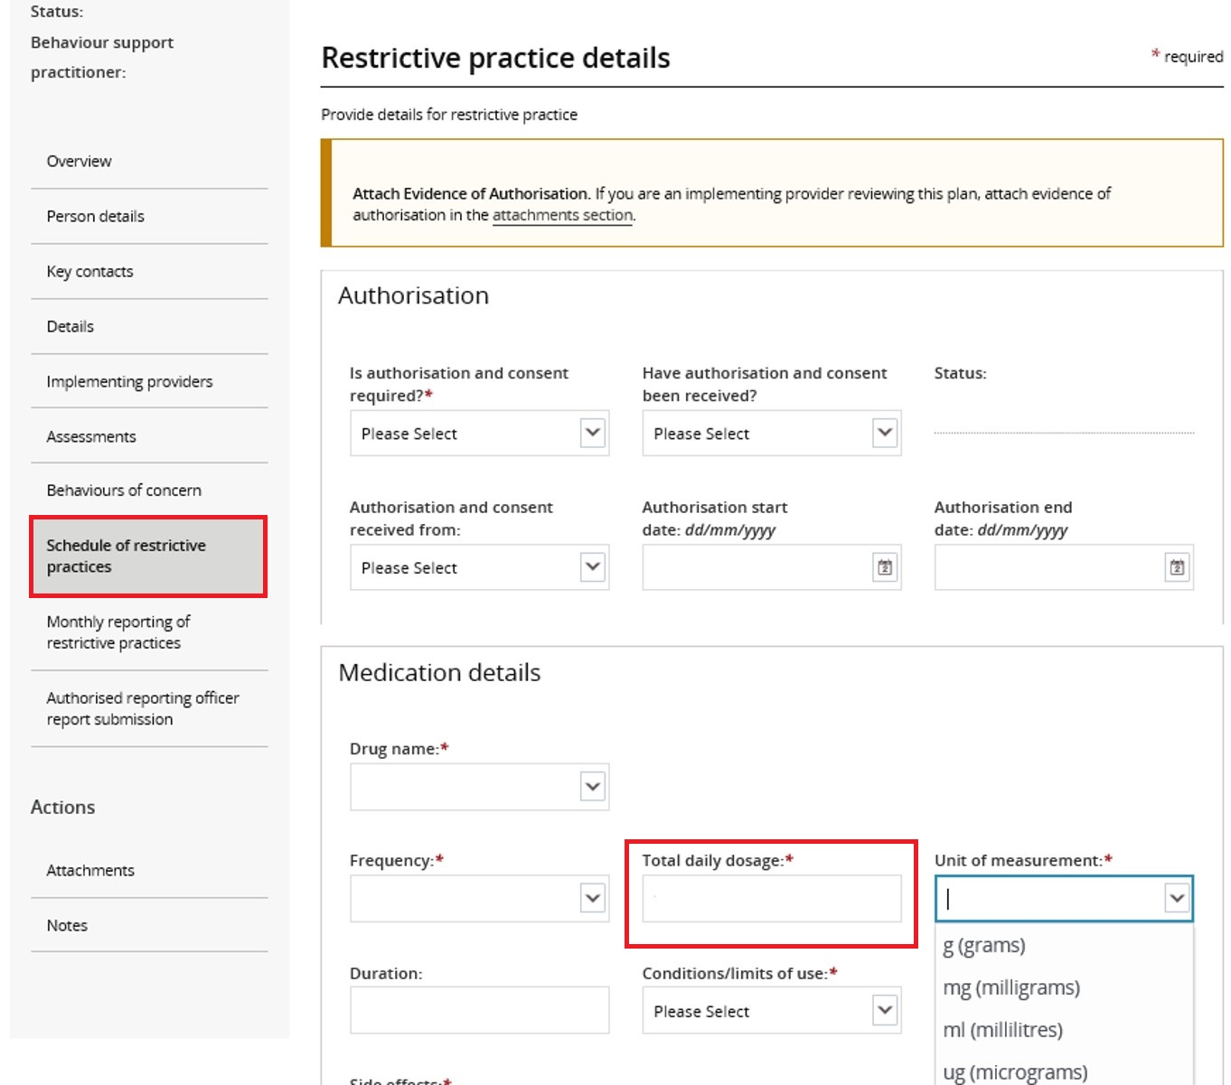
10.5. If you have received evidence of authorisation, record these details under the authorisation section and attach this evidence at the bottom of the restrictive practice details page.
- Tip: NSW, ACT, VIC, TAS, NT, QLD and WA should use ‘Authorising Body’ in the drop-down list. SA should use ‘Guardian’.
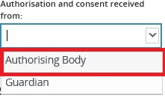
Note – the implementing provider (Authorised Reporting Officer role) can now edit the authorisation section when the behaviour support plan is active. Therefore, if authorisation is not yet obtained, the implementing provider can update this information when they accept the plan and upload the evidence of authorisation (see user guide for implementing providers for additional support).
10.6. To enter additional restrictive practices, repeat steps 10.1 – 10.5.
10.7. If there are multiple providers, the regulated restrictive practice must be added against each provider that will be using the practice. To do this, select the restrictive practice and click Copy. Then change the Provider business name and Service location to reflect the different provider.
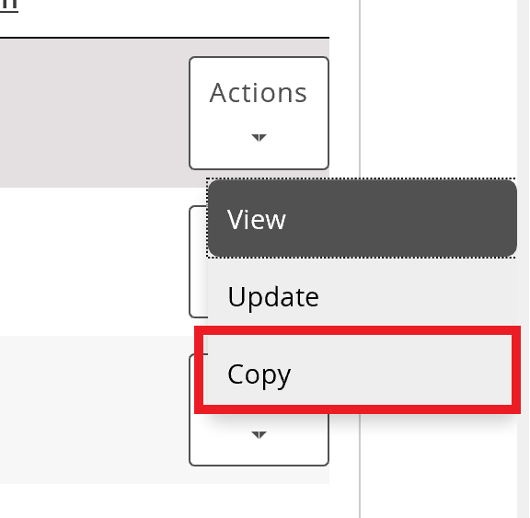
Note: Each implementing provider listed must have at least one restrictive practice listed.

11. Attach the behaviour support plan
11.1. Scroll down the left hand side navigation menu and select Attachments.
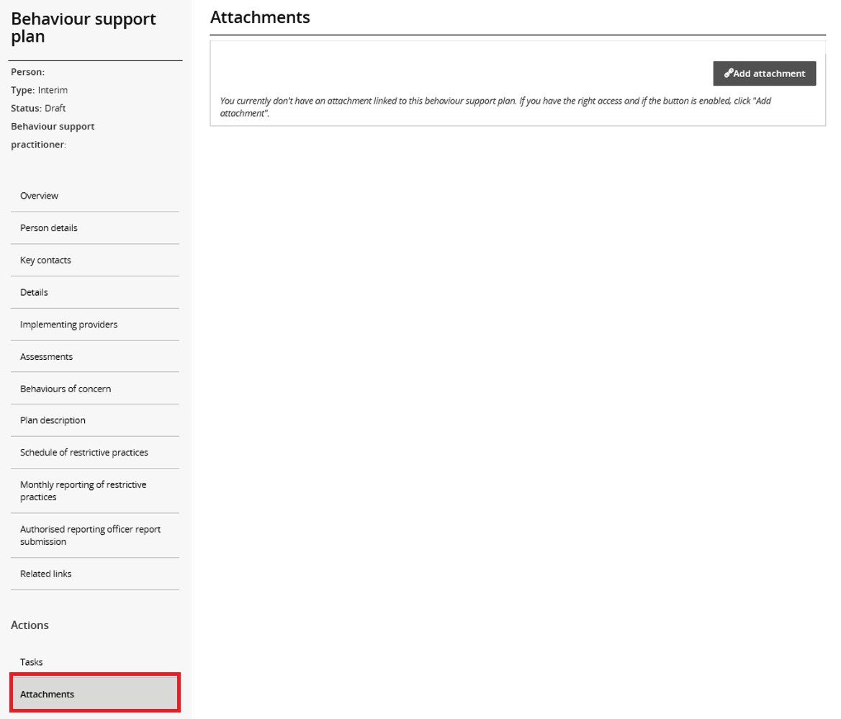
11.2. Click on Add attachment.
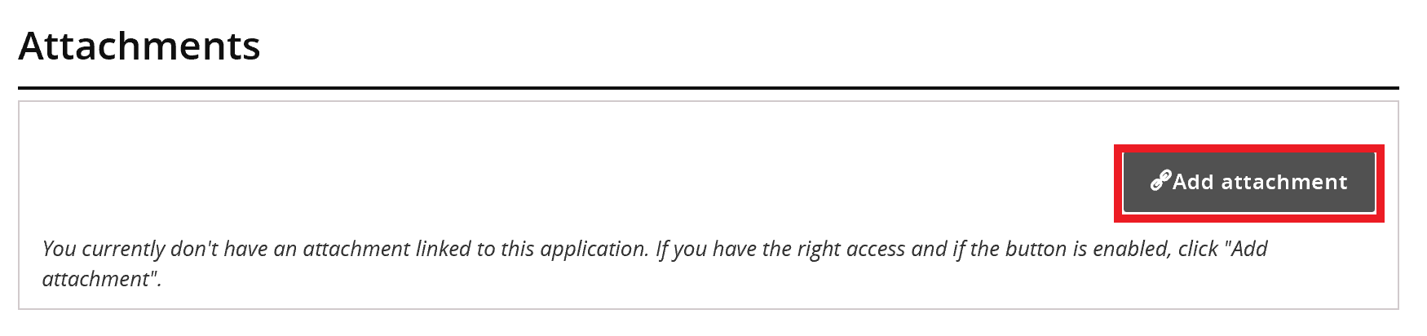

11.3. Once you have selected the file to attach, select Behaviour support plan from the document type drop-down list.
11.5. Click Save and close.
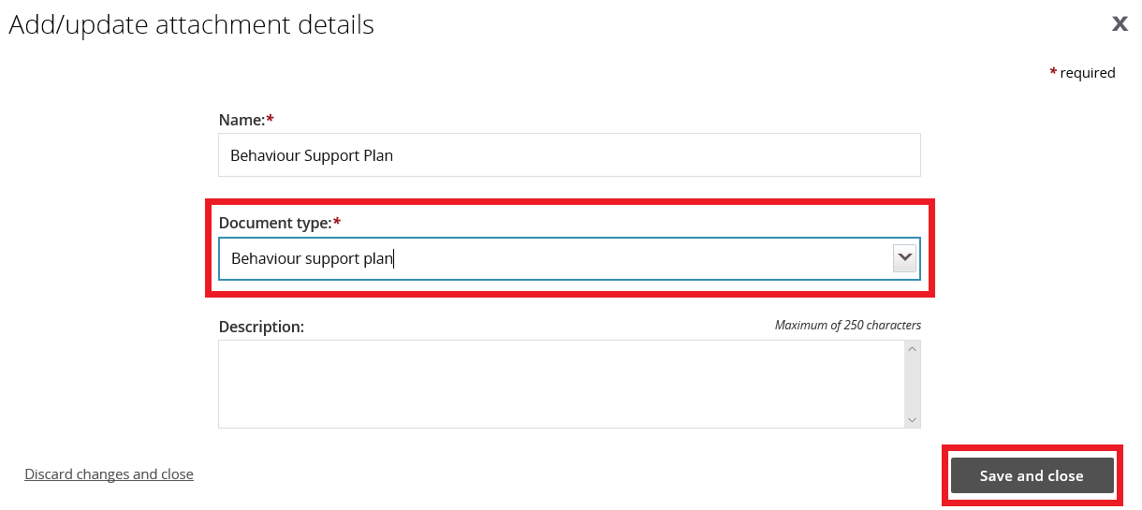
- Tip – Description is not a mandatory field

12. Send draft behaviour support plan to implementing provider(s)
Check all sections listed down the left hand side menu to ensure that you have completed all the details required.
Behaviour Support Practitioner Admin role
12.1. Ensure that a behaviour support practitioner has been linked to the plan. Go to the Details view, click update and then click select to add a behaviour support practitioner.
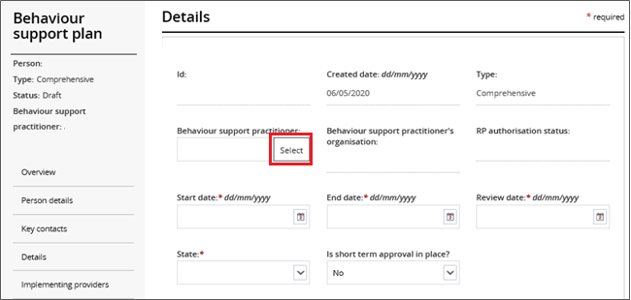
12.2. Click Validate. This will check that all mandatory fields have been completed. An error message will display to identify any missing information.
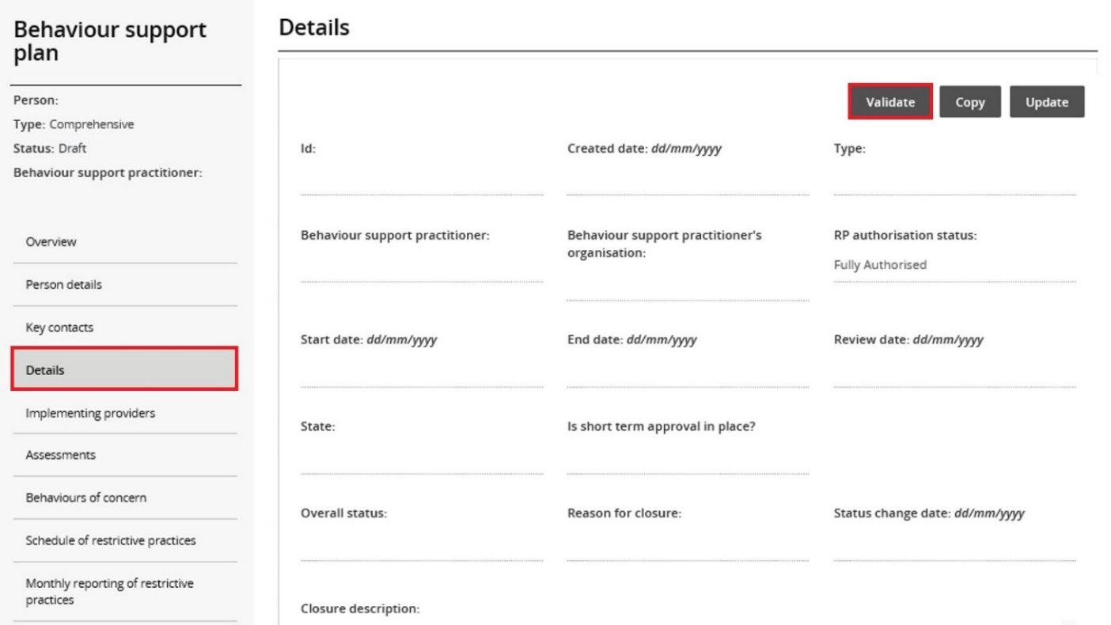
Behaviour Support Practitioner role
Only this role can send the plan to the implementing provider by clicking the Send draft button. This sends the plan to the implementing providers to activate it and commence monthly reporting.
The behaviour support practitioner is responsible for the information contained in the behaviour support plan and entered into the Portal. The practitioner should verify that the information has been entered correctly.
12.3. From the menu, select Details. Click Send draft. Please note, after you have clicked Send draft, the Overall status of the plan changes from Draft to Pending.
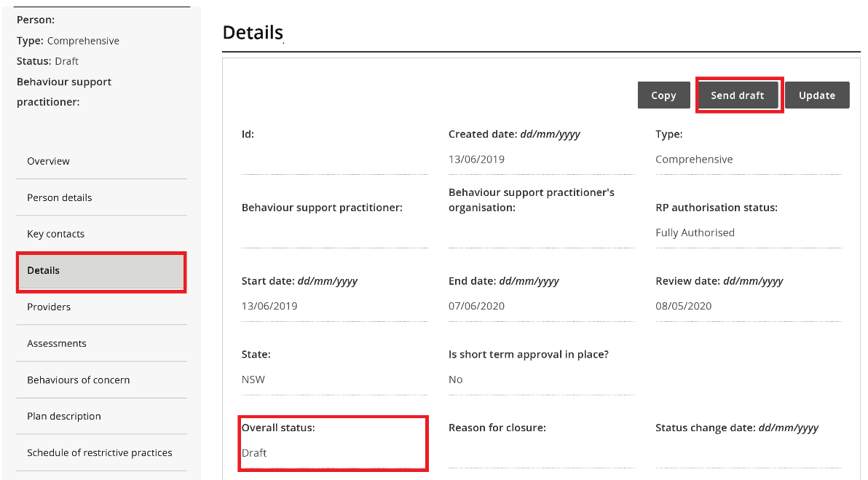
When the status changes to pending, a task is allocated to the primary authorised reporting officer (ARO) for the implementing provider. The primary ARO is the first person that became the ARO for the implementing provider. To find out who the primary ARO is, or to change the primary ARO, the provider can email Tier1Support@ndiscommission.gov.au with their ABN.
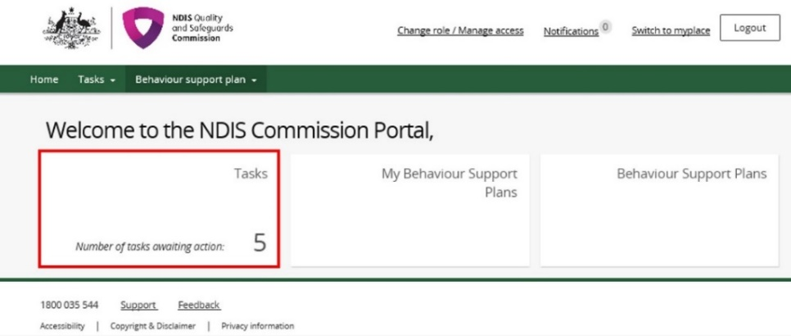
- Tip: Any ARO can still accept the plan by locating the plan through search, navigating to the implementing provider view, and clicking the Approve button (see user guide for implementing providers).
Once the implementing provider has accepted the plan, the status of the plan will change to ‘active’.
Once the end date has passed, the status of the plan will automatically change to ‘expired’.

13. Fix an error in a plan

Draft plans
13.1. When the plan status is ‘draft’, a Remove button is available under the Actions button.
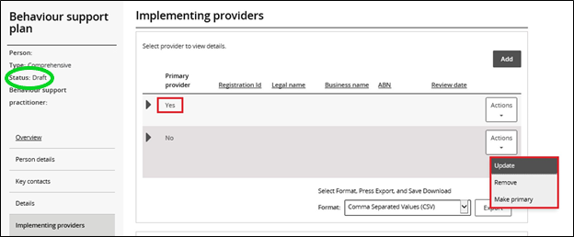
To remove an implementing provider added in error, click Remove. This will also remove all associated behaviours of concern and restrictive practices.
Note: The primary provider can not be removed. Add the correct provider first, make them primary by clicking the make primary button, and then remove the incorrect provider. For more information, see paragraph 7.4.
The remove button is also available under Behaviours of concern and Schedule of restrictive practices, allowing individual behaviours of concern and restrictive practices to be removed.

Pending plans
13.2. An error identified when the plan status is ‘pending’ can be fixed by changing the status back to ‘draft’.
In draft, edits can be made – see step 13.1 for how to remove providers, behaviours of concern or restrictive practices added in error.
To change the status back to ‘draft’, go to the Details view, click Update and then click the Status drop-down box and select Draft.
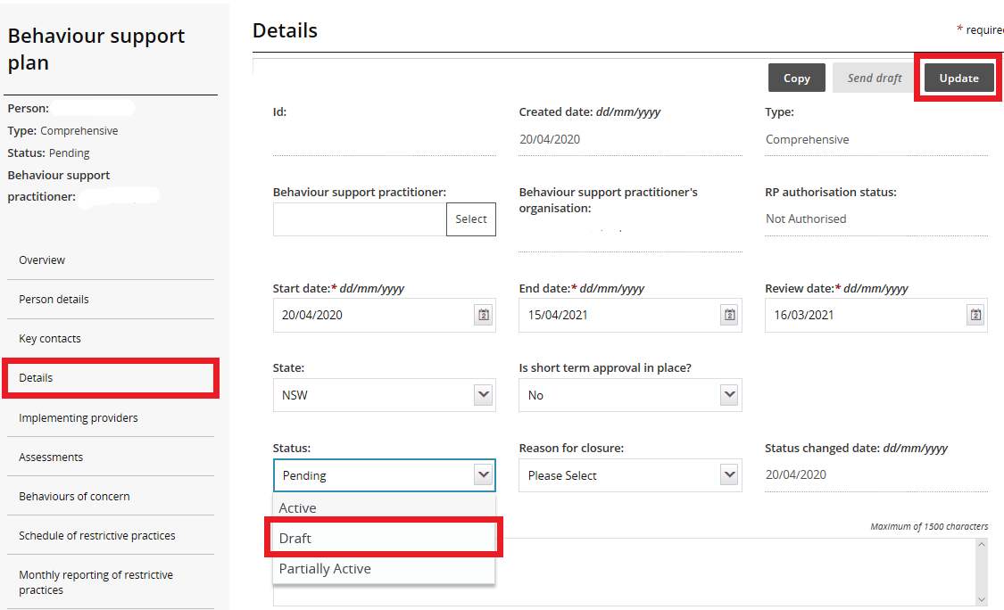

Active Plans
13.3. When the plan status is active, no changes can be made to the plan.
A new plan will have to be lodged. To save time, a copy of the plan can be made by going to the Details page and clicking the Copy button.
This will create a new plan in draft with a new plan ID, but contain the existing information in the original plan. The required changes can now be made.
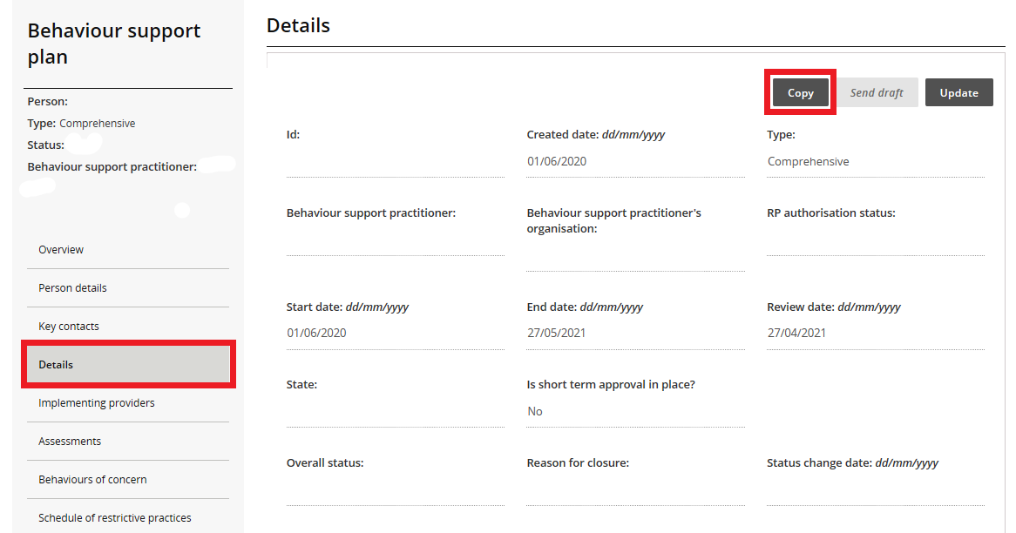
Before clicking the ‘send draft’ button and making the new plan ‘pending’, you will need to close the original active plan. See section 14 for how to close a plan.
Note – if there is a small variation in way a restrictive practice is being used, for example a change in dosage of a medication or change in the way an environmental restraint is being used, the implementing provider can report this variation monthly by selecting report variation when they complete the monthly report. The amendments can be made when the behaviour support plan is reviewed.
If there is a major change in the participant’s circumstances, an NDIS behaviour support practitioner is required to review the behaviour support plan.

14. Close a plan
14.1. In the Details view, click Update
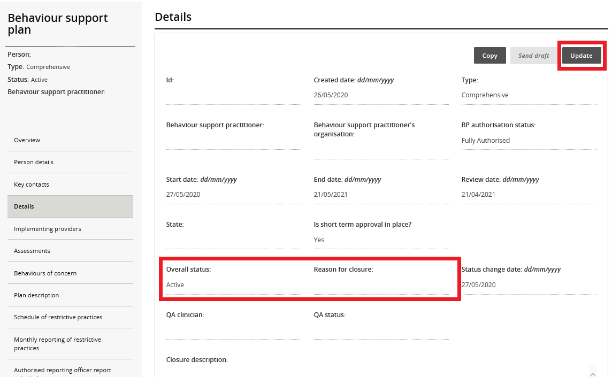
14.2. Select Closed from the Status drop down box
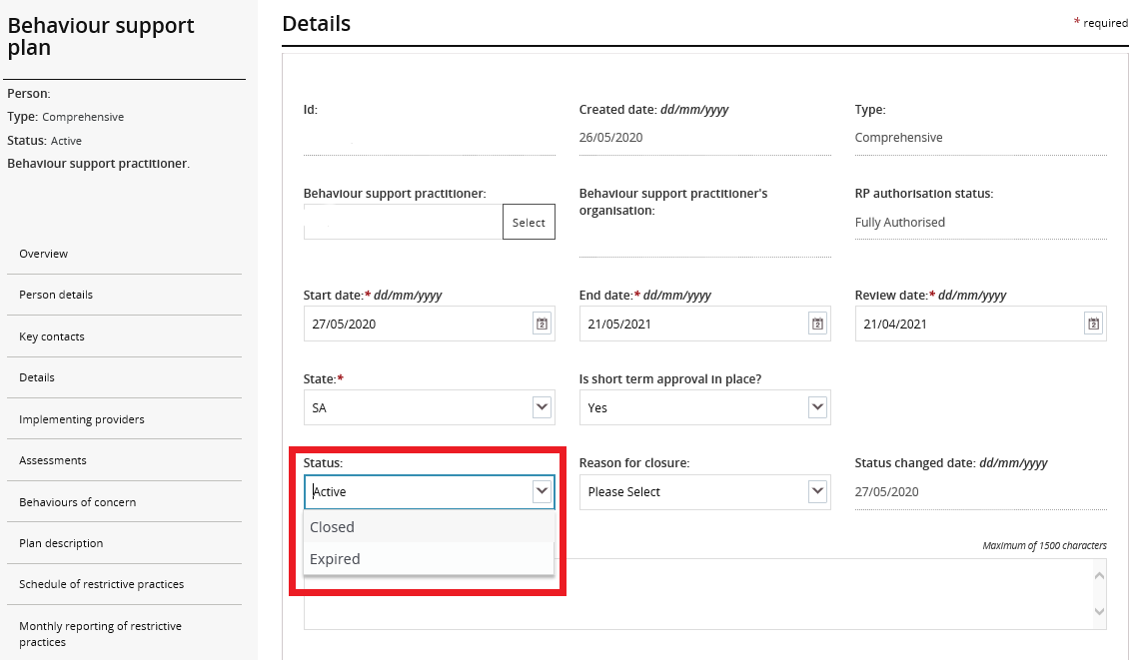

Select reason for closure from the Reason for closure drop-down menu and then click Save.
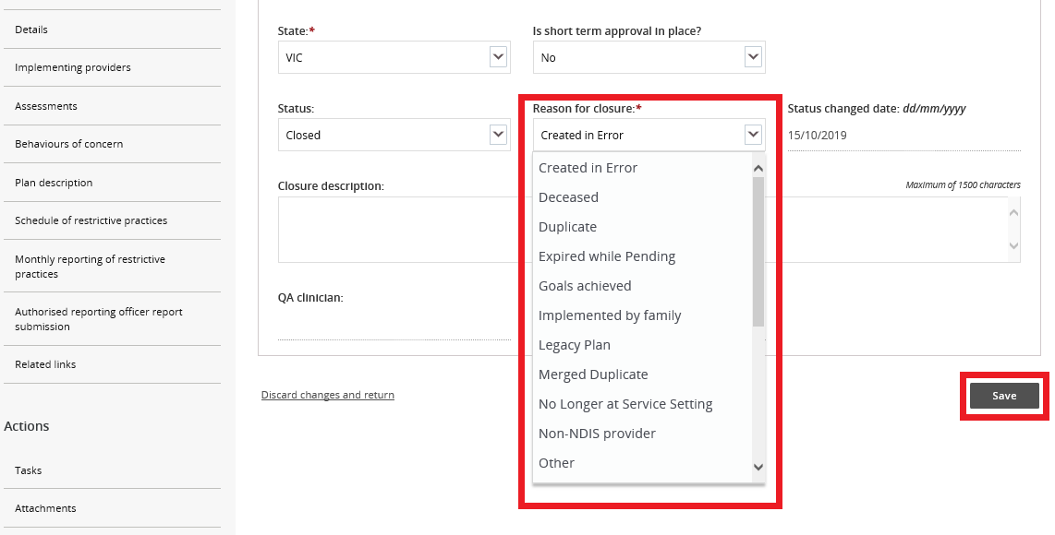
If Other is selected as a reason for closure, additional information is required in the Closure description box.

Contact us
Call: 1800 035 544 (free call from landlines). Our contact centre is open 9.00am to 4.30pm in the NT, 9.00am to 5.00pm in the ACT, NSW, QLD, SA, TAS and VIC Monday to Friday, excluding public holidays.
Email: contactcentre@ndiscommission.gov.au
Website: www.ndiscommission.gov.au

