Your introduction
to the Positive
Behaviour Support
Capability Framework

Who is this document for?
Behaviour support practitioners who:
- have their own business
or
- work for a registered specialist behaviour support provider.
After reading this document, you will understand:
- the NDIS Positive Behaviour Support (PBS) Capability Framework
- people’s roles and responsibilities within the PBS Capability Framework
- where to find more information

What is
positive
behaviour
support?
Positive behaviour support involves making changes to a person’s environment and building a person’s skills to:
- improve the quality of their life and the environment in which they live
- reduce the likelihood of behaviours of concern or challenging behaviours
- reduce and eliminate the need for restrictive practices.

Behaviour support under

the NDIS Commission
Providers who specialise in positive behaviour support must be registered with the NDIS Quality and Safeguards Commission (NDIS Commission) to ensure people with disability receive quality services.
Behaviour support practitioners need to be considered suitable by the NDIS Commission to deliver specialist positive behaviour support under the NDIS.
An NDIS behaviour support practitioner can:
- undertake behaviour support assessments (including functional behaviour assessments)
- develop behaviour support plans.

Information about provider registration can be found in the ‘Your introduction to provider registration’ booklet in this kit, or on the NDIS Commission website.

What is the PBS
Capability Framework?
The PBS Capability Framework lists the guidelines for providing positive behaviour support services under the NDIS.
The aims of the PBS Capability Framework are to:
• improve people’s wellbeing and quality of life
• reduce people’s behaviours of concern
• reduce and eliminate restrictive practices
• help practitioners understand the best ways to provide positive behaviour support
• increase the number of skilled and capable practitioners working in the sector.
The PBS Capability Framework is based on the NDIS Act 2013 (Cth). This Act supports the United Nations (2006) Convention on the Rights of Persons with Disabilities.
All registered providers and behaviour support practitioners must understand and work within these laws.

Who developed the PBS

Capability Framework?
The PBS Capability Framework was developed with help from:
• people with disability and their supporters
• positive behaviour support experts across Australia
• representatives from providers, allied health professionals and government.

You can find the full version of the PBS Capability Framework on the
NDIS Commission website.

Levels of positive behaviour

support practitioners
Behaviour support practitioners can operate at four levels in the PBS Capability Framework, depending on their knowledge and skills (see Figure 1).
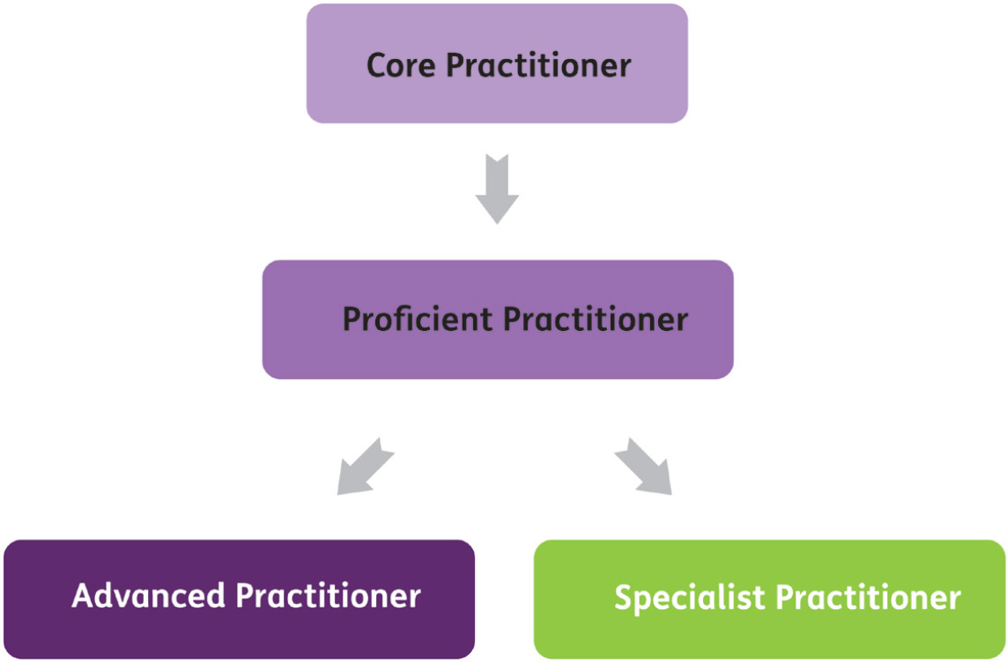

Figure 1: Progression pathway for NDIS behaviour support practitioners through the PBS Capability Framework

Core practitioner
This is an entry-level practitioner who has a good understanding of positive behaviour support. Core practitioners should be supervised by a higher level practitioner when a restrictive practice is being considered in a plan.

Proficient practitioner
At this level, the practitioner is expected to analyse and evaluate information, including appraising the quality of individual plans. They should also be able to build positive behaviour support skills in their organisation and learn new skills from higher-level practitioners.

Advanced practitioner
An advanced practitioner has advanced skills across all capability domains. They should have a strong understanding of positive behaviour support and be able to make effective decisions in complex situations. They should be able to supervise practitioners at all levels and provide quality leadership in the field.

Specialist practitioner
A specialist practitioner should have proficient skills in positive behaviour support and a demonstrated specialisation in a related field. For example, skills working with a specific population or type of disability. They should be able to supervise other practitioners in their area of expertise while continuing to learn from their peers.

Positive behaviour support

in a team
If a participant’s support needs are not complex, a single practitioner with the right expertise can develop the positive behaviour support plan and support its implementation.
If a participant’s support needs are complex, a team of professionals can work with the person and their support network to develop and implement the plan.
When working as part of a team, it is important for each practitioner to know their own role and responsibilities. It is also important for the team to work together to deliver a high-quality, accountable service.

Positive behaviour support

in practice
People with disability who need positive behaviour supports are at the centre of the PBS Capability Framework. Core values and principles of the PBS Capability Framework are reflected in every part of the practice (see Figure 2).

Core principles
The core principles of the PBS Capability Framework emphasise the importance of:
• legal and ethical practice
• cultural awareness
• reflective practice
• evidence-based practice
• supported decision-making
• understanding the different factors and life changes that affect behaviours of concern.

Core values
The core values of the PBS Capability Framework include:
• respect for a person’s opinion
• protection of human rights
• person-centred approaches
• capacity building and participation
• collaboration and teamwork
• honesty
• recognition of the connections between a person’s physical, emotional, spiritual and family wellbeing.
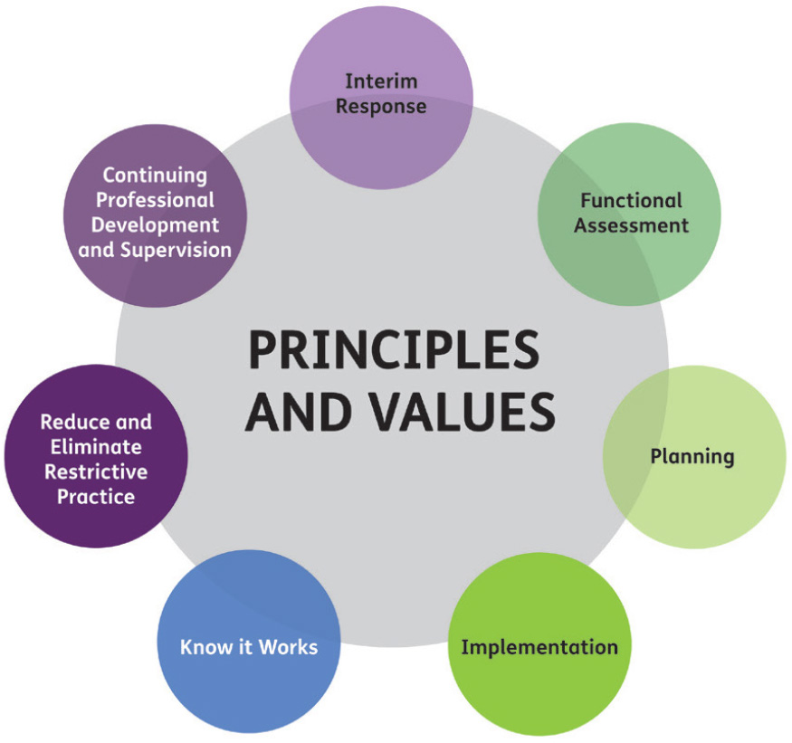

Figure 2: Principles and values of the PBS Capability Framework

Capability domains
The PBS Capability Framework has seven capability domains, or areas of practice, that reflect core principles and values. Each capability domain is broken into three parts:
- Practitioner knowledge (for core practitioners and higher-level practitioners)
- Practitioner skills (for core practitioners and higher-level practitioners)
- Service provider and implementing provider considerations to ensure plans are effectively actioned of expertise while continuing to learn from their peers.

Capability domains

1. Interim response
A person who has behaviours of concern can sometimes be at risk to themselves and others. An initial response is to develop an interim behaviour support plan that minimises the risk and creates safety for the person and others.
Practitioners must produce an interim behaviour support plan within one month of being engaged, to ensure the person and others are safe.
If the plan includes regulated restrictive practices, a comprehensive behaviour support plan must be written within six months of engagement. These plans must be produced by practitioners assessed as proficient or above.

2. Functional assessment
A functional assessment must be done before a comprehensive behaviour support plan is written. This assessment should provide a good understanding of the person, their support needs and their behaviour.
The assessment must focus on a person’s strengths, their likes and dislikes and other important elements of their life. The person must give consent to the assessment and their needs must always be the focus.
If the person’s behaviours are complex, a team approach may be required to better understand why the behaviours are happening.

3. Planning
A quality positive behaviour support plan must be person-centred, evidence-based and proactive. It should also aim to improve a person’s quality of life and support them to make positive change.

4. Implementation
It is important that the plan is implemented well to meet the person’s needs. People who might be involved include family and carers, support workers, teachers or volunteers. Success depends on a team approach where everyone understands the plan and knows how to implement the strategies.

5. Know it works
The plan and its implementation should be measurable and evidence-based. The plan should be checked and updated regularly to ensure the strategies meet the needs of the person.

6. Restrictive practice
A practitioner assessed as being proficient or above can recommend restrictive practices in a person’s behaviour support plan. Restrictive practices should be time-limited and only used as a last resort to protect the person and others from harm.

7. Continuing professional development and supervision
All practitioners should receive ongoing supervision to improve knowledge, skills, confidence and professionalism. They should have a continuing development plan for building their capabilities over time.

We are here to help
For more information about behaviour support or the PBS Capability Framework, contact the Behaviour Support team through the NDIS Commission Contact Centre on 1800 035 544 or email behavioursupport@ndiscommission.gov.au

