Remove a document from an application

IT Quick Reference Guide – Auditor
This Quick Reference Guide explains how an auditor removes a document from an application for the NDIS Quality and Safeguard Commission.

Note:
- Only the user who attached the document can remove the document.
- The application status must be in ‘Submitted’ or ‘In progress’.
- The auditor status can not be in ‘Submitted to Commission’

Search the application you require using the ‘Search my applications’ screen.

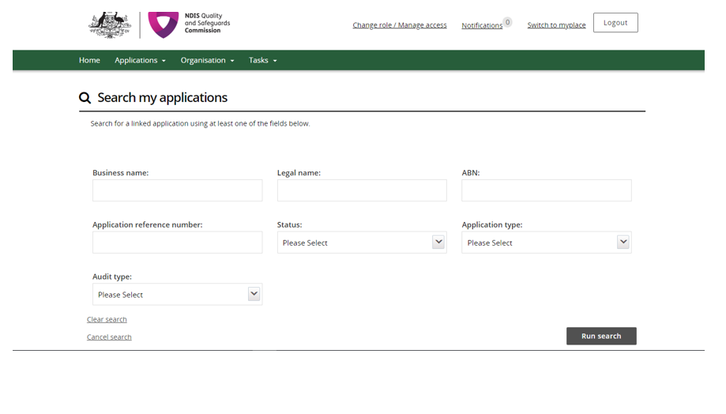

Check the ‘Audit details’ tab to ensure the ‘Audit recommendation’ status is not ‘Submitted to Commission’.

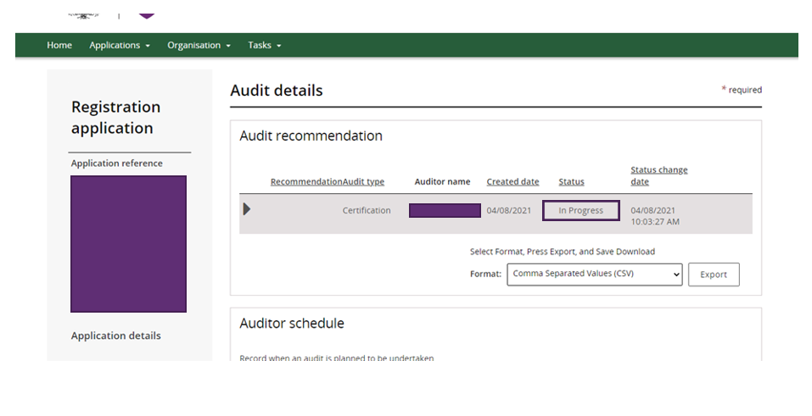

Select the ‘Attachments’ tab.

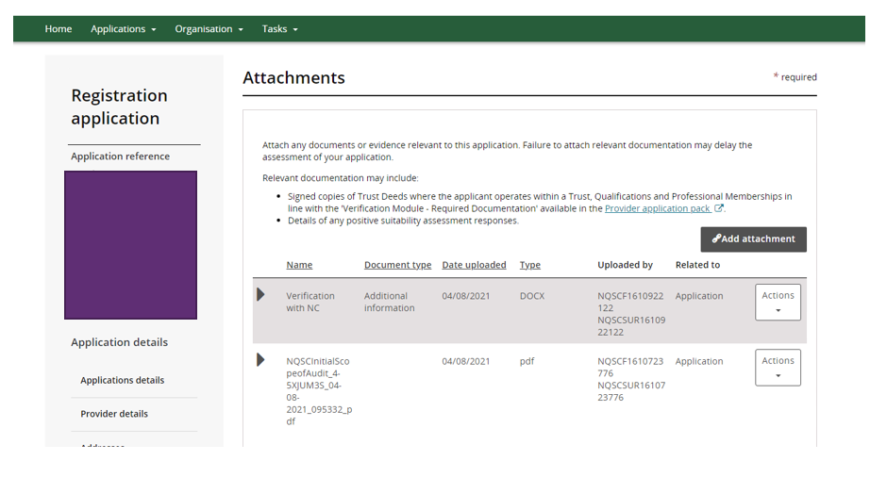

Click the down arrow in the ‘Actions’ box next to the attachment you want to remove. Select ‘Remove’ from the dropdown.

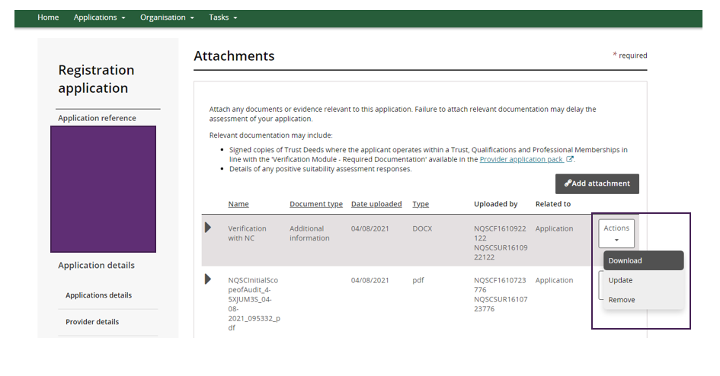

The ‘Confirm delete’ box will appear. Select ‘Yes’ and the attachment will be removed.

