Updating audit outcomes for new NDIS practice standards in COS
Quick Reference Guide - Auditor

Applications for registration where the service delivery questions were completed by the applicant prior to 6 November 2021 will not include the new NDIS Practice Standards of 2.9 (emergency and disaster management) and 4.4 (mealtime management) or Module 1 outcome 8 (severe dysphagia).
If these standards are assessed as part of the audit and are unable to be directly updated in the system, the standard name and outcome should be noted in Audit Details > Audit Recommendation > Recommendation Comments free text.

Adding the new standards to the Audit Details tab in COS
- Log in to the NDIS Commission’s business application system.
- Select My applications from the menu bar and bring up the application you are working on in your usual way.
- Complete all tabs as you normally would after completing a stage 2 audit.
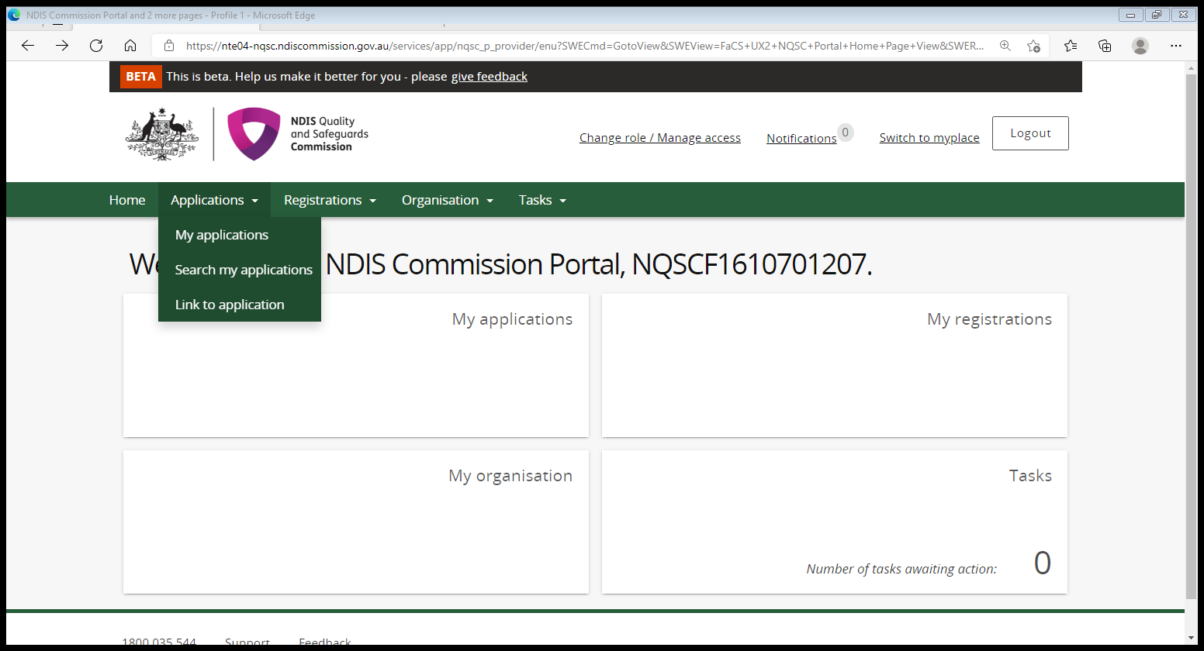

- Select Audit details tab from the left hand menu bar.
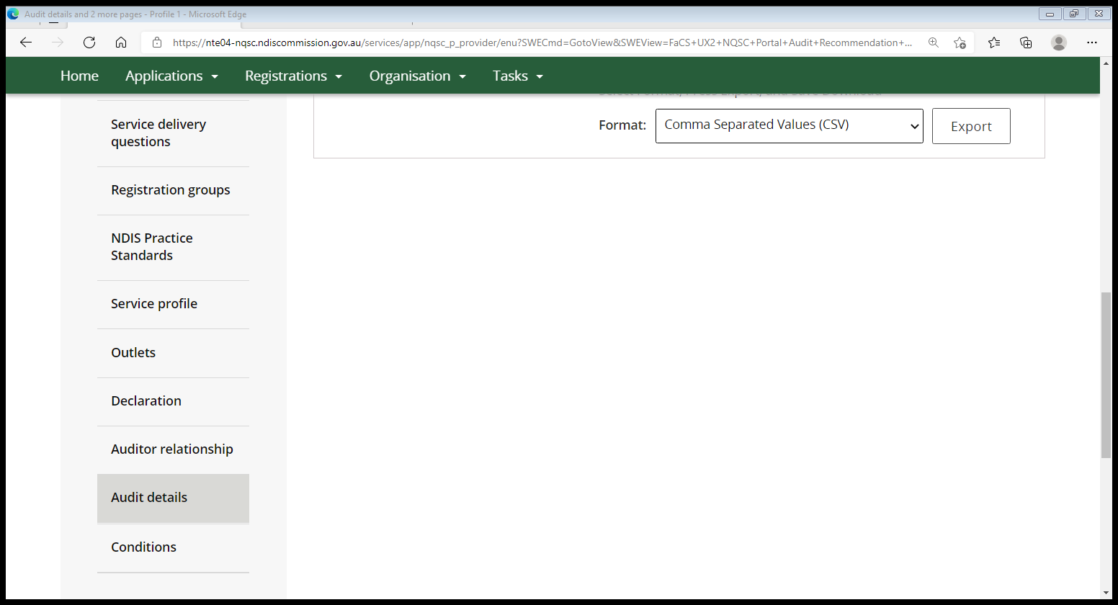

- Click Update to open Audit recommendation field.
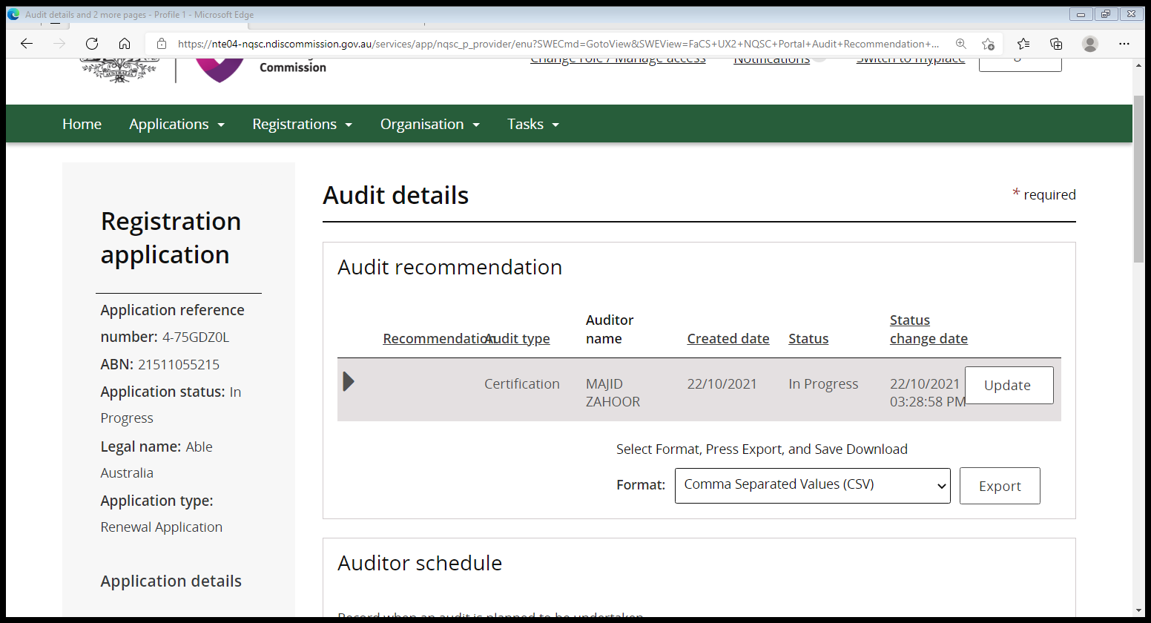

- Complete the Recommendation field by using the drop down arrow. Complete the Recommendation comments and add any new standard or standards, and the rating. Click Save.
Suggesting wording and formatting is shown below.

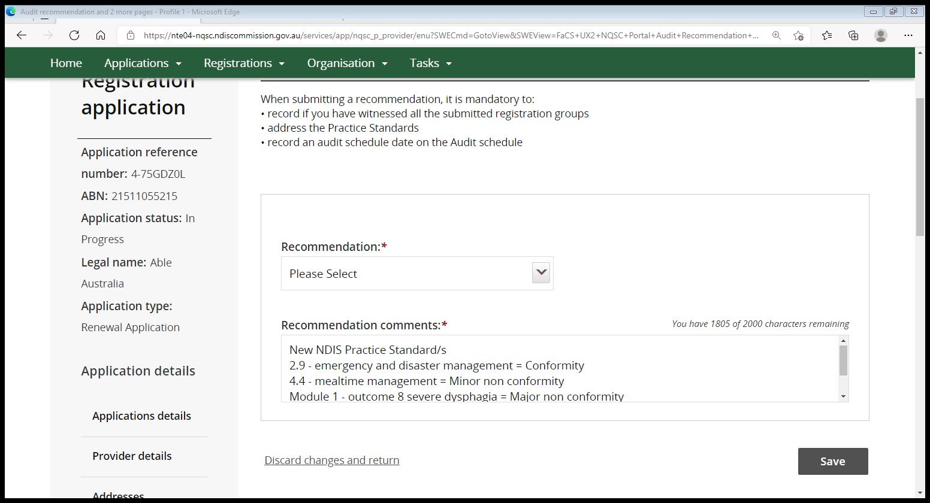

Continue next page

Completing the Core Module text for Mealtime management when not applicable in COS
The mealtime management standard applies with respect to providers who have registered for any certification group that would be expected to provide participants with support with meals.
This may include, for example 115 assistance with daily tasks group living, 117 development of daily living skills, 136 group and centre based activities and potentially 125 participant in community activities.
This may exclude for example groups such as 131 specialist disability accommodation, and 132 specialised support coordination.
If a provider is not providing support with meals at the time of the audit, this should be noted in the practice standard as ‘conforming’ and the auditor should note that “mealtime management does not apply” in the comments field.

- Select NDIS Practice Standards on the left hand tab.
- Select the Action drop down arrow.
- Select View.

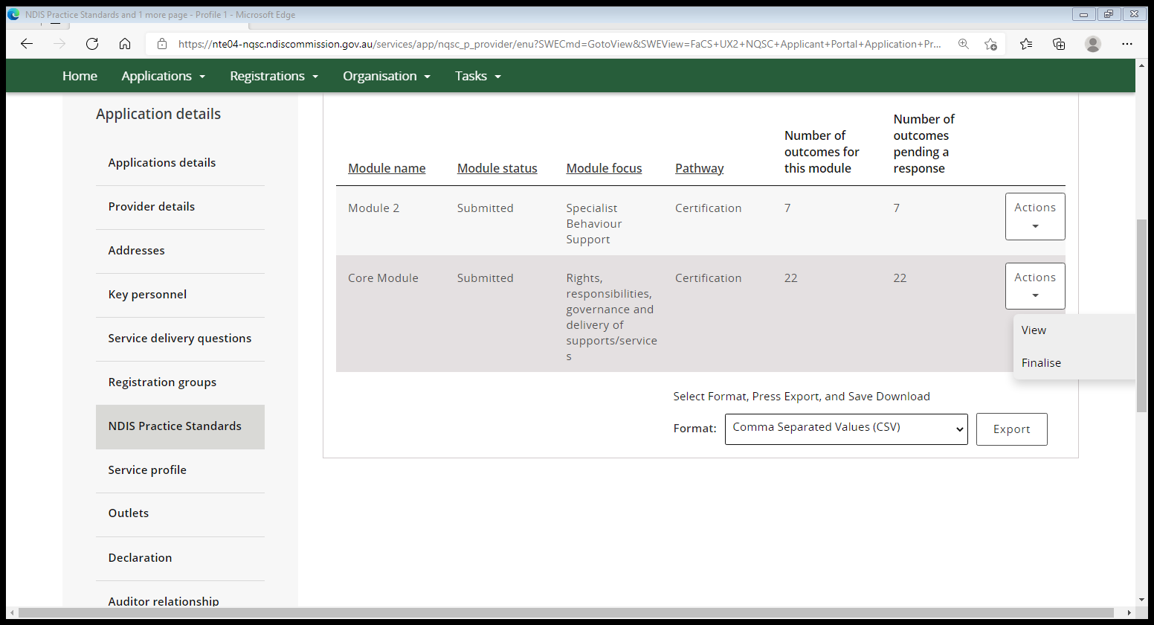

- To open Mealtime Management select update.

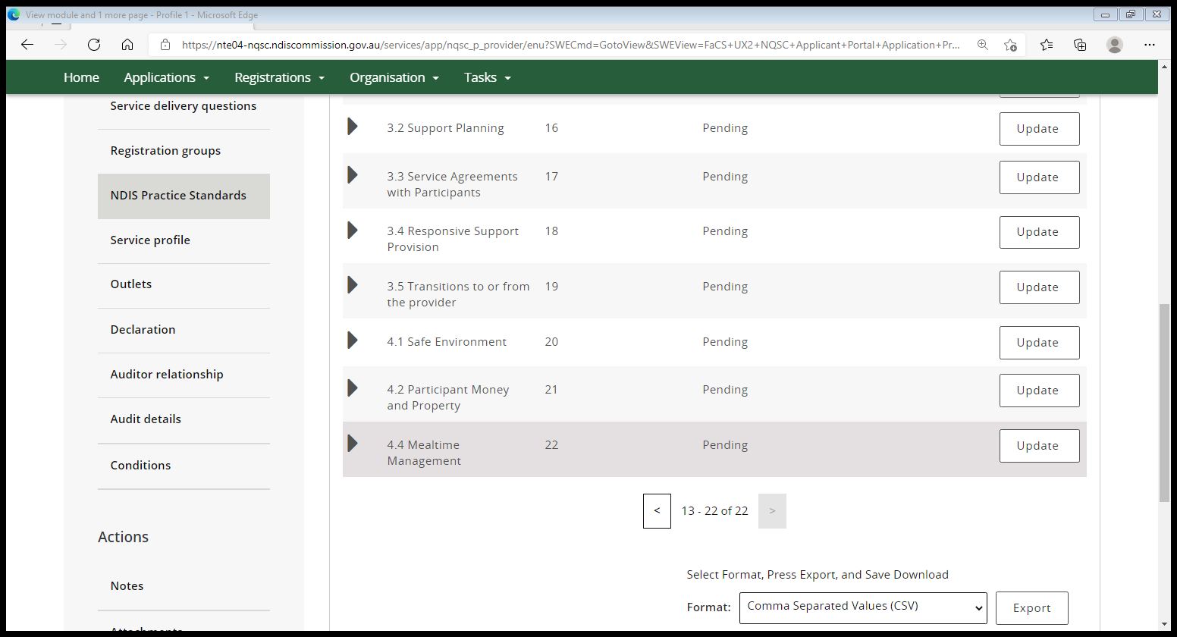

- In the Rating – level of compliance drop down select Conformity.
In the Audit comments text box type in “mealtime management does not apply”.
Select Save and continue.

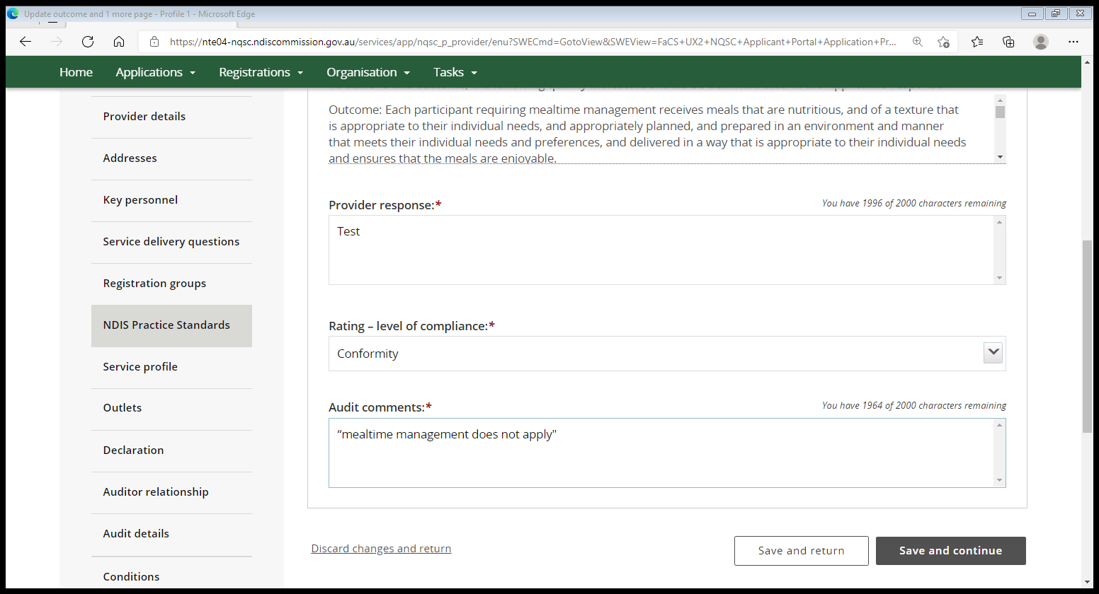

End.

