Complete the 5 day notification form
Quick Reference Guide – Reportable Incidents
Providers are required to submit additional information on the Reportable Incident within 5 days.
This guide outlines the steps for:
- 5 day requirements for reportable incidents – for all Reportable Incidents
- 5 day requirements for death of an impacted person – additional section for death only
- 5 day requirements for unauthorised use of restrictive practices – additional section for unauthorised use of restrictive practices only.
- Attaching additional documentation
Note that for notification of unauthorised use of restrictive practices, you will need to complete the information in the Immediate Notification form before continuing on to complete the additional information in the 5 Day Notification Form to fulfil your reporting obligation.
Before getting started, some useful hints and tips are outlined below:
Tip 1 – Draft the free text sections of information into a word document and copy/paste it across to avoid “time out” restrictions on the portal. Alternatively, scroll to the bottom of the each page and select Save as Draft at least every 25 minutes. The time out restriction of 30 minutes is a PRODA requirement.
Tip 2 – Attach any additional / supporting documentation to avoid exceeding character restrictions within certain fields. Please see Attaching additional documentation section of this document for steps on how to attach documents. There is an attachment limit of 10mb.
Tip 3 – You will need to complete all mandatory fields (marked with an *), otherwise the system will not allow you to submit the form.
Tip 4 – Ensure that you have the right access to complete the Reportable Incidents form. You will need to be registered as either the Provider Authorised RI Approver or the Provider Authorised RI Notifier. Please review the Quick reference guide - getting access to NDIS Portal to ensure you understand the responsibilities of each role and how to set up/ change these within your organisation.
- For further information/ questions, please contact the NDIS Commission Contact Centre on 1800 035 544 or by email: contactcentre@ndiscommission.gov.au
- To provide feedback on the Portal, please contact the NDIS Commission via riportalfeedback@ndiscommission.gov.au

5 Day Requirements for Reportable Incidents (for all Reportable Incidents)
Please ensure that you are logged into the Portal as either the Provider Authorised RI Approver or the Provider Authorised RI Notifier. For information on how to log in or definitions of these roles, please see Quick reference guide - getting access to NDIS Portal
- Click on the My Reportable Incidents tile.
Figure 1: Screenshot of My Reportable Incidents page demonstrating Step 1
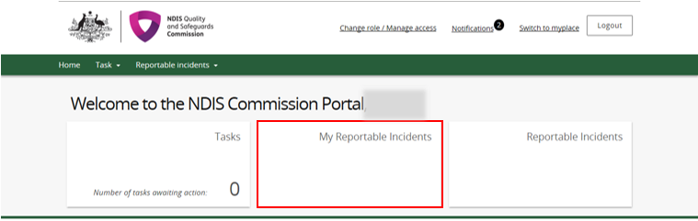
- Click View on the relevant reportable incident.
Figure 2: Screenshot of My Reportable Incidents page demonstrating Step 2
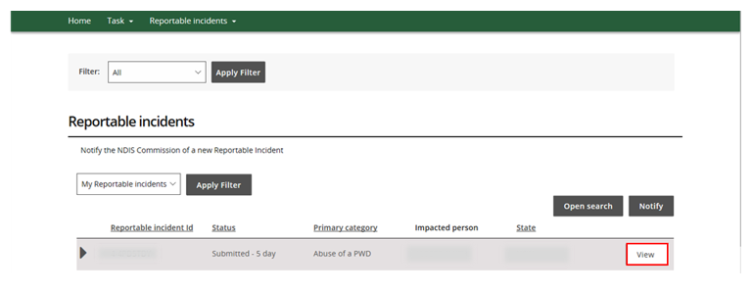

- Review the Incident Specifics task bar on the left hand side.
- The Green Ticks indicate which sections have been completed. Review these and add in any additional information by clicking the Update button
- The Yellow Dot indicates sections that need to be completed. Click Update to complete information required
- Note that the Witnesses section is not a mandatory field for the submission of the form. Steps 5 to 9 are optional.
Figure 3: Screenshot of My Reportable Incidents page demonstrating Step 3
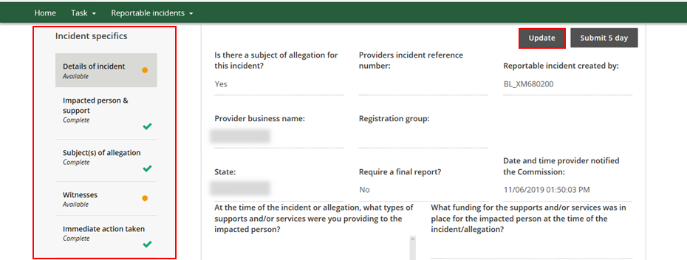
- Click Save on any information added
Figure 4: Screenshot of My Reportable Incidents page demonstrating Step 4
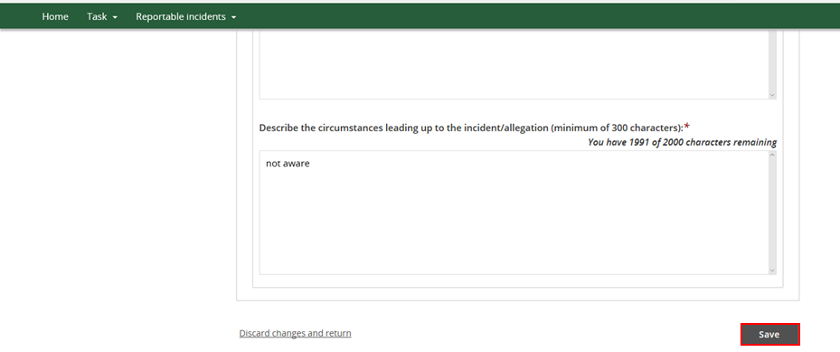

- Click the Witnesses section
Figure 5: Screenshot of My Reportable Incidents page demonstrating Step 5
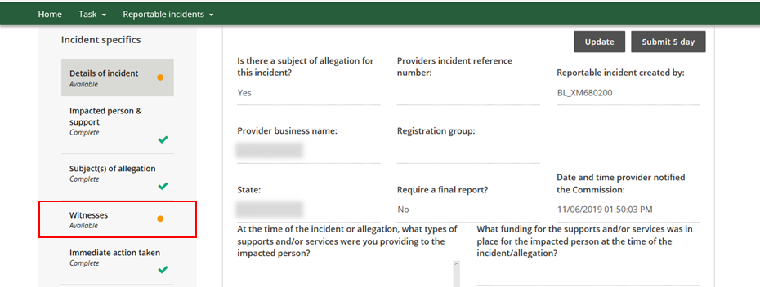
- Click Add
Figure 6: Screenshot of My Reportable Incidents page demonstrating Step 6
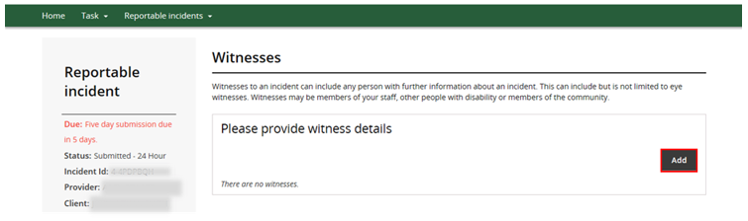
- Click Search
Figure 7: Screenshot of My Reportable Incidents page demonstrating Step 7
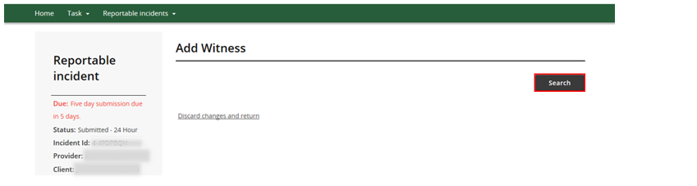

- Type in the Witness’s details, then click Search
Figure 8: Screenshot of My Reportable Incidents page demonstrating Step 8
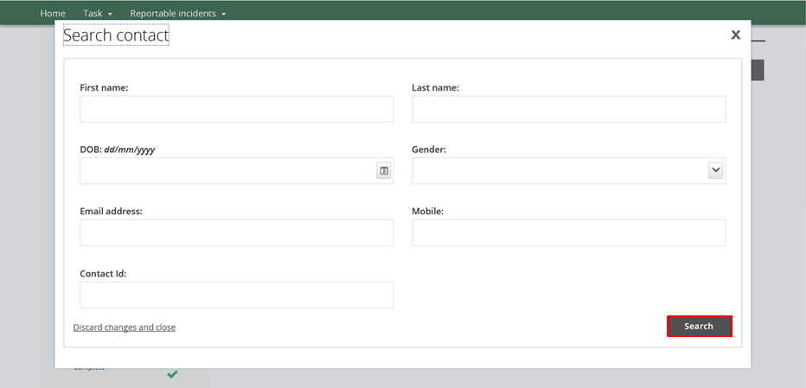
- Select the Witness to be included, and click Select and Close.
- If the details of the witness are not available, click Create. Type in the person’s details required and click Save.
Figure 9: Screenshot of My Reportable Incidents page demonstrating Step 9 – Selecting a witness from the list
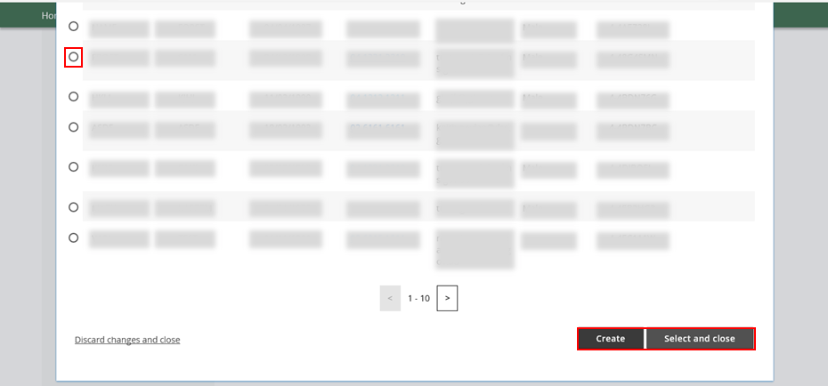
Figure 10: Screenshot of My Reportable Incidents page demonstrating Step 9 – Create a witness
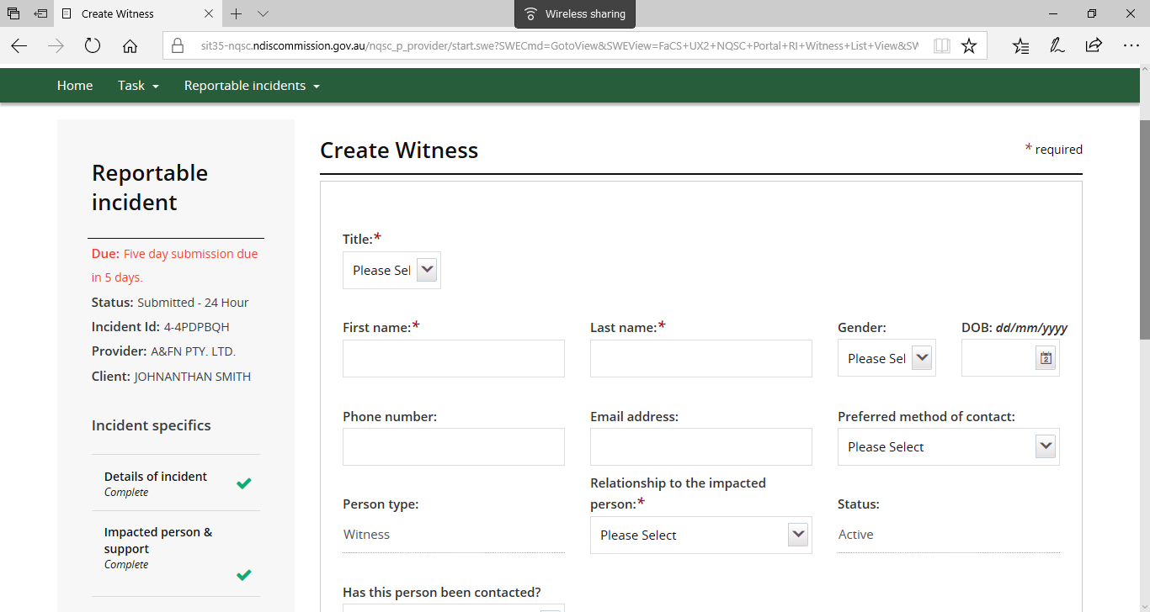
Figure 11: Screenshot of My Reportable Incidents page demonstrating Step 9 – Save a new witness profile
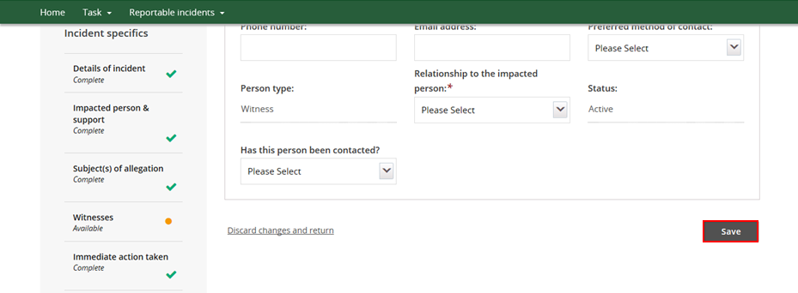

- For Deaths and Unauthorised Use of Restrictive Practices, additional information is required prior to submission. See 5 Day Requirements for Death of an Impacted Person (additional section) or 5 Day Requirements for Unauthorised Use of Restrictive Practices (additional section) for further information.
Figure 12: Screenshot of My Reportable Incidents page demonstrating Step 10
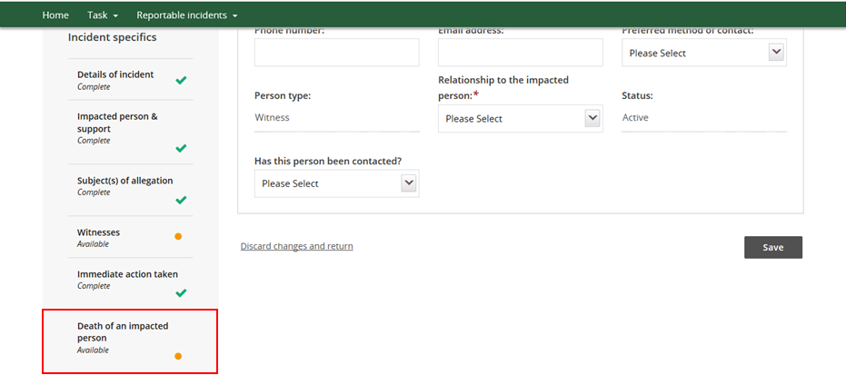
- Review the Incident Specifics Task Bar on the left hand side to ensure all sections are complete (all sections should have a green tick, excluding Witnesses).
- Before submitting, ensure that all necessary supporting documents have been attached. For further information, please see the Attaching Additional Documentation section in this document.
Figure 13: Screenshot of My Reportable Incidents page demonstrating Step 11
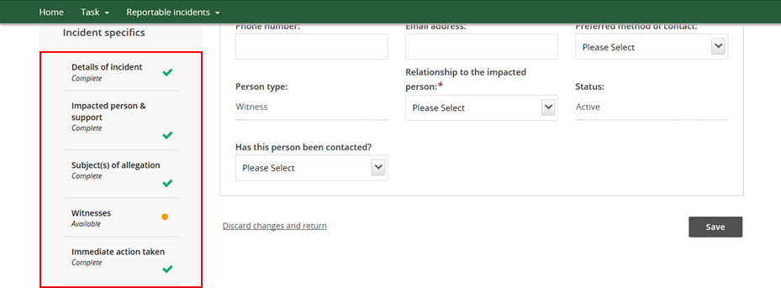

- Click Details of Incident on the Incident Specifics task bar
Figure 14: Screenshot of My Reportable Incidents page demonstrating Step 12
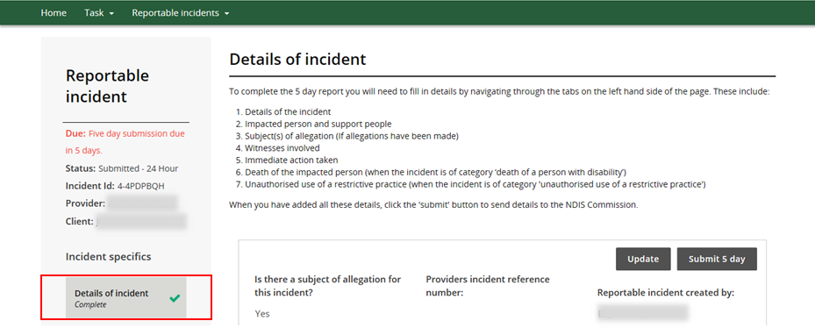
- Click Submit 5 days when ready to submit
- Only the Provider Authorised RI Approver can submit the 5 day notification. If the Provider Authorised RI Notifier is completing the 5 day notification form, they must notify the Approver within their organisation that the form is ready for submission.
- Note that you have not meet your reporting obligation until the incident has been submitted and the time frame is applicable to the time it is submitted and not created.
Figure 15: Screenshot of My Reportable Incidents page demonstrating Step 13
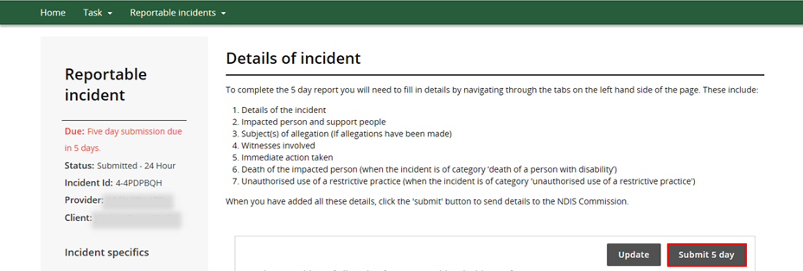

- The Status on the left hand side will change to Submitted – 5 day. This indicates that the form has been successfully submitted to the NDIS Commission.
Figure 16: Screenshot of My Reportable Incidents page demonstrating Step 14
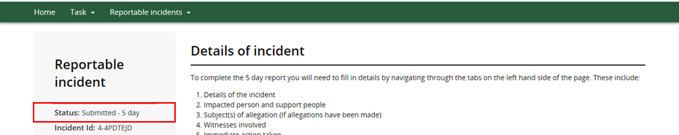

5 Day Requirements for Death of an Impacted Person (additional section)
In addition to the above steps, there is an additional section of information required for reporting the death of an impacted person.
- Click Death of an Impacted Person section.
Figure 17: Screenshot of My Reportable Incidents page demonstrating Step 1
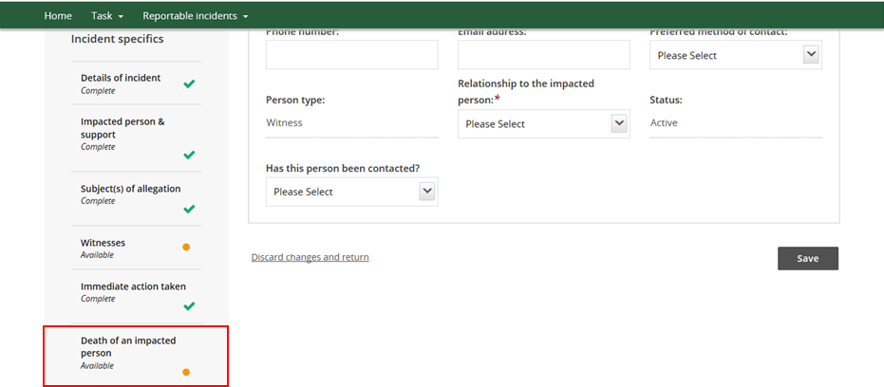
- Click Update
Figure 18: Screenshot of My Reportable Incidents page demonstrating Step 2
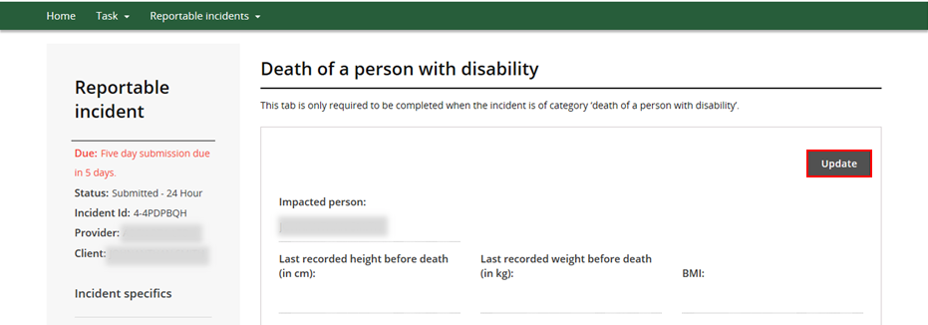

- Type details in for all mandatory fields. Click Save.
Figure 19: Screenshot of My Reportable Incidents page demonstrating Step 3 – Complete relevant information – Part 1
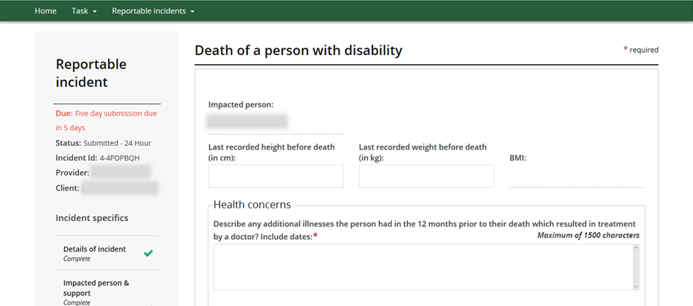
Figure 20: Screenshot of My Reportable Incidents page demonstrating Step 3 – Complete relevant information – Part 2
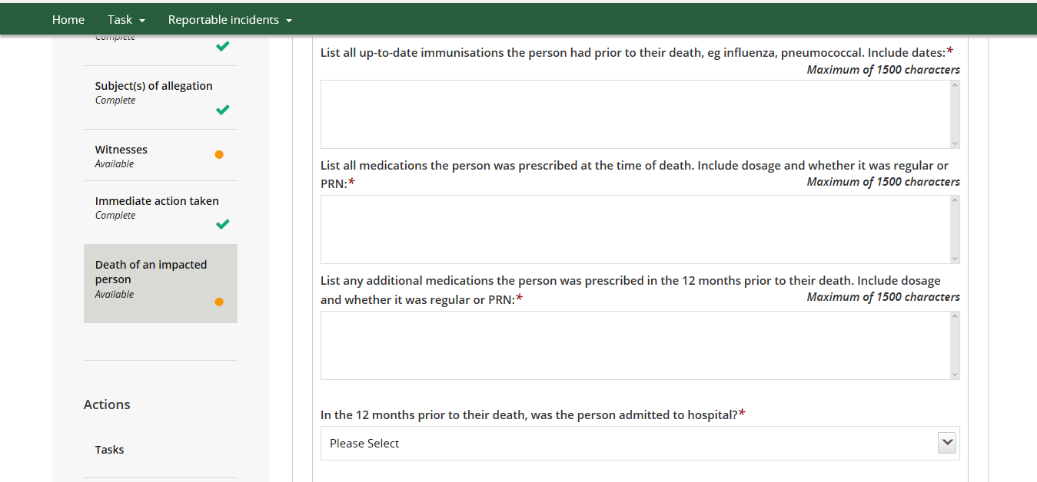
Figure 21: Screenshot of My Reportable Incidents page demonstrating Step 3 – Complete relevant information – Part 3
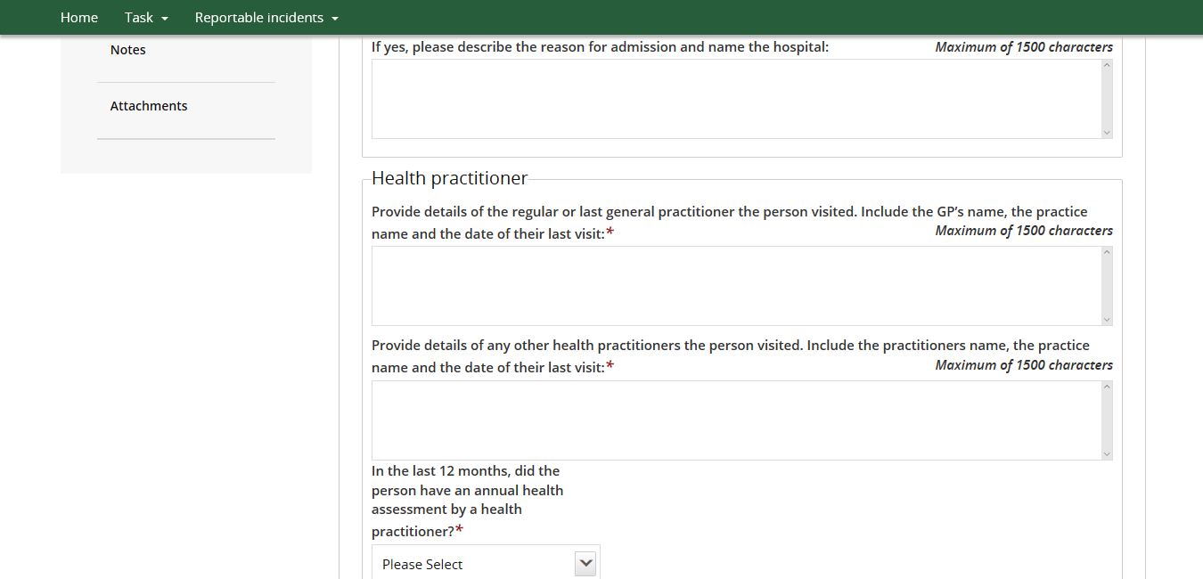
Figure 22: Screenshot of My Reportable Incidents page demonstrating Step 3 – Complete relevant information – Part 4
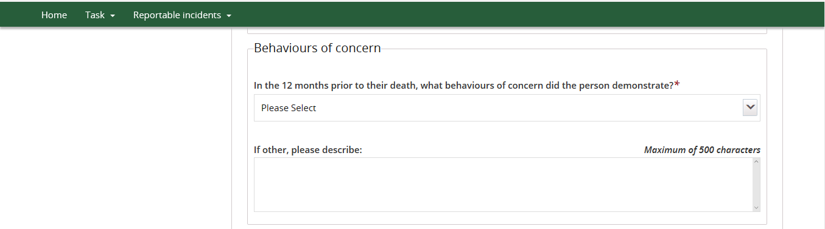
Figure 23: Screenshot of My Reportable Incidents page demonstrating Step 3 – Complete relevant information – Part 5
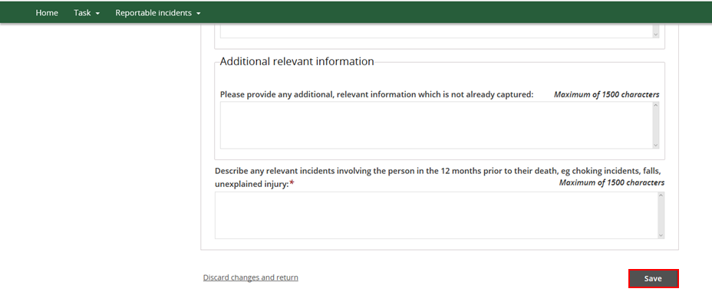
- Return to Step 11 above.

5 Day Requirements for Unauthorised Use of Restrictive Practices (additional section)
In addition to the above steps, there is an additional section of information required for reporting the Use of Unauthorised Restrictive Practices.
- Click Unauthorised Use of Restrictive Practices section.
Figure 24: Screenshot of My Reportable Incidents page demonstrating Step 1
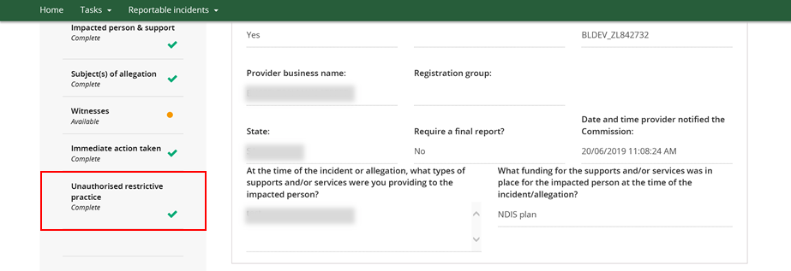
- Click Update
Figure 25: Screenshot of My Reportable Incidents page demonstrating Step 2
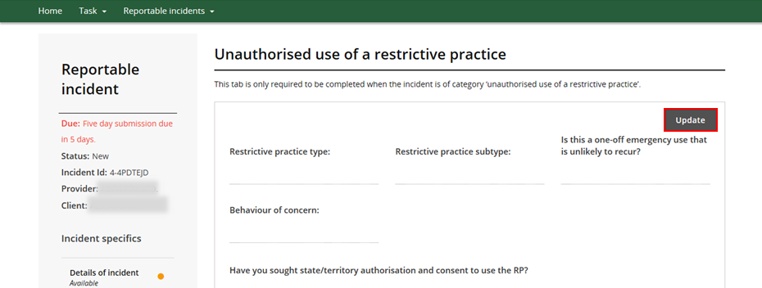

- Type details in for all mandatory fields. Click Save.
Figure 26: Screenshot of My Reportable Incidents page demonstrating Step 3
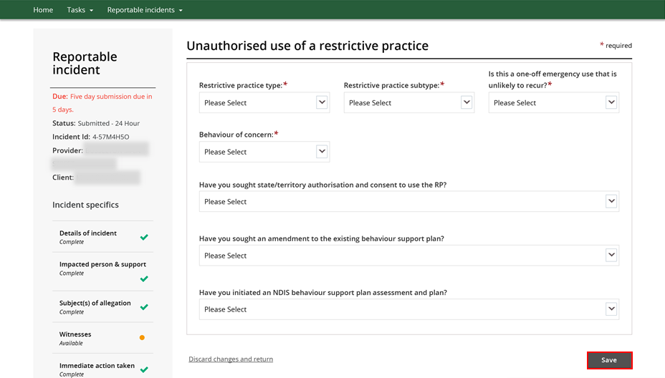

- Return to Step 11 above.

Attaching Additional Documentation
Whilst completing the 5 day notification form, the Provider may choose to attach supporting or additional documentation. The steps below outline the process for attaching documents.
Please note that there is an attachment limit of 10MB per document and any documents attached cannot be removed.
- Scroll to the bottom of the Incident Specifics task bar on the left hand side. Click Attachments
Figure 27: Screenshot of My Reportable Incidents page demonstrating Step 1
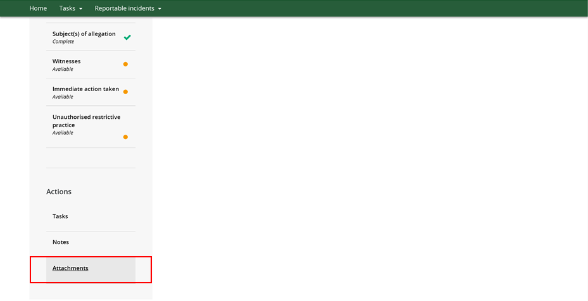
- Click Add Attachment. Select the relevant file from your computer.
Figure 28: Screenshot of My Reportable Incidents page demonstrating Step 2
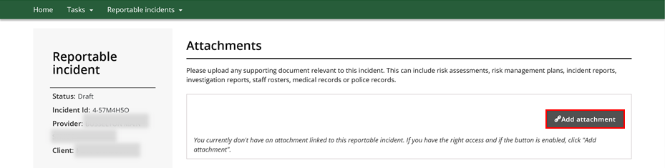

- Type in the relevant Name and select the Document Type from the drop down menu. Click Save and Close. Ensure the document name clearly conveys the information contained in the document
Figure 29: Screenshot of My Reportable Incidents page demonstrating Step 3
