Complete the Final report
Quick Reference Guide – Reportable Incidents
Providers are required to submit a final report when the NDIS Commission requires additional information on the Reportable Incident.
This guide outlines the steps for:
- Accessing the final report
- Submitting the final report
- Attaching additional documentation
Note that there are different final report questions to accommodate different incident types.
Before getting started, some useful hints and tips are outlined below:
Tip 1 – Draft the free text sections of information into a word document and copy/paste it across to avoid the portal from timing out. Alternatively, scroll to the bottom of the each page and select Save as Draft at least every 25 minutes. It is a requirement of PRODA that the portal times-out after 30 minutes of inactivity.
Tip 2 – Ensure that you that you have prepared any relevant supporting documents for attachment in the portal. Please note that there is an attachment limit of 10MB per document and any documents attached cannot be removed.
Tip 3 – You will need to complete all mandatory fields (marked with an *), otherwise the system will not allow you to submit the form.
Tip 4 – Ensure that you have the right access to complete the Reportable Incidents form. You will need to be registered as either the Provider Authorised RI Approver or the Provider Authorised RI Notifier. Please review the Quick reference guide - getting access to NDIS Portal to ensure you understand the responsibilities of each role and how to set up/ change these within your organisation.
- For further information/ questions, please contact the NDIS Commission Contact Centre on 1800 035 544 or by email: contactcentre@ndiscommission.gov.au

- To provide feedback on the Portal, please contact the NDIS Commission via riportalfeedback@ndiscommission.gov.au

Final report requirements for Reportable Incidents
Please ensure that you are logged into the Portal as either the Provider Authorised RI Approver or the Provider Authorised RI Notifier. For information on how to log in or definitions of these roles, please see Quick reference guide - getting access to NDIS Portal
- Click on the My Reportable Incidents tile.
Figure 1: Screenshot of My Reportable Incidents page demonstrating Step 1
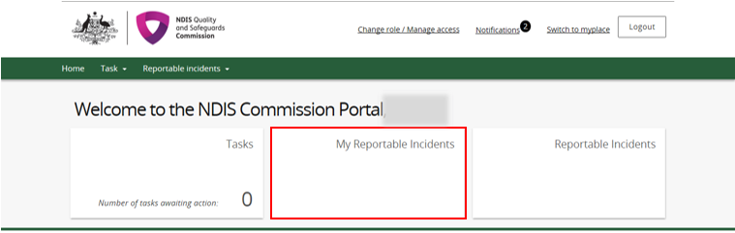
- Click View on the relevant reportable incident.
Figure 2: Screenshot of My Reportable Incidents page demonstrating Step 2
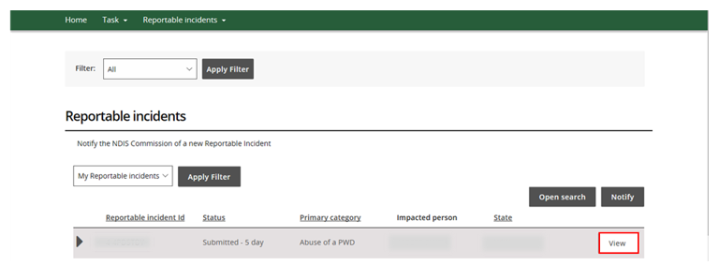

- Review the Incident Specifics task bar on the left hand side.
- The Green Ticks indicate which sections have been completed. Review these and add in any additional information by clicking the Update button.

- The Yellow Dot indicates sections that need to be completed. Click Update to complete information required.
- Click Final report on the Incident specific task bar.

- Click Open to access the final report.
Figure 3: Screenshot of My Reportable Incidents page demonstrating Step 4 & 5
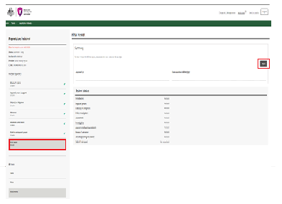

6. Click on each final report sub heading from the left hand navigation bar. Click Update to begin completing the information. Click Add to add information to the fields.
Figure 4: Screenshot of Final report page demonstrating Step 6
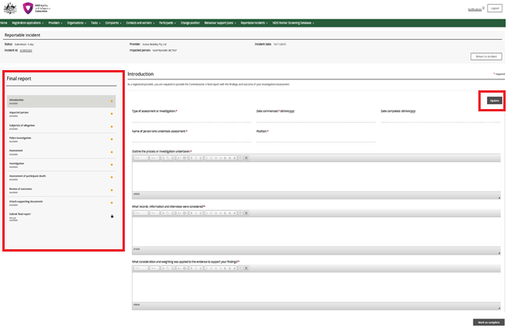

- Begin completing the information fields including the mandatory fields in each section. Fields mark with a red asterisk * are mandatory.
Click Save and close to save.
Figure 5: Screenshot of Final report - introduction demonstrating Step 7
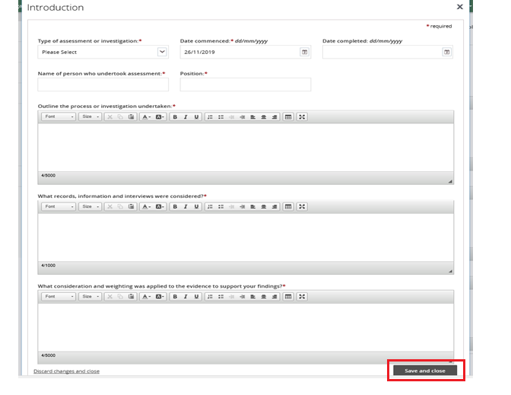

- Once a sub section is completed click Mark as complete and move on to the next section.
Figure 6: Screenshot of Final report Attach supporting documents page demonstrating Step 8
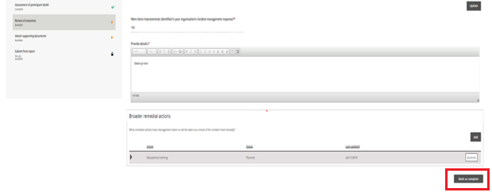

- Review the supporting documents attached to the incident at the Attach supporting documents tab and add additional supporting documentation including your investigation report before marking as complete.
Figure 7: Screenshot of Final report Attach supporting documents page demonstrating Step 9
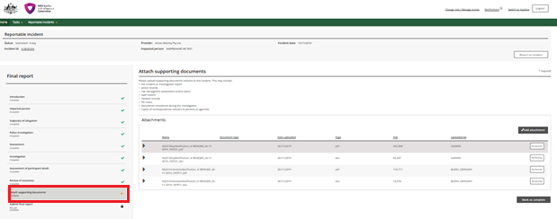

- Click Add Attachment. Select the relevant file from your computer.
Figure 8: Screenshot of attachments page demonstrating Step 10
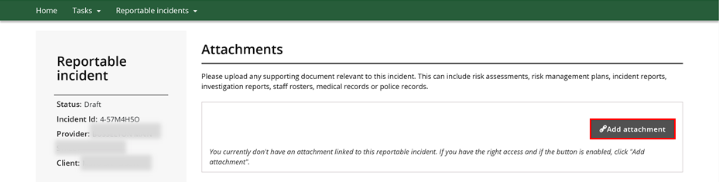

- Type in the relevant Name and select the Document Type from the drop down menu. Click Save and Close. Ensure the document name clearly conveys the information contained in the document
Figure 9: Screenshot Attachments page demonstrating Step 11
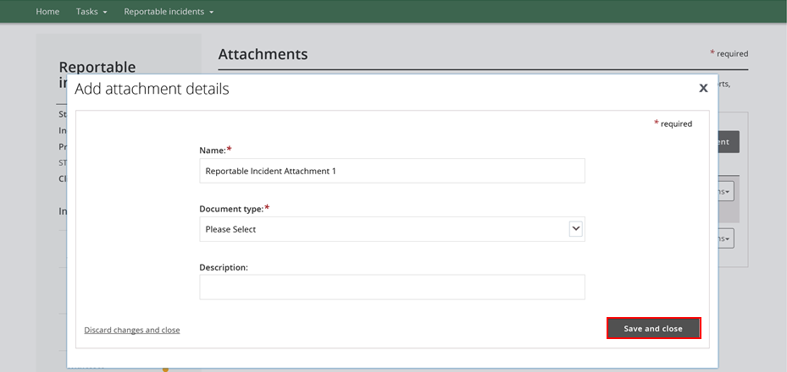
Please note that there is an attachment limit of 10MB per document and any documents attached cannot be removed.

- Once all the sub fields have been marked as complete, Click Submit.
Figure 10: Screenshot of Final report - submit page demonstrating Step 12
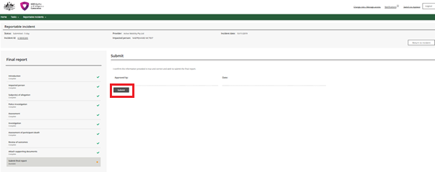
- Only the Provider Authorised RI Approver can submit the Final report. If the Provider Authorised RI Notifier is completing the Final report, they must notify the Approver within their organisation that the report is ready for submission.

- Note that the Final report is to be submitted by the due date, the time-frame is applicable to the time it is submitted and not created or marked as complete.

