Create an Immediate Notification
Quick Reference Guide – Reportable Incidents
As of 1st July 2019, all registered providers are required to notify the NDIS Commission of Reportable Incidents through the NDIS Commission Provider Portal.
Please note that for NSW/ SA Providers, the paper form will be discontinued.
This guide outlines the steps for creating an immediate notification (required within 24 hours):
- Navigating to the reportable incidents form
- Adding a primary contact
- Person with disability impacted by the incident
- Subject(s) of allegation
- Immediate action
- Risk assessment
Note that information in the below form is required within 24 hours for all Reportable Incidents, except for notification of an unauthorised use of restrictive practices.
Before getting started, some useful hints and tips are outlined below:
Tip 1 – Draft the free text sections of information into a word document and copy/paste it across to avoid “time out” restrictions on the portal. Alternatively, scroll to the bottom of the form and select Save as Draft at least every 25 minutes. The time out restriction of 30 minutes is a PRODA requirement.
Tip 2 – Supporting documentation can be attached to the Immediate Notification after submission.
Tip 3 – You will need to complete all mandatory fields (marked with an *), otherwise the system will not allow you to submit the form.
Tip 4 – Ensure that you have the right access to complete the Reportable Incidents form. You will need to be registered as either the Provider Authorised RI Approver or the Provider Authorised RI Notifier. Please review the Quick reference guide - getting access to NDIS Portal to ensure you understand the responsibilities of each role and how to set up/ change these within your organisation.
- For further information/ questions, please contact the NDIS Commission Contact Centre on 1800 035 544 or by email: contactcentre@ndiscommission.gov.au
- To provide feedback on the portal, please contact the NDIS Commission via riportalfeedback@ndiscommission.gov.au

Navigating to the reportable incidents form
Please ensure that you are logged into the Portal as either the Provider Authorised RI Approver or the Provider Authorised RI Notifier. For information on how to log in or definitions of these roles, please see Quick reference guide - getting access to NDIS Portal
- Click on the My Reportable Incidents tile.
Figure 1: Screenshot of My Reportable Incidents page demonstrating Step 1
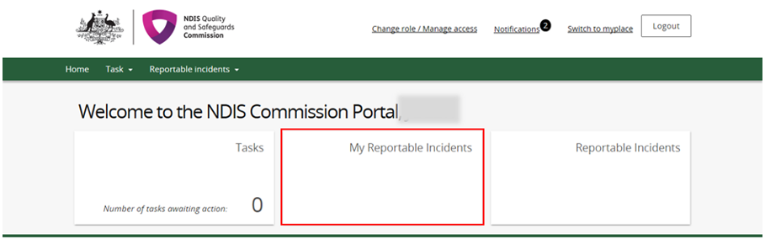
- Click Notify.
Figure 2: Screenshot of My Reportable Incidents page demonstrating Step 2
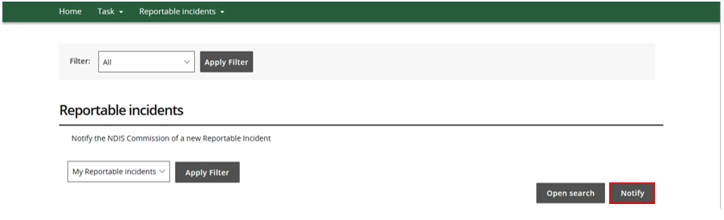

- Read the Notification Requirements and click Continue.
Figure 3: Screenshot of My Reportable Incidents page demonstrating Step 3
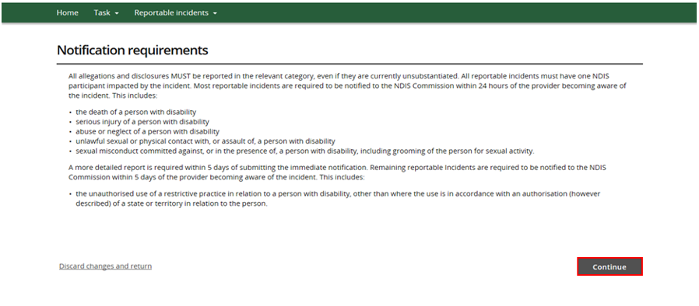
The immediate notification form will then appear on the screen.
- Select the Primary Category from the drop down menu, based on the Reportable Incident that has occurred or are alleged to have occurred. Select a Secondary Category, if relevant.
Figure 4: Screenshot of My Reportable Incidents page demonstrating Step 4
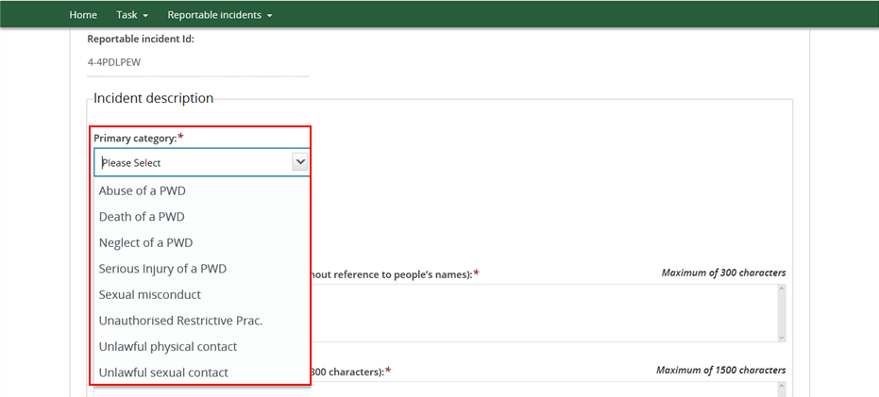

- Type in the details of the Reportable Incident within the mandatory fields.
Figure 5: Screenshot of My Reportable Incidents page demonstrating Step 5
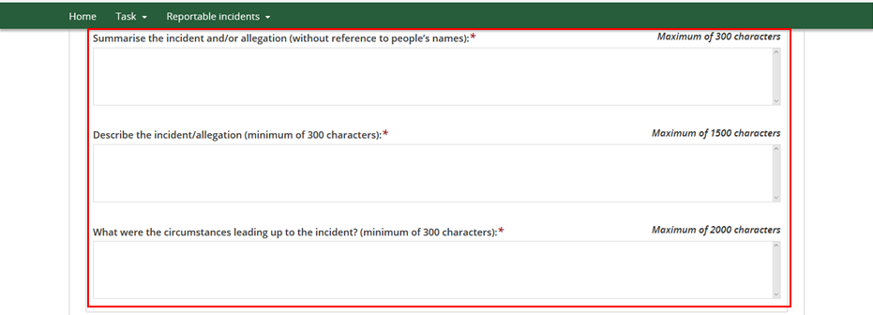
- Add required Incident Notification information.
- Select the Date and Time the providers key personnel was informed about the incident from the drop down calendar. Alternatively, you can type in the date and time using the dd/mm/yyyy hh:mm format.
- In the field when did the incident/ allegation occur, select Date, Date Range or Unknown for the incident, and complete the additional questions which appear e.g. if Unknown is selected, you will be required to provide a reason.
- Complete non-mandatory fields, if information is known.
Figure 6: Screenshot of My Reportable Incidents page demonstrating Step 6
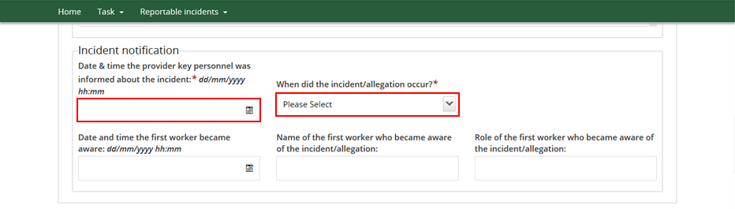

- Add Incident Location information
- Select the State in which the incident occurred from the drop down menu
- Select the Location Type of the incident and complete the additional fields which appear. Note that if Address or SDA is selected, the address will need to be input. Refer to step 8 below.
Figure 7: Screenshot of My Reportable Incidents page demonstrating Step 7
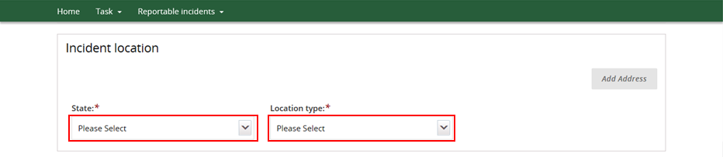
- Click Add Address and type in the – Address in full and the system will match addresses that match your search. Select the correct address and click Save
Figure 8: Screenshot of My Reportable Incidents page demonstrating Step 8 – Add address
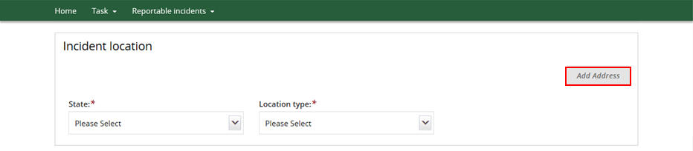
Figure 9: Screenshot of My Reportable Incidents page demonstrating Step 8 - Enter full address
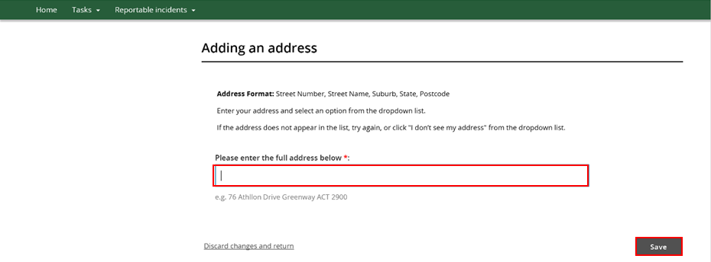

Adding a primary contact
- The details of the nominated Primary Contact within the providers organisation will be auto populated. If the default selection is not appropriate, click Select Primary Contact, and choose the relevant contact from the list.
Figure 10: Screenshot of My Reportable Incidents page demonstrating Step 9
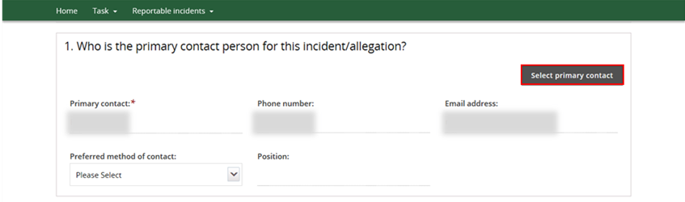

- Your details will be auto populated as the Provider Notifier. If you are not the Notifier, click Select and choose the relevant person from the list.
Figure 11: Screenshot of My Reportable Incidents page demonstrating Step 10
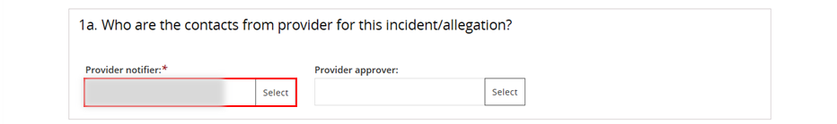
- Click on Select to identify the Provider Approver, who is the person within your organisation who has the authority to submit notifications to the NDIS Commission.
Figure 12: Screenshot of My Reportable Incidents page demonstrating Step 11
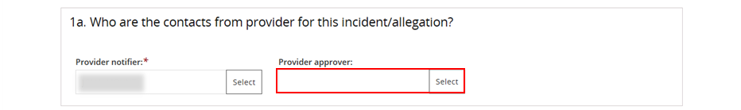

- Enter details of the approver you want to locate and Click Run Search
Figure 13: Screenshot of My Reportable Incidents page demonstrating Step 12
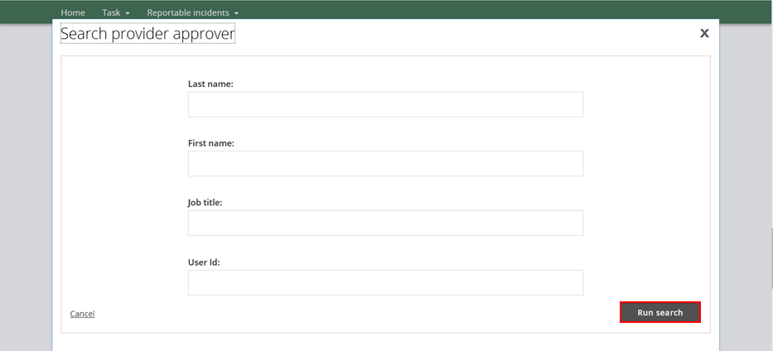

- Select the Provider Approver from the list. Click Confirm.
Figure 14: Screenshot of My Reportable Incidents page demonstrating Step 13
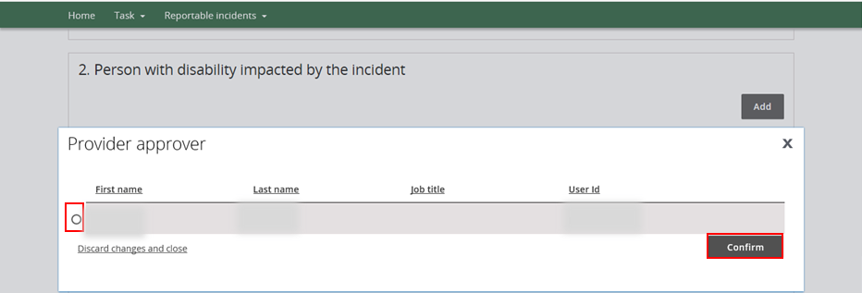

Person with Disability Impacted by the Incident
- Click Add.
Figure 15: Screenshot of My Reportable Incidents page demonstrating Step 14
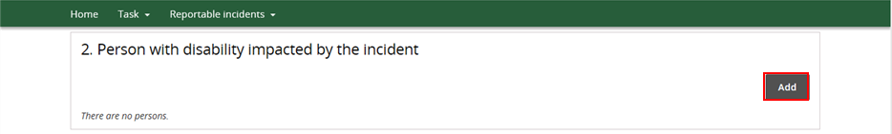
- Click Search
Figure 16: Screenshot of My Reportable Incidents page demonstrating Step 15
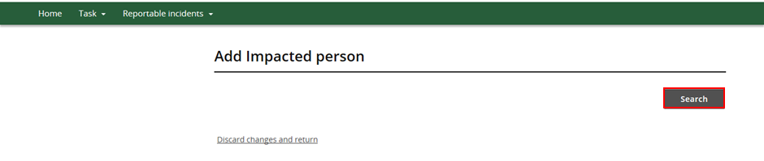
- Type in the participant’s details, then click Search
Figure 17: Screenshot of My Reportable Incidents page demonstrating Step 16
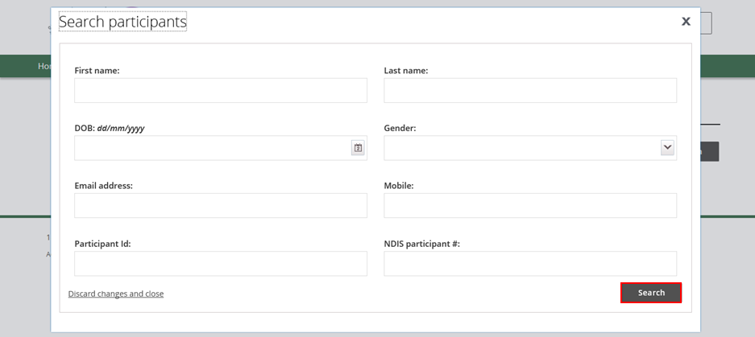

- Select the participant to be added, and click Select and Close. You will be prompted to update the participant’s information, if necessary. Click Save.
- If the details of the participant are not available, click Create. Type in the participant details required and click Save. Please ensure that you fill in as much information as you can, including disability details, health concerns and behaviour of concerns which are further down the page.
Figure 18: Screenshot of My Reportable Incidents page demonstrating Step 17 - Select a participant
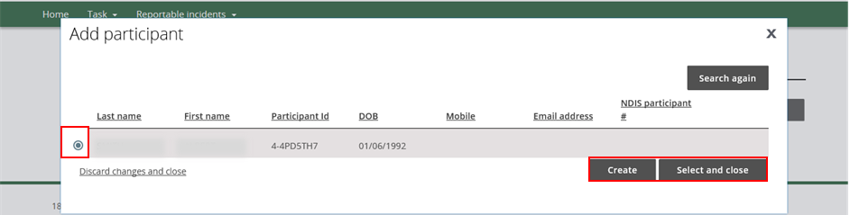
Figure 19: Screenshot of My Reportable Incidents page demonstrating Step 17 - Create impacted person
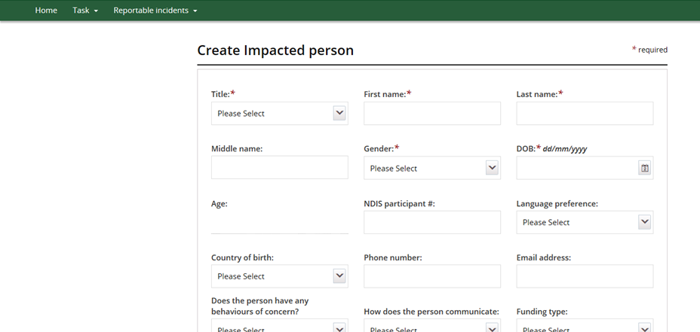
Figure 20: Screenshot of My Reportable Incidents page demonstrating Step 17 - Save information
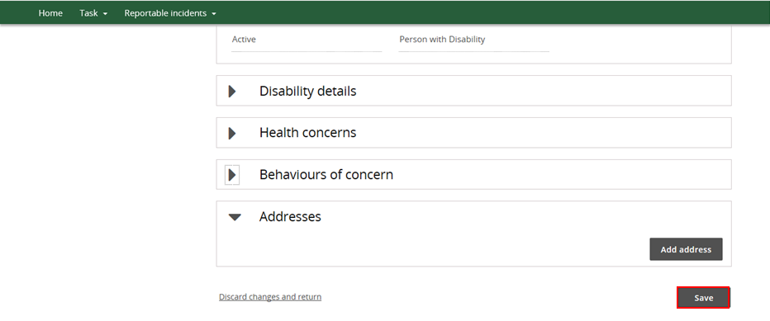

Subject(s) of Allegation
- Click No or Yes from the drop down list to identify if there is a subject(s) of allegation.
- The subject of allegation is a worker, person with disability or member of the general public, who has been accused of being involved with an incident that has occurred in connection with the provision of NDIS supports and services to a person with disability.
Figure 21: Screenshot of My Reportable Incidents page demonstrating Step 18
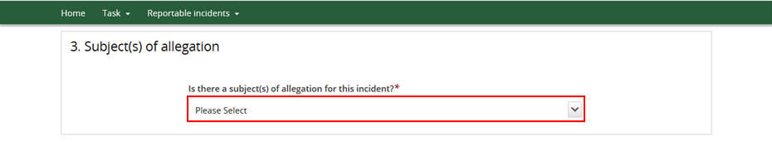
- If Yes, click Add to include details on the Subject of Allegations, depending on whether the Subject is a worker, person with disability or other such as a visitor, family member or member of the community. Note that there can be more than one subject of allegation(s).
Figure 22: Screenshot of My Reportable Incidents page demonstrating Step 19
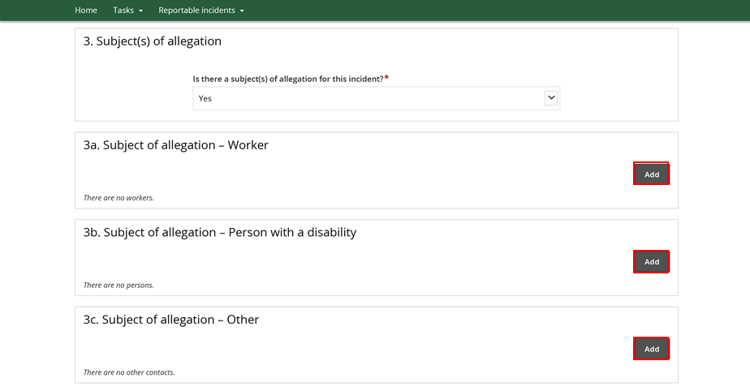
Note that the below process is an example for adding a Worker. The process can be followed for –a subject of allegation who is a person with disability or other person.

- Click Search
Figure 23: Screenshot of My Reportable Incidents page demonstrating Step 20
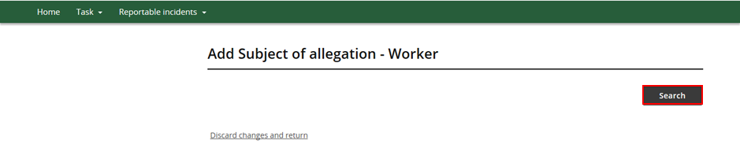
- Type in details of the –person you wish to locate and click Search
Figure 24: Screenshot of My Reportable Incidents page demonstrating Step 21
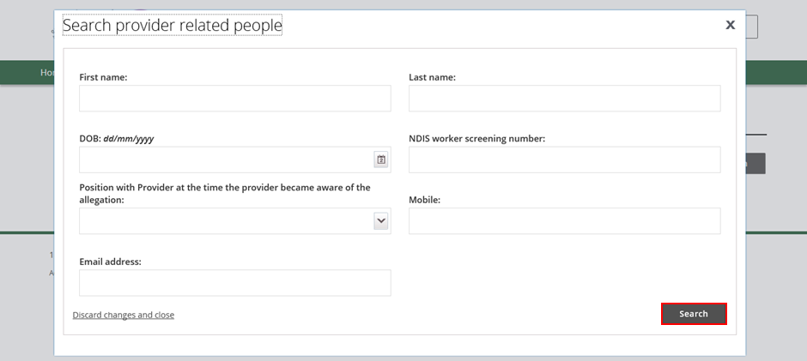

- Select the worker to be listed as a subject of allegation from the Provider Related People list, and click Select and Close. You will be prompted to update the person’s information, if necessary. Click Save.
- If the details of the person are not available, click Create. Type in the person’s details required and click Save.
Figure 25: Screenshot of My Reportable Incidents page demonstrating Step 22 – Select provider related people
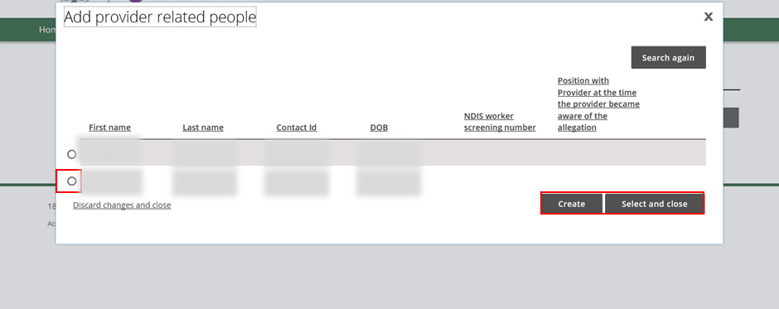
Figure 26: Screenshot of My Reportable Incidents page demonstrating Step 22 - Create subject of allegation - Worker
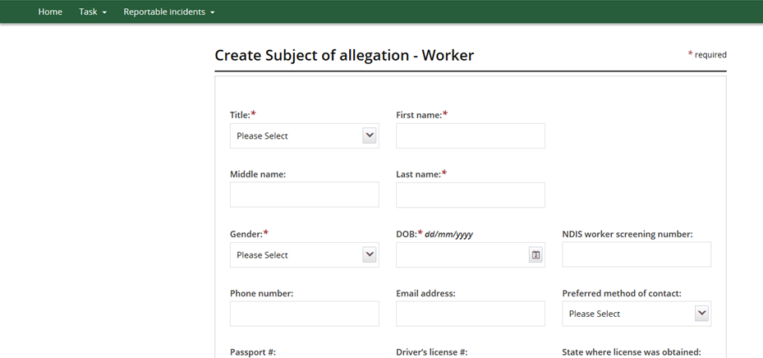
Figure 27: Screenshot of My Reportable Incidents page demonstrating Step 22 - Save information
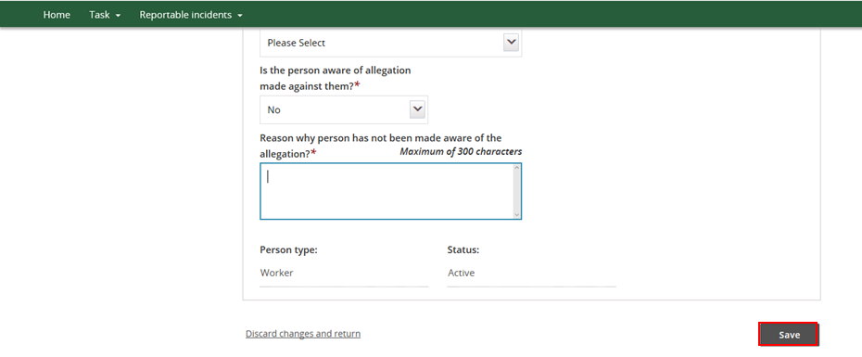

Immediate Action Taken
- Select No or Yes from the drop down menu to whether the police has been informed
- If No, complete the auto populated field on why the police have not been informed
- If Yes, complete the additional fields which appear with details e.g. name of officer informed
Figure 28: Screenshot of My Reportable Incidents page demonstrating Step 23
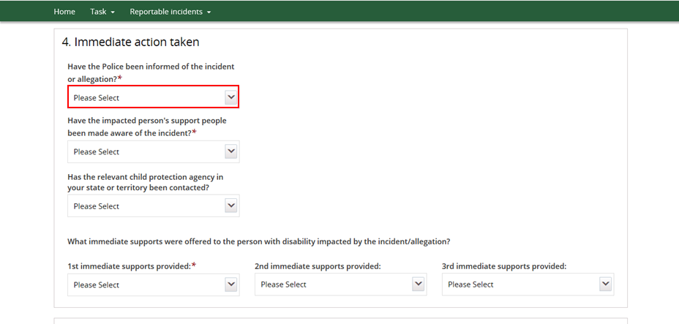
- Select response to the remaining questions on Immediate Actions Taken from the drop down lists.
Figure 29: Screenshot of My Reportable Incidents page demonstrating Step 24
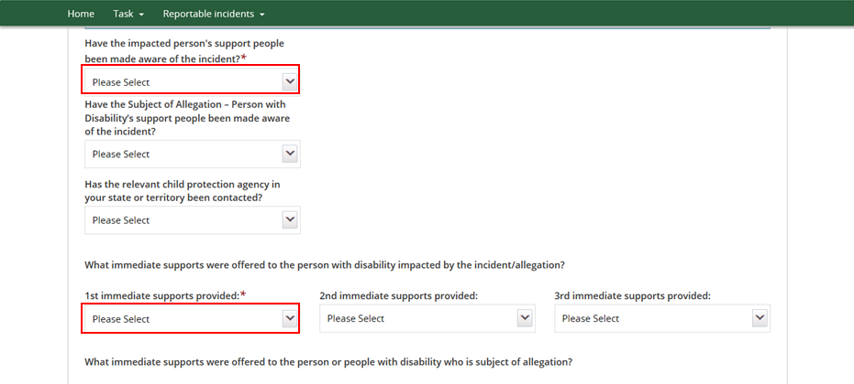

Risk Assessment
- Select In Process, No or Yes from the drop down menu
- If Yes or In Process, complete the auto populated field with details of progress
- If No, complete the auto populated fields with the reason why not.
Figure 30: Screenshot of My Reportable Incidents page demonstrating Step 25
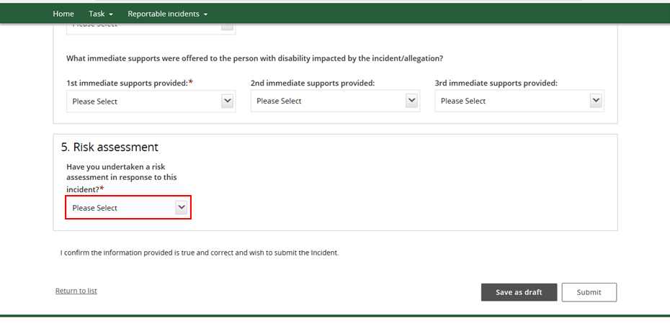
- Review the form and click Save as Draft.
- Note only Provider Authorised RI Approvers within your organisation can Submit (instead of Save as Draft), if the form is ready for submission to the NDIS Commission. See step 30.
Figure 31: Screenshot of My Reportable Incidents page demonstrating Step 26
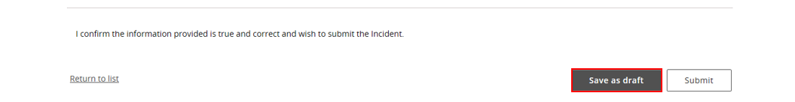

- An acknowledge message will appear on the screen. Read the message and click Proceed.
- At this stage, the form is saved as a draft, but not yet submitted to the NDIS Commission. The Provider Authorised RI Notifier will need to notify the Approver within their organisation that the form is ready. The Approver will then need to go into the system to review and Submit the form.
Figure 32: Screenshot of My Reportable Incidents page demonstrating Step 27
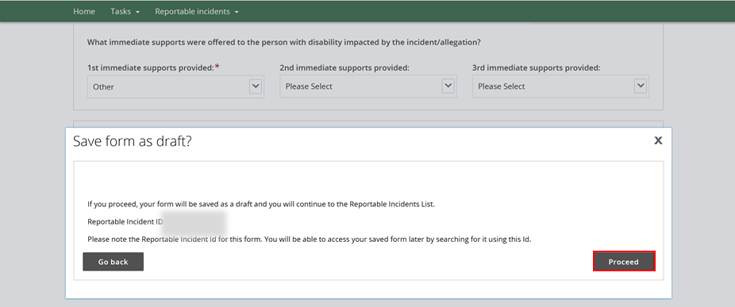
- To submit the form, the Provider Authorised RI Approver will need to log into the NDIS Commission Provider Portal, and click on the My Reportable Incidents tile.
Figure 33: Screenshot of My Reportable Incidents page demonstrating Step 28
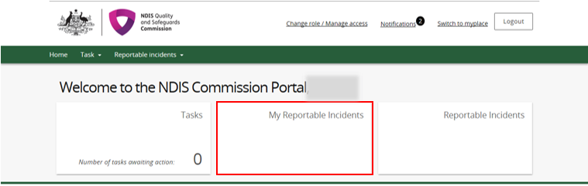

- Click View on the relevant reportable incident for review and submission.
Figure 34: Screenshot of My Reportable Incidents page demonstrating Step 29
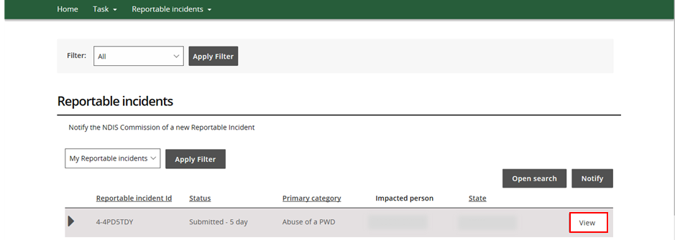

- Review the form and click Submit
Figure 35: Screenshot of My Reportable Incidents page demonstrating Step 30
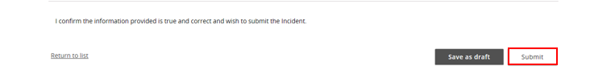

- An acknowledge message will appear on the screen. Read the message and click Complete
- Note that if the acknowledge message does not appear, please contact the NDIS Commission Contact Centre on 1800 035 544 or by email: contactcentre@ndiscommission.gov.au
Figure 36: Screenshot of My Reportable Incidents page demonstrating Step 31
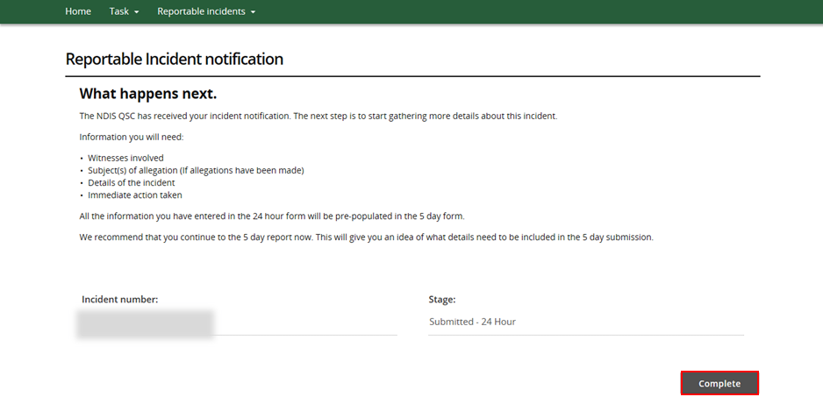

This ends the instructions for the 24 hour notification for Reportable Incidents to the NDIS Commission. Please see Quick Reference Guide – 5 Day Notification Form on how to complete the remaining information due within 5 days.

