Quick reference guide: Manage NWSD access & email preferences
Self-managed & plan-managed participants

Contents
Contents 1
Overview 1
Managing access to the NWSD 2
Manage access as the Authorised Access Delegate 2
Update the access of an existing employee 2
Create access of a new employee 3
Representative requests for access 5
Approve or reject a request for access (as the Authorised Access Delegate) 6
Managing email preferences 8

Overview
- The NDIS Worker Screening Database (NWSD) is a national database which stores NDIS worker screening check information about workers who deliver NDIS supports and services.
- To gain access to the NWSD, a self-managed participant, plan-managed participantor their representative must make an application (refer to Quick Reference Guide – SMP & PMP – Request access to the NWSD). The person nominated as the ‘Primary contact’ on the application will become the default ‘Authorised Access Delegate’.
- The Authorised Access Delegate will be able to add, remove and vary the access of other representatives of the self-managed or plan-managed participant (representatives) to the NWSD.
- This quick reference guide provides information about how to update access to the NWSD and set NWSD email preferences.
For further information please refer to the NDIS Quality and Safeguards Commission website - www.ndiscommission.gov.au/participants/worker-screening-self-managed-participants.

Alternatively, contact the NDIS Quality and Safeguards Commission on 1800 035 544 or by email at nwsd@ndiscommission.gov.au.

Managing access to the NWSD
- There are two ways in which a self-managed or plan-managed participant or their representative can manage access to the NWSD for additional representatives:
- the ‘Authorised Access Delegate’ can add, remove and change the type of access a representative has; or
- a representative may request access or a change to the type of access they have, which the ‘Authorised Access Delegate’ will then consider and approve or reject.
Both methods are described below.

Manage access as the Authorised Access Delegate

Update the access of an existing employee
- Log into PRODA and select the appropriate ‘Provider name’ (the self-managed or plan-managed participant name will be included in the list) and choose the ‘Authorised Access Delegate’ role.
Tip 1 – You must apply for access to the NWSD and register for a PRODA account before you can log in. Refer to Quick Reference Guide – SMP & PMP – Request access to the NWSD for more information.
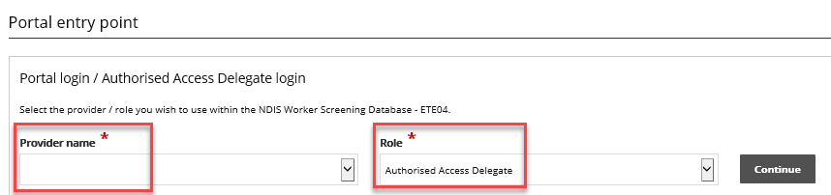
- Select ‘User access list’ from the side menu and ‘Select’ the representative you want to update the access for.
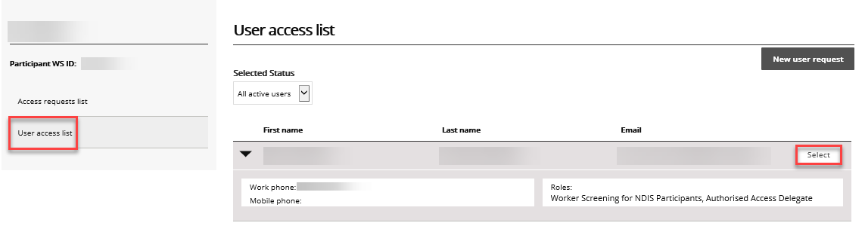
- To add additional access for the representative, in the ‘Required user role(s)’ section select all the user roles you want the employee to have and click ‘Save’.
Tip 2 –Self-managed participants, plan-managed particpants or their representatives should only select ‘Worker Screening for NDIS Participants’ and/or ‘Authorised Access Delegate’. The ‘Worker Screening for organisations’ option is for the use of unregistered providers.
- To remove access, in the ‘Required user roles(s)’ section select the user roles you want to removed and select ‘Revoke access’.

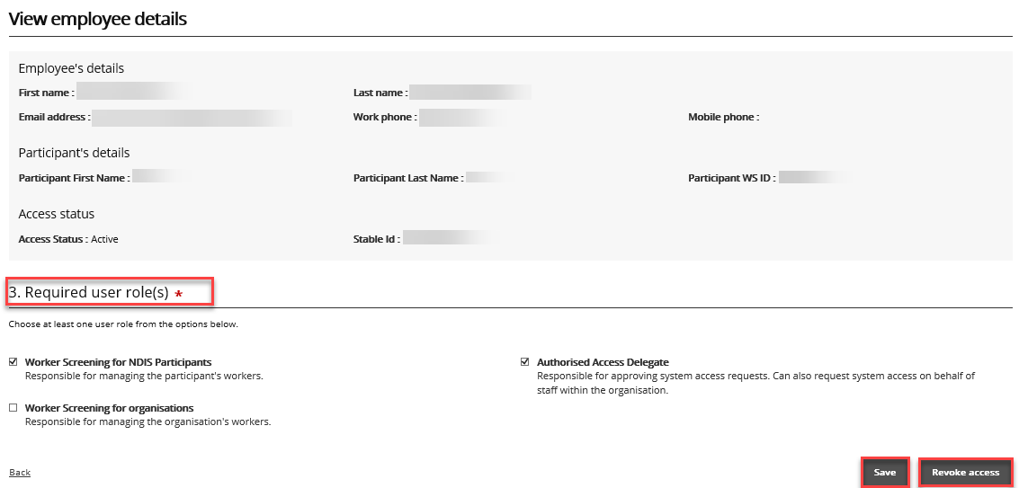

Create access of a new employee
- To give a new representative access to the NWSD, log into PRODA, select the appropriate ‘Provider name’ and choose the ‘Authorised Access Delegate’ role.
- Select ‘New user request’.
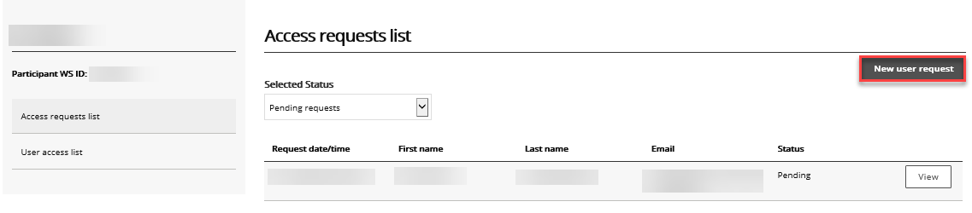

- Read the information presented and if you are ready to continue select the ‘I’m ready to request access’ button.
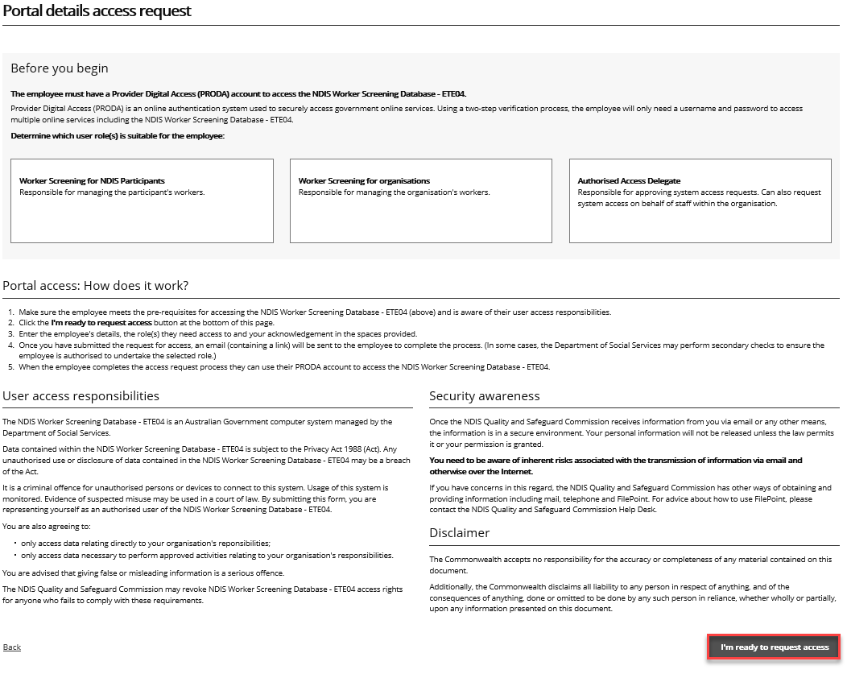
- Enter the required information and in the ‘Required user role(s) section’ select:
  - ‘Worker Screening for NDIS Participants’ which will provide you with access to the NWSD to verify workers and check the status of a worker’s NDIS Worker Screening Check; and/or
  - ‘Authorised Access Delegate’ which enables you to manage who in your organisation has access to the NWSD e.g. approving or rejecting requests for NWSD access.
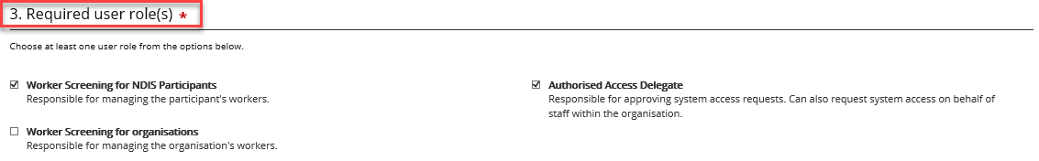

Representative requests for access
- If you are a representative of a self-managed or plan-managed participant seeking access to the NWSD, log into PRODA and select the ‘Request / update my access’ button.
Tip 3 – You must register for a PRODA account before you can log in. If you are having trouble registering for PRODA contact the PRODA Helpdesk on 1800 700 199.
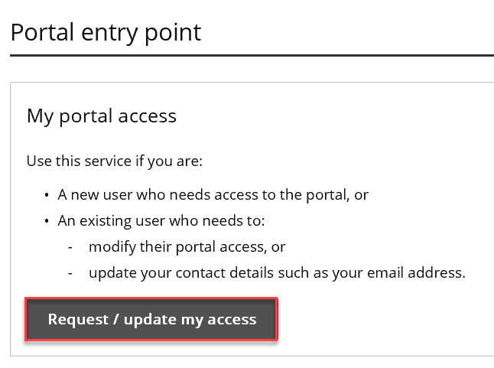
- Read the information presented and if you are ready to continue select the ‘I’m ready to request access’ button.
- Enter the required information and in the ‘Required user role(s) section’ select:
  - ‘Worker Screening for NDIS Participants’ which will provide you with access to the NWSD to verify workers and check the status of a worker’s NDIS Worker Screening Check; and/or
  - ‘Authorised Access Delegate’ which enables you to manage who in your organisation has access to the NWSD e.g. approving or rejecting requests for NWSD access.
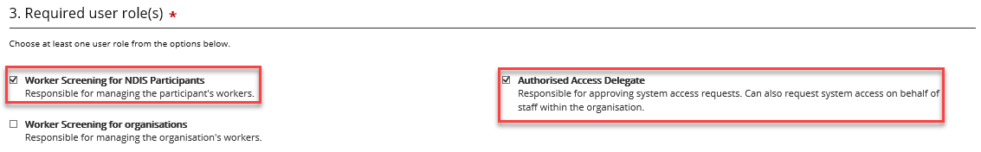
- In the ‘Request access to which account’ section select ‘NDIS Participant who is registered for Worker Screening’ if you are the employee of an unregistered provider. Then select ‘Next’.
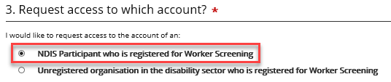
- On ‘The organisation that you work for’ page, enter in the details of the self-managed or plan-managed participant that you work for.
Tip 4 – The ‘Authorised Access Delegate’ of the self-managed or plan-managed participant will be the person who considers your request for access to the NWSD.
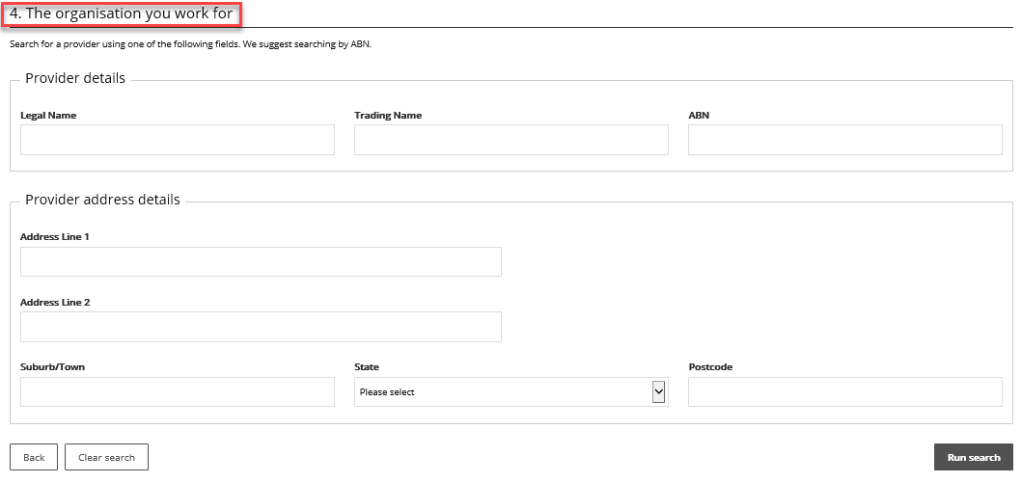
- Your request will be submitted to the current ‘Authorised Access Delegate’ for consideration. You will receive an email once your request has been approved or rejected.

Approve or reject a request for access (as the Authorised Access Delegate)
- When a representative submits a request for access to the NWSD, the ‘Authorised Access Delegate’ will receive an email. Click the link in the email to view the access request.
- Log into PRODA and select the appropriate ‘Provider name’ and ‘Authorised Access Delegate’ as the ‘Role’. Select ‘Continue’.
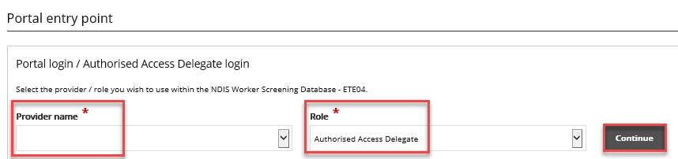

- Navigate to the ‘Access requests list’ and select ‘View’ next for the application you want to assess.
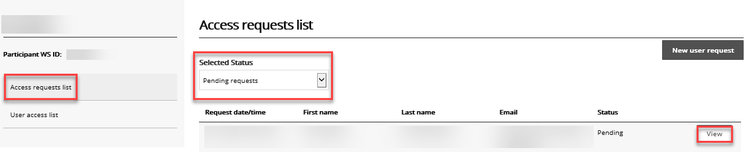
- Review the ‘Required user role(s)’ that the applicant has selected and ensure the appropriate checkbox is ticked.

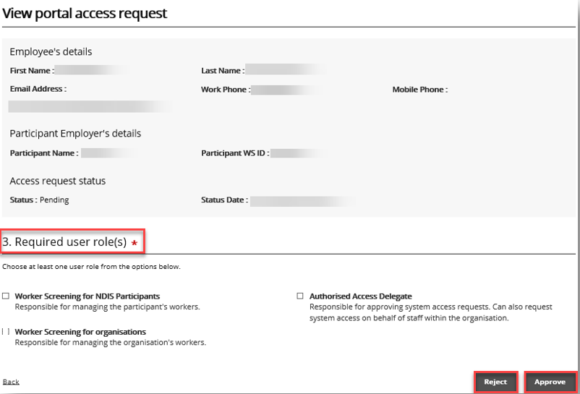
- Select ‘Reject’ or ‘Approve’. The applicant will receive an email advising them of the outcome.

Managing email preferences
- To manage email preferences, log into PRODA and access the NWSD. Then select ‘NDIS Participant details’.
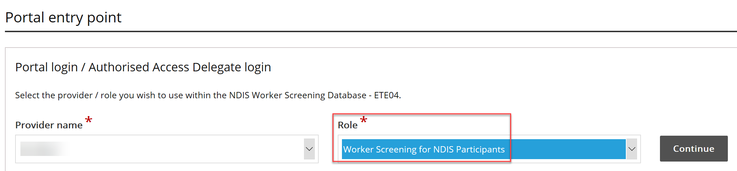
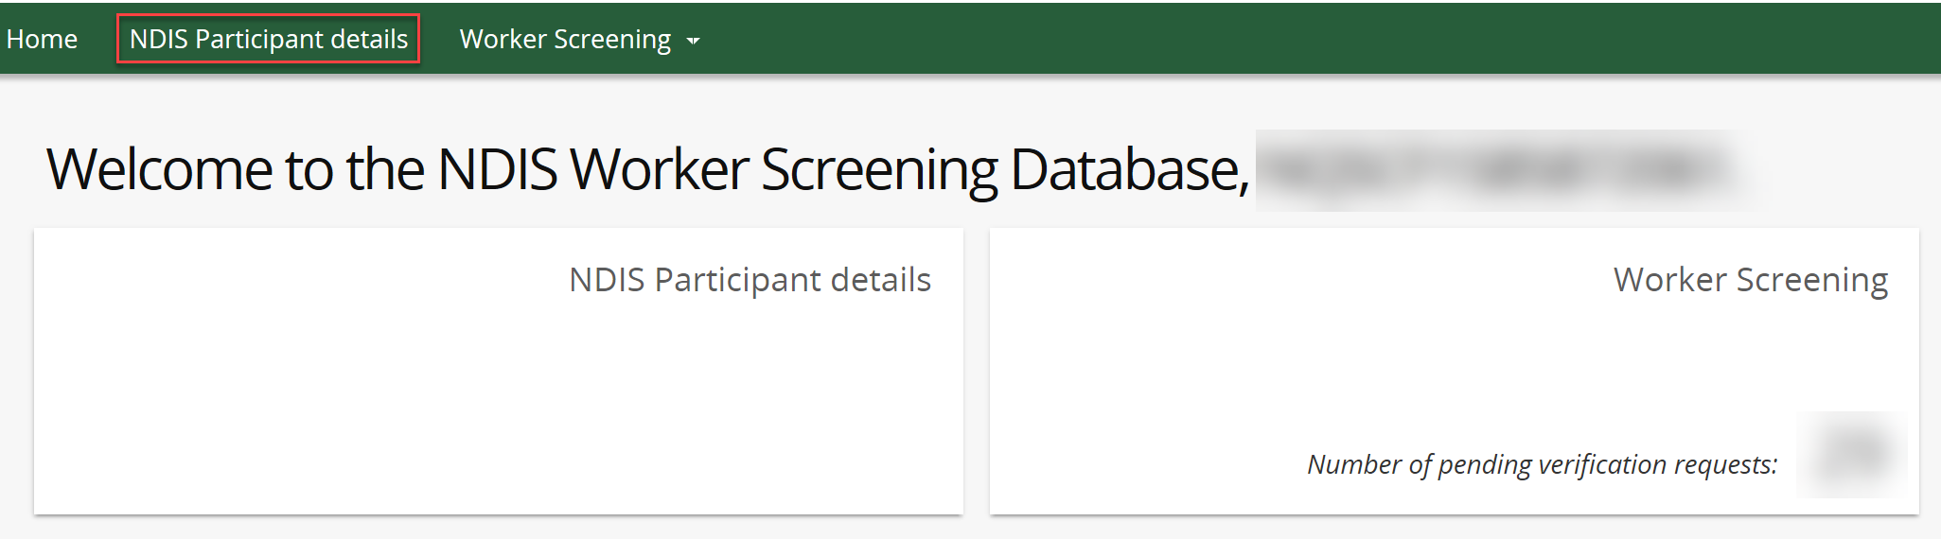
- On the ‘NDIS Participant details’ screen, select ‘Add’ to add a contact who will receive email updates about the status of workers linked (e.g. those who provide NDIS supports and services) to the self-manged or plan-managed participant.
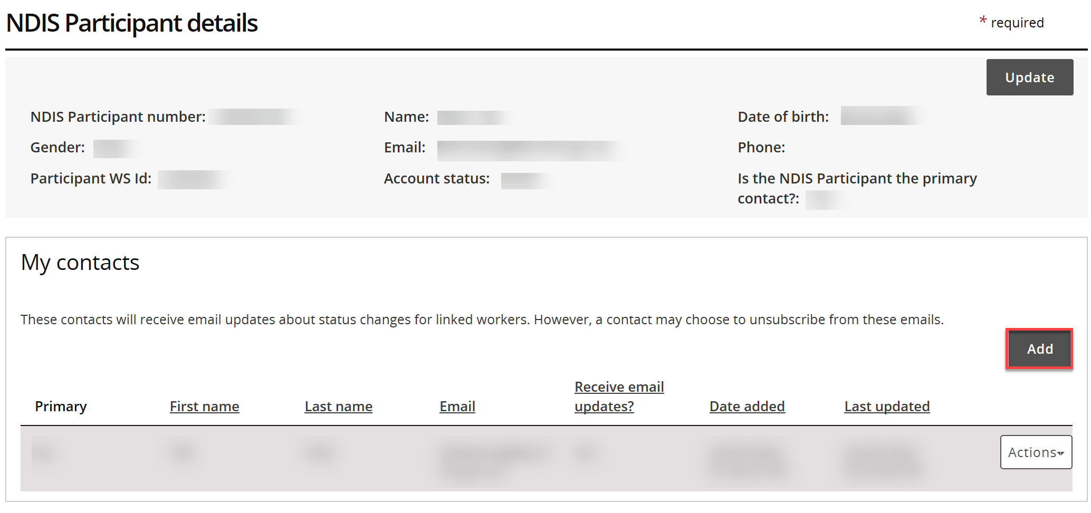
- Alternatively, you can select ‘Remove’ to remove a contact so that they can no receive email updates.
- Or select ‘Update’ to change the email address or email preferences of the contact.
- You can also make a contact a primary contact by selecting ‘Make primary’. The primary contact may receive correspondence from the NDIS Commission about various matters.
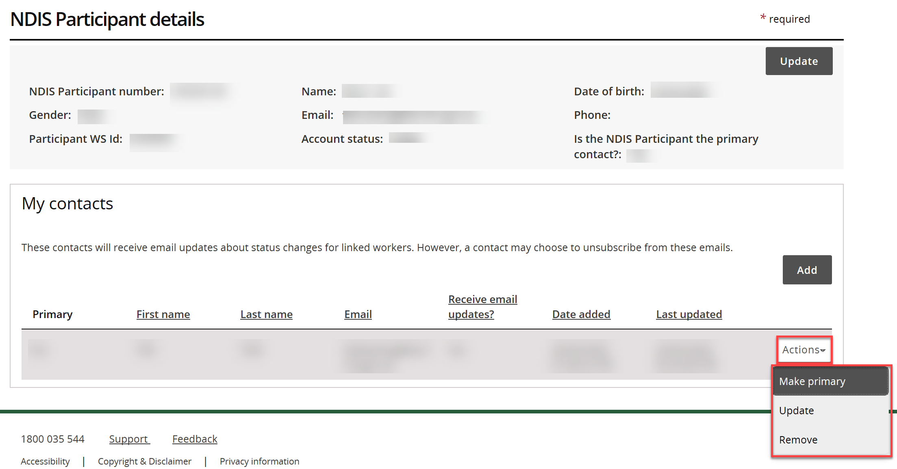
- If you have made a contact the primary contact, but you want to change the primary contact back to the self-managed or plan-managed participant, select ‘Update’. Then select ‘Yes’ in the ‘Is the NDIS Participant the primary contact?’ field.
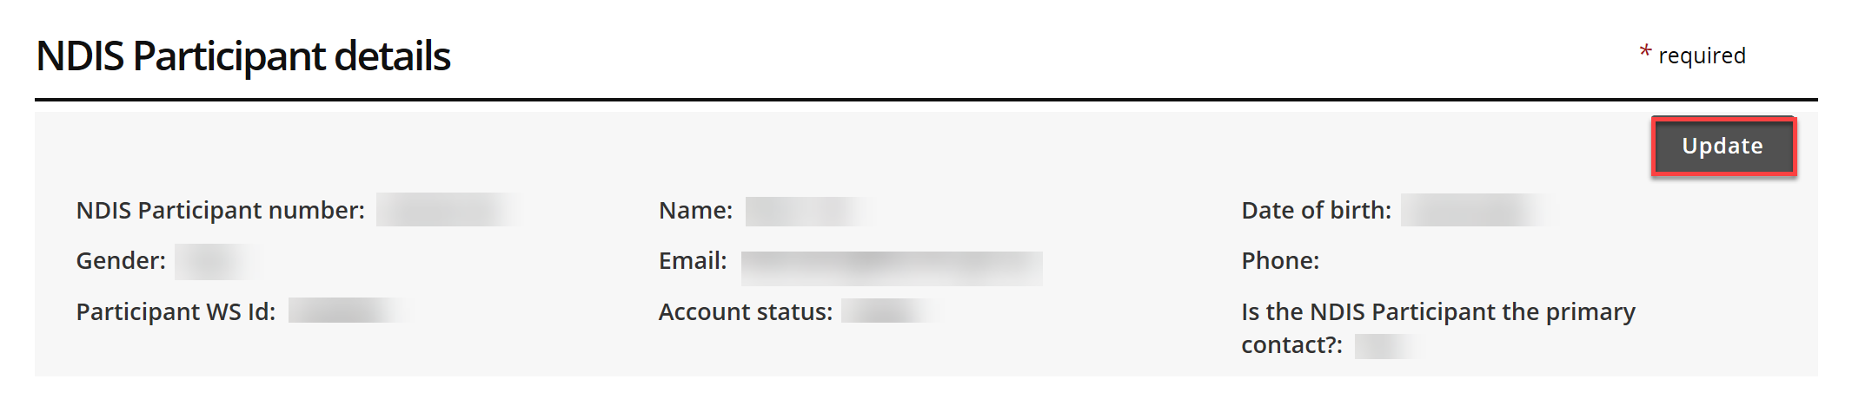
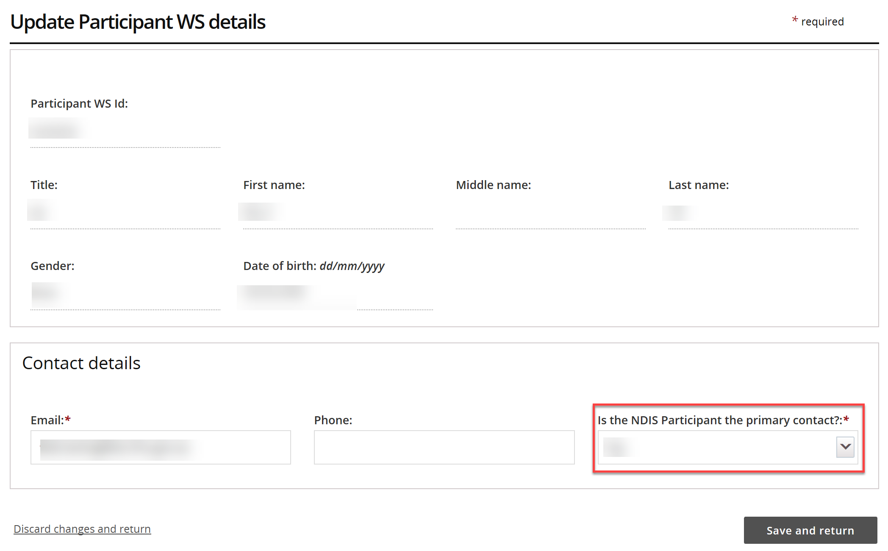
- Once you’ve made the required changes, select ‘Save and return’.

