Quick reference guide: Request access to the NDIS Worker Screening Database (NWSD)
Self-managed or plan-managed participant

Contents
Contents 1
Overview 1
Online form 3
Use of information and the system 3
My NDIS Plan 4
NDIS participant details 4
My key contacts 5
Confirm details 6
The primary contact 6
Workers 7
Summary and declaration 8
Submission received 8
PRODA Account 9

Overview
- The NDIS Worker Screening Database (NWSD) is a national database which stores NDIS Worker Screening Check information about workers who deliver NDIS supports and services.
- Self-managed and plan-managed participants can decide whether they will require their workers to have a worker screening clearance. More information about this can be found on our website - Worker Screening (self-managed and plan managed participants).
- When a worker applies for an NDIS Worker Screening Check they must nominate an employer/s to verify their application. Once verified, the worker will be linked to the employer. The employer can then view and receive upates about the worker’s NDIS Worker Screening Check status e.g. whether they have an NDIS Worker Screening Clearance and when that clearance is due to expire.
- For a worker to be able to nominate an employer/s, the employer must have registered for access to the NWSD. Each employer must only make one application for access to the NWSD, after which they can manage the access of their employees by using the self-service functions (refer to Quick Reference Guide – SMP & PMP – Manage NWSD access & email preferences).

- This quick reference guide provides information for self-managed and plan-managed participants about how to register for NWSD access.
For further information please refer to the NDIS Quality and Safeguards website - Worker Screening (self-managed and plan-managed participants). Alternatively, contact the NDIS Quality and Safeguards Commission on
1800 035 544 or by email nwsd@ndiscommission.gov.au

Online form
- To request access to the NWSD, begin the online form – Register for Worker Screening.
- Enter your email address and select ‘Save and continue’.
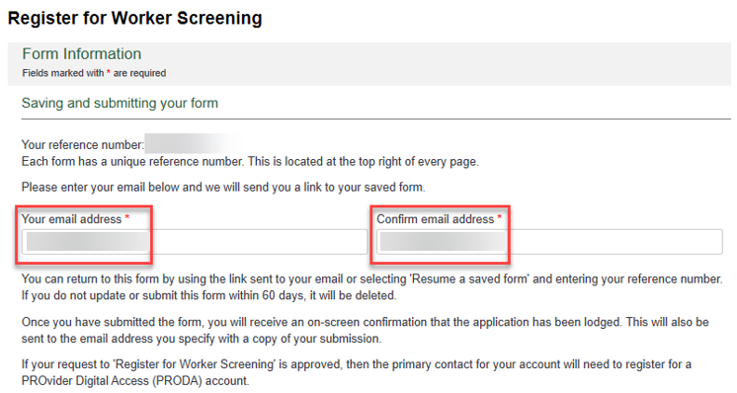
- There are a number of pages on the form which are indicated by the headings on the left hand side of the screen. You can navigate back to a pervious page by using the ‘Back’ button or selecting the page you want to go to. When you have completed a page, select ‘Save and continue’.
Tip 1 – You can exit the form at anytime. You will receive an email with a link to the partially completed form. You must submit the form within 60 days or it will be deleted.

Use of information and the system
- Read through the information on the ‘Use of information and the system’ page and select the checkbox if you agree.
- Select the radio button next to ‘I am an NDIS participant or their representative’ if you are a self-managed participant, plan-managed participant or their representative. Select ‘Save and continue’.

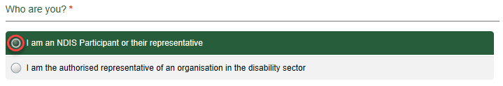

My NDIS Plan
- On the ‘My NDIS Plan’ page select the options that apply to you. Select ‘Save and continue’.
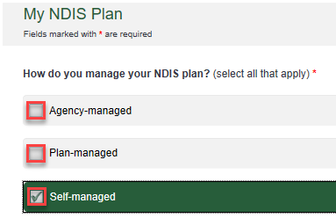

NDIS participant details
- On the ‘NDIS Participant details’ page enter the required fields. Select ‘Save and continue’.
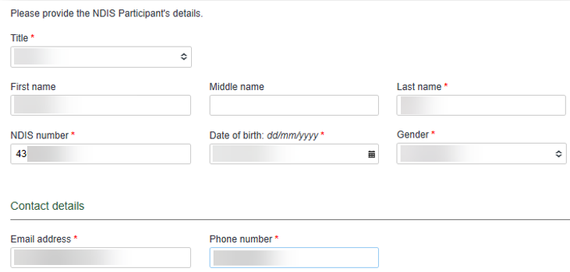

My key contacts
- On the ‘Our key contacts’ page indicate whether the NDIS participant requires access to the NWSD by selecting ‘Yes’ or ‘No’.
Tip 3 – If you select ‘Yes’, the NDIS participant will be considered the ‘primary contact’ who will receive email notifications about workers linked to the NDIS participant, such as the status of a worker’s NDIS Worker Screening Clearance and requests to verify a worker’s NDIS Worker Screening Check application.
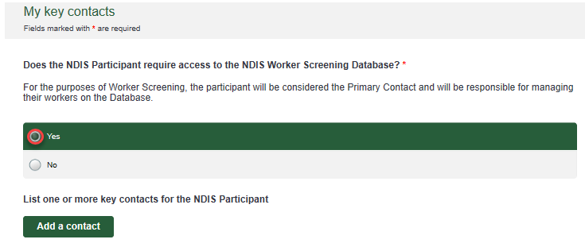
- If you have selected ‘Yes’ you do not have to add any key contacts, but you may choose to.
- If you have selected ‘No’ you must add at least one key contact. A key contact will receive email notifications about workers linked to the NDIS participant, such as the status of a worker’s NDIS Worker Screening Clearance and requests to verify a worker’s NDIS Worker Screening Check application.
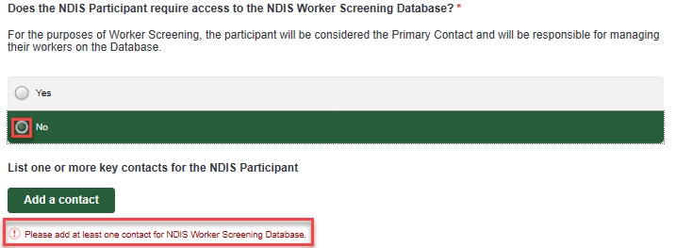
- To add more the one key contact, select ‘Add contact’. To remove a contact, select ‘Remove contact’.

Confirm details
- On the ‘Confirm details’ page check that the information you entered on the ‘My key contacts’ page is the correct current legal name and correct email address for each person.
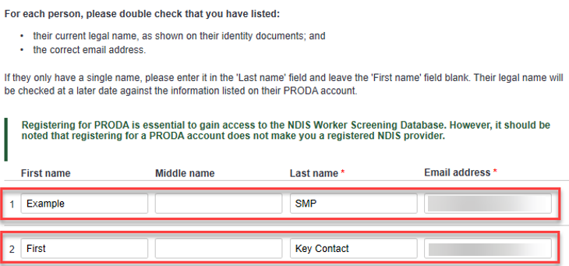
The primary contact
- Select one primary contact from the list of key contacts you have entered, then select ‘Save and continue’.
Tip 5 – The primary contact will be able to access the NWSD on behalf of the NDIS participant and will be responsible for the NDIS participant’s NWSD account. The allows the primary contact to manage user access on behalf of the NDIS participant e.g. adding and removing additional key contacts to the account.
If someone other than the NDIS participant is selected as the primary contact, the NDIS participant will not receive access to the NWSD. The primary contact will receive access (if approved) and access the NWSD on behalf of the participant.
The primary contact will receive email notifications about workers linked to the NDIS participant, such as the status of a worker’s NDIS Worker Screening Clearance and requests to verify a worker’s NDIS Worker Screening Check application.
The other key contacts (those that are not the primary) will not receive these notifications.
Workers
- On the ‘Workers’ page, select ‘Add a worker’ if your organisation is intending to engage any workers that have applied for or have made an application for an NDIS Worker Screening Check application.
If you do not want to add a worker, select ‘Save and continue’ and skip to step 21 below.
- Enter the worker’s ‘Worker last name’ and ‘Application ID’ or ‘Worker Screening ID’ and select ‘Check’. The worker must be verified before you can progress.
Tip 6 – The worker’s application ID is the reference number they received when they made their NDIS Worker Screening Check application. If the worker already has a worker screening clearance, they will have a Worker Screening ID.
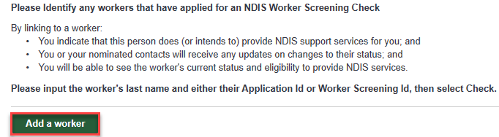
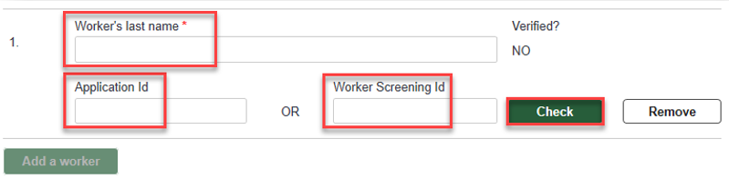

Summary and declaration
- On the ‘Summary and declaration’ page check the details you have entered into the application, enter your name in the ‘My full name’ field and tick the two check box declarations if you agree, then select ‘Submit’.
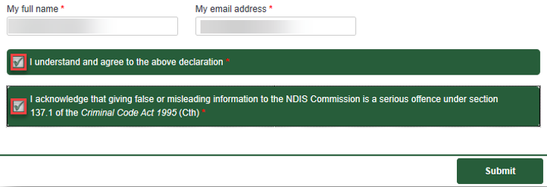

Submission received
- Once the application is submitted you will receive a confirmation email with a copy of your application, and be taken to a confirmation screen.
- From the confirmation screen you can also choose to email a copy of the completed application to a different email address or download a copy of the application to save.
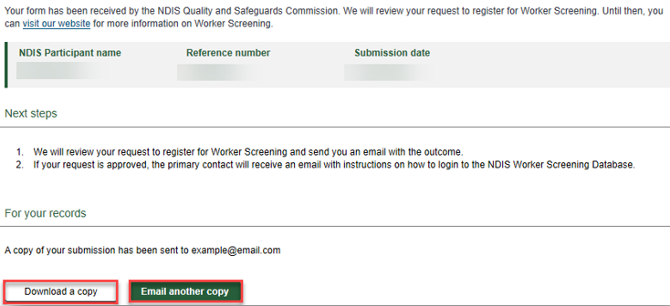

PRODA Account
- If your request for access to the NWSD is approved, you will receive an email prompting you to complete the access request.
- Follow the link provided in the email which will take you to a PRODA sign in page. If you already have a PRODA account, log in. If you do no have a PRODA account register by following the link.
Tip 7 - If you are having trouble registering for PRODA contact the PRODA Helpdesk on 1800 700 199.
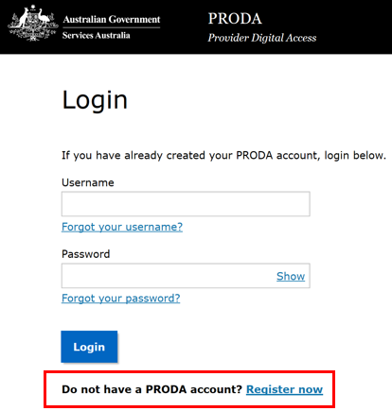
- On the ‘Portal entry point’ screen, select the correct ‘Provider name’ (which is the name of the NDIS pariticpant) and ‘Role’. Choose the ‘Worker Screening for NDIS Participants’ to go directly to the NWSD.

