Rate and finalise practice standard outcomes
IT Quick Reference Guide - Auditors
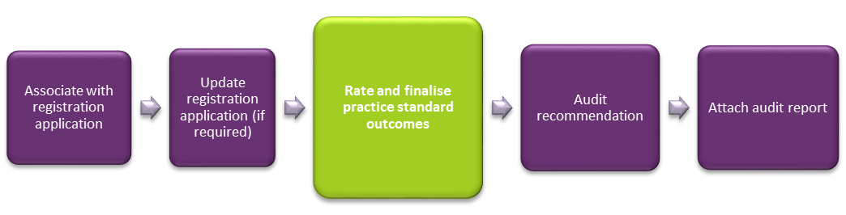
This guide demonstrates how an Auditor rates practice standard outcomes and finalises all practice standard modules for each registration application. This guide will help you to do the following:
- Rate practice standard outcomes
- Finalise practice standard module
- Add registration groups
- Witness a service delivery for registration group
- Not witness a service delivery for registration group
- Remove a registration group
- Update service delivery questions

Rate practice standard outcomes
Each outcome must be rated before the practice standards can be finalised.
- Click Practice standards in the left hand side menu.
- Select a practice standards module.
- Select an outcome to rate then click Update.
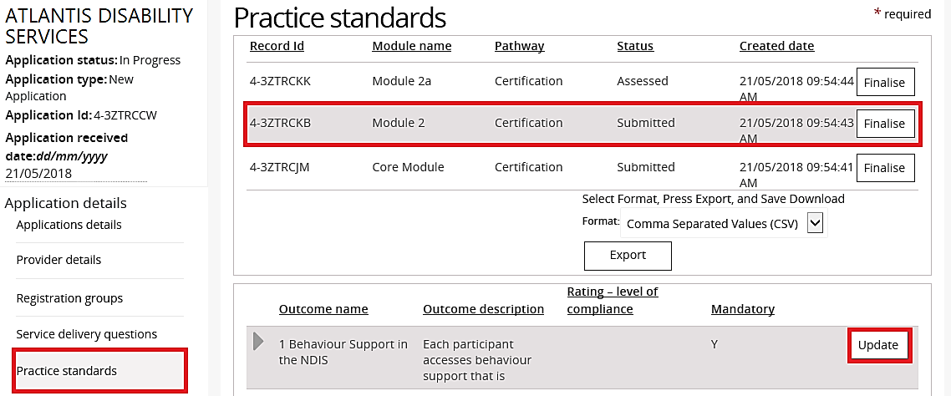
The Practice standards outcome window opens.

- Type Audit comments, select a rating at Rating – level of compliance then click Save.
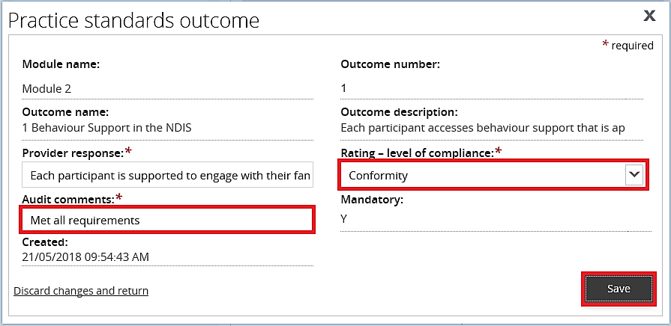
The Practice standard window is displayed again.
- Repeat step 3 - 4 until all outcomes have been rated.

Finalise practice standard module
Once all practice standards have been rated, they must each be finalised. This is a prerequisite for making an audit recommendation.
- Click Practice standards from the left hand side menu.
- Select a practice standards module then click Finalise.
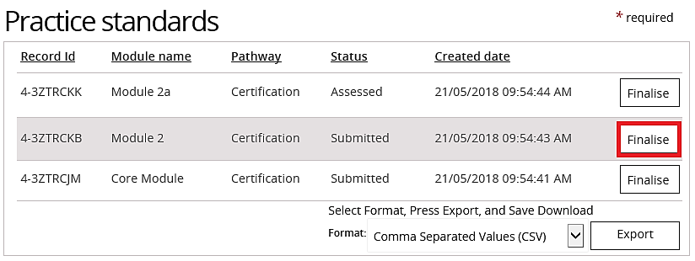
The status of the practice standard module changes from Submitted to Assessed.
- Repeat step 2 until all practice standards modules have been finalised.

Assess the registration groups

Add registration groups
- Click the Registration groups from the left hand side menu then click Add.
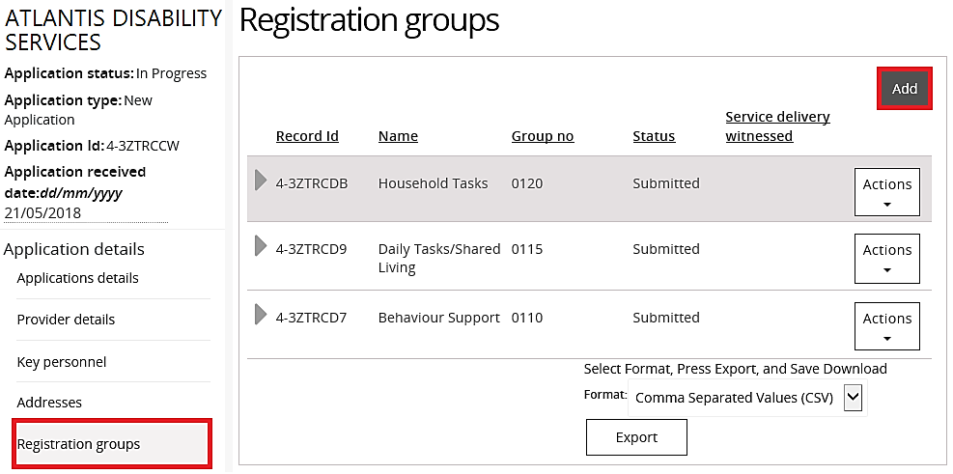

- Select new registration group then click Add.
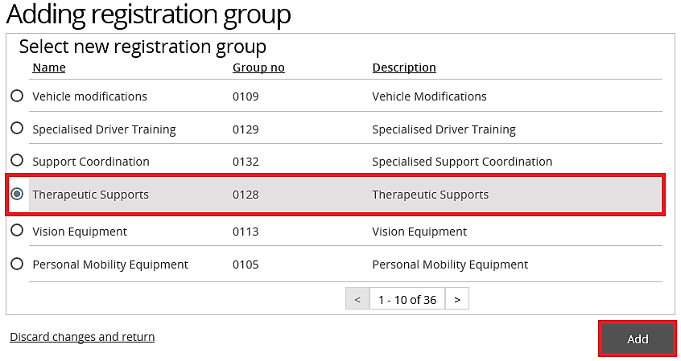
The registration group is added.

Witness a service delivery for registration group
- Click the Registration details from the left hand side menu.
- Select the Registration group to witness, click the Actions drop down menu then select Witnessed.
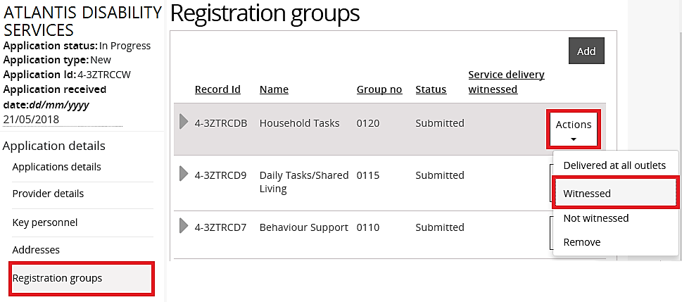
The Registration group is marked as Witnessed.

Not witness a service delivery for registration group
- Click the Registration details from the left hand side menu.
- Select the Registration group to not witness, click the Actions drop down menu then select Not Witnessed.
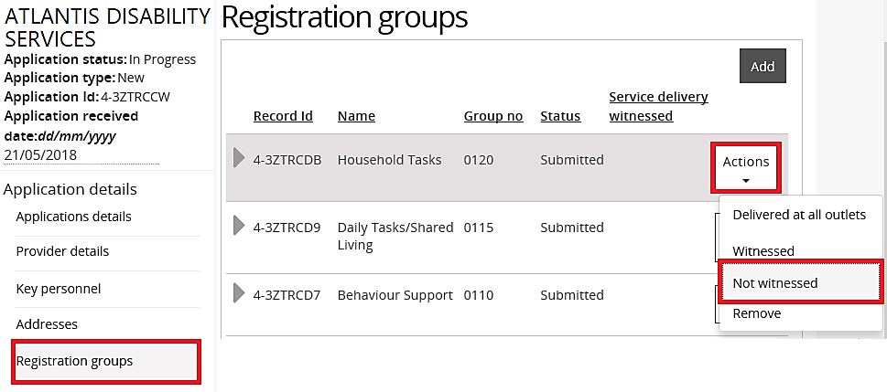
The registration group is marked as Not witnessed.

Remove a registration group
- Click Registration groups from the left hand side menu.
- Select the Registration group to remove, click the Actions drop down menu then select Remove.
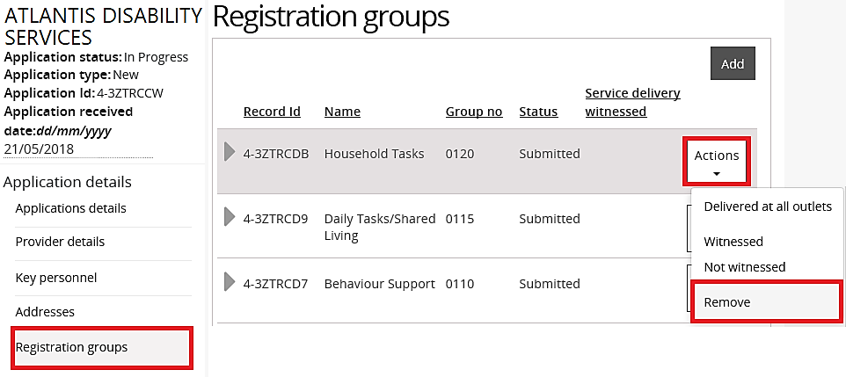
The registration group is removed.

Update service delivery questions
- Click Service delivery questions from the left hand side menu then click Update.
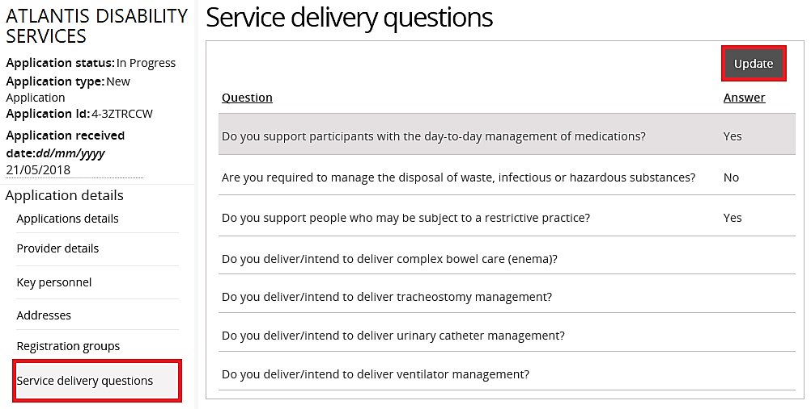

- Select the answers to the Service delivery questions.
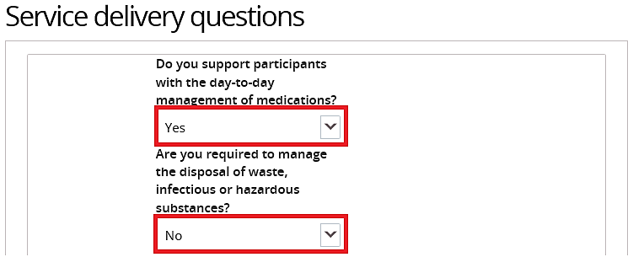

- Click Save.
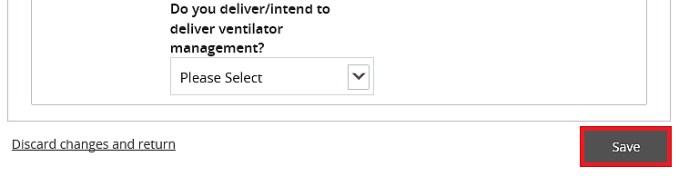
The service delivery questions have been updated.

