Update contact details in My Registration

Quick reference guide - Provider
Providers can update their own contact details in the NDIS Commission Portal. Details that can be updated include:
- Provider details (only ACN and trading name can be updated)
- Contact details and parent entity details
- Address details

Step by step guide
- Login to NDIS Commission Portal
- Select My Registration from the home screen.
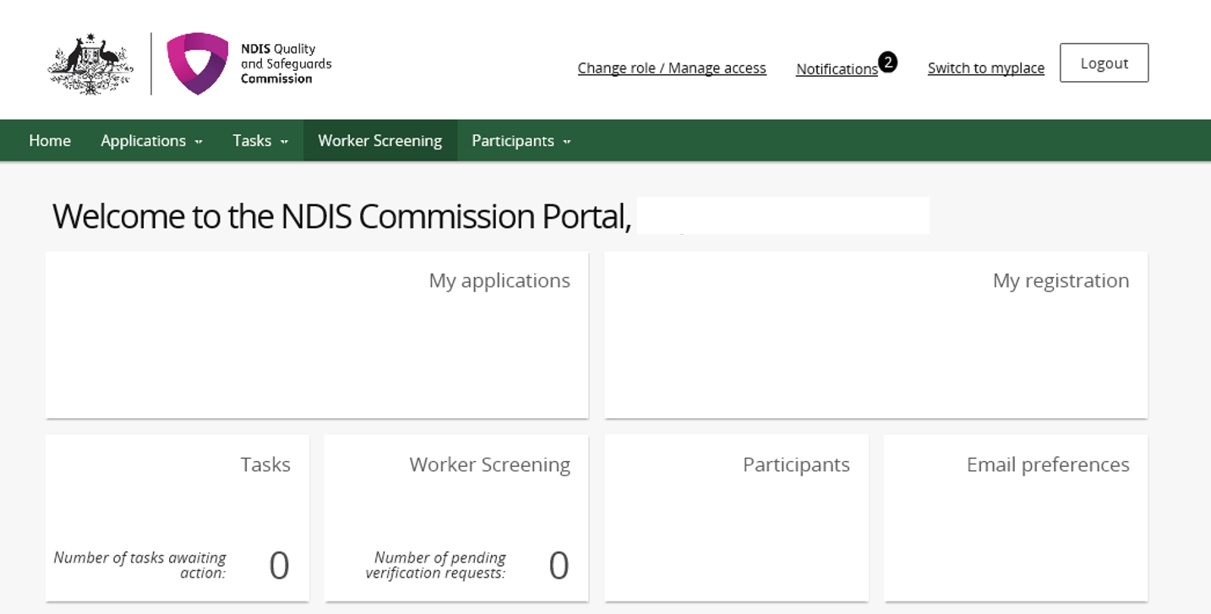

- In the Provider details tab click Update.
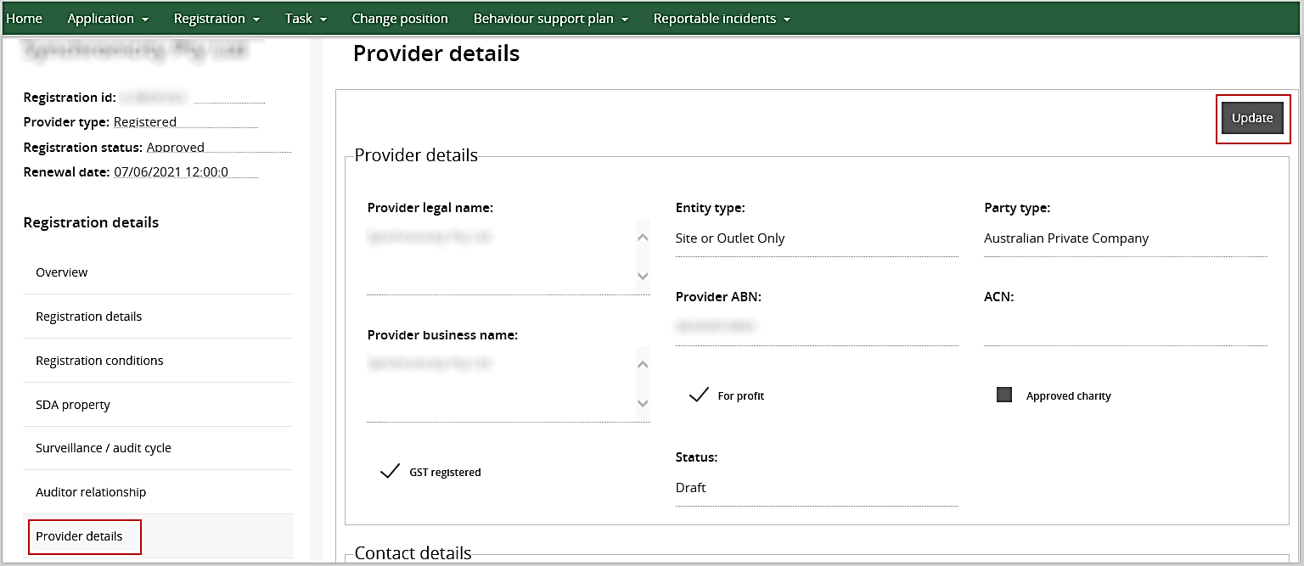
Update provider business name or ACN (if needed) and click Save.
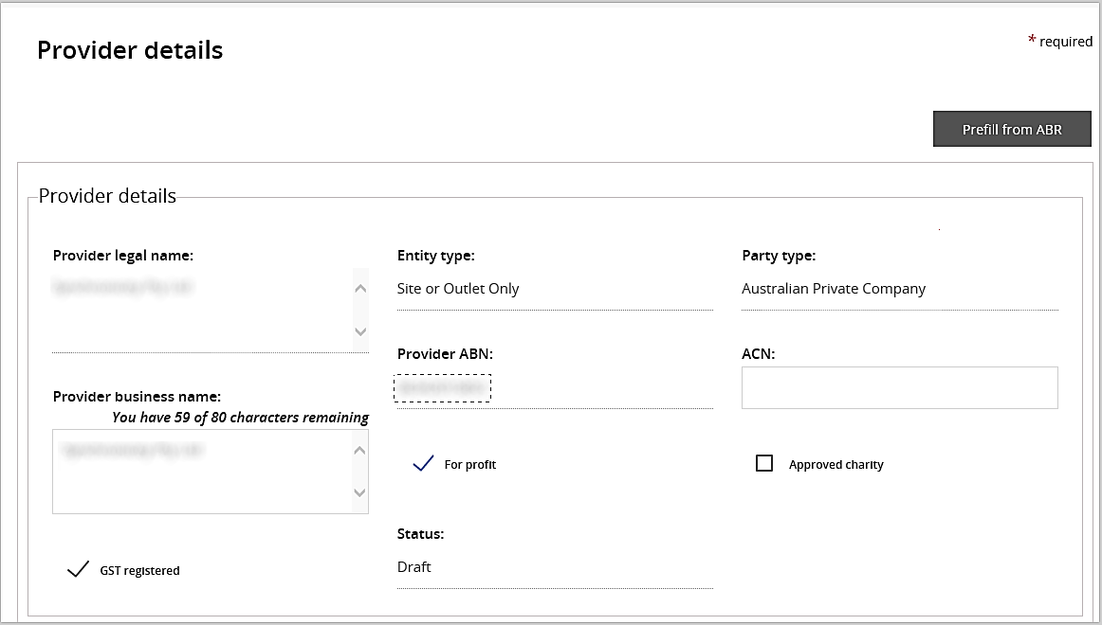
- If required, update Contact details and click Save.
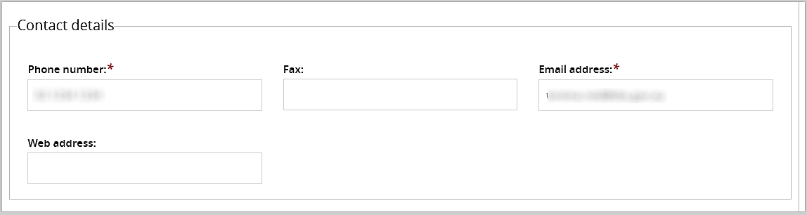

- If required, update Parent entity details and click save.
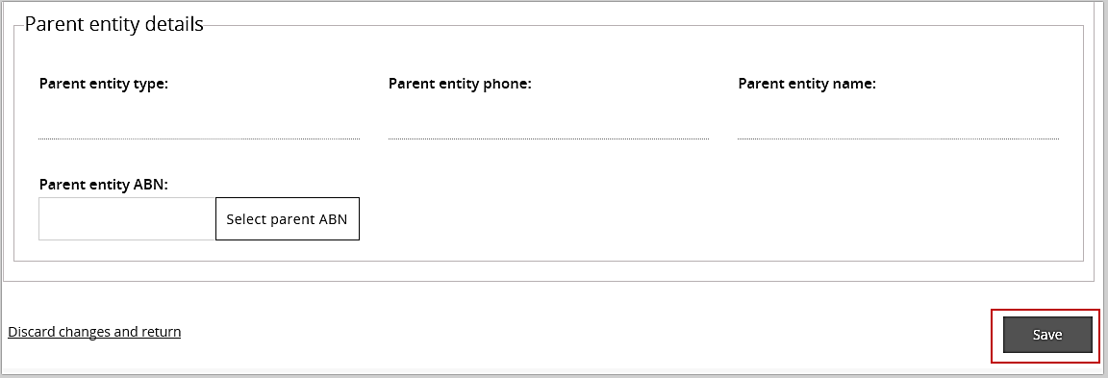

- In Address tab select Add address button to update the address details.
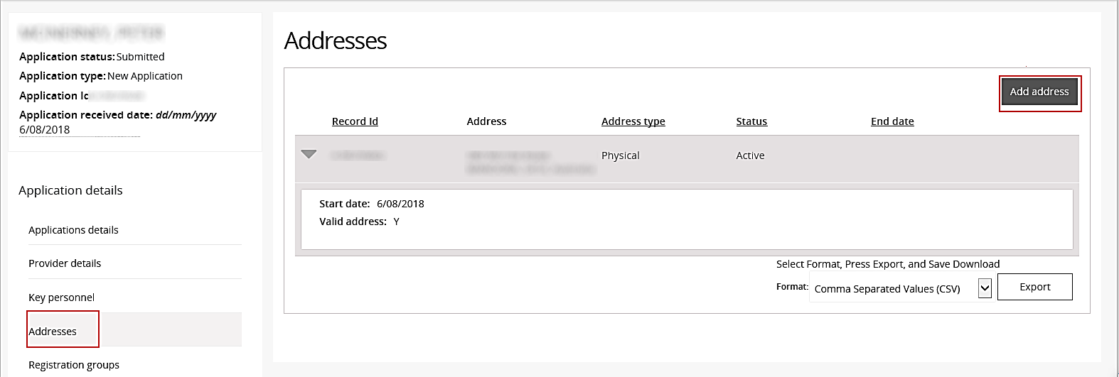
- From the drop down menu, add the address start date and select either postal or physical. Start typing the address, select the correct address and click Save.
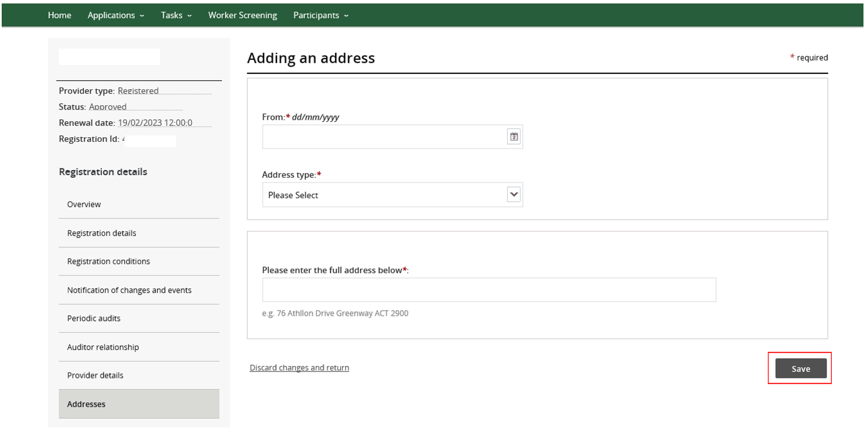
- If address does not appear then select, I don’t see my address and Save.
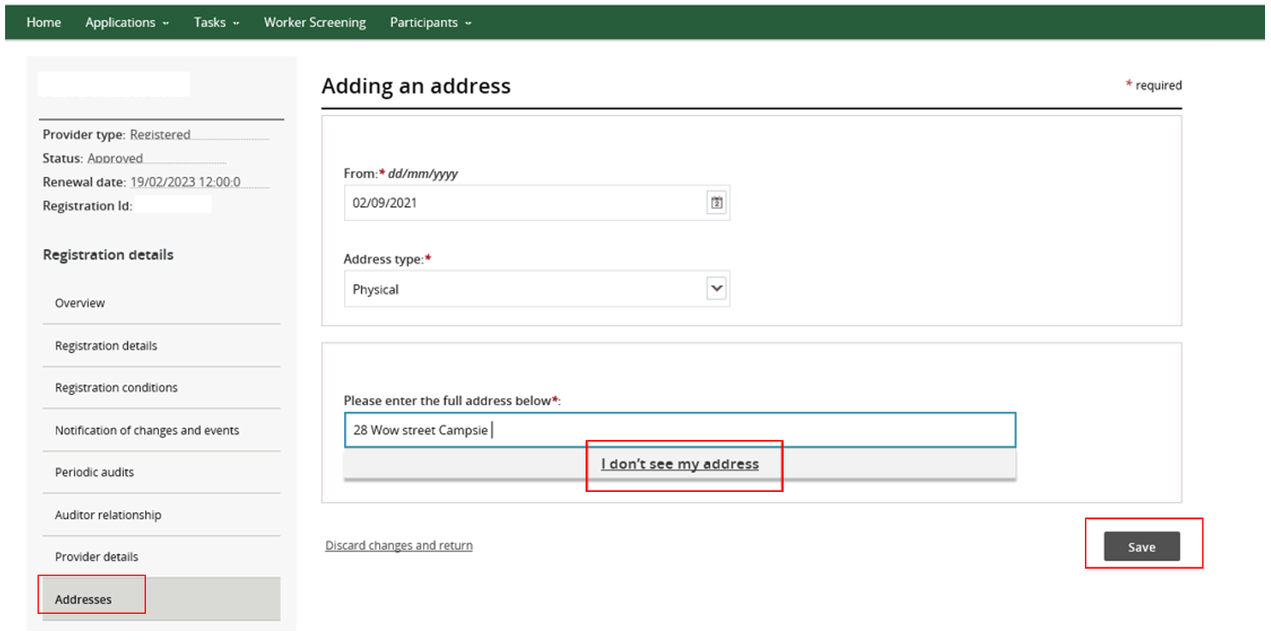
More address option will appear. Complete address and select Save
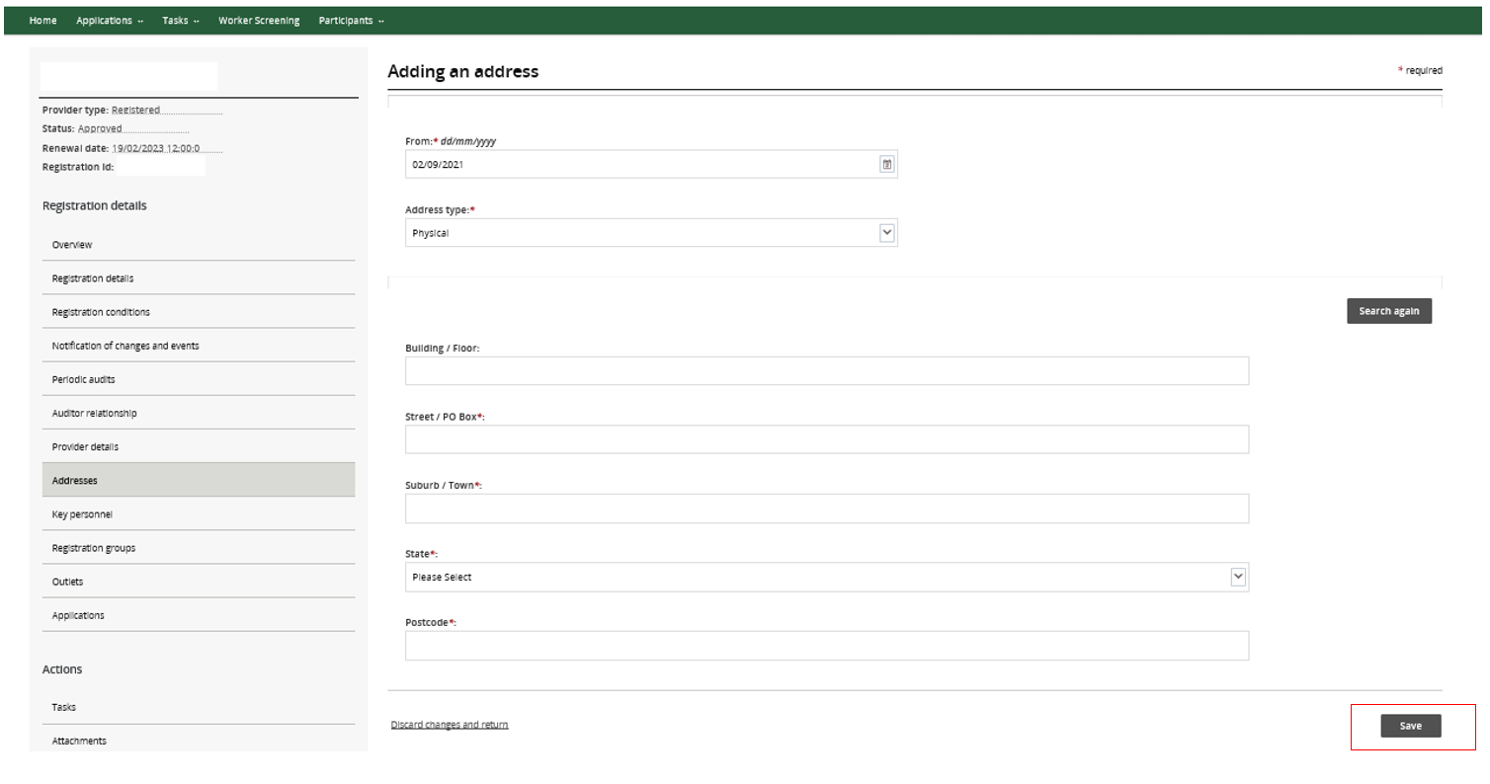
The updated address will appear. Please note there is no availability to remove the old address however, it will become inactive in the system and the NDIS Provider Register.
End.

