Quick reference guide:
Generate Employer ID document
Registered provider

KEY MESSAGES
- This quick reference guide provides information about how to generate a document to give to workers which provides the Employer ID. Providing this document will assist your workers in accurately selecting you as an employer as part of their application for an NDIS Worker Screening Check.

- When a worker applies for a NDIS Worker Screening Check they must nominate at least one employer to verify their application.

- Using an organisation’s Employer ID is the most accurate way for a worker to nominate an employer for their NDIS Worker Screening Check application.

- If a worker nominates your organisation as their employer, you have 30 days to action a verification request. A reminder email will be sent to you 28 days, 14 days and 7 days prior to the expiry of the verification request.

- Once verified, a worker’s application will progress and screening will commence.

CONTACT US
WEB | Worker screening EMAIL | nwsd@ndiscommission.gov.au PHONE | 1800 035 544

How to generate Employer ID document

Access the ‘About my role as an employer’ section
- Go to the NDIS Commission Website and select the ‘Portals’ button and ‘Registered NDIS providers’ option.
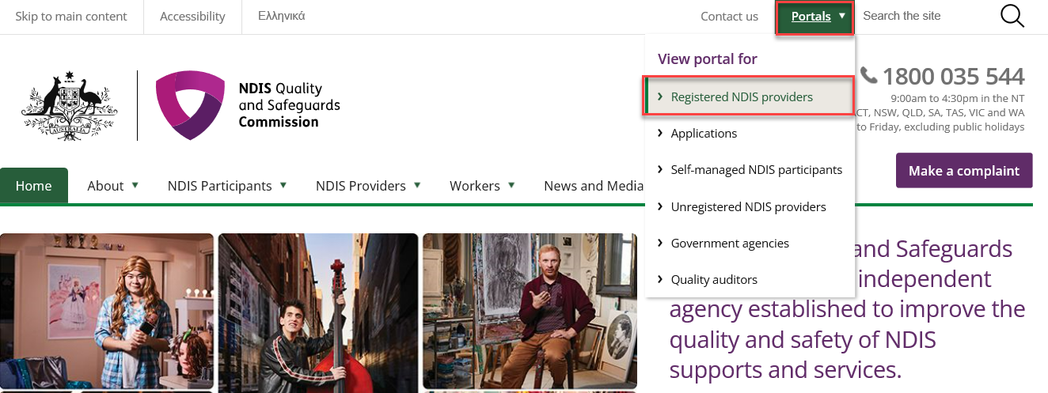
- Select ‘Login with PRODA’.
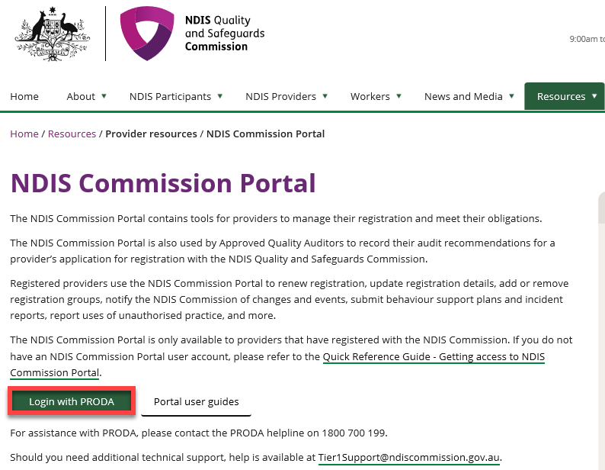
Tip – Registered providers will receive access to the NDIS Worker Screening Database as part of the registration process. The NDIS Worker Screening Database can be accessed via the NDIS Commission Provider Portal.

- At the ‘Portal entry point’ select the ‘Provider name’ of the registered NDIS provider that you are logging into the NDIS Commission Portal on behalf of. Select either ‘Worker screening officer’ or ‘Registrant’ as the ‘Role’.
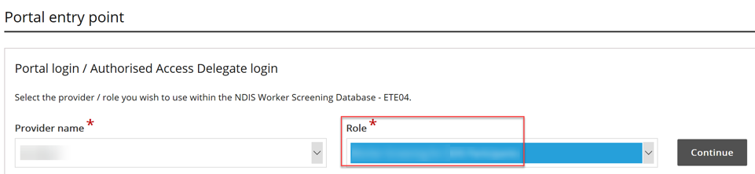
- Select the ‘Worker Screening’ tile.
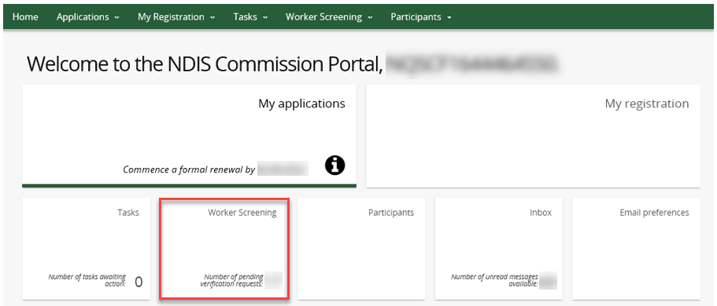
- Select the ‘About my role as an employer’ menu option.

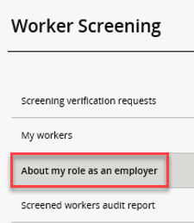

Generate a document with your Employer ID

- You will be presented with information about your role as an employer. 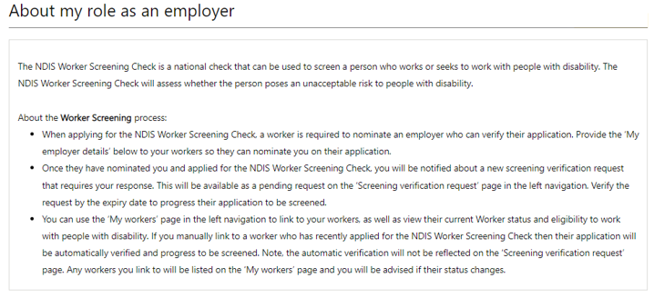
- To generate a document to provide to your workers’ that includes your Employer ID, select ‘Generate document’, and ‘Download’ the document.
Tip – The Employer ID is the same as your Registration ID.

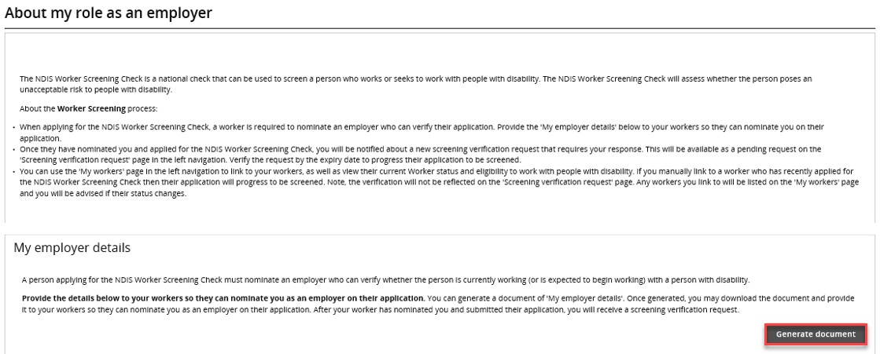
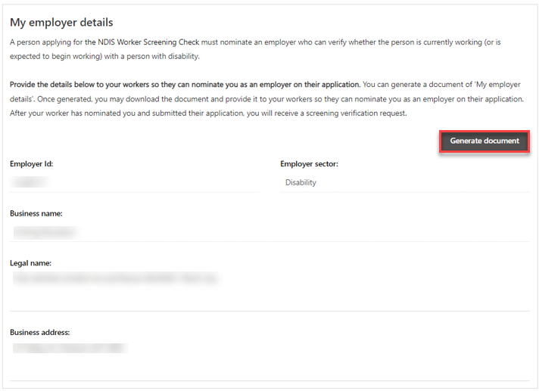
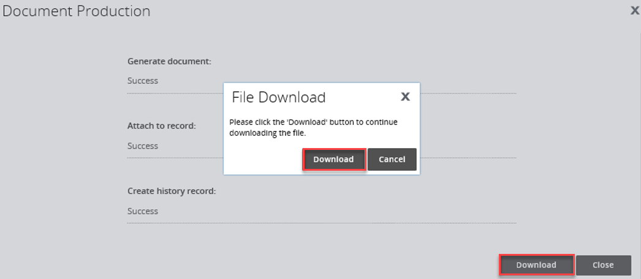

- The document can be saved and will be available on the ‘Attachments’ section of the page once it has been downloaded.
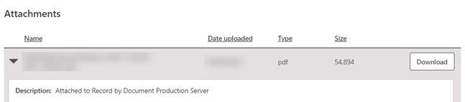

- An example of the document which will be generated is provided on the next page. Provide this to your worker’s so that they can accurately nominate your organisation on their NDIS Worker Screening Check application by using your Employer ID.

