Quick reference guide
NDIS Commission Provider Portal Inbox
Unregistered NDIS Provider & Self or Plan-Managed Participants

Contents
Contents 1
Inbox notification 2
Access the Inbox 3
View inbox messages 5
Search or filter messages 7
Identify who has viewed a message 8

- The NDIS Commission is changing the way it communicates with unregistered NDIS providers , self and plan-managed participants about NDIS Worker Screening matters.

- From 12 June 2022, unregistered NDIS providers, self and plan-managed participants will receive a notification to their email account alerting them to a message in their NDIS Commission Worker Screening Database Inbox .

- All communication about NDIS Worker Screening can only be accessed via the NDIS Commission Worker Screening Database Inbox.

- Regularly check your NDIS Commission Worker Screening Database Inbox for important messages about worker screening.

- This quick reference guide provides information about how to access and manage messages in your NDIS Commission Provider Portal Inbox.

Inbox notification
- When you receive a message in your NDIS Commission Worker Screening Database Inbox you will receive an email alert about the message.
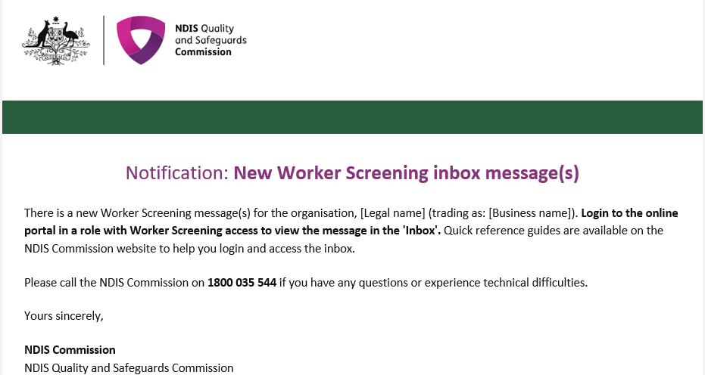
- The representatives that will receive the email alert are those with the email preference of ‘Default recipient’, and/or ‘Worker Screening’.

- For information about how to manage email preferences please refer to the QRG - https://www.ndiscommission.gov.au/document/2596

- Email alerts are sent at 6am, 12 noon and 4pm daily (if messages are available). If an inbox message is read before the email alert about that message is sent, an email alert won’t be sent.

For example, if a representative of the organisation or the participant opens the inbox at 9.30am and reads a message before the next email alert is sent at 12 noon, an email alert about the message will not be sent. Other representatives of the organisation or the participant will need to check the inbox regularly to ensure that all messages are viewed, as they won’t receive the email alert for the message that someone else has read before the next email alert batch was sent.

Access the Inbox
- Go to the NDIS Commission Website and select the ‘Portals’ button and ‘Unregistered NDIS providers’ or ‘Self-managed NDIS participants’ option.
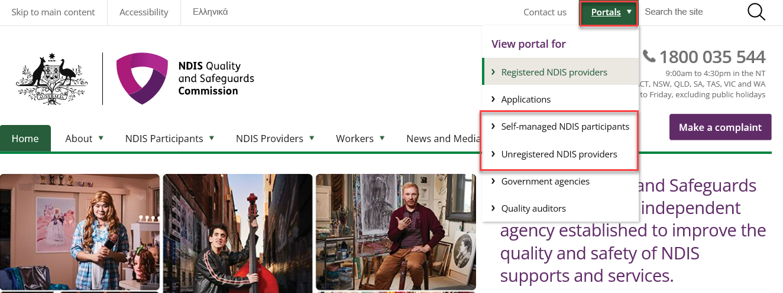
- Select ‘Login with PRODA’.
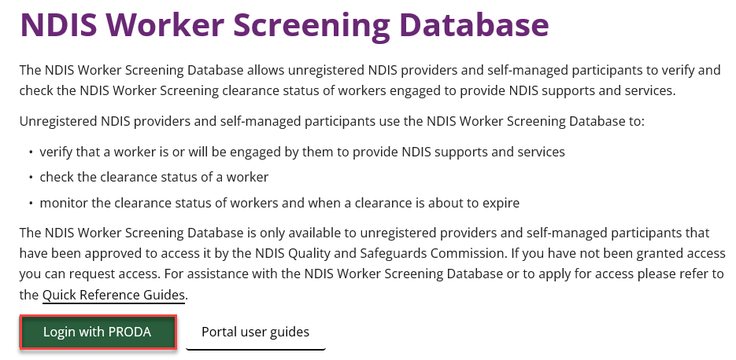
- At the ‘Portal entry point’ select the ‘Provider name’ of the unregistered NDIS provider, self or plan-managed participant that you are logging into the NDIS Worker Screening Database on behalf of. Select either ‘Worker screening for organisation or ‘Worker screening for participants’ as the ‘Role’.
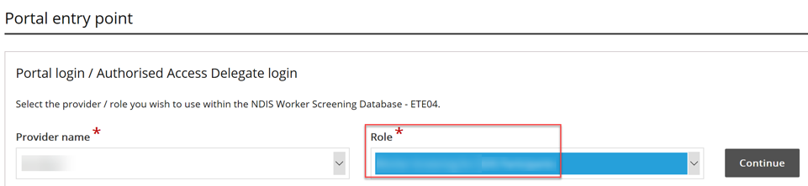
- Select the Inbox tile.
Unregistered providers:
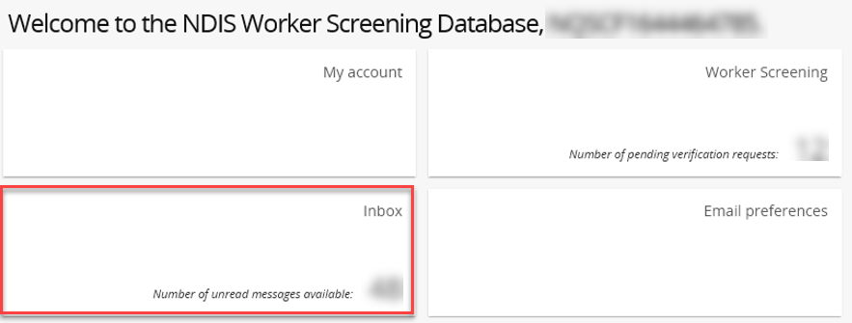

Self/plan-managed participants:
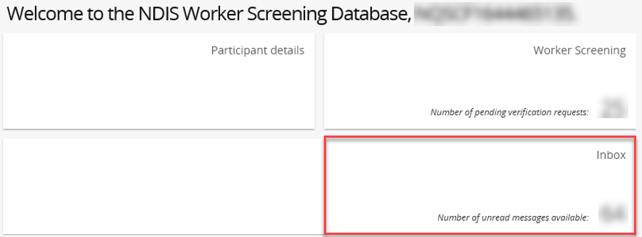

View inbox messages
- To view a message select ‘Actions’ and ‘View’.
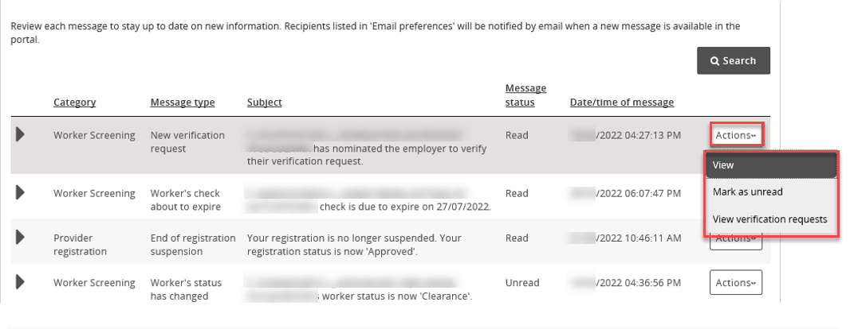
- The message will appear at the bottom of a new page along with information about the message, such as who has viewed it and what email addresses received the email alert about the new message.
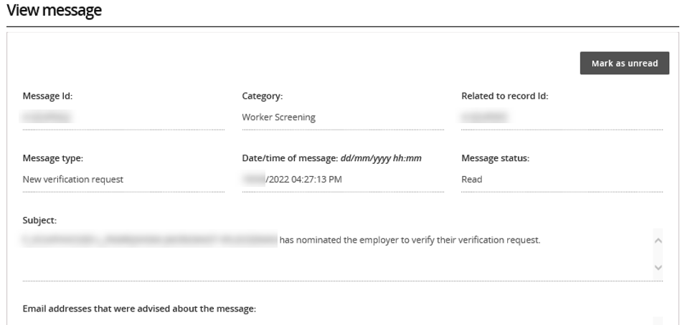
- The message will appear at the bottom of the page. Use the buttons along the top of the message to expand or print the message.

- If the message relates to a worker screening verification request, select ‘View verification requests’ button to navigate directly to the verifications page.
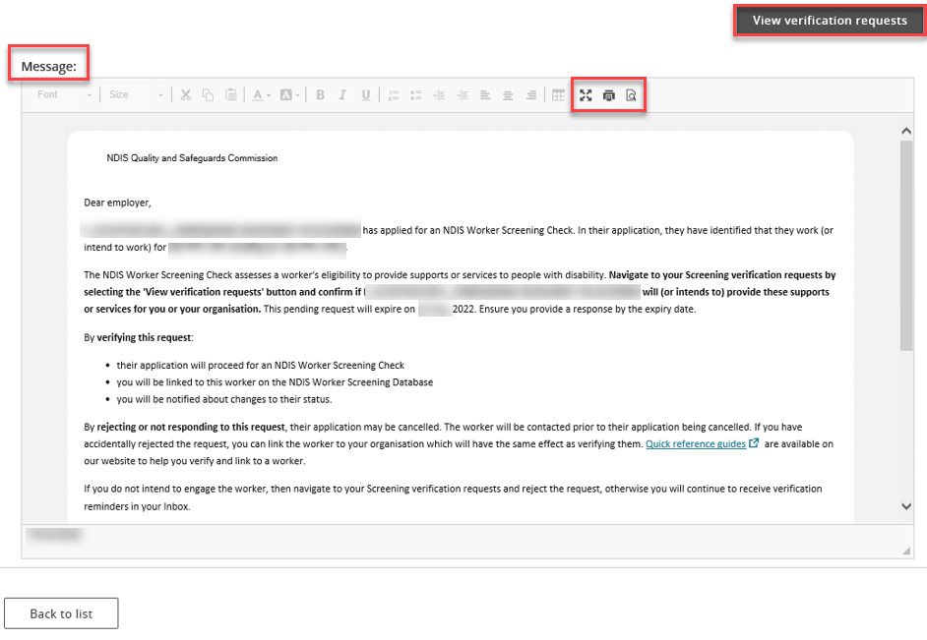

Search or filter messages
- Use the filter options to show only read or unread messages in your inbox, or use the search function to display only particular messages e.g. all messages about Worker Screening.
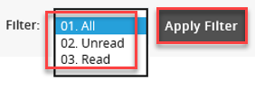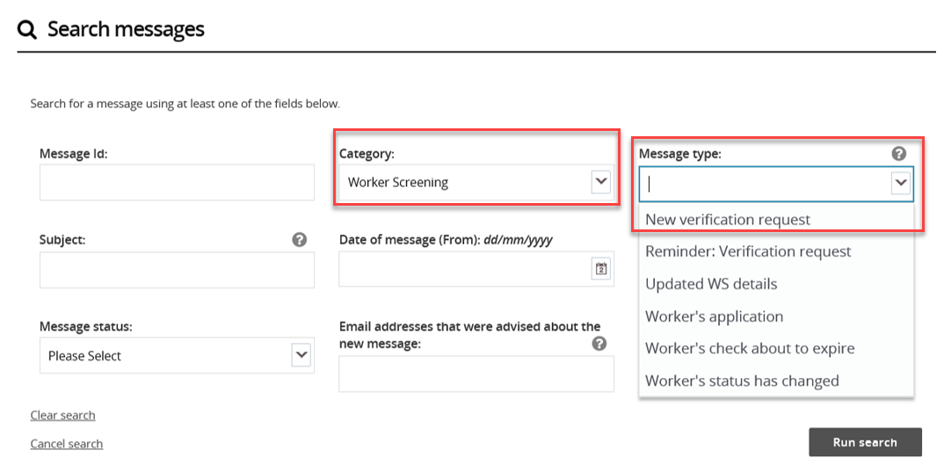

Identify who has viewed a message
- Expand the message in the inbox using the twistie arrow to view who has read the message and at what date/time.

- If a user views a message and then marks it as ‘Unread’, their details will still appear in the ‘Message first read by’ field.

- The ‘Email addresses advised of the message’ lists those email addresses that received the email alert about the message being available in the inbox.

