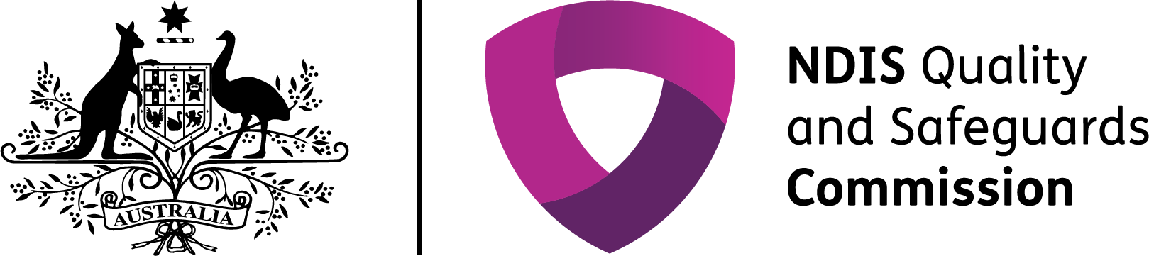

The NDIS Quality and Safeguards Commission

## A new system of quality and safeguards in the NDIS

The NDIS Quality and Safeguards Commission (NDIS Commission) is an independent government body that works to improve the quality and safety of NDIS services and supports, investigates and resolves problems, and strengthens the skills and knowledge of providers and participants.

### The NDIS Commission will commence in the Northern Territory on 1 July 2019 and will progressively roll out across Australia.

Map of Australia showing the commencement dates of the NDIS Commission in each state and territory:
- 1 July 2018 in NSW and SA
- 1 July 2019 in ACT, NT, QLD, TAS and VIC
- 1 December 2020 in WA

When it is operational in all states and territories, the NDIS Commission will provide a single, national registration and regulatory system for providers that will set a consistent approach to quality and safety across Australia.



## Sprinter with blade leg in mid stride.What has changed for providers in the Northern Territory?

The NDIS Commission introduced several changes for Northern Territory providers.

These include a new NDIS Code of Conduct and NDIS Practice Standards, which set out expectations for the quality and safety of the services and supports providers deliver. There have also been changes to provider registration and the way complaints are made, incidents are reported, behaviour support plans are developed and checked, and worker screening is undertaken.

Unregistered providers are also subject to new requirements including the NDIS Code of Conduct and complaints handling arrangements.

**Upward purple arrow with 2 diagonal downward green arrows.**

**The NDIS Commission provides information and guidance to support providers to understand and meet their quality and safeguards requirements.**

| Function | Prior to the NDIS Commission | Under the NDIS Commission |
| --- | --- | --- |
| Provider registration | Providers who met the requirements of the Northern Territory Quality and Safeguarding Framework (the NT Framework), were registered by the NDIA. | The NDIS Commission registers providers. Registered providers are required to comply with the NDIS Practice Standards, the NDIS Code of Conduct and requirements for incidents management, complaints management, worker screening and behaviour support (where applicable). |
| Standards of quality and safety | Providers needed to meet the requirements of the NT Framework. If a Quality Improvement Plan resulted from audit, providers were to meet this Plan within specified timeframes as a condition of their NDIA registration. | Registered providers must meet and be audited against the relevant NDIS Practice Standards. |
| Code of Conduct | Registered providers were to have their own Code of Conduct, Code of Ethics or Service Charter. | All providers and workers in the NDIS must meet the NDIS Code of Conduct. |
| Worker screening | Registered providers were to have undertaken Working with Children Checks and a national police check, prior to staff being employed. | All states and territories will progressively transition to a nationally consistent Worker Screening Check for employees of registered providers who have more than incidental contact with people with disability. |
| Complaints management | Registered providers were to have a clear and accessible complaints handling and dispute resolution system, including accessible information for Aboriginal people and people from culturally and linguistically diverse backgrounds.  If participants were not satisfied with the outcome of their complaint, providers were to advise participants of their right to make a complaint to the Health and Community Services Complaints Commission. If the complaint was unable to be raised or resolved with the provider, the NT Department of Health could refer the complaint to the Health and Community Services Complaints Commission, the Office of the Children’s Commissioner and the Anti-Discrimination Commission. Complaints about the NDIA or participant plans could be made to the NDIA or the Commonwealth Ombudsman. | Complaints about the quality or safety of NDIS supports and services can be made to the NDIS Commission. Complaints about the NDIA or participant plans continue to be made to the NDIA or to the Commonwealth Ombudsman. Registered providers are required to have effective and proportionate internal complaint management and resolution arrangements in place. Registered providers must afford procedural fairness to people when managing complaints. |
| Behaviour support | The *Disability Services Act 2014* provided for the use of restrictive practices, included within a behaviour support plan, in an NTG care facility. There was no legislative basis for other disability providers to undertake restrictive practices.  On 1 January 2018, the Northern Territory Critical Incident Reporting Guidelines came into effect, which provided for the reporting of the use of restrictive practice as a Level 1 incident. | Providers who use or are likely to use restrictive practices, or who develop behaviour support plans must be registered with the NDIS Commission and meet supplementary requirements of the NDIS Practice Standards. The NDIS Commission approves behaviour support practitioners using a capability framework. Providers must lodge behaviour support plans with the NDIS Commission and report monthly on the use of restrictive practices. The Northern Territory government will be responsible for the legislative and policy frameworks regarding the authorisation of regulated restrictive practices in the NDIS. |
| Incident management | On 1 January 2018, the Northern Territory Critical Incident Reporting Guidelines applied to all disability service providers. On 4 March 2019, an amended version aligning closely with the NDIS Commission reportable incidence guidelines was released. | Registered providers must have effective incident management systems in place. Registered providers must notify the NDIS Commission about reportable incidents. These include the death or serious injury of a person with disability, allegations of abuse and neglect of a person with disability, unlawful sexual or physical contact with a person with disability, sexual misconduct committed against a person with disability and unauthorised use of restrictive practice. |

## Then and now in quality and safeguards

*Where transition arrangements apply after 1 July 2019, the NDIS Commission will work with existing state based agencies and regulatory bodies to handle complaints and manage reportable incidents, in line with the appropriate jurisdiction.*

**Find out more**

You can find more information and resources, including the NDIS Practice Standards and NDIS Code of Conduct, on the NDIS Commission website at [www.ndiscommission.gov.au](http://www.ndiscommission.gov.au/). You can contact the NDIS Commission at [contactcentre@ndiscommission.gov.au](mailto:contactcentre@ndiscommission.gov.au) or on **1800 035 544**.