Fact sheet
Practice reviews:
Reflection exercises for reviewers

About this fact sheet
This fact sheet provides steps to a guided reflection, to be used by people doing a practice review – to help them if they get stuck.
It is one in a series of resources about practice reviews, and should be read in conjunction with other NDIS Commission fact sheets and publications about practice reviews. As a minimum, it is suggested that you also read the Practice Review Framework for NDIS Providers, and the What is a Practice Review fact sheet.

Key messages
A practice review is a reflective process that examines a provider’s engagement with a group of participants, and improvements that can be made to their experience of service, often with a focus on a particular practice area, a cluster of services, and/or a particular team of support workers.
Reflection is an important step of the practice review process.
It is critical at the end of the process, when considering the learnings and implications of the practice review, as well as during the other steps of the practice review (as outlined in Table 2 in the How to do a practice review fact sheet).
This reflection exercise is designed for the person or people leading the practice review. It is a way to work through complex issues that might arise during the practice review.

Key definitions
Reflection: Awareness of self within the moment, having a clear mind so as to be open to possibility of that moment (Johns, 2009).
Reflective Practice: Learning through and from experience towards gaining new insights of self and practice (Finlay, 2008).
Types of Reflective Practice (Schon, 1983; 1987; 1995):
- Reflection-in-Action: A way of thinking about a situation whist engaged within in.
- Reflection-on-Action: All of the thinking that occurs after an event.
Reflection task
The Johari Window (Luft & Ingham, 1955) is a reflective technique designed to help individuals better understand their relationships with themselves and others. It can be used to identity and capture feelings, experiences, views, attitudes, skills, intentions, and motivations within or about an individual, or in relation to their group. In particular, it can be useful for identifying any blind spots.
In this context it has been adapted to support practice review panels during difficult times of the practice review process. It is useful for increasing self and team awareness when managing a response to change.
The Johari Window asks 4 questions:
- What is known to you about yourself and also known by others? (Open).
- What is unknown by you about yourself but known by others? (Blind).
- What do you know about yourself that others do not know? (Hidden).
- What is unknown to you about yourself and also unknown by others? (Unknown).

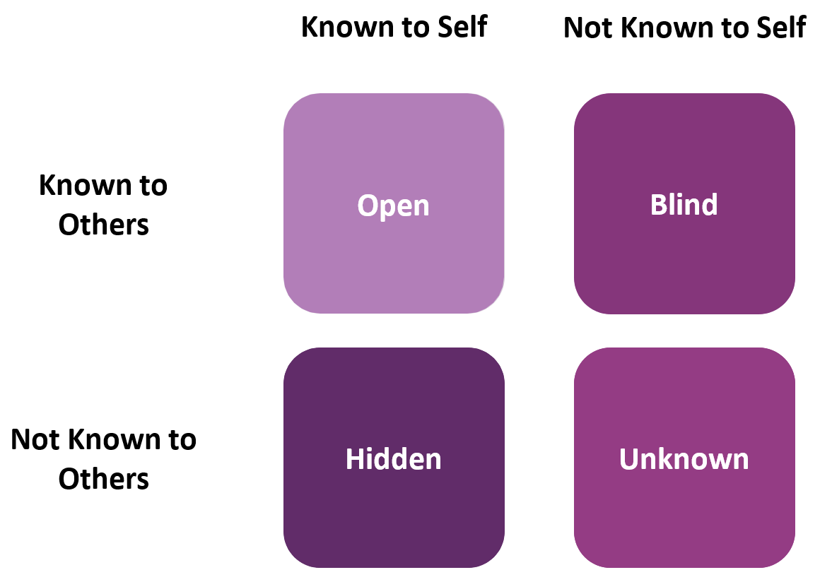
References:
Finlay, L. (2008). Reflecting on ‘Reflective practice’. Practice-based Professional Learning Paper 52, The Open University.
Johns, C. (2009). Becoming a Reflective Practitioner. 3rd ed. UK: Wiley Blackwell.
Schon, D.A. (1995). The Reflective Practitioner: How professionals think in action. UK: Taylor & Francis Ltd.
Luft, J., and Ingham, H. (1955). ‘The Johari window, a graphic model of interpersonal awareness’, Proceedings of the western training laboratory in group development. Los Angeles: UCLA.

Related resources
Refer to the Practice Review Framework for NDIS Providers for a complete list of documents related to this series.
Practice Review Framework for  NDIS Providers | How to do a practice review fact sheet | How to engage people  in a practice review
Questions and prompts to use in a practice review with people with disability | Consulting with people with disability during a practice review

Contact Us
Call: 1800 035 544 (free call from landlines).
Our contact centre is open 9.00am to 5.00pm (9.00am to 4.30pm in the NT), Monday to Friday, excluding public holidays.
Email: contactcentre@ndiscommission.gov.au
Website: www.ndiscommission.gov.au

