NDIS Quality and Safeguards Commission

Regulated Restrictive Practices

Easy Read guide

How to use this guide
The NDIS Quality and Safeguards Commission (NDIS Commission) wrote this guide.
When you see the word ‘we’, it means the
NDIS Commission.
We wrote this guide in an easy to read way. We use pictures to explain some ideas.
We have written some words in bold.
This means the letters are thicker and darker. We explain what these words mean.
This Easy Read guide is a summary of
another guide.
This means it only includes the most important ideas.
You can find the other guide on our website at www.ndiscommission.gov.au/document/2236
You can ask for help to read this guide.
A friend, family member or support person
may be able to help you.

What’s in this guide?
About this guide 4
What are rights? 7
What is a behaviour of concern? 9
What is behaviour support? 11
Who can write behaviour support plans? 13
What are regulated restrictive practices? 14
What happens when an environmental restraint is in place for someone else? 21
What is a prohibited practice? 22
What are the Rules? 23
Who must follow the Rules? 25
What are important points about the use of restrictive practices? 26
How to stop or use restrictive practices less 27
Asking questions 28
For more information 30

About this guide
This guide was written for participants of the National Disability Insurance Scheme (NDIS) and other people supporting them.
The NDIS is a way the Australian Government supports people with disability.
Participants are people with disability who
take part in the NDIS.

 | This guide is about:
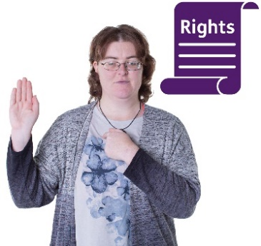 | - the rights of people with disability
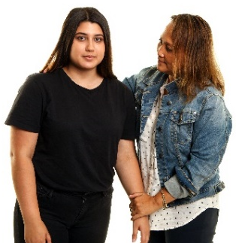 | - the role of positive behaviour support  in helping you
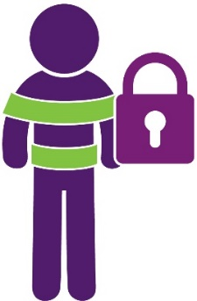 | - the use of restrictive practices.
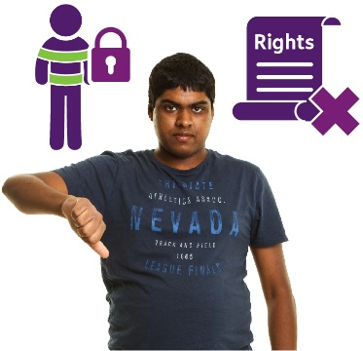 | Restrictive practices can take away your rights.
They stop you from going places and doing
what you want.
Restrictive practices are sometimes used
to help keep you safe.
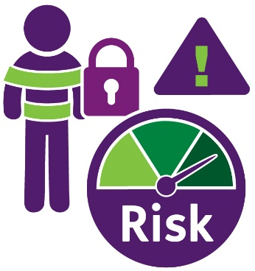 | Restrictive practices can also have risks.
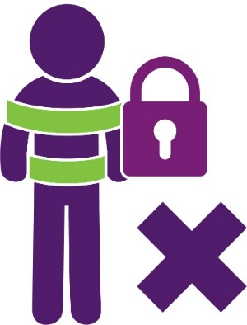 | Restrictive practices must be used less  and stopped whenever possible.

What are rights?
 | Rights are things that every person should have.
 | For example, you have the right to:
 | - be safe
 |  | - be treated fairly
 |  | - be respected for who you are
 |  | - participate in activities.
 |  | There are laws to protect your rights.
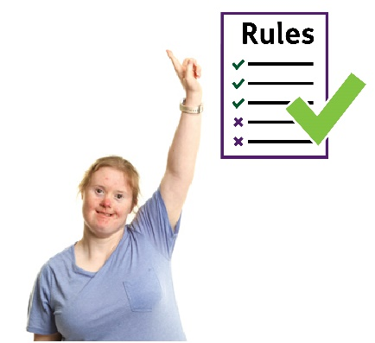 |  | Laws are rules about how people should  behave. Everyone should follow the laws.
People can get into trouble if they do not
follow the laws.

What is a behaviour of concern?
A behaviour of concern is something that can cause harm to you or to the people around you.
It can be something you say or do.
For example:
- breaking something
- hitting someone
- hitting yourself
- yelling at someone.
Behaviours of concern can happen for many reasons. They can happen when things are not going well in your life or your needs are not
being met.
For example:
- if you are feeling unhappy, sad, scared, angry, confused, worried or sick
- when there are lots of changes in your life
- when you are misunderstood or not
listened to.

What is behaviour support?
 | Behaviour support involves:
 | - Working closely with you, your family and other people to help you live your best life.
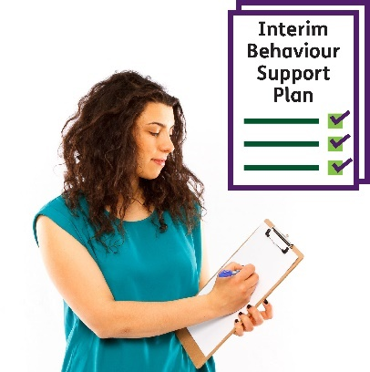 | - Finding ways to keep everyone safe.  This is written in an interim behaviour support plan.
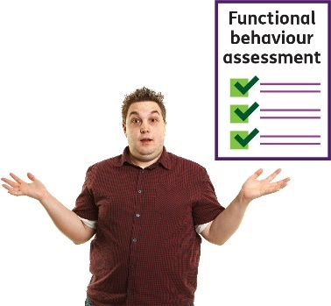 | - Understanding what is happening and why.  This is called a functional behaviour assessment.
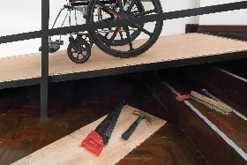 | - Making changes to your environment  to meet your needs.
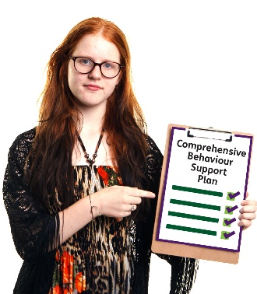 | - Teaching you new skills and ways to  cope when things are not going well.  This is written in a comprehensive behaviour support plan.
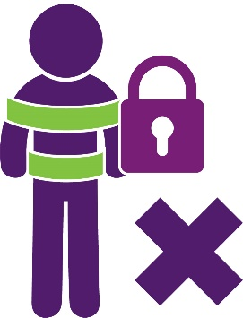 | - Using less or no restrictive practices  if possible.  Restrictive practices stop you from  doing what you want and can take  away your rights.
- Checking to make sure things are
getting better for you.

Who can write behaviour support plans?
People who write behaviour support plans
are called behaviour support practitioners.
A behaviour support practitioner can help you
to live your best life. They help by providing behaviour support.
They will write the plan with you, your family
and other people who support you.
For example, your teachers, support workers
and even your doctor.

What are regulated restrictive practices?
The NDIS Commission regulates five types
of restrictive practices.
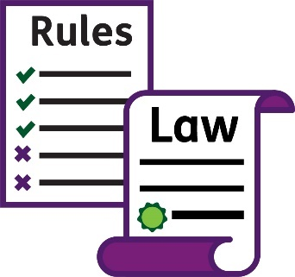 | This means there are laws and rules about  their use. We look at how they are used.
 | They include:
 | - Seclusion
 | - Chemical restraint
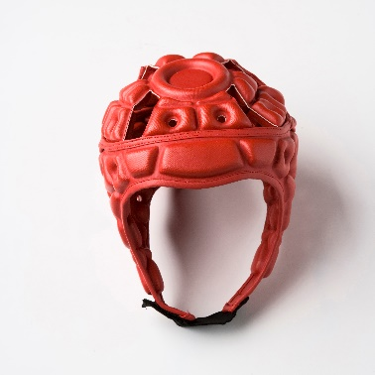 | - Mechanical restraint
 | - Physical restraint
 | - Environmental restraint.
 | These are explained in more detail on the following pages.

What is seclusion?
This is when you are in a room alone and you are not allowed to leave.
For example, being made to stay in a room
on your own.

What is chemical restraint?
This is when you are given medicine to change
or stop a behaviour.
For example, taking medicine to help stop
you from hurting yourself.
This does not include any regular medicine you might be given by your doctor for things not related to behaviour.
For example, it is not chemical restraint if your doctor gives you medicine to help you get better from a cold or flu.

What is mechanical restraint?
This is when a device or equipment is used
to stop a behaviour.
For example:
- Putting on a helmet to stop you from hurting your head if you are banging it
on a wall.
- Wearing certain clothing such as a body
suit to stop you from picking your skin
and hurting yourself.
This does not include devices or equipment that support your body or help your body to heal.
For example, wearing a cast to help your arm
heal from a fracture.

What is physical restraint?
This is when someone stops you from moving
a part of your body to stop a behaviour.
For example, if someone holds your arm down
to stop you from hitting yourself.
Physical restraint does not include someone holding a part of your body to help you with
an activity.
For example, someone holding out your arm
to help you get dressed.

What is environmental restraint?
Environmental restraint is when you are
stopped from:
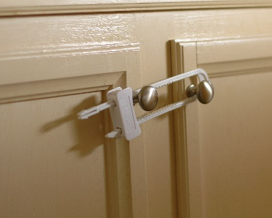 | - having certain things
 | - doing certain activities
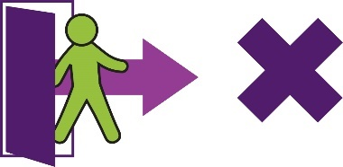 | - going to certain places in your home  or in the community.

 | For example, if someone:
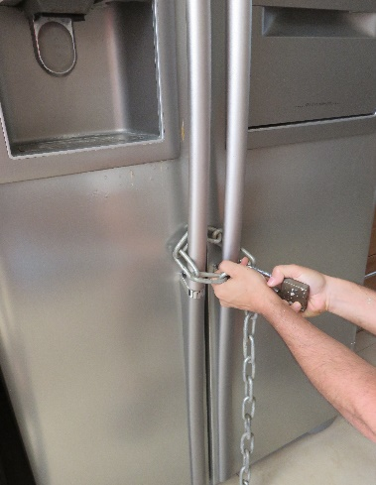 | - locks the fridge to stop you from eating  too much food
- locks the front door to stop you from
leaving your home.
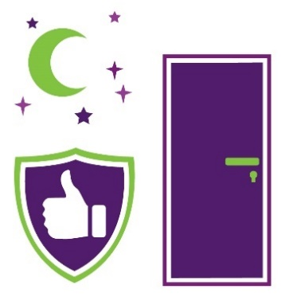 | Locking the front door at night for safety is not  an environmental restraint, as long you can still leave if you wanted to.

What happens when an environmental restraint is in place for someone else?
It can be hard if you live with someone who
needs environmental restraint.
For example, your front door may need to
be locked to protect someone you live with.
But your NDIS providers need to make sure
you can still leave when you want to.
NDIS providers include any services that
are paid for by a person’s NDIS plan.

What is a prohibited practice?
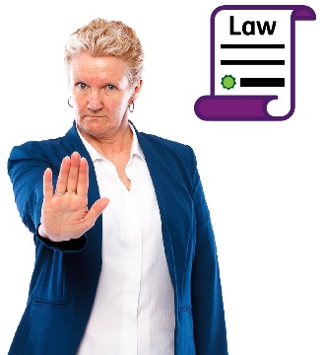 | Some things are never ok.  They are prohibited by law. These laws can  be different in each state and territory.  Prohibited means that NDIS providers are  not allowed to do these things.
 | Some examples of prohibited practices are:
 | - something done to punish you
 | - taking away your basic needs and supports
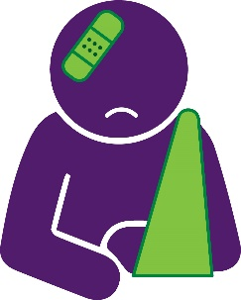 | - using too much pressure that causes you physical injury or pain.

What are the Rules?
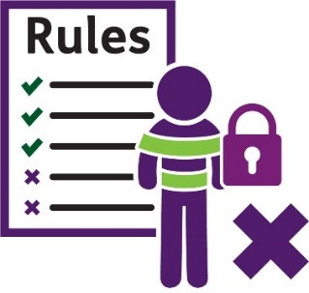 | There are Rules about the use of regulated restrictive practices.
The Rules say that regulated restrictive
practices should:
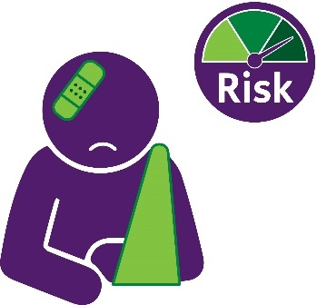 | - only be used if you or others are at risk  of getting hurt
 | - help keep everyone safe
 | - be used after trying other things first
 | - be used for the shortest time possible
- be used less or stopped over time.
This may involve teaching you new things
or helping you to join in activities.
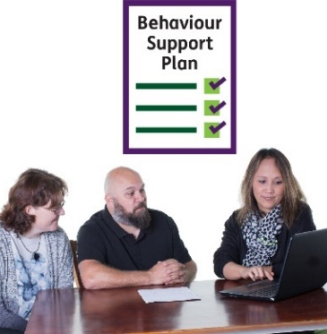 | - be included in your behaviour support plan.  This plan must be written with you, your family and other people who support you.
 | A copy of the plan must also be given to the NDIS Commission.
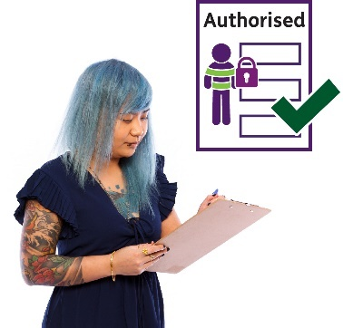 | - be authorised or approved for use by an NDIS provider (if required). This happens in different ways in each state and territory.
- be reported to us when used by
NDIS providers.

Who must follow the Rules?
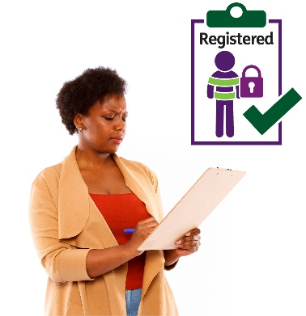 | NDIS providers who use regulated restrictive practices or write behaviour support plans need to be registered.
This means they have been checked and approved.
They have to follow the Rules.
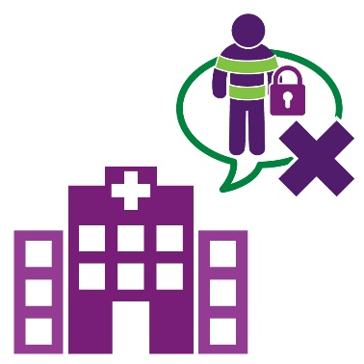 | Services that are not paid for by your NDIS plan do not need to report to us. The Rules do not apply to them.
Families do not need to tell us about their use
of restrictive practices.

What are important points about the use of restrictive practices?
Restrictive practices can be upsetting and
should only be used for serious behaviours
of concern.
NDIS providers who support you need to be
well trained when using a restrictive practice. They need to make sure you are safe.
You should always have a say about any restrictive practice that is in your plan.
The reason for a restrictive practice should
be explained to you before it is used.

How to stop or use restrictive practices less
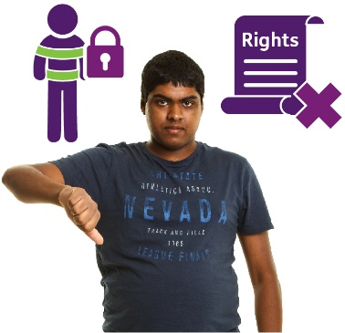 | Restrictive practices are sometimes used to help keep you safe. However, they also take away your rights. They stop you from going places and doing what you want.
 | It is important that everyone works together to:
- use less or no restrictive practices
whenever possible
 | - find other ways to meet your needs
- help you learn new things and have the
best life possible.

Asking questions
 | If you have more questions about restrictive practices, you can talk to your:
 | - NDIS provider
 | - behaviour support practitioner.
 | You can ask them questions such as:
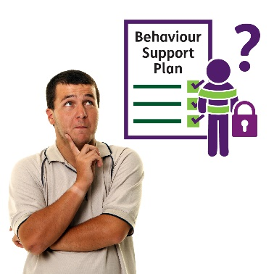 | - Why do I have a restrictive practice  in my behaviour support plan?
- When will a restrictive practice be used
and how?
- How will you keep me safe when using
a restrictive practice?
 | - How will you stop or use a restrictive practice less over time?
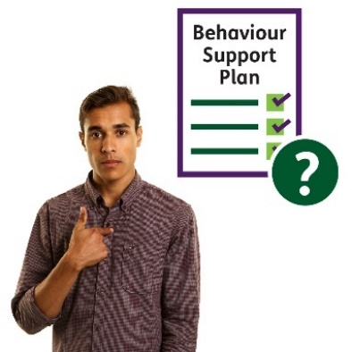 | - Does my behaviour support plan tell you who I am and what my needs are?
 | You can also contact the NDIS Commission if you have any questions about a restrictive practice.

For more information
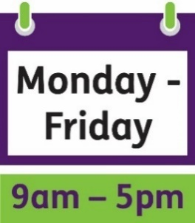 | You can call the NDIS Quality and Safeguards Commission from 9am to 5pm, Monday to Friday.  1800 035 544
 | You can visit our website: www.ndiscommission.gov.au
You can email our national behaviour support team:
behavioursupport@ndiscommission.gov.au
You can email the behaviour support team where
you live:
- ACTBehaviourSupport@ndiscommission.gov.au
- NSWBehaviourSupport@ndiscommission.gov.au
- NTBehaviourSupport@ndiscommission.gov.au
- QLDBehaviourSupport@ndiscommission.gov.au
- SABehaviourSupport@ndiscommission.gov.au
- TASBehaviourSupport@ndiscommission.gov.au
- VICBehaviourSupport@ndiscommission.gov.au
- WABehaviourSupport@ndiscommission.gov.au
You can write to us:
NDIS Quality and Safeguards Commission
PO Box 210
Penrith
NSW 2750
TTY
133 677
The National Relay Service
Speak and Listen
1300 555 727
SMS relay number
0423 677 767
Internet relay calls
internet-relay.nrscall.gov.au

The Information Access Group supported the NDIS Quality and Safeguards Commission to create this Easy Read document.
We reviewed the Easy Read text developed by the NDIS Quality and Safeguards Commission and provided our recommendations.
We developed the Easy Read images using stock photography and custom images. The images may not be reused without permission. For any enquiries about the images, please visit www.informationaccessgroup.com.
Quote job number 4054-A

