NDIS Quality and Safeguards Commission

Regulated Restrictive Practices with children and young people with disability

Easy Read guide

How to use this guide
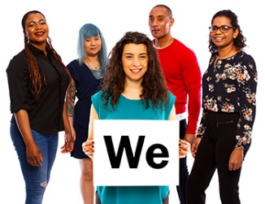 | The NDIS Quality and Safeguards Commission (NDIS Commission) wrote this guide.  When you see the word ‘we’, it means the  NDIS Commission.
We wrote this guide in an easy to read way.
We use pictures to explain some ideas.
We have written some words in bold.
This means the letters are thicker and darker. We explain what these words mean.
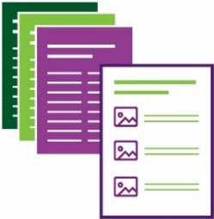 | This Easy Read guide is a summary of  another guide.  This means it only includes the most  important ideas.
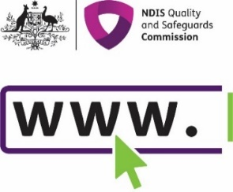 | You can find the other guide on our website at www.ndiscommission.gov.au/document/2741
You can ask for help to read this guide.
A friend, family member or support person
may be able to help you.

What’s in this guide?
About this guide 4
What are rights? 6
What are behaviours of concern? 8
Who can help and how? 11
What is behaviour support? 12
What are regulated restrictive practices? 14
What are prohibited practices? 17
What is not a regulated restrictive practice? 18
What are the Rules? 20
Using regulated restrictive practices 22
Who must follow the Rules? 24
How to stop or use restrictive practices less 25
For more information 26

About this guide
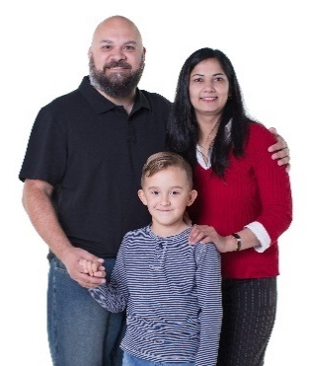 | This guide was written for children, young  people and their families. It may also be  of interest to others.
 | This guide is about:
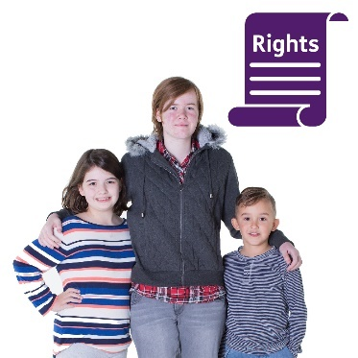 | - the rights of children and young people  with disability
- the role of positive behaviour support
in helping them
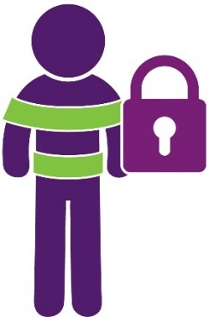 | - the use of restrictive practices.
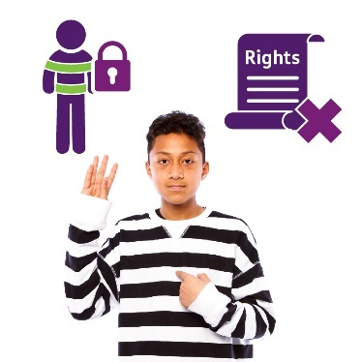 | Restrictive practices can take away children  and young people’s rights.
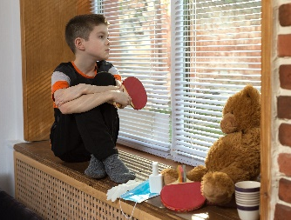 | They stop them from going places and doing  what they want.
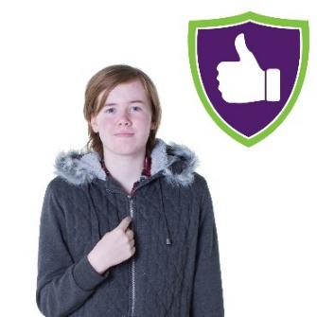 | Restrictive practices are sometimes used  to help keep children and young people safe.
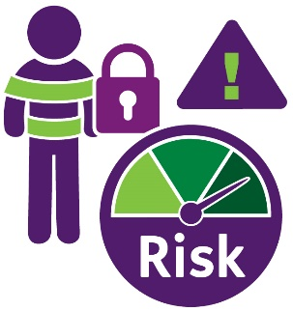 | Restrictive practices can also have risks.
Restrictive practices must be used less
and stopped whenever possible.

What are rights?
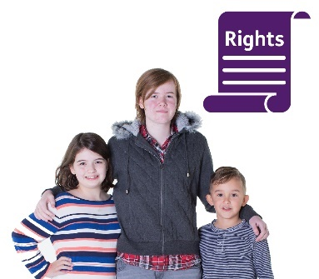 | Rights are things that every child or young person should have.  They are things they should be able to do.
 | For example, all children have the right to:
 | - be safe
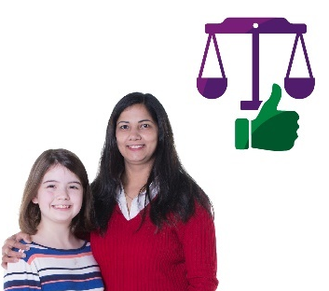 | - be treated fairly
 | - be respected for who they are
 | - participate in activities.
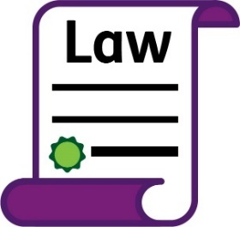 | There are laws about the rights of children  and young people.
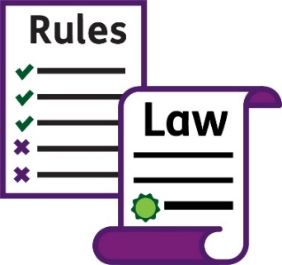 | Laws are rules about how people should behave. Everyone should follow the laws.
 | People can get into trouble if they do not follow the laws.

What are behaviours of concern?
Children and young people sometimes do things that put themselves or others in danger.
These are called behaviours of concern.
They may:
- yell, hit, kick, bite, bang their head,
throw things or take things that
they shouldn’t
- get into trouble at school, home or with
the police
- not get to go to certain places or do
certain activities.

There are many different reasons why
behaviours of concern can happen.
For example, children and young people
can have difficult times in their life.
 | They may:
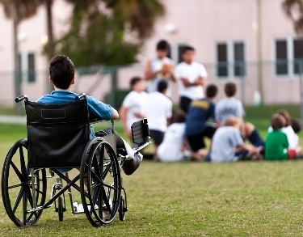 | - not be getting what they need
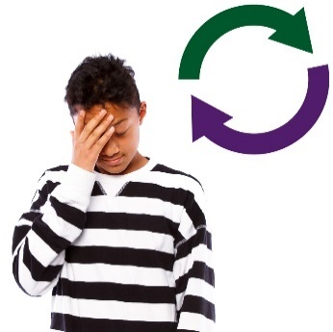 | - be going through lots of change
- feel sad, scared, angry, confused,
worried or sick
 | - find it hard to get along with others
- feel like other people are not listening
to them.
Children and young people may need some
extra help at these times.

Who can help and how?
 | Children and young people can get help from many people.
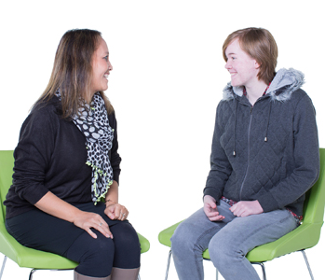 | This includes their family, friends, teachers,  carers and doctor.  It also includes their behaviour  support practitioner.
Behaviour support practitioners help people
to live their best life.
They do this by providing behaviour support.

What is behaviour support?
 | Behaviour support involves:
 | - Everyone working together to help children and young people to live their best life.
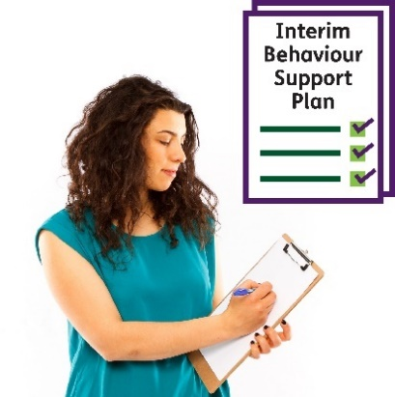 | - Finding ways to keep everyone safe.  This is written in an interim behaviour support plan.
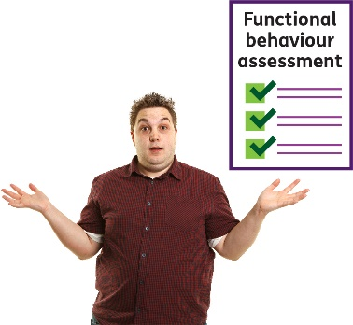 | - Understanding what is happening and why.  This is called a functional behaviour assessment.
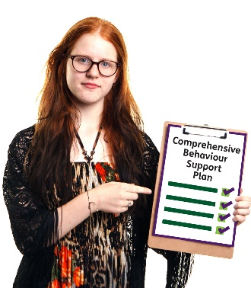 | - Meeting the child or young person’s needs and teaching them new skills.  This is written in a comprehensive behaviour support plan.
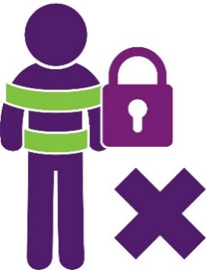 | - Using less or no restrictive practices  if possible.
Restrictive practices stop children
and young people from doing what
they want.
They can take away their rights.
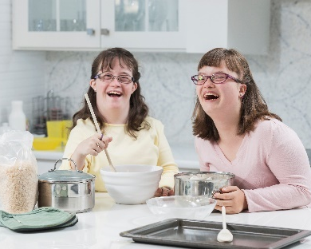 | - Checking to make sure things are  getting better.

What are regulated restrictive practices?
The NDIS Commission regulates five types
of restrictive practices.
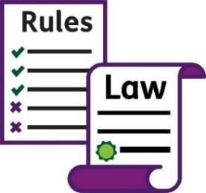 | This means there are laws and rules about their use. We look at how they are used.
 | Regulated restrictive practices include:
- Seclusion.
This is when a child or young person is
in a room on their own and they are not allowed to leave.
 | NDIS providers are not allowed to do this with children and young people in some states and territories.
 | NDIS providers work with children and young people with disability. They are paid for by their NDIS plan.
- Chemical restraint.
This is when medicine is used to change
or stop a behaviour.
For example, a child taking medicine
to help them stop hurting themselves.
- Mechanical restraint.
This is when a device is used to stop
a behaviour.
For example, a child or young person wearing a splint to stop them biting themselves.
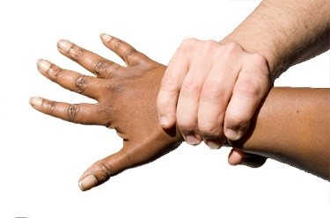 | - Physical restraint.  This is when someone stops a child or young person from moving a part of their body.  For example, holding a young person’s arm to stop them from hitting another person.
NDIS providers are not allowed to use
certain types of physical restraint in
some states and territories.
These can be dangerous.
For example, holding a young person face down on the ground.
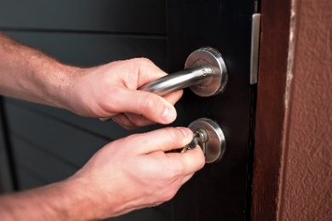 | - Environmental restraint.  This is when a child or young person is stopped from having certain things, doing certain activities or going to certain places.  For example, locking a door to stop a child from going into their yard or bedroom.

What are prohibited practices?
Some things such as physically hurting a child
or young person is never ok.
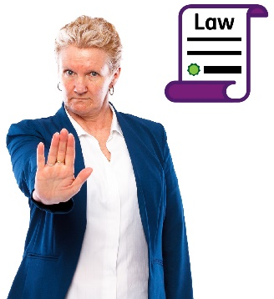 | This is prohibited by law.  This means that NDIS Providers are not  allowed to do these things.

What is not a regulated restrictive practice?
Not all things that adults do to keep children
and young people safe are regulated
restrictive practices.
 | For example:
- holding a child’s hand when they cross
the road
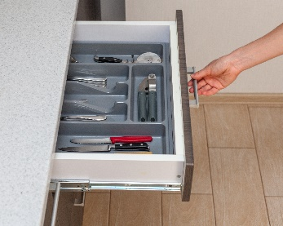 | - putting dangerous things out of reach of young children, such as lighters and knives
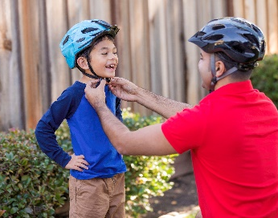 | - making sure a child or young person wears a helmet when they ride their bike.
 | These strategies are used with children and young people of a similar age.
 | They are used with children both with and without disability.
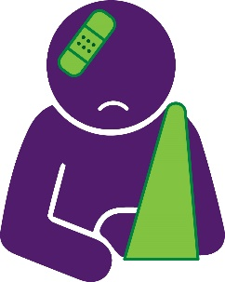 | They are used to prevent injuries.
They are not used in response to behaviours
of concern.
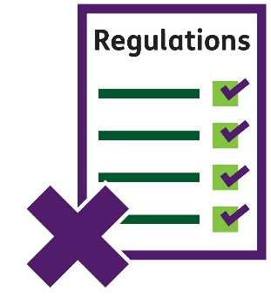 | They are not regulated restrictive practices.
 | They are not looked at by the NDIS Commission.

What are the Rules?
 | There are Rules about:
 | - how to work with children, young people and their families
 | - who can provide behaviour support
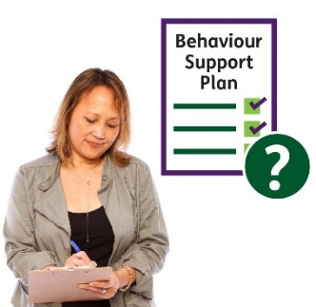 | - how behaviour support plans are written and what needs to be in them
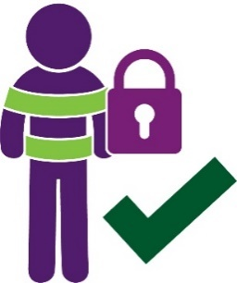 | - the use of regulated restrictive practices
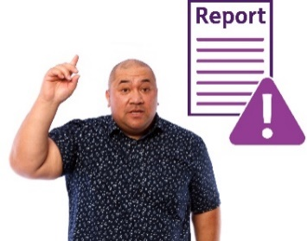 | - reporting.
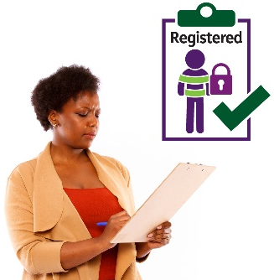 | For example, NDIS providers who use regulated restrictive practices or write behaviour support plans need to be registered.
 | This means they have been checked and approved. They have to follow the Rules.

Using regulated restrictive practices
 | Regulated restrictive practices should:
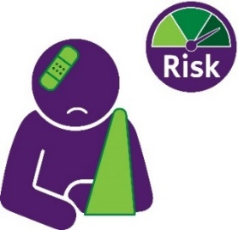 | - only be used if someone is at risk  of getting hurt
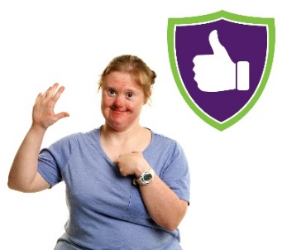 | - help keep everyone safe
 | - be used after trying other things first
 | - be used for the shortest time possible
- be used less or stopped over time.
This may involve teaching children and young people new things or helping them
to join in activities.
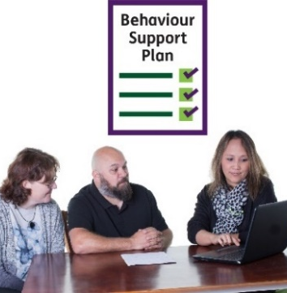 | - be included in a behaviour support plan.  This plan must be written with the child or young person, their family and other people who support them.
A copy of the plan must also be given
to the NDIS Commission.
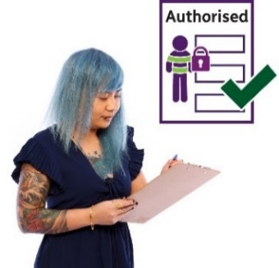 | - be authorised or approved for use  by an NDIS provider (if required).  This happens in different ways in each  state and territory.
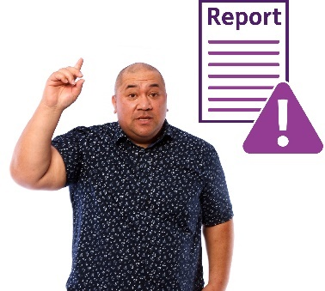 | - be reported to us when used by  NDIS providers.

Who must follow the Rules?
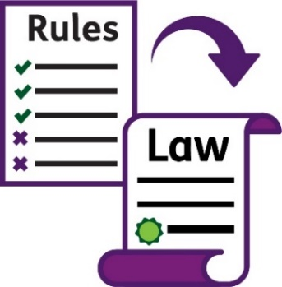 | Registered NDIS providers must follow the Rules when supporting children and young people with disability. These Rules are law.
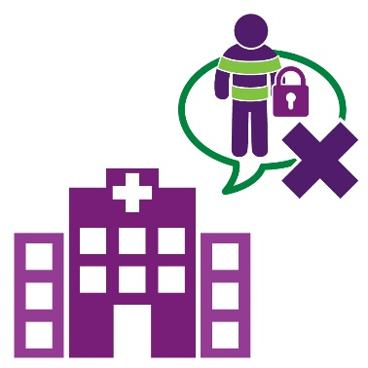 | Services that are not paid for by the child or young person’s NDIS plan do not need to report  to us. The Rules do not apply to them.
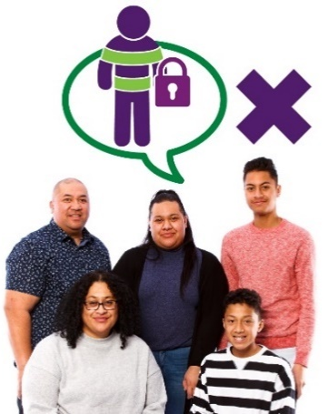 | Families do not need to tell us about their use  of restrictive practices.

How to stop or use restrictive practices less
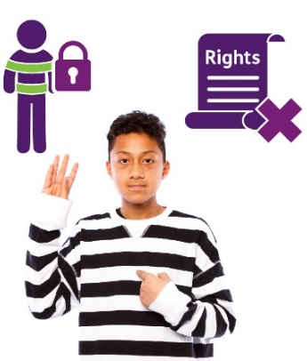 | Restrictive practices are sometimes used to help keep children and young people safe. However, they also take away their rights. They stop them from going places and doing what they want.
 | It is important that everyone works together to:
- use less or no restrictive practices
if possible
- find other ways to meet children
and young people’s needs
- help children and young people learn
new things and have the best life possible.

For more information
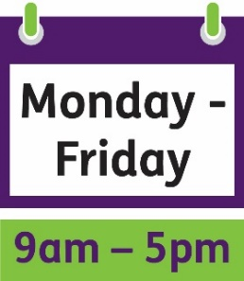 | You can call the NDIS Quality and Safeguards Commission from 9am to 5pm, Monday to Friday.  1800 035 544
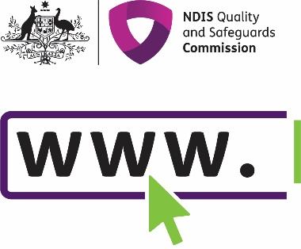 | You can visit our website: www.ndiscommission.gov.au
You can email our national behaviour support team:
behavioursupport@ndiscommission.gov.au
You can email the behaviour support team where
you live:
- ACTBehaviourSupport@ndiscommission.gov.au
- NSWBehaviourSupport@ndiscommission.gov.au
- NTBehaviourSupport@ndiscommission.gov.au
- QLDBehaviourSupport@ndiscommission.gov.au
- SABehaviourSupport@ndiscommission.gov.au
- TASBehaviourSupport@ndiscommission.gov.au
- VICBehaviourSupport@ndiscommission.gov.au
- WABehaviourSupport@ndiscommission.gov.au
You can write to us:
NDIS Quality and Safeguards Commission
PO Box 210
Penrith
NSW 2750
TTY
133 677
The National Relay Service
Speak and Listen
1300 555 727
SMS relay number
0423 677 767
Internet relay calls
internet-relay.nrscall.gov.au

The Information Access Group supported the NDIS Quality and
Safeguards Commission to create this Easy Read document.
We reviewed the Easy Read text developed by the NDIS Quality and Safeguards Commission and provided our recommendations.
We developed the Easy Read images using stock photography and custom images. The images may not be reused without permission.
For any enquiries about the images, please visit www.informationaccessgroup.com.
Quote job number 4054-B

