What is TelePBS

Easy English

July 2021

Positive Behaviour Support (PBS) helps people to:
- live better lives
- participate in their community
- have fewer behaviours of concern

Behaviours of concern are actions that might not be safe.
For example, if a person hurts someone

TelePBS is getting Positive Behaviour Support using your phone, computer, or tablet

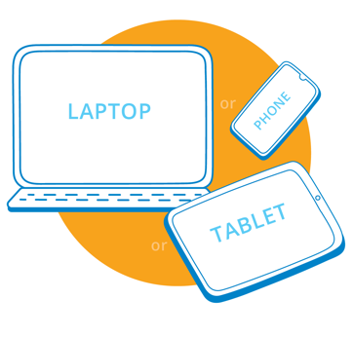

You can choose different ways to get TelePBS

You can talk to your behaviour support worker
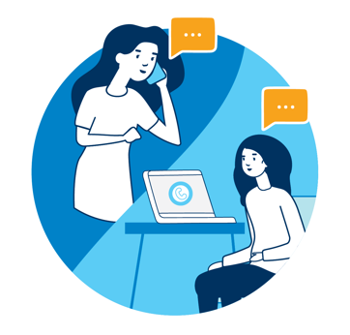

You can see and talk to your behaviour support worker

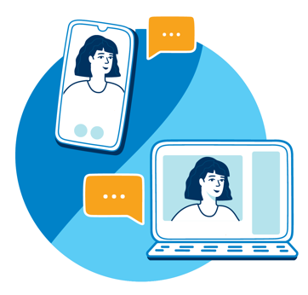

You can text message or email your behaviour support worker

Sometimes you can see your behaviour support worker in person too

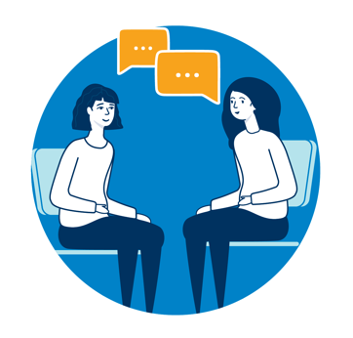

Some questions you can think about:
- How do I want to get TelePBS?

- Do I have internet access on my phone or computer so that I can use TelePBS?
- Do I need help with my phone or computer to use TelePBS?

Useful links
Interpreter services: TIS National
www.tisnational.gov.au

NDIS resources
https://www.ndiscommission.gov.au/resources

Authors:
Dr. Genevieve Johnsson, Autism Spectrum Australia, University of Sydney Centre for
Disability Research and Policy
Dr. Kim Bulkeley, University of Sydney Centre for Disability Research and Policy
© Copyright 2021

