Fact Sheet: When to notify the NDIS Commission about a reportable incident

The NDIS Commission regulates how registered NDIS providers manage serious incidents.
All NDIS providers – registered or unregistered – are responsible for the delivery of quality and safe NDIS supports and services.
Registered NDIS providers (you) are required to have incident management systems in place that meet certain requirements. They are also required to notify us of all reportable incidents that occur, or are alleged to have occurred, in connection with their provision of NDIS supports or services.
Reportable incidents include the following:
- The death of a person with disability
- Serious injury of a person with disability
- Abuse or neglect of a person with disability
- Unlawful sexual or physical contact with, or assault of, a person with disability (excluding, in the case of unlawful physical assault, where the contact with, and impact on, the person is negligible)
- Sexual misconduct committed against, or in the presence of, a person with disability, including grooming of the person for sexual activity
- The use of a restrictive practice in relation to a person with disability if the use is unauthorised, i.e. not in accordance with an authorisation (however described) of a State or Territory that has an authorisation process in relation to the use of that practice or not in accordance with a behaviour support plan for the person.
You need to notify the NDIS Commission (us) within set timeframes about reportable incidents that occur, or are alleged to have occurred, in connection with your provision of NDIS supports and services. Most reportable incidents must be notified to us within 24 hours of you becoming aware of the incident.
An exception to this rule is notifying the NDIS Commission of the use of a restrictive practice that is unauthorised or not in accordance with a behavior support plan. In these instances, the provider must notify the NDIS Commission within five business days of being made aware of the incident. If however, the incident has resulted in harm to a person with disability, it must be reported within 24 hours.
When you notify us of a reportable incident, you need to provide specific information about the incident and any steps already taken in response to the incident. More information on this can be found in the Information Requirements for reportable incident notification factsheet on our website.

What reports we don’t take
Incidents involving people with disability that do not occur in connection with the provision of NDIS supports or services do not have to be reported to us. For example, an incident that occurs in a school setting involving a teacher and a student with disability would be reported to the relevant State or Territory body, as opposed to us.
If you become aware of an incident that occurred, or is alleged to have occurred, in connection with the provision of NDIS supports or services by another NDIS provider, you can make a complaint about it to our Complaints Team.

Reporting to multiple bodies
All incidents must be recorded and managed within the registered NDIS provider’s incident management system, whether or not they are incidents that have to be reported to the NDIS Commission.
Some incidents may need to be reported to multiple bodies. For example, an unlawful physical assault during the delivery of NDIS supports and services may need to be reported to police and to us. If it involves a child, child safety authorities may also need to be notified. A registered NDIS provider needs to have the reporting and management process for this clearly documented in their incident management system.
Figure 1: Reporting overview on the next page details where different types of incidents or complaints should primarily be reported and where they do not require notification to the NDIS Commission.

Figure 1: Reporting overview
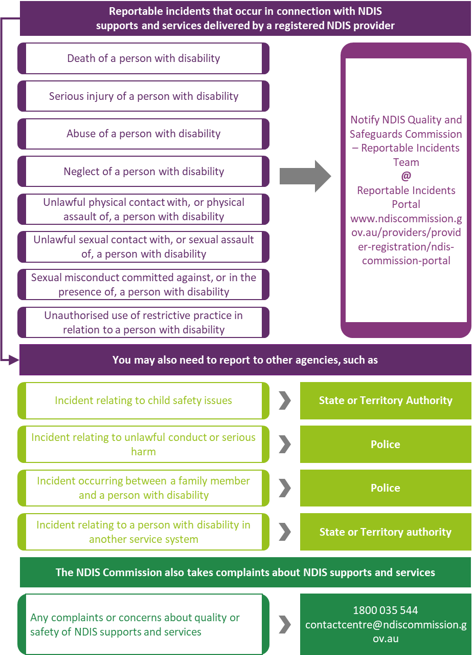

Find out more
You can find out more information and resources on the NDIS Commission website. You can contact the NDIS Commission Reportable Incidents Team at reportableincidents@ndiscommission.gov.au or by calling 1800 035 544

