Getting access to the NDIS Commission Applications Portal
  - Quick reference guide – Applicants
The Quick Reference Guide explains the step-by-step process of successfully logging in to the Applications Portal through PRODA for the first time.
The Applications Portal has two functions it gives you the ability to:
- apply to register as a provider
- be considered suitable as an NDIS behaviour support practitioner
To access the Applications Portal you need a PRODA account.

In this guide
Getting access to the NDIS Commission Applications Portal 1
Logging in to the Applications Portal through PRODA for the first time 1
Logging in to the Applications Portal through PRODA using an existing PRODA account 10
About PRODA 12
Requirements 12
Learn more and register 12
Help with accessing the NDIS Commission Portal 12

Logging in to the Applications Portal through PRODA for the first time
- Go to the NDIS Commission website. Click Portals select Applications Portal
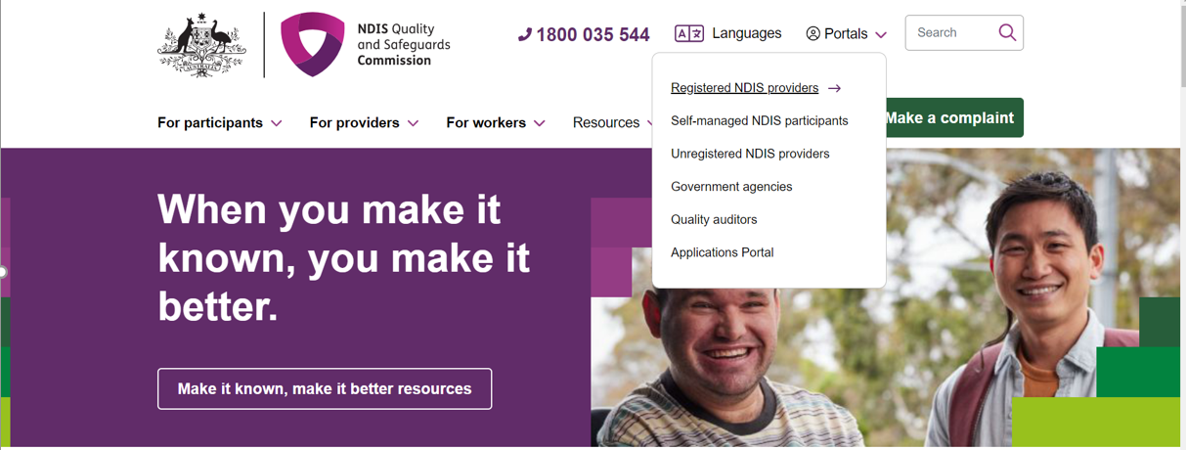
- Once you get to the Applications Portal webpage, click Login with PRODA
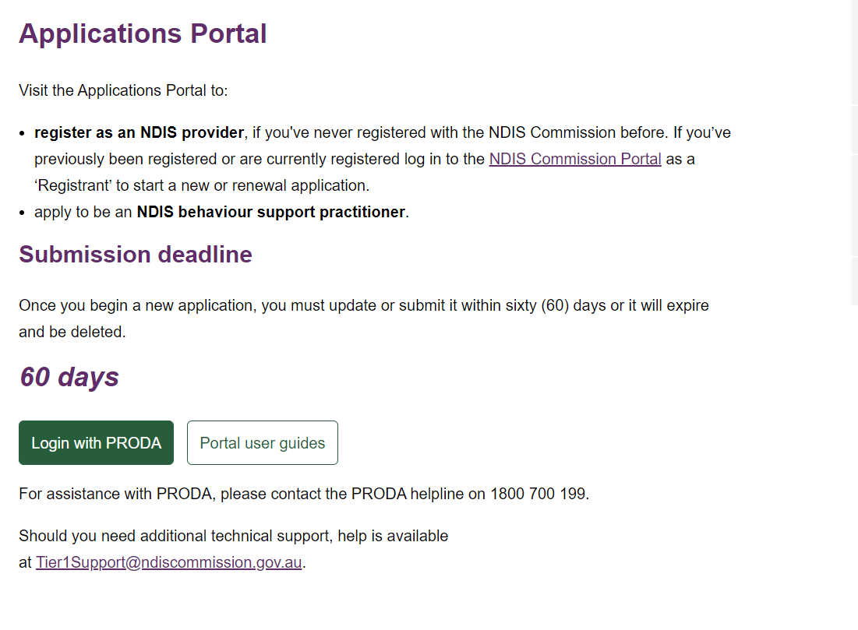
- Enter your details and select login. If you have not registered select Register Now
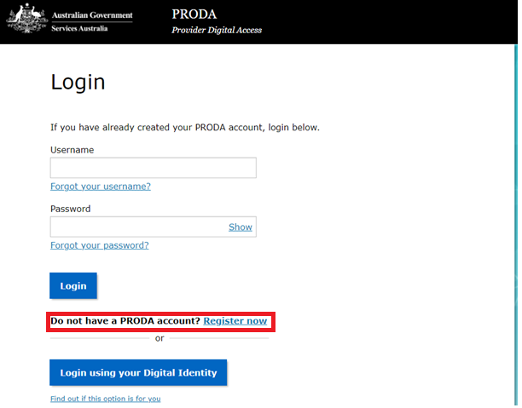
- Follow the steps within PRODA to create your account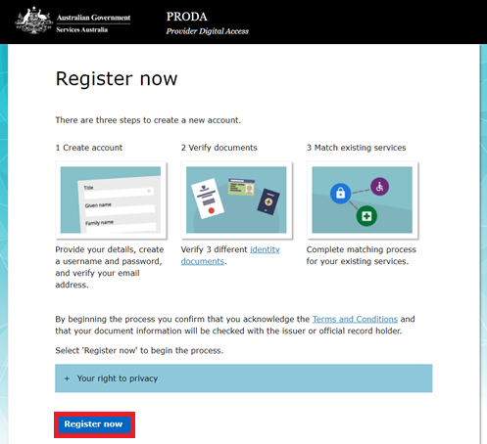
- Once you have been through the registration process, you will receive this notification, “Your identity has been successfully verified!”. Click Next.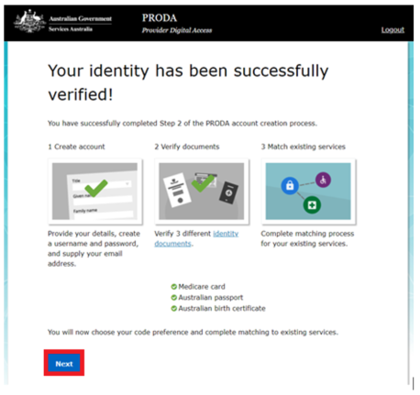
- Select your verification code preference, then select Next
- Once you have received your code and entered it via your preferred method click Next
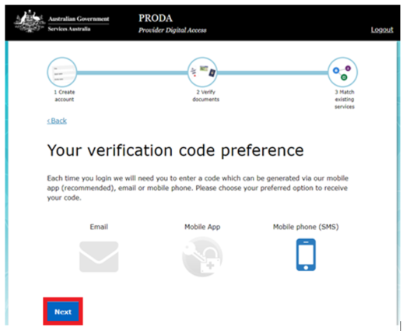

- You will then see other portals that can be linked to your PRODA account. Click on the application portal
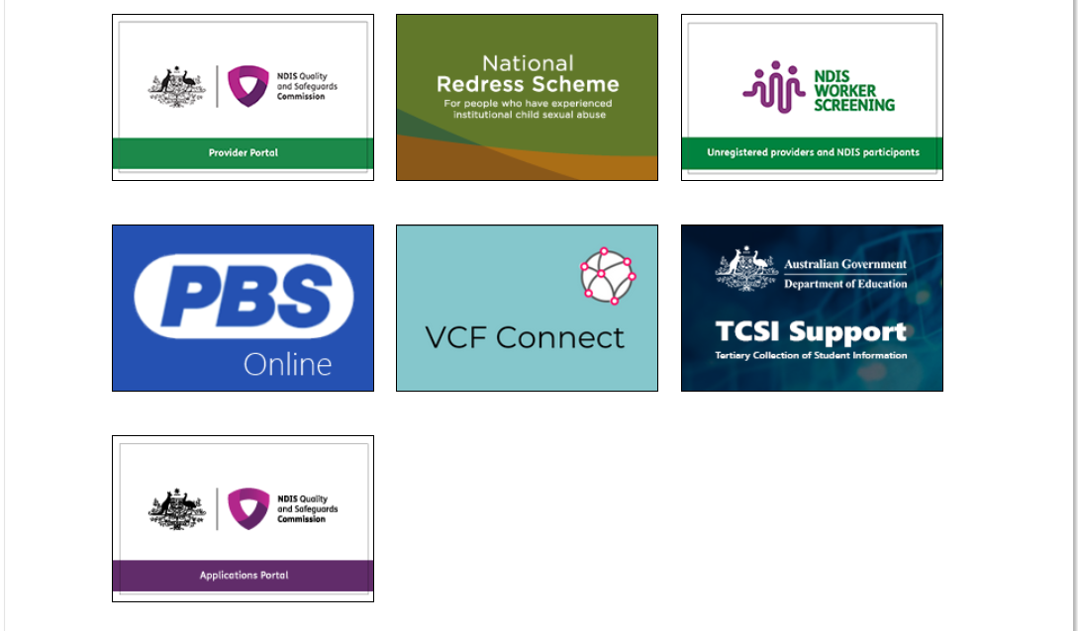
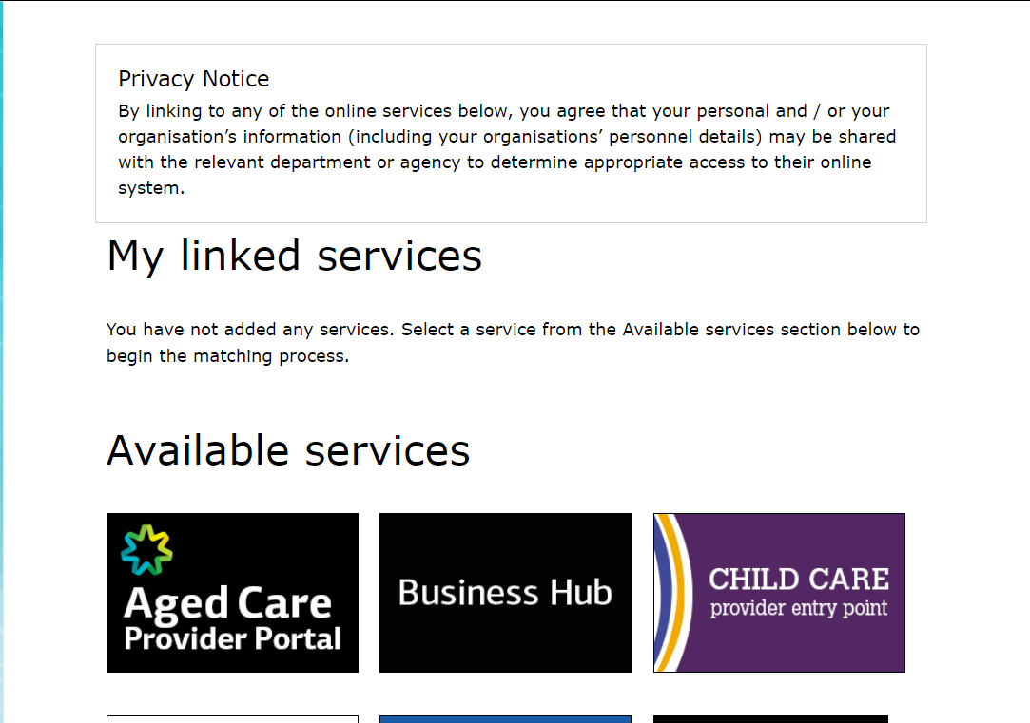

- Login again with your PRODA details if requested. You will be taken to the New portal access page. After you have read the information, select Begin
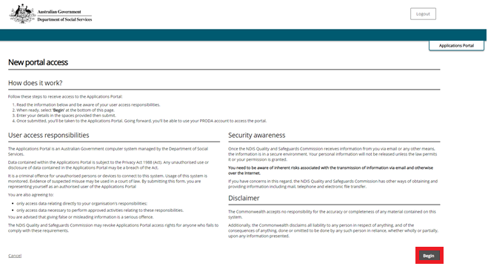
- Fill out your details and click Next
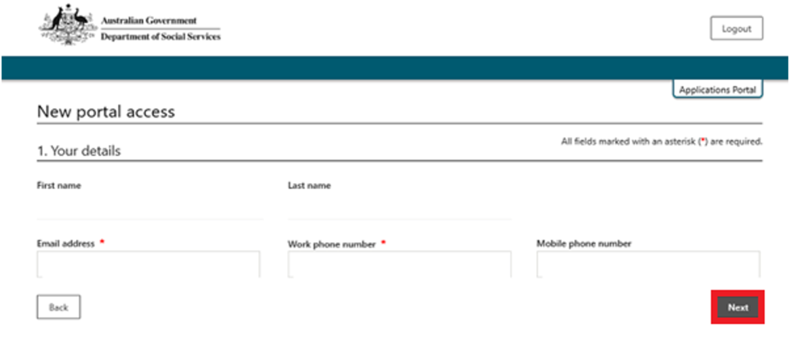
- Check if your details are correct. If correct, tick the confirm button and click submit. If incorrect, select the Back button to correct your details, then repeat this step.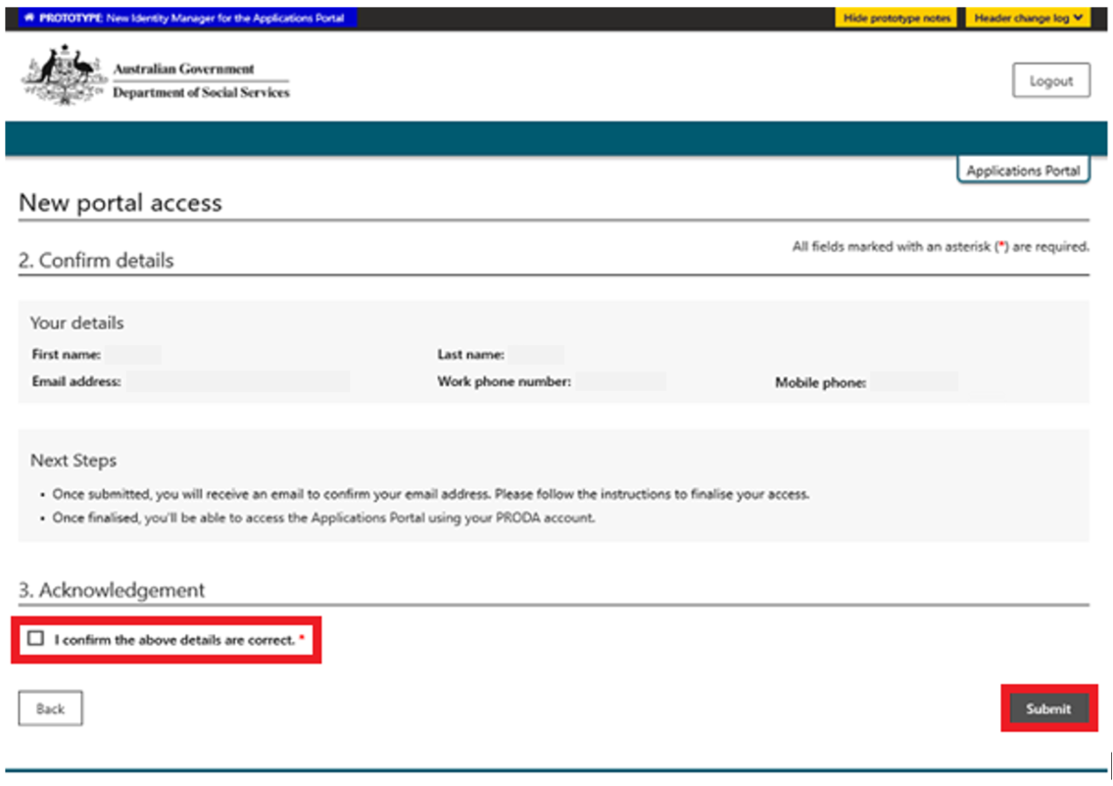

- If all details are correct, select Finish. PRODA will send an email to the email address you have entered. Access this email in your inbox and click Confirm my email address.
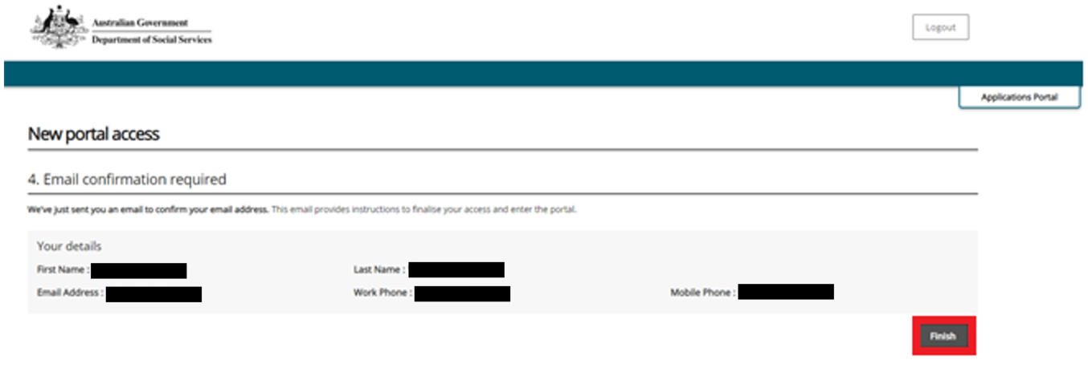
- Once you have confirmed your email address you will take you to the Applications Portal login screen, select I agree.
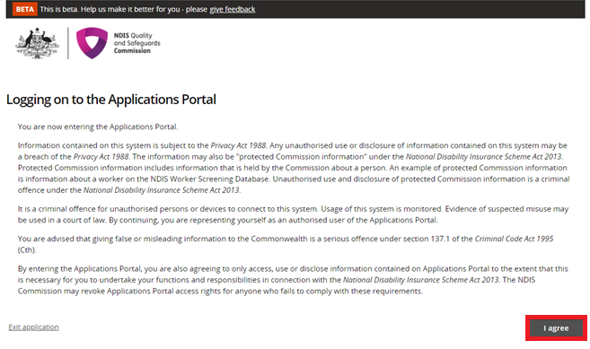
- If you are applying to be a registered Provider, select New application to be registered as an NDIS provider
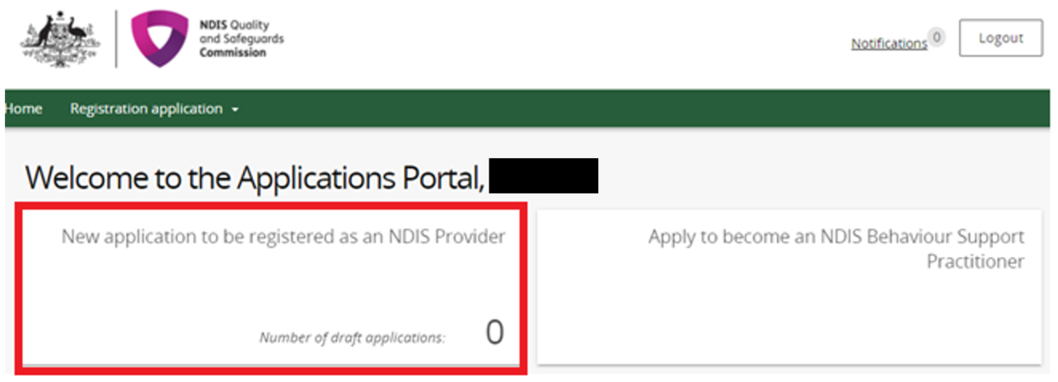
- Click Start new application
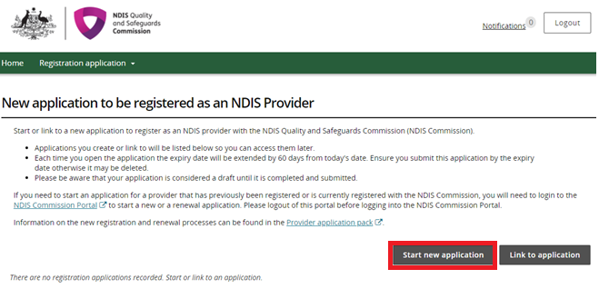
- If you are applying to be considered suitable as an NDIS behaviour support practitioner select Apply to become an NDIS behaviour support practitioner
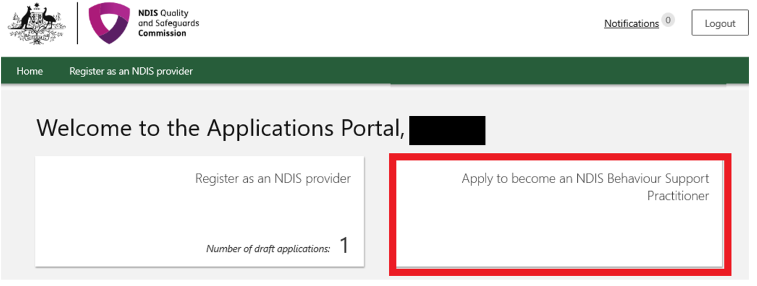

For practitioner applications refer to the quick reference guide: Applying to be considered suitable as an NDIS behaviour support practitioner

Logging in to the Applications Portal through PRODA using an existing PRODA account

- Go to the NDIS Commission website. Click Portals select Applications Portal
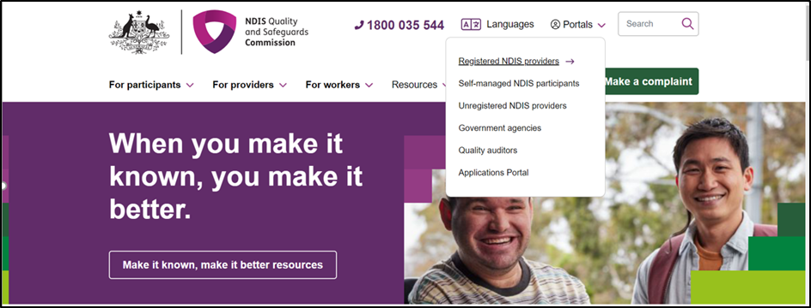

- Once you get to the Applications Portal page, click Login with PRODA
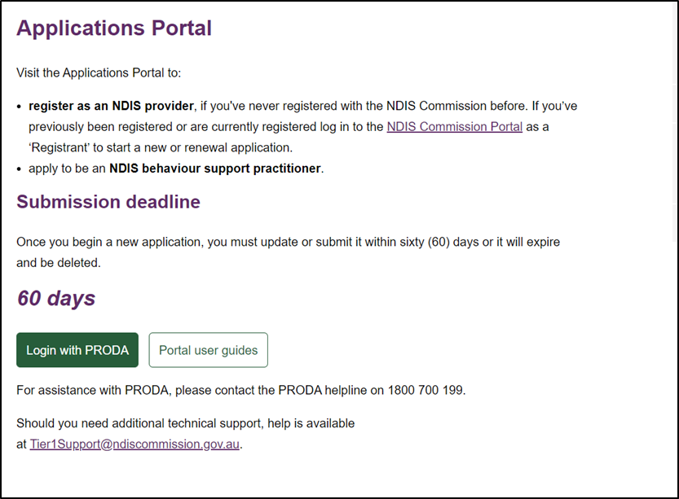
- Enter your username and password. Click Login
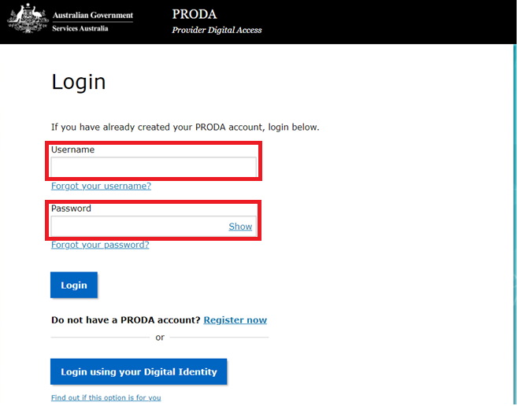

- Enter your verification code
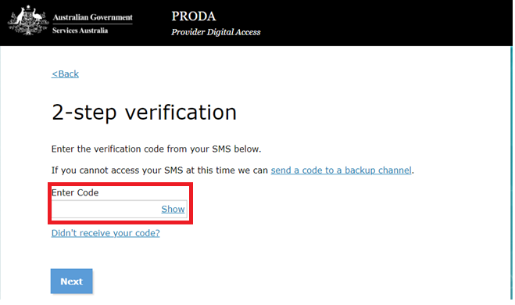
Then follow steps 13 through to 16 in this Quick Reference Guide.

About PRODA
PRODA is an online authentication system used to securely access government online services.
PRODA is managed by the Department of Human Services.
Most individuals who need access to the NDIS Commission Portal will require a PRODA account.
Once you’ve authenticated your identity with PRODA, your username and password will allow you to access multiple online services including the NDIS Commission Portals.

Requirements
- An email address which is unique to you (not a shared email address).
- At least three (3) specified and valid Australian Government issued identity documents to verify your identity online. A full list of acceptable documents is available on the PRODA registration page.
Also, check you are using the minimum browser version required for the service you are accessing. To access PRODA to set up an account you’ll need one of these minimum browser versions:
  - Internet Explorer 9
  - Mozilla Firefox 30
  - Google Chrome 39
  - Safari 5.

Learn more and register
- Register for a PRODA account
- Learn more about PRODA
- PRODA eLearning
If you require assistance with your PRODA account, see the Contact Us section of the PRODA help page

Help with accessing the NDIS Commission Portal
- I do not have a PRODA account, how can I create one?
See Register for a PRODA account to register and create a new PRODA account.
- I am unable to create a PRODA account, what can I do?
Please contact the PRODA Help Desk on 1800 700 199 or by email.
- I have a PRODA account but I cannot log on to the NDIS Commission Portals, what can I do?
If your organisation is registered with the NDIS Commission, contact the NDIS Commission Contact Centre on 1800 035 544 or send us an email.

