Registration renewal process guide
Information for Residential Aged Care providers seeking to renew their registration
September 2022
Version 1

Contents
What is this guide about? 3
About us 3
Residential aged care provider transition registration cycle 4
Why do I need to renew my registration with the NDIS Commission? 6
What are the requirements to register as an NDIS provider under the NDIS Commission? 7
What are the NDIS Practice Standards? 8
When do I need to renew my registration with the NDIS Commission? 10
How do I renew my registration? 11
Assessing against the NDIS Practice Standards 12
Certification 12
Proportionate requirements 12
What happens after I submit an application to renew registration? 13
Can I change my renewal application after it is submitted? 13
More information 14
Annexure A – Step-by-step guidance for renewal of registration with the NDIS Commission 15
Step 1: Accessing PRODA 15
Step 2: Check your access 16
Step 3: Commence renewal 22
Step 4: Start Application 22
Step 5: Organisation details 26
Step 6: Key personnel 28
Step 7: Addresses 29
Step 8: Registration groups 29
Step 9: Service delivery questions 30
Step 10: Self-assessment 31
Step 11: Suitability questions 32
Step 12: Outlets 36
Step 13: Scope of Audit 38
Step 14: Commence Audit process See step 4 on page 5. 38
Step 15: Your auditor will submit your audit to the NDIS Commission through the NDIS Commission Portal 38
See step 5 on page 6. 38
Step 16: The NDIS Commission will assess your suitability and advise you of the application outcome in writing 38
See step 6 on page 6. 38
Glossary of Terms 39

What is this guide about?
This guide outlines the process for residential aged care providers renewing their NDIS provider registration under the requirements of the NDIS Quality and Safeguards Commission (NDIS Commission).

About us
The NDIS Quality and Safeguards Commission is an independent agency established to improve the quality and safety of NDIS supports and services.
We work with NDIS participants, service providers, workers and the community to implement a nationally consistent approach so that across Australia, participants can access services and supports that promote choice, control and dignity.
The NDIS Commission:
- responds to concerns, complaints and reportable incidents, including abuse and neglect of NDIS participants
- promotes the NDIS principles of choice and control, and works to empower participants to exercise their rights to access quality services as informed, protected consumers
- requires NDIS providers to uphold participants' rights to be free from harm
- registers and regulates NDIS providers and oversees the NDIS Code of Conduct and NDIS Practice Standards
- provides guidance and best practice information to NDIS providers on how to comply with their registration responsibilities
- monitors compliance against the NDIS Code of Conduct and NDIS Practice Standards, including undertaking investigations and taking enforcement action
- monitors the use of restrictive practices within the NDIS with the aim of reducing and eliminating such practices
- is working in collaboration with states and territories to design and implement nationally consistent NDIS worker screening
- focuses on education, capacity building and development for people with disability, NDIS providers and workers
- facilitates information sharing with the National Disability Insurance Agency (NDIA), state and territory authorities and other Commonwealth regulatory bodies.

Is the NDIS Commission independent of the National Disability Insurance Agency (NDIA)?
Both the NDIS Commission and the NDIA play a part in ensuring the delivery of the NDIS.
The NDIA’S focus is on:
- providing individualised plans for people with disability; and
- coordinating service bookings, payments and access to plans for providers.
The NDIA will also detect and investigate allegations of fraud. The NDIS Commission does not regulate the NDIA. Complaints about the NDIA or participant plans should be made directly to the NDIA.

Residential aged care provider transition registration cycle

Step 1 – Residential aged care providers supporting NDIS participants transition to regulation by the NDIS Commission.
The Department of Health invoices the NDIA for the NDIS support costs associated with NDIS participants living in residential aged care facilities and the funds are paid through your usual aged care contract payments.
The Department of Health and the NDIA advised the NDIS Commission in November 2020 of all residential aged care providers supporting NDIS participants receiving NDIA funding through their aged care payments.
These organisations were automatically registered with the NDIS Commission on 1 December 2020.
Step 2 – Residential aged care providers supporting NDIS participants commence their registration renewal.
When you were registered, the NDIS Commission sent your organisation a certificate of registration. Among other things, the certificate included a date by which your organisation has to commence registration renewal with the NDIS Commission.
You must complete your registration renewal on, or by, the date on your certificate of registration. If you do not do this, there may be consequences for both your organisation and the NDIS participants you support. Those consequences may include:
- Compliance action against your organisation, as you are required under the National Disability Insurance Scheme Act 2013 and supporting Rules to be registered while you support NDIS participants;
- Loss of transition advantages – for example, if you re-register, you will be required to undertake a third party audit against the NDIS Practice Standards prior to determination by the NDIS Commissioner as to your suitability as a new registrant;
- An inability to continue to support the NDIS participants in your facility. This may have a significant impact on the lives of the NDIS participants you support.
Commencing the registration renewal is a simple process that takes about five minutes. There is step-by-step information on how to do this under the heading ‘How do I renew my registration?’ After starting the registration renewal process, you have nine months to complete all elements of the registration process including undergoing a quality audit against the NDIS Practice Standards.
Step 3 – The residential aged care provider submits the application and receives an Initial Scope of Audit
Once you have successfully submitted your application, you will receive an ‘initial scope of audit’ document by email from the NDIS Commission, summarising the registration requirements that apply to your organisation.
Step 4 – The residential aged care provider contacts and engages an Approved Quality Auditor.
It is your responsibility as the applicant to engage an Approved Quality Auditor to complete your certification audit. We recommend that you request a quote from more than one auditor to make your decision. Auditors will use the ‘initial scope of audit’ document you received to quote for their services.
Auditors will complete their audit in a way that takes into consideration your organisation’s size and scale, the number of NDIS participants you support and the type and complexity of the NDIS services you deliver. They will also seek approval from the NDIS Commission to undertake a modified NDIS RAC audit in accordance with the NDIS Approved Quality Auditor Scheme Guidelines.
Step 5 – The audit is completed and submitted to the NDIS Commission by the auditor.
The auditor will work with you to help you understand the audit findings and give you the opportunity to ask and answer any questions. The auditor will submit the outcome of the audit through the NDIS Commission portal.
Step 6 – The application is assessed by the NDIS Commission and a decision is made on the application.
Once an application is complete with the submission of an audit report, the NDIS Commission is required to complete an assessment of the suitability of your organisation as the applicant and all key personnel. Sections 9 and 10 of the National Disability Insurance Scheme (Provider Registration and Practice Standards) Rules 2018 set out the matters that the Commissioner is required to consider in assessing suitability.
For successful applicants: You will receive formal advice of the outcome of your application and a certificate of registration outlining the services you are registered to provide, the period of registration, and any conditions you must follow to keep your registration.
For unsuccessful applicants: You will receive formal advice of the outcome of your application and reasons for the decision including information about how to request a review of the decision if you disagree with it. You may contact the NDIS Commission and request a review within three months of the decision. If your application is still unsuccessful following the review, you may seek a further review by the Administrative Appeals Tribunal.
For more information on the modified NDIS RAC audit refer to: Steps in the NDIS audit and registration process (Part D).

Why do I need to renew my registration with the NDIS Commission?
NDIS providers are required to be registered to support NDIS participants in any of the following circumstances:
- they receive direct funding from the NDIA to deliver supports and services to NDIS participants; and/or
- they develop behaviour support plans; and/or
- they implement regulated restrictive practices; and/or
- they operate Specialist Disability Accommodation; and/or
- they deliver plan management supports to NDIS participants.
The majority of residential aged care providers supporting NDIS participants are required to be registered with the NDIS Commission because they receive NDIS funding through the National Disability Insurance Agency (NDIA) for the participants they support. The term used to describe this arrangement is that the NDIS participant’s plan is, ‘Agency managed.’
Registered residential aged care providers are required to meet obligations under the NDIS Code of Conduct and the NDIS Practice Standards. The Quality Indicators provide a guide to understanding your obligations under the NDIS Practice Standards as a registered NDIS provider delivering supports and services to NDIS participants.

What are the requirements to register as an NDIS provider under the NDIS Commission?
Most residential aged care providers delivering supports or services to NDIS participants must register as an NDIS provider and meet relevant parts of the NDIS Practice Standards in relation to these supports and services.
There are cases where a residential aged care provider does not have to be registered with the NDIS Commission, these include:
- the participant’s NDIS support plan reflects their choice to reside in residential aged care; and
- payment for the NDIS supports provided by the residential aged care provider is paid from the NDIS plan funds by the NDIS participant themselves or a registered plan manager; and
- The NDIS participant is not subject to regulated restrictive practices as part of the NDIS support they receive from the residential aged care provider.
If all of these elements apply, residential aged care providers do not have to be registered.
An important part of assessing that a provider meets the NDIS Practice Standards through an audit is to consider how the provider implements its policies and procedures in the course of delivering supports and services to NDIS participants. The process of assessing a provider against the NDIS Practice Standards includes inputs from NDIS participants and other stakeholders experiencing the services.
The NDIS Code of Conduct also considers the behaviours and conduct of workers (and the provider) in how it goes about supporting people accessing their services.
Approved Quality Auditors are trained in how to consider the experience of NDIS participants, and the operational practices of an NDIS provider in delivering supports and services.
These are all important inputs the NDIS Commission considers with any new registration application, or renewal.
Registered NDIS providers are required to:
- comply with conditions of registration and the NDIS Practice Standards;
- as part of their registration application or renewal process, complete a self-assessment against the NDIS Practice Standards and undergo an audit against the NDIS Practice Standards by a certified auditing body approved by the NDIS Commission;
- comply with the NDIS Code of Conduct and support their workers to meet its requirements;
- have an in-house complaints management and resolution system and support participants to make a complaint;
- have an in-house incident management system and notify the NDIS Commission of reportable incidents;
- ensure all workers are screened through a new national worker screening process; and
- meet behaviour support requirements (if applicable), including reporting restrictive practices to the NDIS Commission.
What are the advantages of registration?
A residential aged care provider registered with the NDIS Commission brings substantial opportunity to expand business operations, build workforce capability and assist a wider range of individuals within the community. Advantages of being NDIS registered include:
- connecting and delivering supports to a wide range of participants, regardless of how their plan is managed;
- being part of a competitive marketplace;
- marketing your services as being a registered NDIS provider;
- creating opportunities to expand skills and provide a variety of duties within your workforce; and
- provide your workforce access to tools, resources and training modules offered by the NDIS Commission to enhance your business capability.

I already meet the requirements under aged care. Why do I need to undertake both an Aged Care Quality and Safety Commission audit and NDIS audit?
Residential aged care providers are required to undertake both the NDIS and Aged Care Quality and Safety Commission audits, demonstrating compliance against standards which have been legislated by the Australian Government.
The Aged Care Quality Commission undertakes audits against the Aged Care Quality Standards, while NDIS audits assess a provider’s conformity with the NDIS Practice Standards and Quality Indicators.
NDIS audits focus on the quality and safety of services and supports delivered to NDIS participants and are not inclusive of other residents at the facility. Opportunities for acceptance of certain evidence from an aged care audit will be considered against applicable standards in the NDIS audit, avoiding any duplication.

What are the NDIS Practice Standards?
NDIS Practice Standards create an important benchmark for providers to assess their performance, and to demonstrate how they provide high quality and safe supports and services to NDIS participants. Together with the NDIS Code of Conduct, the NDIS Practice Standards will assist NDIS participants to be aware of the quality service provision they should expect from NDIS providers.
The NDIS Practice Standards set out requirements that applicants must meet to be registered as an NDIS provider. The NDIS Practice Standards consist of a core module and several supplementary modules that apply according to the types of supports and services NDIS providers deliver.
The Core module covers:
- rights and responsibility for participants
- governance and operational management
- the provision of supports, and
- the support provision environment
The supplementary modules cover:
- High intensity daily personal activities
- Specialist behaviour support, including implementing behaviour support plans
- Early childhood supports
- Specialised support co-ordination, and
- Specialist disability accommodation.

Each module has:
  - a series of high-level, participant-focused outcomes, and
  - for each outcome, quality indicators that auditors will use to assess a provider’s compliance with the Practice Standards.

Which modules apply to me as a residential aged care provider?
As a residential aged care provider, your certificate of registration will show that you are currently registered for class of support 0115 Daily Tasks/Shared Living. This means that you are required to complete the core module and undertake a certification audit.
If your organisation uses regulated restrictive practices as part of a behaviour support plan while delivering daily tasks/shared living supports to NDIS participants, under NDIS legislation your organisation is an “implementing provider”. As an implementing provider, you will be required to also complete module 2A under supplementary modules.
Some NDIS participants at your facility may receive supports under class of support 0104 - high intensity personal daily activities. Where supports under 0104 are included in the participant’s NDIS support plan, you must also complete module 1 under supplementary modules. If your organisation does not deliver high intensity personal daily activities under the class of support 104 (i.e. this type of support is not included the participant’s NDIS plan), then you do not need to answer yes to service delivery questions numbered 4-10 (step 11) and you are not required to complete module 1.
Please ensure that when answering service delivery questions in your online application, your responses are in relation to the NDIS participants you support and not inclusive of other aged care residents at the facility.

When do I need to renew my registration with the NDIS Commission?
You must commence an application in the NDIS Commission portal to renew registration no later than the registration end date (or renewal date) on your current certificate of registration.
After commencing the application, transitioned providers have 9 months from your registration renewal date to complete all elements of your registration, including a third party audit against the NDIS Practice Standards.
If the renewal application is not commenced in the NDIS Commission portal by the due date, your NDIS registration will lapse. This means there will be implications for the NDIS participants you support, and for your organisation, as you must be a registered NDIS provider to continue supporting NDIS participants in your facility.
What are the implications if I don’t renew my registration with the NDIS Commission?
If the renewal application is not commenced in the NDIS Commission portal by 1 December 2022, your NDIS registration will lapse. This means there will be implications for the NDIS participants you support, as you must be a registered NDIS provider to continue supporting NDIS participants in your facility. There may also be implications for you organisation under the National Disability Insurance Scheme Act 2013 (NDIS Act) and associated Rules.
NDIS participants in your facility are covered by security of tenure requirements for all care recipients in the Aged Care Act 1997. It important for you to be aware that the NDIS Commission may advise the Aged Care Quality and Safety Commission if residential aged care providers do not commence their NDIS registration renewal 1 December 2022, as it risks those security of tenure provisions for NDIS participants residing in their facility.

How do I renew my registration?
All transitioned residential aged care providers have 9 months from their renewal date to complete all elements of their registration, including a third party audit against the NDIS Practice Standards. Audits are proportionate and focus on the NDIS participants you support – not other residents in your facility.
This step-by-step guide will assist residential aged care providers complete their renewal and audit requirements. If you need assistance, please contact the NDIS Commission’s Registration team on 1800 035 544.

GET SET UP

Step 1- page 16
Log into the NDIS Commission Portal – PRODA
START YOUR REGISTRATION RENEWAL APPLICATION

Step 2- page 17
Check your access:
I don’t have access to PRODA – how do I get access?
See Register for a PRODA account to create a new account.
I don’t have access to PRODA but another staff member does:
After logging in to PRODA, at Portal entry screen, click Request access for myself. Complete steps under ‘Request new user roles’ from page 4.
I need to add myself as a Key Personnel so I can complete the renewal, how do I do this?
See page 18 of this booklet. The NDIS Commission will review information added and send you suitability questions before providing Key Personnel access.

Step 3- page 22
Commence your renewal:
Select ‘My Applications’ to commence the renewal process.

Step 4- page 23
Select ‘Start application’ and follow steps from page 22 of this booklet.
You must complete all sections until you receive a green tick. Your application will remain in draft until it is submitted.

Step 5- page 36
Once you have successfully submitted your application, you will received a Scope of Audit.

Step 6
Commence the audit process:
Engage an Approved Quality Auditor to undertake the audit process.
Tip: Obtain a quote from 2-3 auditors as quotes will vary.
APPOINT AN APPROVED QUALITY AUDITOR & COMMENCE AUDIT

Step 7
Your auditor will submit your audit to the NDIS Commission through the NDIS Commission Portal.

ASSESSMENT OUTCOME

Step 8
The NDIS Commission will assess your suitability and advise you of the application outcome in writing.

Assessing against the NDIS Practice Standards
All residential aged care providers renewing their registration must undergo an audit by an Approved Quality Auditor against the applicable NDIS Practice Standards, in accordance with requirements under Section 73E of the National Disability Insurance Scheme Act 2013.
As a residential aged care provider, you will be registered for the class of support 0115 Daily Tasks/Shared Living. This class of support requires the provider to undergo a certification audit.

Certification
A certification audit includes a two stage audit. Stage one involves an assessment of documents, policies, procedures and systems, usually conducted off site. Stage two involves an on-site assessment and engagement with NDIS participants and workers. Providers have the opportunity to correct any areas of non-conformity identified at Stage one before undergoing Stage two.
Providers will be assessed against the NDIS Practice Standards that apply for the supports being delivered under a participant’s NDIS plan. This will include an assessment against the core module and any supplementary module relevant to the type of support they deliver.
To comply against the core module, providers will be assessed against:
- Rights of participants and responsibilities of providers;
- Provider governance and operational management;
- Provision of supports; and
- Provision of supports environment.

Proportionate requirements
Registration requirements under the NDIS Commission are designed to be proportionate. This means a provider with few participants and workers supporting them is not expected to present the same evidence as a large, national provider with a large workforce and many participants. Auditors will make sure that the way the NDIS provider demonstrates how they meet each standard is appropriate to their size, scale and the supports they deliver.
NDIS audits focus on the quality and safety of services and supports delivered to NDIS participants and are not inclusive of other residents at the facility.
Third party audits are expensive. Why do I need to pay?
There is no cost to register your organisation with the NDIS Commission. However, all providers are required to undergo an audit as part of the registration process. NDIS audits are undertaken by Approved Quality Auditors. The cost of an audit is dependent on the size and scale of your organisation. It is encouraged that your organisation seek quotes from different Approved Quality Auditors as quotes between auditors can vary.

What happens after I submit an application to renew registration?
Once you have submitted your registration renewal application with the NDIS Commission, you will receive confirmation of your submission in an email. The NDIS Commission’s system will also generate an ‘initial scope of audit’ document based on the information provided on the registration renewal application. This document will assist you to engage an approved quality auditor to assess your organisation against the relevant modules, or parts of the modules of the NDIS Practice Standards. Once the audit is complete, your auditor will report the audit outcomes to the NDIS Commission.
The NDIS Commission will assess your application based on the audit outcomes and an assessment of the suitability of your organisation, and your organisation’s key personnel, to provide supports and services to people with disability.

Can I change my renewal application after it is submitted?
Once you have submitted your application you will not be able to make any changes to the information provided. The quote(s) provided by an approved quality auditor will be based on the information which you provide as part of your renewal application. You are not able to update this information prior to selecting an approved quality auditor, and, once you have selected one, requesting them to change this information may impact on the quote provided, the timing or the duration of the audit. For this reason, it is important that the information you enter in the renewal application is as complete and accurate as possible. You can discuss any required changes with your chosen approved quality auditor once they are associated with your registration record on the NDIS Commission’s system.
I don’t want to be registered with the NDIS Commission. Can I move the NDIS participant out, or can I tell them to give up their NDIS plan?
It remains a first principle of the NDIS that all NDIS participants are supported to exercise choice and control over their lives, including decisions about changes to their service providers.
NDIS participants must not be forced or coerced to move out of a residential aged care facility. Where there is mutual agreement with the participant to transition out, the registered residential aged care provider must liaise with the NDIA Young People in Residential Aged Care Team (aged.care.advisory.team@ndis.gov.au) to ensure smooth and timely transfer of NDIS participants.
If the NDIS participant you support wishes, or has a goal in their NDIS plan, to leave residential aged care, the NDIS participant should be encouraged to work with their NDIA planner to explore the options available to them. The NDIA is able to support the participant with a plan review if appropriate, or provide information about living in and moving out of residential aged care so they are able to exercise choice and control about changes to their services providers and care needs.
If you identify that a NDIS participant may require assistance, please encourage them to make contact with the YPIRAC team on 1800 800 110, or send an email to aged.care.advisory.team@ndis.gov.au.

More information
For more information about NDIS provider registration please visit the NDIS Commission website at: www.ndiscommission.gov.au.

Annexure A – Step-by-step guidance for renewal of registration with the NDIS Commission
This annexure provides step-by-step guidance for the renewal of your provider registration. You should review this information as you work your way through the registration renewal application within the NDIS Commission’s system.

Step 1: Accessing PRODA
- Visit the NDIS Commission website to login to the NDIS Commission Portal

- Click the Login with PRODA button

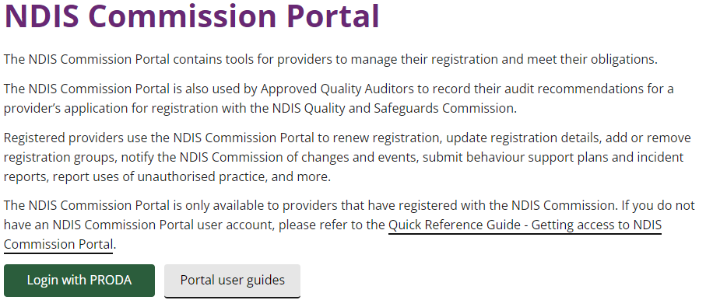

Step 2: Check your access
I don’t have access to PRODA – how do I get access?
If you don't have access to the 'Registrant' role for this provider:
- Login to the NDIS Commission Portal with your PRODA account (if you do not have a PRODA account you will be prompted to create one).
- Select 'Request/update my access' and instructions provided.
- Use the below details to complete and submit your access request:
Required user role(s): Registrant
Provider ABN:
Provider legal name:
Provider trading name:

See Register for a PRODA account to create a new account.
Note: The Registrant is responsible for managing and varying an NDIS Provider’s current scope of registration, managing the organisation’s workers and notifying the NDIS Commission about a reportable incident. Registrant includes ‘Worker Screening Officer’ role.
I don’t have access to PRODA but another staff member does:
The staff member who has access to PRODA will be required to log in. At Portal entry screen, click Request access for myself. Complete steps under ‘Request new user roles’ from page 4 here.
I need to add myself as a Key Personnel so I can complete the renewal, how do I do this?
Providers can add or manage their own key personnel in the NDIS Commission Portal.
Note: Registered NDIS providers are responsible for keeping their key personnel information and contact details in their registration record with the NDIS Commission updated at all times via the NDIS Commission Portal. Key personnel can include, but is not limited to, CEO, executive staff members, managers and all members of the board of directors.
It is your responsibility to inform the NDIS Commission at the time of applying for registration, or renewing registration, of all the people who are key personnel of your organisation.
Add or change key personnel
- Log in to the NDIS Commission’s business application system.
- Select Registration from the menu bar then click Registration details.
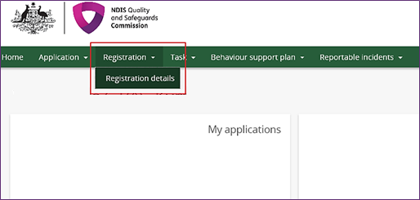

- Select Key personnel from the left hand menu bar.
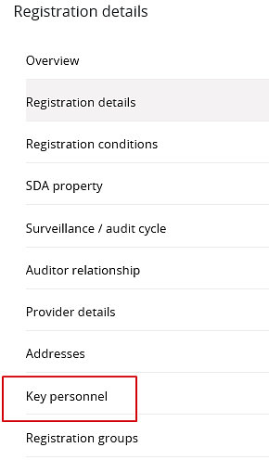
Add Key Personnel
- Click Add.
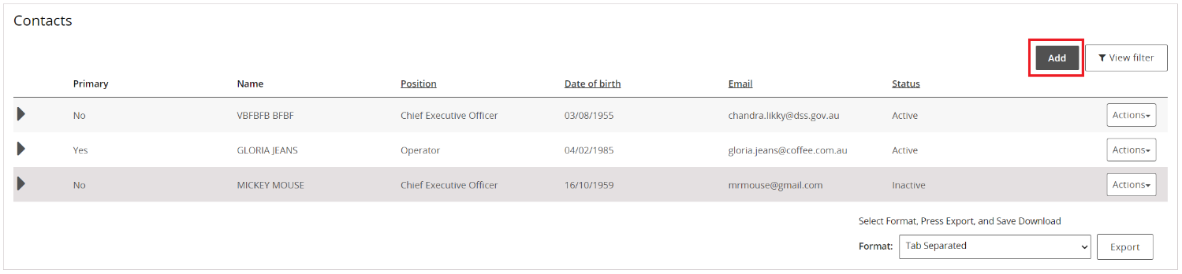
The Key personnel details window opens.

- Type the details of the new key personnel then click Save and continue.
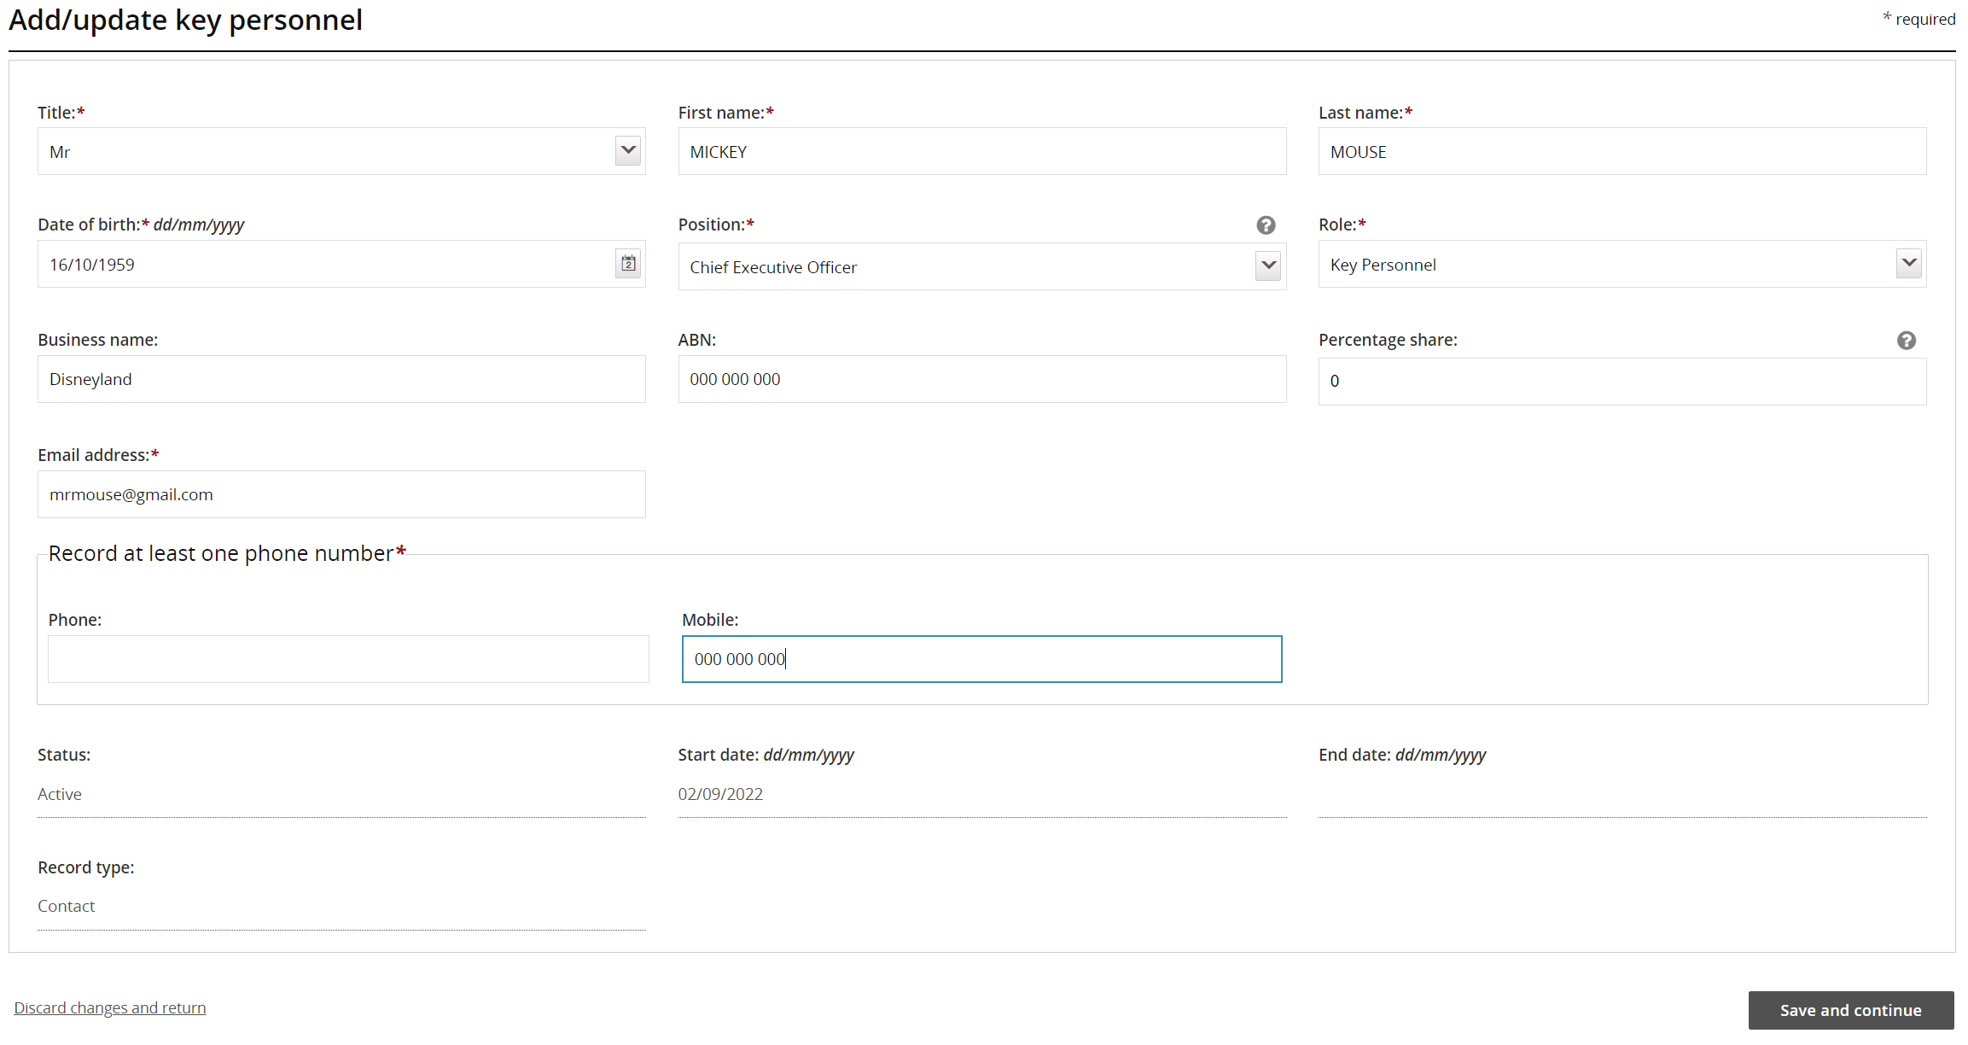
- Answer the suitability questions, the click Submit and return
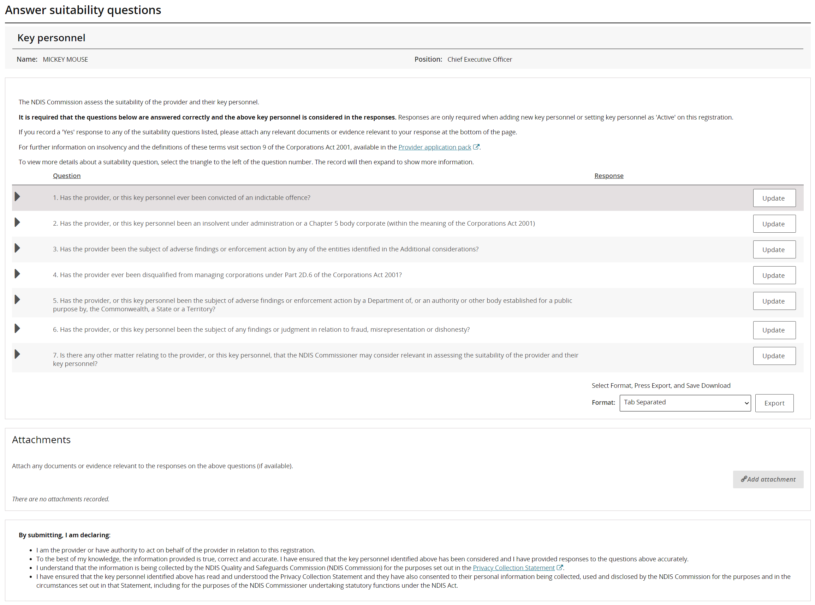
Manage Key Personnel
- Select Actions then select an option from the drop down list. You can view, update, make primary or remove the selected key personnel.
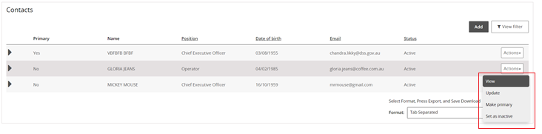
- To view the details of key personnel, click View. The personnel details are displayed.
- To update the details on record for key personnel, click Update.
- To make a key personnel the primary contact, select Make primary.
This option only appears if the person selected is not currently a primary contact. You can only have one primary contact.

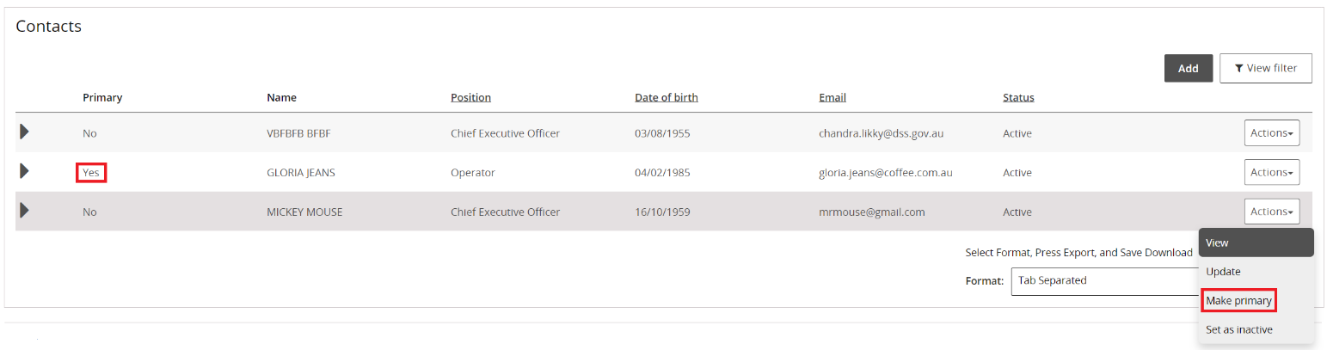

- To make a key personnel inactive, select set as inactive. Once a person is made inactive, they cannot be made active again. However, they can be added again as a new person.

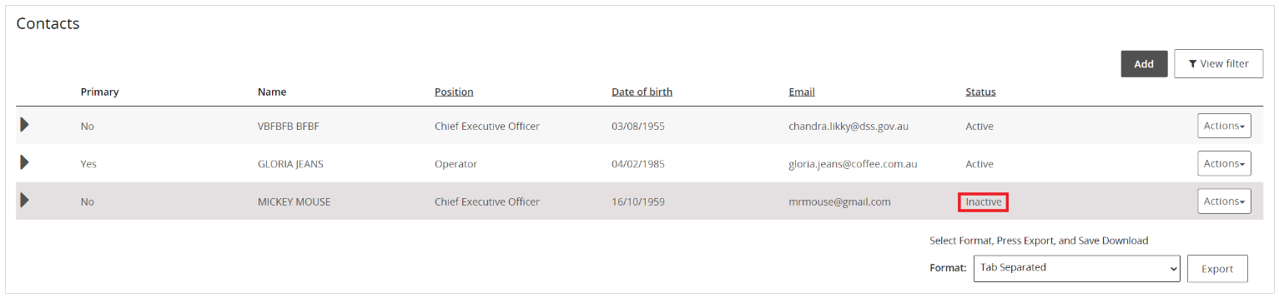

Step 3: Commence renewal
- Select MY APPLICATIONS

NOTE: If you are eligible to start your Renewal in the ‘My Applications’ box you will see Commence a formal renewal by xx/xx/xxxx. If this is not showing you are not able to commence your renewal yet- it will appear 6 months out from your renewal date.

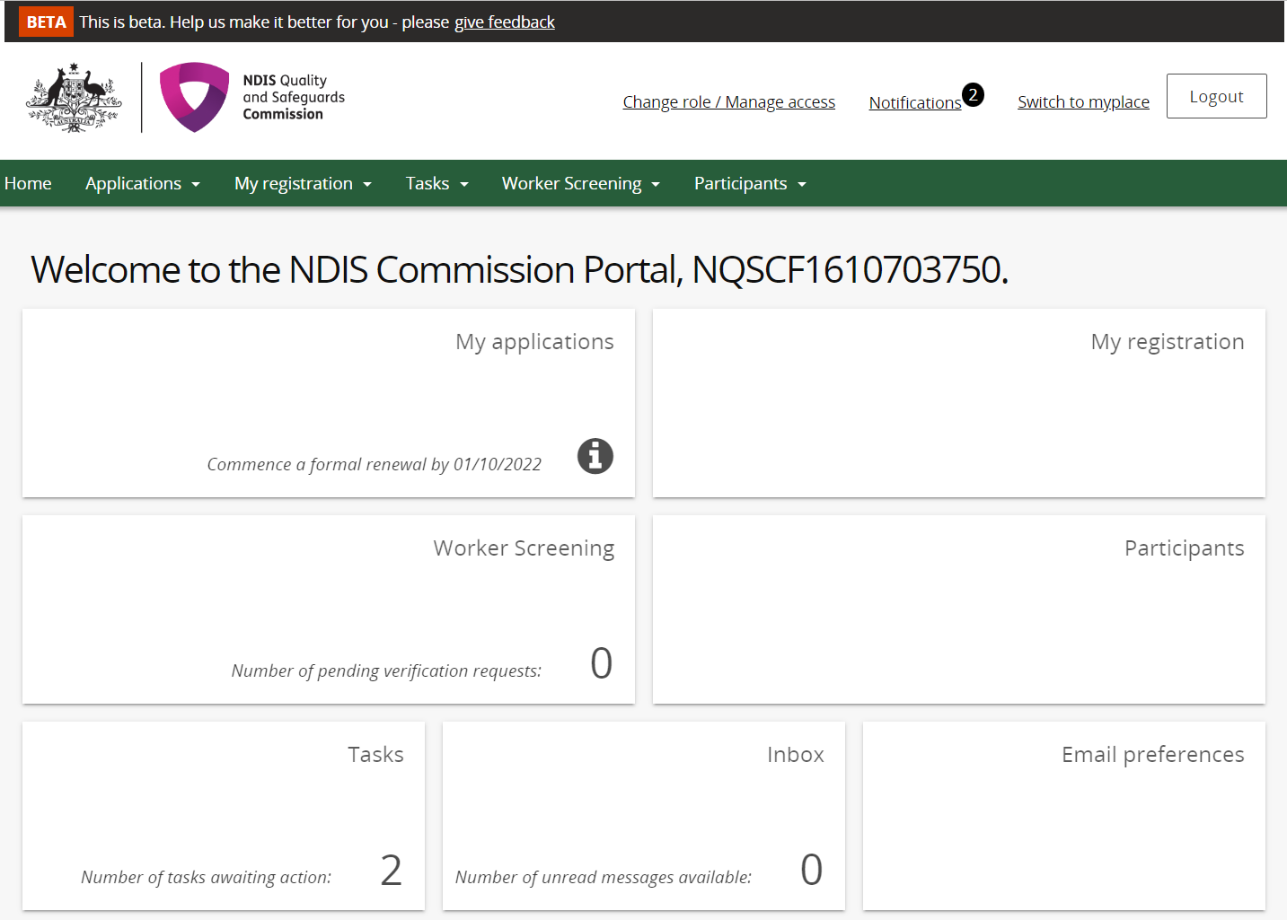

Step 4: Start Application
1. If you wish to commence your renewal select Start application.

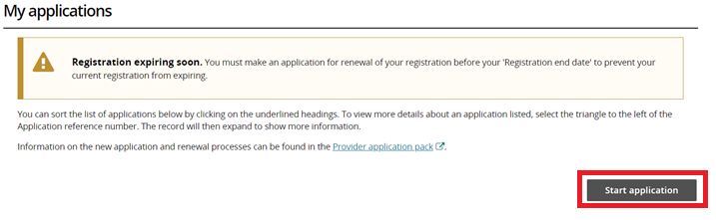

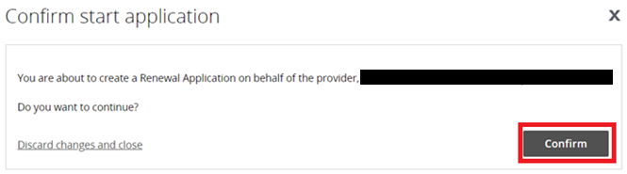

- Start to complete the renewal process by working through each of the different sections in the left hand menu and update each screen ensuring the correct details are captured.
You will be able to submit the application once you have completed and a green tick shows for all the relevant pages.

Note: Please be aware that your application is considered draft until it is completed and submitted.
After you have commenced this application, you may return to it at any time by going to ‘My Applications’ and viewing your renewal application.
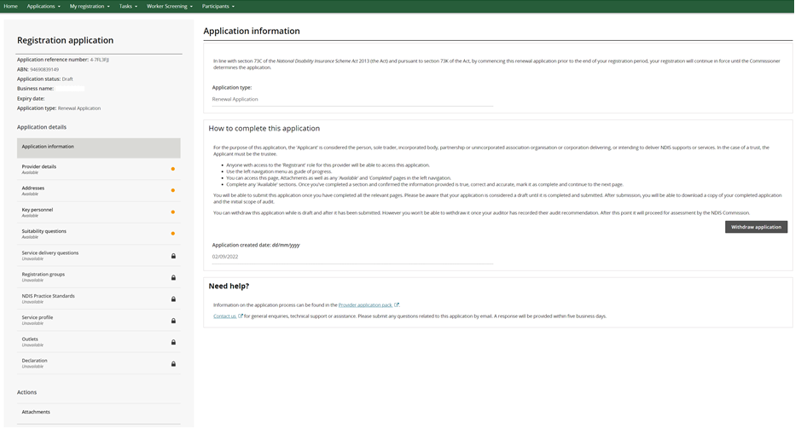

Step 5: Organisation details
In this section you will provide information about your organisation, including corporate structure and the primary contact in relation to the registration renewal application and also in relation to the registration
Provider details | Contact details | Parent entity details
- Provider business name: If the provider has a business name registered, you can enter the name here. If the provider has not registered a business name, enter the provider’s legal name.  - Australian Company Number: Enter the ACN.  - Whether the organisation is for profit: Check this box if the organisation is for profit. A not-for-profit (NFP) organisation is an entity that is operating for its purpose and not the profit or gain (either direct or indirect) of its individual members. For further details about not-for-profit organisations refer to the Australian Tax Office website.  - Whether the organisation is an approved charity: Check this box if the provider is registered as a charity with the Australian Charities and Not-for-profit Commission (ACNC). | ‘The provider’ is the organisation (including sole providers) which is delivering, or intending to deliver, NDIS supports or services. Please provide the details of the primary contact for the registration renewal application. The primary contact must have the authority to act on behalf of the provider in relation to the registration renewal application.  - Primary contact phone number  - Primary contact fax  - Primary contact email address  - Provider web address | Enter the parent entity’s Australian Business Number (ABN) (where applicable).

Step 6: Addresses
In this section you will provide address details for your organisation.
Addresses
Update the physical and / or postal address for the provider. You will also need to provide the date that that your organisation first moved to that address (if unsure please estimate).
- Physical address
- Postal address

Step 7: Key personnel
In this section you will provide information about your organisation’s key personnel. Key personnel are the individuals who hold key executive, management or operational positions in your organisation, such as directors, managers, board members, chief executive officer or chairperson. You must include all key personnel on your application. This information will form part of the NDIS Commission’s suitability assessment.
Key personnel
‘Key personnel’ means individuals who hold key executive, management or operational positions in your organisation, such as directors, managers, board members, chief executive officer or chairperson. You must include all key personnel on your application.
If any key personnel hold multiple positions within your organisation, please select the most senior position they hold.
For each key personnel please provide:
- Full name and title
- Date of birth
- Position
- Role (e.g. general staff, data management)
- Business name (if applicable)
- ABN (if applicable)
- Percentage share
- Email address
- Phone

Step 8: Suitability questions
In this section you will answer a series of questions about your organisation and your organisation’s key personnel listed at Step 3. The answer to these questions will inform the NDIS Commission’s suitability assessment. The responses will be assessed on a case-by-case basis.
Has the provider ever been in receivership, subject to a winding up order and/ or under administration?
This includes where the provider:
- Is under external administration (or equivalent in home jurisdiction)
- Is subject to a winding up order or an application for winding up (or equivalent in home jurisdiction)
- Has a receiver or receiver and manager been appointed to the company (or equivalent in home jurisdiction)
- Has a company administrator been appointed to the company (or equivalent in home jurisdiction)
- Is the company currently subject to a deed of company administration (or equivalent in home jurisdiction)
- Has received notice that action for the involuntary cancellation of its incorporation had commenced or is proposed.

Have any of the provider's Officeholders ever been convicted of an indictable offence
This includes convictions of indictable offences against a law of the Commonwealth, State or Territory or other jurisdiction (including foreign country).
Where the answer is yes, please indicate which key personnel was convicted, and the nature of the conviction.

Is the provider, or any of the provider's officeholders or directors an insolvent under administration, or been an insolvent under administration (or equivalent in home jurisdiction)?
Where the answer is yes, please provide details of the insolvency, including key personnel (where relevant).

Has the provider, or any of the provider’s officeholders or directors commenced bankruptcy proceedings?
Where the answer is yes, please provide details of the bankruptcy, including key personnel (where relevant).

Have any of the officeholders or directors been disqualified as a director of a company, and /or disqualified from managing corporations?
This includes where the applicant’s key personnel have been disqualified from managing corporations under Part 2D.6 of the Corporations Act 2001.
Where the answer is yes, please provide details, including name of relevant key personnel.

Has the provider or any of the provider's officeholders been the subject of any investigation, adverse findings or enforcement by any regulator, including authorities responsible for the quality or regulation of services for people with disability?
This includes any adverse findings, or enforcement action by:
- a Department of, or an authority or other body established for a public purpose by, the Commonwealth, a State or a Territory, including those with responsibilities relating to the quality or regulation of services provided to people with disability, older people or children
- the National Disability Insurance Agency
- the Australian Securities and Investment Commission
- the Australian Charities and Not for profits Commission
- the Australian Competition and Consumer Commission
- the Australian Prudential Regulation Authority
- the Australian Crime Commission
- AUSTRAC
- a work health and safety authority of a State of Territory
- a body of a State or Territory that has similar responsibilities to those mentioned above.
Enforcement actions may include:
- Banning orders
- cancellation of NDIS registration
- involuntary cancellation of an entity’s incorporation status.
- Any other compliance or enforcement activity
Where the answer is yes, please provide details, including key personnel (where relevant).

Have any of the provider's officeholders, or the provider overall, been the subject of any findings or judgment in relation to fraud, misrepresentation or dishonesty?
This includes where the applicant’s key personnel, or the applicant overall has:
- been the subject of any findings or judgment in relation to fraud, misrepresentation or dishonesty in any administrative, civil or criminal proceedings, or is currently party to any proceedings that may result in the applicant being the subject of such findings or judgment
- been disqualified from managing corporations under Part 2D.6 of the Corporations Act 2001
Where the answer is yes, please provide details, including key personnel (where relevant).

Step 9: Service delivery questions
In this section you will answer specific questions in relation to the NDIS supports and services delivered by your organisation. The answers to these questions assist in tailoring the relevant modules, or parts of the modules of the NDIS Practice Standards that your organisation will be assessed against.
Service Delivery
Please answer yes or no to the below questions.
Services delivered by the provider including:
- Day-to-day management of medications
- Disposal of waste, infectious or hazardous substances
- Use of restrictive practices
- Complex bowel care (enema)
- Tracheostomy management
- Urinary catheter management
- Complex wound management
- Sub-cutaneous injections
- Enteral (PEG, nasogastric tube) feeding and management
- Severe dysphagia management
- Ventilator management

Step 9: Registration groups
In this section you will list all the registration groups that you are delivering, or intending to deliver, NDIS supports and services under.
The registration groups which you select will determine the relevant sections of the NDIS Practice Standards that you will be assessed against as part of the NDIS Commission’s renewal process. You will be required to provide supporting evidence in regards to the supports and services delivered as part of the audit process.
Registration Groups
- Add or remove registration groups which the provider wishes to be registered for.

Step 11: NDIS Practice Standards
In this section you will be required to provide your self-assessment against the applicable NDIS Practice Standards. When providing the self-assessment response you need to consider the applicable quality indicators, as outlined in the National Disability Insurance Scheme (Quality Indicators) Guidelines 2018.
Based on your organisation’s service delivery profile, the Registration Groups you selected, and your responses to the service delivery questions, the renewal form will display the applicable NDIS Practice Standards relevant to your organisation.
Your self-assessment responses will inform the desktop audit undertaken by approved quality auditors. Documents should be uploaded to support the claims made in the self-assessment responses (where applicable).
Note for the verification module, please state your profession in the first self-assessment response. Please also refer to the Verification Guidelines for information on documentary evidence required.
Self-assessment
- Provide your self-assessment response against each of the applicable standards.

Step 12 Service profile
In your application, you will be asked to provide information about your service delivery. The answers to these questions will help the NDIS Commission determine the size and scope of services and supports delivered.
Number of participants currently getting service? | Number of staff employed | Participant groups | Age groups
This should be the number of NDIS participants you provide services and/ or supports to. If you are preparing to deliver new supports and services, please respond based on expected numbers. If you are unsure, enter an estimation, however please be aware that this information may be taken into account by an approved quality auditor when providing a quote for services. | This should be the number of workers you engage to deliver NDIS supports and services. Workers include employees, volunteers and contractors. If you are unsure, enter an estimation however please be aware that this information may be taken into account by an approved quality auditor when providing a quote for services. | Select which of the listed participant groups you deliver to, or intend to deliver to (choose all that apply). | Select which of the listed age groups you deliver to, or intend to deliver to (choose all that apply).

Step 13: Outlets
In this section you will provide information about your organisation’s outlets. You will be asked to add, remove or update any provider outlets.
Outlets include premises where a participant’s supports and services are provisioned and managed on a daily basis. This may include those premises where participants live in a group home setting (for example if the organisation operates their business from that premises, including holding and maintaining participants files from that address). For mobile outlets the address may be the registered business address or the location where the service delivery is administered (for example a clinic or office). If your mobile outlet address is your home, you may choose not to display this publicly.
This information helps the NDIS Commission determine the size and scope of services and supports delivered by your organisation. The NDIS Commission may publish this information on the NDIS Provider register.
Outlet details
- Outlet name: Please enter the name of the outlet.
- Outlet type: Outlets can be either fixed “physical” offices (like a clinic, group centre or shopfront), or “mobile” (if the applicant delivers supports and services in participant homes or other non-fixed addresses).
- Hide address: If you choose to hide the address of the outlet, the address will not be published with the rest of the outlets details on the provider register.
- Display publically: If you choose to display the outlet publicly the outlet will be published on the provider register. The NDIS Commission will not display address information about “mobile” outlets, even if you’ve chosen to display the outlet publicly.
- Contact name: Please enter the primary contact for the outlet.
- Phone number: Please enter the primary phone number for the outlet.
- Email address: Please enter the primary email address for the outlet.

Outlet Address
- The business address must be completed in full and not be a PO Box.
- For example: Level 1 Main Building 220 Business Street Canberra City ACT 2601

Outlet Operating hours
- Click on the clock on each day to enter the operating hours.

Outlet Service area
- Please enter the service area type, service area state and service area.

Outlet Registration groups
- Please enter the registration groups, support items and professions available to participants at this outlet.

Step 13: Submit application to Commission
Once you are happy with all of the information in your application submit it to the Commission

Step 14: Scope of Audit
See step 3 on page 5.

Step 15: Commence Audit process
See step 4 on page 5.

Step 16: Your auditor will submit your audit to the NDIS Commission through the NDIS Commission Portal

See step 5 on page 6.

Step 17: The NDIS Commission will assess your suitability and advise you of the application outcome in writing

See step 6 on page 6.

Glossary of Terms
Agency managed plan is a participant’s NDIS plan which is managed by the National Disability Insurance Agency (NDIA). NDIS providers that are providing NDIS supports and services to participants with an Agency managed plan are required to be registered with the NDIS Commission.

Approved Quality Auditor assess an organisation against the components of the NDIS Practice Standards that are relevant to the services and supports they deliver. The NDIS Commissioner approves a person or body to become an approved quality auditor under section 73U of the NDIS Act.

Behaviour support plan (BSP) is a plan developed through the NDIS by practitioners who are considered suitable by the NDIS Commissioner. A BSP must be in place when an NDIS participant is identified as having complex behaviours of concern and contain evidence-informed strategies with a goal to improve the person’s quality of life. The plan may be:
(a) a comprehensive behaviour support plan; or
(b) an interim behaviour support plan.

Class of support is the support type that a registered NDIS provider is funded to deliver and is listed on the provider’s certificate of registration. Sometimes referred to as ‘registration groups’.

Certification audit is undertaken when a provider delivers a class of support (or registration group) that requires assessment by certification method as set out in section 20 of the NDIS (Provider Registration and Practice Standards) Rules 2018. A certification audit includes a stage one and stage two audit, as per Section 13 of the NDIS (Approved Quality Auditors Scheme) Guidelines 2018.

Corrective action plan is a plan developed by an Approved Quality Auditor to ensure that corrective actions addressing non-conforming areas against the NDIS Practice Standards are monitored for closure.

Mid-term audit must be undertaken by an approved quality auditor and is undertaken no later than;
(a) 18 months after the beginning of the period for which the provider’s registration is in force; or
(b) Such longer period after the beginning of that period as the Commissioner allows.
Section 13B of the NDIS (Provider Registration and Practice Standards) Rules 2018 sets out the requirements for mid-term audits.

NDIS behaviour support practitioner means a person the NDIS Commissioner considers is suitable to undertake behaviour support assessments (including functional behavioural assessments) through the NDIS and to develop behaviour support plans that may contain the use of restrictive practices.

NDIS Code of Conduct promotes safe and ethical service delivery by setting out expectations for the conduct of both NDIS providers and workers. It applies to all providers and workers delivering NDIS support and services, registered or unregistered.

NDIS participant is a person with a disability who meets the access requirements to become a participant in the NDIS.

NDIS Practice Standards specify the quality standards to be met by registered NDIS providers to provide supports and services to NDIS participants. Together with the NDIS Code of Conduct, the NDIS Practice Standards build NDIS participants’ awareness of what quality service provision they should expect from registered NDIS providers.

NDIS Practice Standards Rules means the National Disability Insurance Scheme (Provider Registration and Practice Standards) Rules 2018.

NDIS Practice Standard modules consist of a core module and several supplementary modules that apply depending on the types of supports and services you deliver. Each module has a series of high-level, participant-focused outcomes and quality indicators that approved auditors use to assess compliance with the NDIS Practice Standards.

NDIS plan outlines a participant’s goals, aspirations and support required to help them manage every day activities safely. The NDIS plan includes funding that is determined by the NDIA as ‘reasonable and necessary’ to achieve their goals.

Out of cycle audit is undertaken when a provider applies for a scope extension following the addition of any class of support by a registered NDIS provider or where they are applying to the NDIS Commissioner for a variation of registration. The audit aims to evaluate the effectiveness of implementation and address the relevant modules associated with the requested additional classes of support.

Plan managed participant is when a participant uses the services of a registered plan manager to manage the funding in their NDIS plan. Plan- managed participants can access supports and services in from registered or unregistered providers (with the exception of supports that require registration: behaviour support, implementing restrictive practice and specialist disability accommodation).

Provisional certification audit is undertaken when a provider;
(a) has applied for registration that is subject to the certification assessment method; and
(b) is a new provider that has developed systems and processes to deliver NDIS supports and services and has not yet commenced service delivery, as per Section 27 of the NDIS (Approved Quality Auditors Scheme) Guidelines 2018.

Quality indicators are parameter that providers and auditors will use to assess a provider’s compliance with the Practice Standards

Registration group is the type of support an NDIS provider is funded to deliver (see also ‘Class of support’).

Registered plan management provider is a registered NDIS service provider who manages the funding in a participant’s plan where the participant is authorised by the NDIA to plan-manage (see also ‘Plan-managed participant’).

Registration renewal is the process of submitting a registration renewal application prior to the renewal date listed on the certificate of registration.

Restricted practice is defined as any practice or intervention that has the effect of restricting the rights or freedom of movement of a person with disability.

Residential aged care service means residential care service as defined in section 1-3(5) of the Aged Care Act 1997.

Scope of audit is a document which summaries the type of audit required and what an organisation needs to do to demonstrate compliance against relevant NDIS Practice Standards.

Self-managed participant or plan is when a participant manages their own NDIS funding where the participant is authorised by the NDIA to self-manage.

Service agreement means a written agreement between the provider and the participant on the supports to be provided and the conditions surrounding those supports.

Specialist behaviour support provider means a registered NDIS provider whose registration includes the provision of specialist behaviour support services.

Specialist disability accommodation (SDA) is a range of housing funded through the NDIS and designed for people with extreme functional impairment or very high support needs.

Support network means family, friends, carers and other people who have a supportive relationship with a participant.

Support plan means a document developed in response to a request for supports by the Participant and an appropriately skilled professional within the provider organisation prior to the commencement of supports.
Transitional arrangements are specific arrangements for residential aged care providers that commenced regulation with the NDIS Commission on 1 December 2020. The transitional arrangements are set out in the National Disability Insurance Scheme Legislation Amendment (Transitioning Aged Care Providers) Rule 2020 (the Transition Rule). Arrangements are in place for registration for residential aged care providers, NDIS Worker Screening and Positive Behaviour Support (these arrangements have now expired).

Verification audit is undertaken when a provider delivers only lower risk classes of support (or registration group) that requires assessment by verification method as set out in section 20 of the NDIS (Provider Registration and Practice Standards) Rules 2018. Method of verification audit is set out in Section 12 of the NDIS (Approved Quality Auditors Scheme) Guidelines 2018.

Worker Screening relates to Registered NDIS providers ensuring that key personnel and other workers in certain types of roles have a worker screening clearance that meets the requirements of the NDIS Practice Standards. From 16 June 2021, changes were made to the Aged Care Act to allow the recognition of the NDIS Worker Screening Check for the purposes of aged care requirements. More information can be found on page 7 of the Aged Care Worker Screening Guidelines.

