NDIS behaviour support Practitioners
  - Quick reference guide – How to Update Practitioner Profile
This guide can be read in conjunction with our FAQ on the behaviour support practitioner profile.
When a behaviour support practitioner is considered suitable, their portal access moves from the applications portal to the NDIS provider portal.
Important note: An auto-generated verification email is sent when the application is approved. This can end up in you spam or junk email folder. You must click on the link in this email to complete your practitioner profile access.
This Quick Reference Guide explains the step-by-step process of logging in to the NDIS Commission Practitioner Profile.

In this guide
- Logging in to the NDIS Commission Provider Portal
- Updating the Practitioner Profile details
- Updating the contact details on the NDIS Commission website
- Accessing your outcome letter
- Help with accessing the NDIS Commission portal

Logging in to the NDIS Commission portal
- Click Portal. Select Registered NDIS providers.
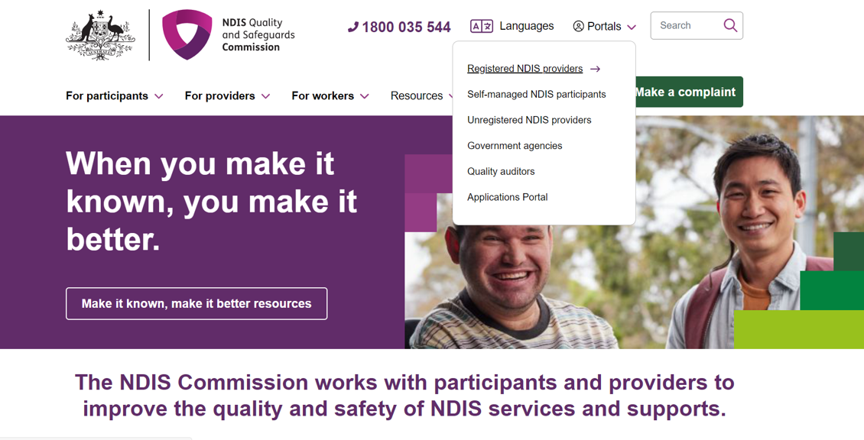
- Click Login with PRODA.
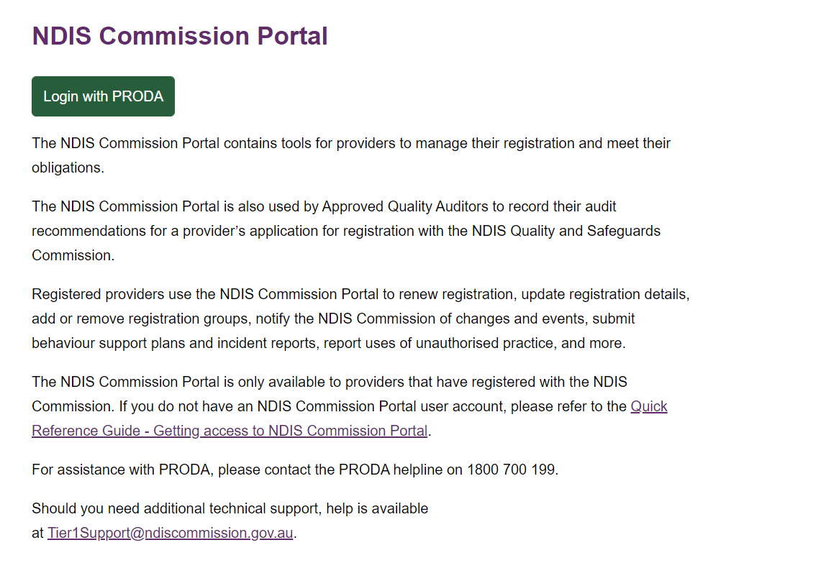
- Type the PRODA Username and Password then click Login.
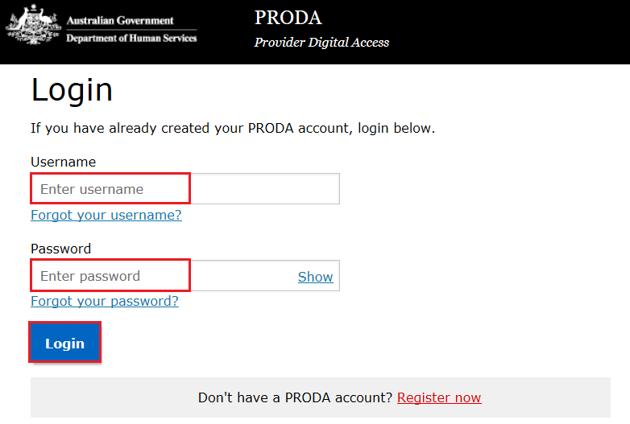
- Enter the PRODA verification Code then click Next.
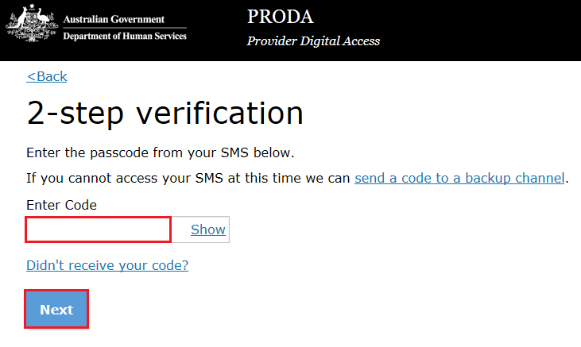
- Select the Provider name and the Role to logon and then click Continue
For the practitioner profile, your name will appear under the provider name. This is for technical purposes only and you are not considered a provider in this context (unless you are a sole trader who is also registered as an NDIS provider).
If you are logging in to lodge a behaviour support plan, select the provider name that you are lodging the plan on behalf of and refer to the Quick Reference Guide on lodging behaviour support plans.

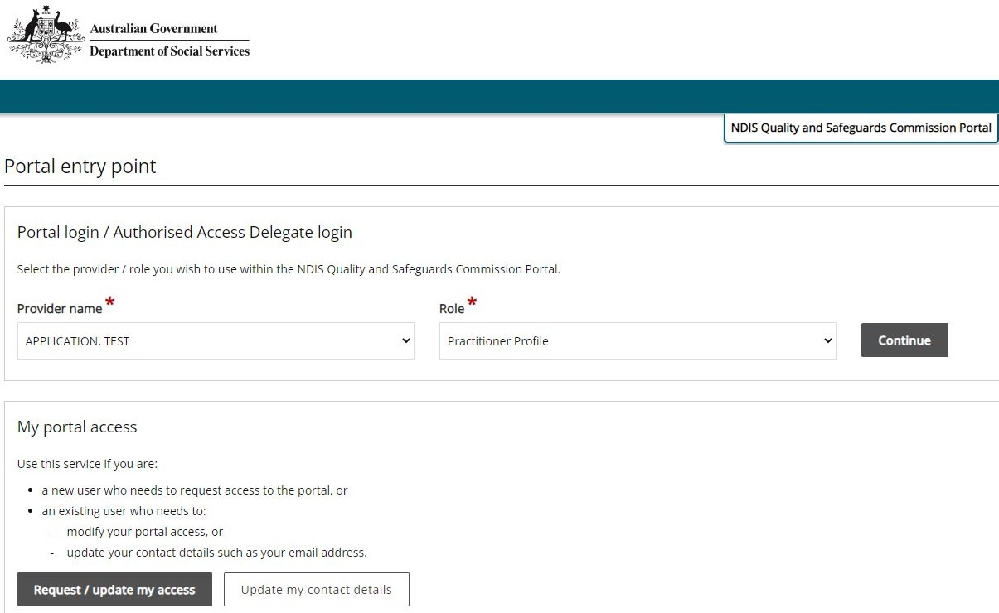
- Click I agree.
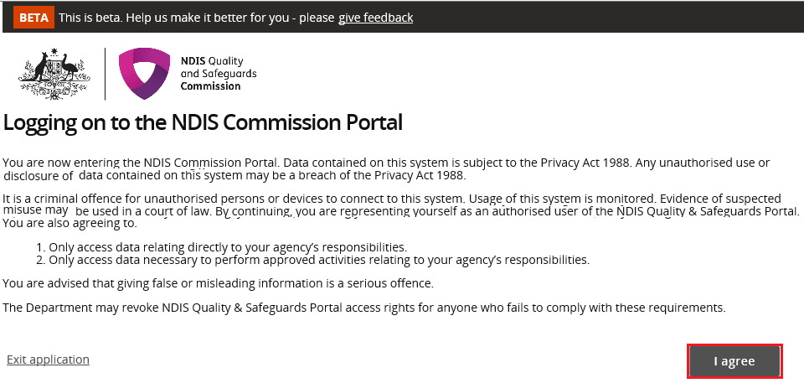
This should successfully log you on to the Portal.

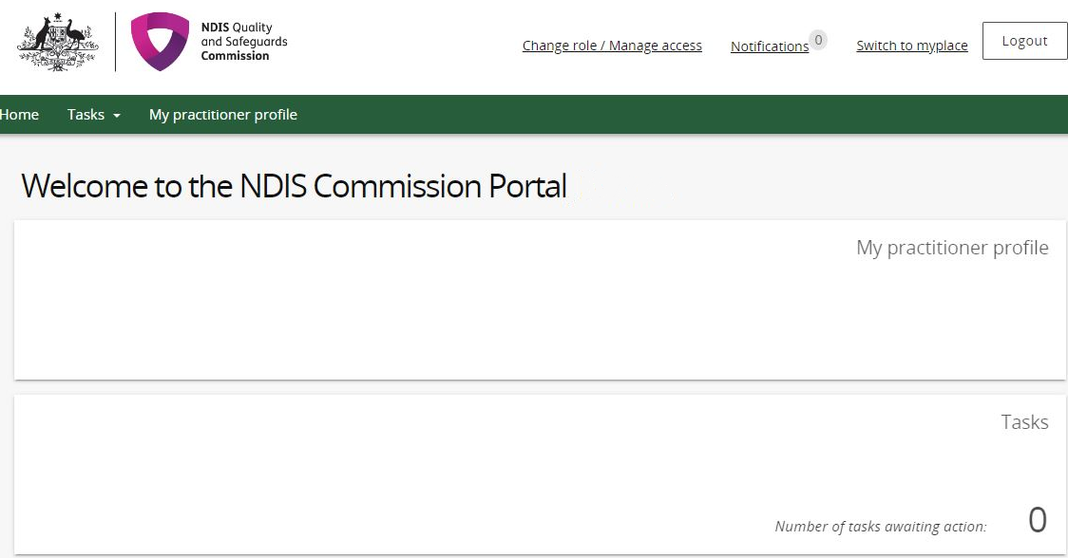
- Click My Practitioner Profile.

Updating the Practitioner Profile details
- Click Personal details / Professional details / Professional experience to make any changes.
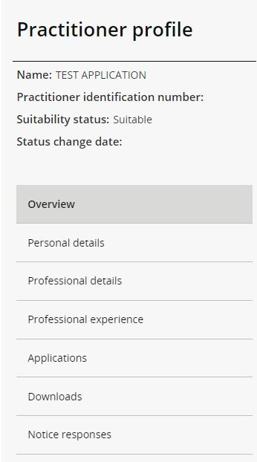

Updating the contact details on the NDIS Commission website
- Click Professional details.

- Click update (this will allow you to consent to your name, email address, phone number and postcode being placed on a list of NDIS behaviour support practitioners to be published on the NDIS Commission’s website).

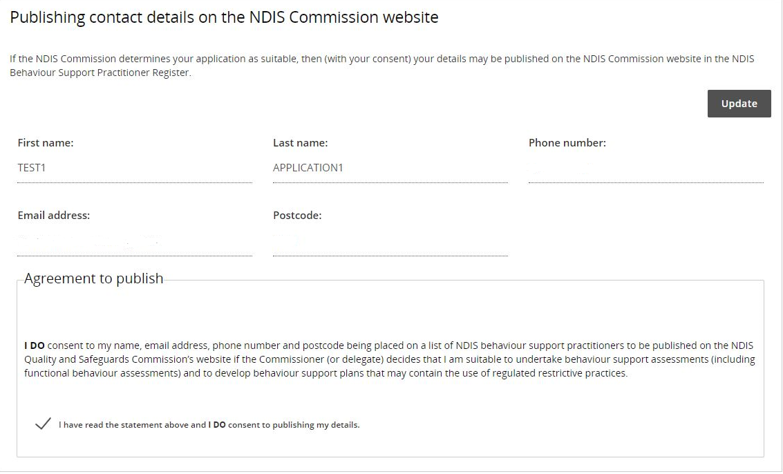

Help with accessing your Practitioner Suitability Outcome letter.
- Login to the NDIS Commission Provider Portal.
- In the Portal entry point, select your name under the provider drop down (please note this is for technical purposes only and you are not considered a provider in this context).
- Select Practitioner Profile under the Role drop down box.
- Click on My practitioner profile.
- Click on Applications in the left menu.
- Select Actions on your Completed application from the drop down list and click View.
- Click Downloads on the left menu then download the latest Application Outcome Letter from the list.

Help with accessing NDIS Commission Portal
The following questions and answers are for Providers who are having difficulties accessing the NDIS Commission Portal
- I do not have PRODA account, how can I create a PRODA account?
See Register for a PRODA account to register and create a new PRODA account.
- I am unable to create a PRODA account, what can I do?
Please contact the PRODA Help Desk on 1800 700 199 or proda@humanservices.gov.au.
- I have a PRODA account but I cannot log on to the NDIS Commission Portal, what can I do?
If your organisation is registered with the NDIS Commission, contact the NDIS Commission Contact Centre on 1800 035 544 or tier1support@ndiscommission.gov.au.

Further information or support
Contact the NDIS Quality and Safeguards Commission
Phone: 1800 035 544 (Mon-Fri)
Email: ndispractitioners@ndiscommission.gov.au

