BSP Template Review
Summary of Findings
July 2023

Executive Summary
- The NDIS Commission has undertaken a review of the current behaviour support plan templates, that is, the Interim and Comprehensive Behaviour Support Plan (BSP) templates. This report summarises the methodology and key findings of the review.
- The BSP Template Review process was co-designed with people with disability and consisted of an anonymous online survey, focus groups, and targeted consultation with peak bodies and providers. It also involved a review of evidence-informed practice.
- Strengths, challenges and ideas for improvement were explored.
- A total of 603 responses were received via the online survey (n=426) and focus groups (n=177).
- More than 80% of survey respondents had used the NDIS Commission’s BSP templates and 67% of BSPs reviewed in recent quality evaluations had used or adapted the Commission’s template.
- Data from recent BSP quality evaluations (using the BSPQEII), found that use or adaptation of the Commission’s Comprehensive BSP template was associated with marginally higher quality plans compared with other formats. However the quality remained ‘under-developed’ on average.
- Some survey respondents liked that the templates provided a consistent format and helped them meet some of their legal and policy requirements. However they also reported that the templates were hard to change and make person-centred.
- Four key themes and ten sub-themes were identified that the BSP templates will need to achieve:
Principles
            - Upholds human rights and promotes the reduction and elimination of restrictive practices
            - Person-centred, strength-based and proactive to improve quality of life
Design
- Co-designed to meet diverse user needs
- Increased accessibility
Content
            - Content areas are fit-for-purpose
            - Goal-driven and measurement of outcomes
            - Based on contemporary evidence-informed practice
            - Supports compliance with regulatory requirements
Systems, tools and resources
            - Considers the connection with other systems
            - Supported by complementary resources and guidance
- Recommendations are offered to address these key themes. They include a suite of accessible and co-designed behaviour support plan templates which support best practice in behaviour support, uphold participant’s rights and promote the reduction and elimination of restrictive practices.
Contents
Executive Summary 1
Background to the BSP Template Review 3
Purpose 4
Scope 4
Methodology 4
1. Online survey 5
2. Focus groups 5
3. Targeted consultation 6
4. Evidence-informed practice 6
Findings 8
Usage of the BSP templates 8
Quality of the BSP templates 8
Strengths associated with the current templates 9
Challenges associated with the current templates 9
Key Themes 10
Discussion 11
1. Upholds human rights and promotes the reduction and elimination of restrictive practices 11
2. Person-centred, strength-based and proactive to improve quality of life 12
3. Co-designed to meet diverse user needs 13
4. Increased accessibility 14
5. Content areas are fit-for-purpose 15
6. Goal-driven and measurement of outcomes 16
7. Based on contemporary evidence-informed practice 17
8. Supports compliance with regulatory requirements 18
9. Considers the connection with other systems 19
10. Supported by complementary resources and guidance 20
Recommendations 21
References 27
Acknowledgements 27
Appendix – Quotes 28

Background to the BSP Template Review

Template Origins
In 2018, the NDIS Quality and Safeguards Commission (NDIS Commission) made two behaviour support plan templates available on the website. They included an Interim Behaviour Support Plan template and a Comprehensive Behaviour Support Plan template.
These templates were informed by positive behaviour support and the legislated requirements as outlined in the NDIS (Restrictive Practices and Behaviour Support) Rules 2018 and the NDIS (Registration and Practice Standards) Rules 2018. The structure was also aligned with the Commission's Operating System, which is the portal used by practitioners and providers to lodge behaviour support plans containing regulated restrictive practices and complete monthly reporting.
In response to sector feedback, revisions were made in 2019 to streamline the templates and improve their fit with practice. This involved changes to the format and design, removing some content and unnecessary repetition. Overall the length of the documents was reduced by 80%. No further updates have occurred since this time.
The NDIS Commission has never mandated the use of the behaviour support plan templates. Rather specialist behaviour support providers and NDIS behaviour support practitioners can choose to use them or any other plan format that best meets the needs of the NDIS participant and their supporters; provided that it also complies with the Rules and any authorisation requirements (however described) in the relevant state or territory. It is noted that in some jurisdictions, such as Victoria, NDIS providers must use either the NDIS Commission’s template or an alternate form as specified by the Victorian Senior Practitioner.
The NDIS Commission’s templates were the first nationally consistent behaviour support plan templates available to the sector. Whilst not flawless, the templates have provided a scaffold to support practice and an important foundational benchmark.

The Quality of Behaviour Support Plans
In 2022 the NDIS Commission published a paper on Behaviour Support Plan Quality. This involved the evaluation of 2,744 Comprehensive Behaviour Support Plans containing regulated restrictive practices that were lodged with the NDIS Commission between 1 July 2020 and 31 December 2021. The results indicated that 80% of the behaviour support plans were of 'weak' or 'under-developed' quality (using the BSPQEII tool); and only 32% showed evidence of consultation with the person with disability.
In response, the NDIS Commission commenced a number of activities to uplift the quality of behaviour support plans. This has included co-designing participant fact sheets about positive behaviour support, rights and what can be expected from providers; BSP checklists for providers outlining the requirements when developing behaviour support plans; and the current review of the existing BSP templates. A number of grant projects are also underway including ‘The Right Direction’ and ‘Deciding with Support’ which produced a suite of evidence-based and co-designed supported decision making tools for behaviour support.
The NDIS Commission completed further reviews of BSP quality in 2023. This involved a random sample of 100 Comprehensive Behaviour Support Plans that were active, partially active or pending in the Commission’s Operating System (COS) in the month of February 2023. This review found that over the past 12-18 months there have been small improvements in BSP quality, however more work is required. 71% of Comprehensive Behaviour Support Plans were found to be of 'weak' or 'under-developed' quality and only 40% showed evidence of consultation with the person with disability.

Purpose
The BSP Template Review aims to:
- Evaluate the effectiveness of the current behaviour support plan templates.
- Co-design future fit templates which reflect contemporary evidence informed practice, uphold participant’s rights and promote the reduction and elimination of restrictive practices.
This report aims to summarise the findings of review and to make recommendations to inform the next phase of the co-design work.

Scope
There are a number of factors which impact on the utility of the BSP templates. Whilst all provide helpful contextual information, some are beyond the scope of this review to resolve.
For example:
  - National Disability Insurance Agency (NDIA) planning processes and funding decisions;
  - Proposed amendments to legislation and / or policy on restrictive practices and authorisation;
  - Reporting systems, including PRODA and the Commission’s Operating System (COS or ‘the portal’).

Methodology
The BSP Template Review involved:
- An anonymous online survey, that was co-designed and written in Plain English.
- Focus groups, facilitated nationally with practitioners and providers.
- Targeted consultation, with peak bodies representing participants, families, providers, state and territory authorisation bodies, NDIA and the Department of Social Services.
- A review of evidence-informed practice.
A thematic analysis was then completed to identify, analyse and share key themes emerging in the data. Importantly, people with lived experience of disability were involved in all stages of the review.

1. Online survey
An online survey platform, Survey Monkey, was used to collect anonymous, non-identifiable feedback on the BSP templates. The survey consistent of a series of seven questions including a combination of multiple choice options and free text responses. Respondents were asked about their personal and professional experiences using the templates, what they liked and disliked about the templates and for ideas to strengthen or reimagine them for the future. Decision logic was utilised to streamline the survey and only present respondents with relevant questions based on their previous answers provided.
As shown in Figure 1, there were 426 respondent to the online survey. This included people with disability (2.5%), family, friends and guardians (6.3%), behaviour support practitioners (77.7%), support workers and implementing providers (8.2%), and mainstream services (1%). 4% of respondents had other roles in allied health, state and territory authorisation and research. Some also had dual roles (e.g., as parent and practitioner). 95.5% of survey respondents indicated they had been involved in developing and / or implementing a behaviour support plan.
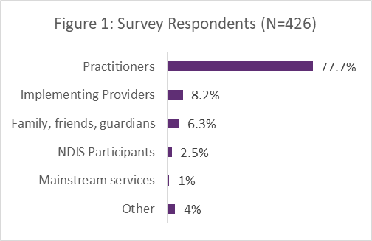

2. Focus groups
A total of 12 focus groups sessions were facilitated by the NDIS Commission across Australia. These locations are shown in Figure 2, and included Western Australia, the Northern Territory, South Australia, Victoria, the Australian Capital Territory, New South Wales and Queensland.
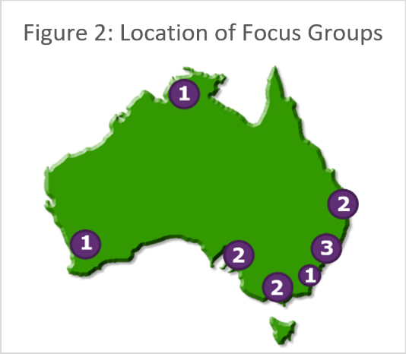
As shown in Figure 3, there were 177 participants in the focus groups. This included NDIS behaviour support practitioners (67.2%), implementing providers (15.8%) and people in restrictive practice authorisation roles (15.8%). 1.1% of participants were from other roles including researchers and university lecturers.
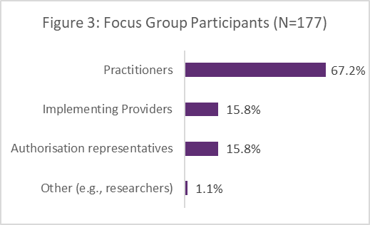

3. Targeted consultation
Targeted consultation was sought from a number of key groups, including:
- Inclusion Australia, a peak body representing people with disability
- Alliance 20, a consortium of some Australia’s largest disability service providers
- Senior Practitioners Practice Leadership Group which includes representatives from
  - State and Territory authorisation bodies
  - Technical Advisory Branch (NDIA)
  - Department of Social Services.

4. Evidence-informed practice
As outlined below, this review considered both research-based and practice-based evidence.

Systematic Literature Review on Behaviour Support Plan Quality (2023)
A systematic literature review was prepared for the NDIS Commission by Professor Karen Nankervis and Dr Maria Vassos from The University of Queensland. They categorised quality markers for BSPs into three areas being behaviour assessment, technical compliance with behavioural principles and plan implementation. These quality markers are outlined below.

Behaviour Assessment
- Person-centred approach to assessment and plan development
- Direct observation of the person in the relevant environments using data collection methods
- The use of indirect data collection methods such as interviews and standardised measures
- Other sources of information consulted e.g., reports from health professionals, case notes etc.
- Technical Compliance with Behavioural Principles
- Clear description of the behaviour(s) including frequency, duration, and severity
- An analysis of the antecedents/triggers, setting events and consequences
- Proposed function(s) of the behaviour(s) and the identification of functionally equivalent replacement behaviour(s) (FERBs)
- Person-centred goals which are measurable and achievable around behaviour change and quality of life
- Person-centred environmental change(s) linked to setting events and triggers/antecedents to reduce behaviour(s) and enhance quality of life
- Skill development to teach alternative behaviours, FERBs and other relevant skills
- Person-centred reinforcement to support the teaching of behaviours and skills
- Other strategies related to meeting the physical, health, and social needs of the person
- Reactive strategies to maintain the safety of the person and others, prompting desired behaviours, re-direction or distraction, debriefing, etc.
- A plan to fade-out the use of restrictive practices as soon as possible
- Plan Implementation
- Social validity - Acceptance of the proposed interventions by the person with disability, and other people implementing the BSP or who have an interest in the person’s wellbeing
- Training – Staff and family members are supported to implement the proposed interventions, which may include role playing, coaching, feedback and mentoring
- Regular and planned communication to review and troubleshoot implementation issues
- Outcome measurement to assess the effectiveness of the BSP to achieve the proposed intervention goal(s), be it behavioural outcomes or quality of life outcomes
- Treatment fidelity / planned process to measure if the BSP is being implemented as intended
- A planned process to review the BSP on a regular basis to check its effectiveness
- Readability – Concise plans that use plain, easy to read and understand language
See Evidence Matters: Developing Quality Behaviour Support Plans for the full report and references.

Practice-based evidence / alternate BSP templates
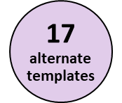
Practitioners, providers and other interested parties were invited to share alternate behaviour support plan templates to inform the review.
Samples were also collected via a search of online grey literature.
In total 17 alternate behaviour support plan templates were considered.

Findings

Usage of the BSP templates
In considering current rates of usage, the 2023 review of BSP quality found that 67% of Comprehensive BSPs from a random sample of lodged plans had used or adapted the NDIS Commission’s template. Further, as shown in Figure 4, more than 80% of survey respondents reported that they had used the Commission’s templates at least once.
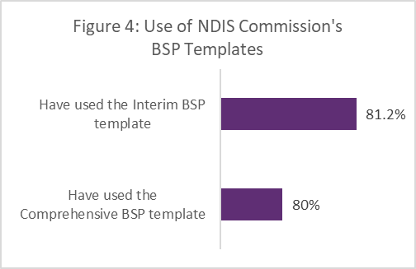
Whilst some people said: “The template should be mandatory…so that all plans are then set out the same.” Others supported the current approach: “Make its use optional.”
For those that had not used the templates:
- 13 - 19% were not aware the templates existed. This indicates the importance of a broader communication strategy.
- 27% said they did not like the current templates.
- Other reasons given for not using the templates included provider decisions and personal preferences to best meet the needs of the person with disability and align with other contemporary models of practice.

Quality of the BSP templates
A random sample was taken of 100 Comprehensive Behaviour Support Plans lodged with the NDIS Commission and which were active, partially active or pending in COS in the month of February 2023. These plans were sorted into three groups in accordance with whether the NDIS Commission’s BSP template was used, had been adapted, or whether an alternate BSP format was used. Corresponding data from the 2023 BSP quality reviews was then used to determine if there was any difference in BSP quality between these groups. It was found that plans which used or adapted the NDIS Commission’s Comprehensive Behaviour Support Plan template were associated with marginally higher quality scores on the BSP-QEII (average score of 15) when compared with plans in alternate formats (average score of 14). However, regardless of the BSP template used, the overall quality of BSPs was still found to be ‘under-developed’ on average.

Strengths associated with the current templates
The top two things that survey respondents liked about the current templates (as shown in Figure 5) were that 1) they helped them meet their legal and policy requirements and 2) provided a consistent format for behaviour support plans.
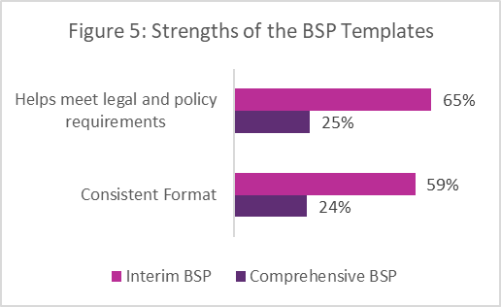
Note: An error was identified in the online survey which meant respondents could only choose one thing they liked about the Comprehensive BSP template, as opposed to selecting multiple options. This issue was isolated to a single item. It explains the differences in the percentages as shown above.
Feedback from focus group validated the findings of the survey about the strengths of each template.

Challenges associated with the current templates
The top two things that survey respondents disliked about the current templates (as shown in Figure 6) were that 1) they were hard to change and make person-centred and 2) it is not clear what goes in each section or what the words mean.
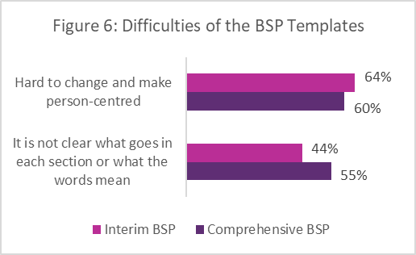
The focus groups and targeted consultation feedback, echoed the importance of co-production and a person-centred approach. In addition, extensive feedback was also provided about the templates purpose, length, design, contents and accessibility. This feedback was used to inform the thematic analysis.

Key Themes
A thematic analysis was undertaken to synthesise the available information obtained from the survey, focus groups, targeted consultation and review of evidence informed practice. This identified four key themes:
- Principles, being the foundational values and philosophy underpinning use of the templates.
- Design, being the look, functionality and accessibility of the templates.
- Content, being the alignment of the information contained in the templates with the documents’ purpose, evidence-informed practice and the regulatory environment.
- Systems, tools and resources, being the relationship of the templates to other existing resources and guidance material.
For the purpose of this report, these themes have been broken into ten sub-themes which are discussed in further detail. Whilst the current BSP templates demonstrate aspects of these themes, feedback indicated significant changes are required to genuinely achieve these objectives.
Figure 7: Key Themes
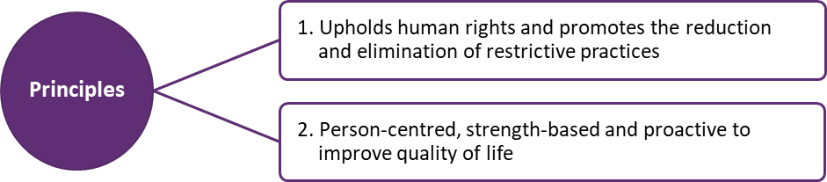
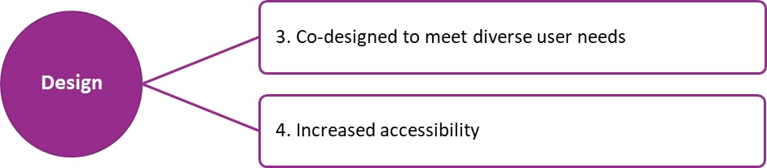
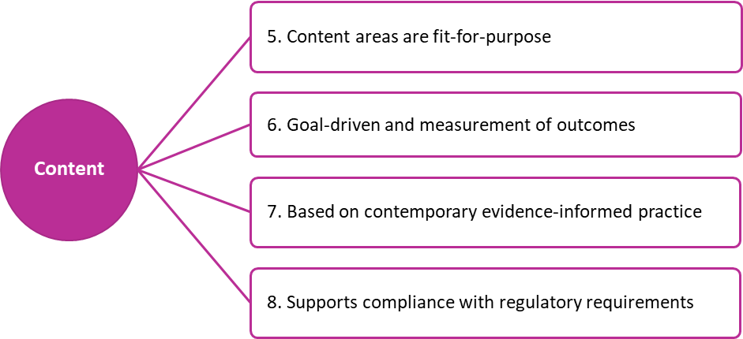
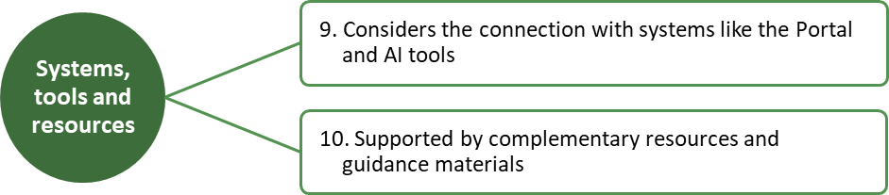

Discussion

Upholds human rights and promotes the reduction and elimination of restrictive practices
“Restrictive practices
are and should be considered a
serious infringement
on a person's human rights.”
– NDIS behaviour support practitioner

It is without dispute that human rights must be the central tenet on which any BSP template is developed. Respecting, protecting and fulfilling the rights of people with disability aligns with Australia’s obligations under the Convention on the Rights of Persons with Disabilities (CRPD). It supports the objects and principles of the NDIS Act 2013 and reflects contemporary evidence-informed practice in behaviour support.
This review has highlighted the need to strengthen the alignment of the BSP templates with a human right lens, particularly in relation to the use of restrictive practices. The NDIS Act 2013 defines a restrictive practice as “any practice or intervention that has the effect of restricting the rights or freedom of movement of a person with disability”. There are five kinds of restrictive practices that are subject to regulation and oversight by the NDIS Commission including seclusion, chemical restraint, mechanical restraint, physical restraint and environmental restraint. There are stringent conditions regarding the use of these practices as outlined in the NDIS (Restrictive Practices and Behaviour Support) Rules 2018. This includes (but are not limited to) that regulated restrictive practices must be:
  - Clearly outlined in a behaviour support plan
  - Authorised in accordance with state and territory authorisation processes (however described)
  - Used only as a last resort in response to risk of harm and after first exploring and applying evidence-based, person-centred and proactive strategies
  - The least restrictive response possible in the circumstances to ensure safety
  - Reduce the risk of harm to the person or others
  - Proportionate to the potential negative consequences or risk of harm
  - Used for the shortest time possible to ensure the safety of the person or others.
Participants must be informed about the intention to include regulated restrictive practices in their BSP. They must also be given opportunities to participate in community activities and develop new skills that have the potential to reduce or eliminate the need for restrictive practices in the future. Previous iterations of the BSP templates (i.e. V1, 2018) included additional prompts regarding some of the above conditions. However, these sections may have been unintentionally diluted in the 2019 streamlining of the BSP templates. There is a notable absence of the word ‘rights’ in both templates.
In remedying this situation it is pertinent that the revised templates thoughtfully and deliberately call out participant’s rights; that evidence of consultation and co-production is required; that greater structure and scaffolding is provided to ensure the conditions of use around restrictive practices are adequately demonstrated; and that ‘fade out plans’ are effective in reducing and eliminating the use of restrictive practices. Since publishing the templates in 2019 the NDIS Commission has developed a number of resources which could assist in achieving these goals. This includes co-designed fact sheets about participant’s rights in behaviour support and the Positive Behaviour Support Capability Framework which articulates the knowledge, skills and values required by practitioners to deliver behaviour support including the development of behaviour support plans (BSPs).

Person-centred, strength-based and proactive to improve quality of life
One criticism of the current BSP templates is that they focus too heavily on behaviours of concern and restrictive practices rather than celebrating, and understanding the person more holistically. This highlights an unintentional disconnect with a rights-based approach and the values underpinning positive behaviour support. On further review, it is possible that the streamlining of the templates in 2019 may have inadvertently contributed to this situation. In response, it is critical that the revised BSP templates adopt a person-centred, strength based and proactive approach; and that this is reflected in the structure, sequence and language used throughout the templates.
“I don't like BSPs,
because they fail to address
my human side.
It focuses on my challenging behaviours,
never my strengths.”
– person with disability
Stakeholders resoundingly told us that that the BSP templates must:
  - Be co-produced with people with disability and their supporters
  - Prioritise getting to know the person in a meaningful way (e.g., ‘All about me’ elements)
  - Focus on strengths and skills of the person with disability
  - Be disability affirming and celebrate diversity
  - Respect the person’s voice and support their decision making
  - Identify the person’s goals, needs and preferences
  - Facilitate trust and relationships
  - Foster an understanding of them as a person (e.g., including what is important to and for them)
  - Provide information about the environment(s) and supports around the person (including how these systems can support them and set them up for success)
  - Acknowledge behaviour happens for a reason. It is not who the person is
  - Be weighted towards proactive rather than reactive supports and strategies
  - Be holistic, easily tailored and responsive to the person’s needs and circumstances
  - Be re-ordered to align with a person-centred, strength based and proactive approach.
“understand[ing] underlying drivers of behaviour, such as unmet needs, communication barriers or… trauma responses … creates opportunities for person-centred support that promotes peoples’ strengths and works proactively with the person… and other[s] to find holistic solutions”
– Inclusion Australia
Revising the templates through this lens provides the opportunity to alter the frame of reference taken by other people when supporting the person and implementing the behaviour support plan. It could be argued that this approach puts people on the path to success, with relationships and understanding being the foundation on which to achieve meaningful change and promote quality of life.

Co-designed to meet diverse user needs
In revising the BSP templates, a co-designed approach has been and will continue to be essential to ensure we hear, understand and accommodate the needs and perspectives of the diverse users involved. First and foremost, the voice of people with disability must be at the centre. People with disability have told us emphatically that behaviour support plans must focus on their personhood, their rights and inherent dignity rather than reducing the focus to behaviour alone, or worse yet restrictive practices. The templates must also compel practitioners to provide evidence of the steps taken to consult and co-produce BSPs consistent with the legislative requirements.
“Involving the person
in their BSP recognises
people with disability as experts of their own lives,
as well as promoting
choice and control and ownership of decisions and strategies to
improve quality of life.”
– Inclusion Australia
Other stakeholders and partners in the co-design process include:
  - Family members, friends, guardians and other supporters
  - NDIS behaviour support practitioners and specialist behaviour support providers
  - Support workers and providers implementing behaviour support plans
  - Allied health professionals and mainstream supports and services
  - Researchers and others with an interest in the wellbeing of people with disability
  - Restrictive practice authorisation bodies and other agencies involved in safeguarding, regulation, authorisation or funding capacities.
These stakeholders have important roles in the development, implementation, monitoring, review, authorisation, safeguarding, regulation and funding of behaviour support plans. The methodology underpinning this review has sought to understand the needs and views of each of these parties, and their feedback has been synthesised and woven through all thematic elements.
It is a rather ambitious aim to develop BSP templates that adequately cater to the broad and diverse needs of people with disability, their supporters and other stakeholders. With this in mind, it is proposed that a suite of templates might be a more appropriate outcome. In fact it should be expected that some individuals will be best supported through tailored plans customised to their unique needs and circumstances as opposed to using a specific template as the base. For example, for individuals with multiple and complex needs or specific requirements due to psycho-social disability, episodic or degenerative conditions. This is in keeping with a person-centred approach and presents the opportunity for innovation, including templates in an Easy Read format specifically designed with and for participants.
Although some people have welcomed this review, others have expressed concerns about how the changes might impact them. Further consultation and piloting of the revised templates will be beneficial to ensure the recommendations of this review are successfully enlivened and that any issues, gaps or barriers are promptly identified and rectified prior to full scale rollout.
“…people who will be writing them [need to] have a voice of what needs to be
included and omitted.”
– NDIS behaviour support practitioner

Increased accessibility
“Simplify the format.
Simplify the language
so it is accessible.”
– implementing provider

Designing for accessibility aims to accommodate the needs of all users and ensure equal opportunity to access information, consistent with Article 9 of the CRPD. All stakeholders and sources of evidence consulted agreed that the BSP templates need to be more accessible. This means ensuring that the templates are easy to find, access, perceive, distinguish, navigate, use, adapt, understand and implement.

4.1 Easy to find and access
Just like the strategies in a behaviour support plan need to be easy to find and follow, the BSP templates need to be easy for practitioners and other interested parties to find and access. A portion of survey respondents were unaware that the templates existed. This highlights the need to consider their ease of access on the website and a communication strategy to support broader visibility.

4.2 Easy to read and distinguish
In addition to being designed in a way that is visually appealing, the BSP templates must be presented in a way that is easy to read. This includes using fonts, text size, line spacing and colour contrast ratios that are easy to see and process. Colour alone should also not be relied on to convey meaning but rather supported with descriptive text. Accessibility also requires careful consideration of formatting elements. For example, avoiding tables and drop down elements where possible, using in-built heading and paragraph styles, alternative text and placing any images in line with text to ensure the content is accessible for people with disability including those who user screen readers.
“The template can be challenging for people to navigate and find the information that they need. The formatting of the tables makes the document visually hard to
read and access.”
– specialist behaviour support provider

4.3 Easy to navigate, use and adapt
The BSP templates need to be succinct and logically sequenced through a person-centred lens for ease of navigation and use. Consideration should be given to a table of contents, descriptive hyperlinks and quick reference summaries to help users find the information they need. The design and format must be easy to adapt without requiring specialised software or advanced computer skills. For example, the templates should be flexible, open-ended, and not restricted or locked. Providers have indicated that they need to be able to easily add their own logo and stylise the document in accordance with their branding.

4.4 Easy to understand and implement
In revising the BSP template it is critical that the target audience is kept in mind to ensure they are easy to understand and implement in an effective and meaningful way. In undertaking this review, concerns have been raised about the length and readability of many behaviour support plans. It is noted that some are in excess of 100 pages and pitched at a university-grade level. This is incongruent with implementers needs. Instead, jargon and legalese words need to be replaced with Plain English and everyday language. Some stakeholders have suggested incorporating visual supports as an adjunct to the text to further support understanding. To summarise in the words of W3C, the body responsible for web accessibility standards, “accessibility is essential for people with disability and useful for all.”

Content areas are fit-for-purpose
This review identified the need to clearly articulate the purpose of each document and align the contents with that purpose. Currently the two templates are very similar and neither includes goals or a statement of purpose. Furthermore, some of the terminology is not consistently understood (e.g., high/low risk scenarios and formulation). This impacts the usability of the templates. In ensuring the content is fit-for-purpose, any extraneous information needs to be removed, for example, information about processes not directly relevant to the person such as portal procedures and legalese about compliance. This will rightfully reinstate the focus on the person. Functional assessment also needs to be removed from the Interim BSP template. This information is unlikely to be available at the time of writing the Interim BSP and/or may delay its delivery. It is also not in keeping with the necessary focus on safeguarding and risk mitigation.
“[The Interim BSP]
should just be a
Safety Plan
developed immediately to keep everyone safe.
Leave the … comprehensive information to the Comprehensive BSP.”
– NDIS behaviour support practitioner

Some of the key content areas flagged by stakeholders include the following:
  - Identifying information about the person, plan and practitioner
  - Purpose of the plan and the person’s goals (both behavioural and for improved quality of life)
  - Evidence of consultation with the person, other people and sources of information
  - Information about the person, their strengths, skills, history, health, communication and other needs. This must fit the type of plan and person’s wishes about sharing personal information.
  - Proactive strategies that build on the person’s strengths, build trust, relationships and promote quality of life (noting an Interim BSP may focus on preventative strategies linked to triggers)
  - A clear description of behaviours of concern, known triggers and setting events etc.
  - In Comprehensive BSPs only - a summary of meaning or proposed function(s) which captures the multiple factors contributing to and maintaining the presenting difficulties
  - Environmental change strategies to remove barriers and address ‘environments of concern’
  - Skill building opportunities (in Comprehensive BSPs), e.g., to teach FERBs (where appropriate), and other daily living or ‘lagging’ skill to improve quality of life and reduce restrictive practices
  - Response strategies to keep everyone safe (possibly presented as an escalation cycle)
  - Restrictive practice protocols/procedures linked to legislated conditions of use including fade out strategies to support the reduction and elimination of restrictive practices
  - Information about the implementing contexts including the training and support required
  - Data collection, outcome measurement, communication and review processes
  - A sign off section (e.g., for the practitioner, supervisor of core practitioners, parent/ Guardian/decision maker; and to record training and implementation support for workers).
There are differing views about whether to include a functional assessment in the Comprehensive BSP however a summary of findings may promote understanding. Note, contrary to survey feedback, QLD consent and authorisation bodies have confirmed there is no requirement to separate the two.

Goal-driven and measurement of outcomes
This review provides a significant opportunity to strengthen the focus on goals and outcomes. This is particularly important given the Commission’s previous findings that 80% of Comprehensive Behaviour Support Plans do not include clear goals or objectives. Stakeholders have echoed these concerns and highlighted that the current templates only include placeholders and prompts for behavioural goals. This could be mistaken to imply that the person alone is responsible for changing, learning new skills and / or “fixing the problem”. This is of course inaccurate. In contrast, a contemporary, evidence-informed approach to behaviour support requires a broader conceptualisation of goals including quality of life and goals related to environmental and systemic change. A ‘SMART’ approach in collaboration with the person is also indicated to agree upon and work towards Specific, Measurable, Achievable, Realistic and Time-bound goals.
“…needs to be more focus on goals relating to
quality of life and environmental change, rather than only
teaching skills”
– NDIS behaviour support practitioner

Person-centred goals and outcome measures can help ensure:
  - Supports and services are focused and meaningful
  - Connections are made between strategies, supports and the person’s goals or aspirations
  - Principles of supported decision making are promoted
  - Collaboration and coordination occurs and fosters a shared understanding
  - Priorities are understood
  - Behaviour support is evidence-informed
  - Strategies address the person’s needs, the function of behaviour and their broader life goals
  - Opportunities for change are readily identified and embraced
  - Environmental and systemic changes are considered and pursued
  - Progress is noticed and celebrated (including small wins) to build momentum
  - Barriers and issues are identified and resolved
  - Confidence and hopefulness is fostered
  - Results are achieved and measured as efficiently as possible.
In revising the BSP templates, further consideration is needed to bolster the focus on outcome measurement. Currently the templates only briefly mention incident reports, data collection and communication in the context of implementation support. Revisions could involve drawing on the Commission’s Compendium of Resources as a starting reference point for relevant outcome measurement tools (e.g., frequency, episodic, impact and quality of life measures). Additional emphasis must also be placed on the voice of the person to ensure their views are adequately considered in any monitoring and review processes.
“…a stronger focus on how strategies are measured”
– Family member

Based on contemporary evidence-informed practice
It is essential that any revision to the BSP templates are congruent with contemporary evidence-informed practice. This means that they need to integrate the best available research with the perspectives of people with disability, clinical expertise and information from the implementing or practice contexts. This is why a multi-faceted methodology was adopted to inform this review.
“…extracted from 90 sources
…[BSP] quality markers could be categorised into … behavioural assessment, technical compliance with behavioural principles, and plan implementation.”
– Nankervis & Vassos (2023)

Evidence-informed practice:
- Upholds the rights of people with disability
- Involves doing more of ‘what works’
- Focuses on outcomes and explains why things work
- Promotes continuous learning, quality improvement and innovation
- Is a fundamental part of positive behaviour support.
Positive behaviour support is an evidence-informed, person-centred and proactive approach that upholds the rights of people with disability, and integrates contemporary ideology of disability service provision with the clinical framework of applied behaviour analysis and other contemporary models of evidence-informed practice. Findings of a systematic literature review have been detailed previously in this report, but by way of reminder were found to include behaviour assessment, technical compliance with behavioural principles and plan implementation.
In undertaking this review, stakeholders emphasised the importance of contemporary ideology and other approaches such as trauma-informed practice. Given the high prevalence of systemic violence and abuse experienced by people with disability, a trauma-informed approach is considered an essential part of contemporary evidence-informed practice in behaviour support. Trauma-informed practice involves creating safe environments and understanding the psychological and neurobiological impacts of trauma. It shifts the focus from ‘what is wrong with a person’ to an understanding ‘what has happened to them’. It further reconceptualises behaviour of concern as a potential trauma response, building empathy and supporting the person’s regulation and other needs. In revising the BSP templates, consideration should be given to integrating trauma-informed principles of safety, trust, choice, collaboration and empowerment (Kezelman and Dombrowski 2021). Samples of other BSPs show ways some of this could be achieved.
“Triggers are not always the reason behind a behaviour it is far more complex than that...
[An] understanding of
neuroscience and trauma-informed care needs to be the focus.”
– Implementing provider

Overall, the behaviour support plan templates need to draw on principles of applied behaviour analysis and also allow flexibility to integrate other evidence-informed lenses as appropriate to meet the needs of the individual. In doing so positive behaviour support plans can be tailored to the individuals needs and put strategies and supports in place that have the greatest likelihood of improving their quality of life.

Supports compliance with regulatory requirements
“balance
between developing a template that ensures all
regulations
are included and ….
one that is
easy to use, implement and person centred.”
– NDIS behaviour support practitioner
In addition to developing person-centred and accessible behaviour support plans, specialist behaviour support providers have a range of legislative and policy obligations they must also adhere to. These requirements include conditions of registration. They aim to provide necessary safeguards for participants and a benchmark for quality supports and services.
Some of these requirements are outlined in the:
- NDIS Act 2013
- NDIS (Code of Conduct) Rules 2018
- NDIS (Provider Registration and Practice Standards) Rules 2018
- NDIS (Quality Indicators for NDIS Practice Standards) Guidelines 2018
- NDIS (Restrictive Practices and Behaviour Support) Rules 2018.
In addition to these national requirements, there are state and territory laws and policies, including in relation to use of restrictive practices. Providers and practitioners have reported that understanding and adhering to all these different requirements can be challenging, particularly when providing services across multiple jurisdictions. This is an area where additional guidance and resources have been requested. Stakeholders have also reported that this is an area where the BSP templates can be particularly helpful in providing prompts and scaffolds to assist them in meeting their regulatory requirements.
Work to align nationally consistent principles for restrictive practice authorisation is ongoing. This means that there are currently significant differences in the authorisation requirements and processes across jurisdictions. Additional work is needed to ensure that the revised BSP templates include all information required by the state and territory restrictive practice authorisation schemes (or at least as much as possible). Whilst an important goal, it is important to acknowledge that this may be difficult to achieve. As such there may be components where practitioners and providers will continue to need to provide additional contextualisation to ensure they adhere to all their requirements, including those beyond the scope of the NDIS Commission’s powers.
“There is additional information required in plans by the
Authorisation schemes, which is different in different States/Territories.”
– National specialist behaviour support provider
Although the current templates are approved by the NDIS Commissioner for the purposes of section 23 of the NDIS (Restrictive Practices and Behaviour Support) Rules 2018, use of these templates has never been mandated by the NDIS Commission. It is recommended that this approach is maintained, until at least such time as:
  - The BSP templates are shown to reliably facilitate high quality behaviour support plans (i.e. that are statistically significant findings).
  - When use of a consistent template has the broad support of participants, providers and authorisation bodies.

Considers the connection with other systems
It is important to acknowledge that a behaviour support plan is not a standalone document. Rather it has close intersections with a number of other tools and systems which are a necessary part of quality assurance, regulation and reporting. Where possible, aligning the sequence and content of the revised templates with existing tools and systems will assist providers to transfer information from the revised BSP templates to other required systems as efficiently and easily as possible, minimising administrative burden. In doing so consideration must be given to the strengths and limitations of each tool or system to ensure the most useful elements are included. This involves considering which systems are essential versus desirable for use. Any revisions must also prioritise the needs and perspectives of the person with disability and their supporters as opposed to being driven purely by operating systems or a provider centric view.
“it would be good to have…. [sections] that match the Commission's requirements on the portal, and in order for ease of input”
– NDIS behaviour support practitioner
For example, the revised BSP templates need to consider the connections with:
- The Commission’s operating system (‘the portal’) used to lodge plans containing regulated restrictive practices and submit reports on the use of restrictive practices etc.
- Measures of BSP quality both existing and emerging (e.g., BSP-QEII, Essentials 10, BSPQA-tool and AI tools – due for release in late 2023)
- Any existing BSP templates or forms approved by the state and territory authorisation bodies (e.g., The Victorian Senior Practitioner’s approved BSP form, QLD’s Model Plan and Statement of use of restrictive practices)
- Forms, processes and systems used to lodge applications for restrictive practice authorisation in each state or territory such as, RIDS (ACT and VIC), RPA System (NSW and NT), RPS (SA), DPAC Forms (TAS), Disability Connect/OPG (QLD)
- Recommendations of the NDIS Review and / or Disability Royal Commission (as relevant).
Whilst the NDIS Commission’s portal is largely outside the scope of this review, one area of particular relevance is the restrictive practice sub-types. Examples of sub-types can be found in Appendix A of the current BSP templates. The sub-types help providers to readily identify and report on restrictive practices in the portal, for example, when multiple environmental restraints are used. However, there are no data definitions which impacts on their reliability and / or consistency of use. Further some sub-types may not be compatible with latest thinking (e.g., in relation to the regulation of safe transportation). This needs to be resolved and decisions made about which sub-types should be retained, removed or combined. This should occur in consultation with the state and territory authorisation bodies to promote national consistency. Consideration is also needed about whether this should be retained as an appendix or best captured in a complementary resource such as a portal quick reference guide.
“…there should be an expectation that practitioners
self-assess the
plan [quality]
against the
BIP-QEII…
or some other
measurement [tool]”
– NDIS behaviour support practitioner

Supported by complementary resources and guidance
“… list of any mandatory sections in a plan would support practitioners know what the commission requires for an interim and a comprehensive”
– NDIS behaviour support practitioner
The BSP templates currently includes minimal prompts and explanatory notes. Further, the prompts that do exist tend to focus on restrictive practices as opposed to more proactive elements. This is an area where greater clarity and guidance is needed either in the BSP templates, in complementary resources or a combination of the two. Some practitioners have also requested guidance in the form of samples and examples. This may pose a risk of a cut and paste approach which is at odds with a person-centred approach to behaviour support.
In addition to the BSP templates, some practitioners requested a checklist of requirements for Interim and Comprehensive Behaviour Support Plans. This resource is now available (see link below). To facilitate finding other useful resources, it has been suggested that descriptive hyperlinks could be embedded in the BSP templates.
Although the templates provide scaffolding and foundational support, they do not guarantee BSP quality or meaningful outcomes for people with disability. These elements are largely dependent on the practitioner and providers involved. Consistent with the Positive Behaviour Support Capability Framework, practitioners need to develop a broad range of knowledge and skills to provide effective behaviour support. This “how to” guidance may be acquired in various ways including formal training, supervision, coaching and mentoring, co-allocations with more skilled practitioners, communities of practice, written guidance and practice resources.
“Many practitioners have never done any formal PBS training so these headings do not provide enough guidance on what is expected and it is up to supervisors to train them in
how to do PBS”
– NDIS behaviour support practitioner
Since the BSP templates were published in 2019, the NDIS Commission has published a number of resources which will complement the revised BSP templates. This includes:
- Participant Fact Sheets about Behaviour Support
- Positive Behaviour Support Capability Framework
- Compendium of Resources for Positive Behaviour Support
- Practice Guides around restrictive practices and Medication purpose form
- Practice Alerts and Evidence Summaries
- Evidence Matters: Developing Quality Behaviour Support Plans
- Organisational approaches to reducing restrictive practices
- Interim and Comprehensive BSP Checklists
- NDIS Commission Portal Quick Reference Guides
There are also a number of projects underway including the development of artificial intelligence tools to assess BSP quality, practice guidance around dignity of risk and resources to facilitate support-decision making in behaviour support. Additional links will be shared with the sector once available. The revised BSP templates will need to be aligned with these resources as much as possible and include relevant cross-linkages so that the sector can also benefit from these additional guidance resources.

Recommendations
The recommendations of this review have been organised in accordance with the ten sub-themes detailed in this report. Note, some recommendations relate to multiple sub-themes, however will only be recorded in one area to avoid duplication and repetition.

To uphold the person's human rights and promote the reduction and elimination of restrictive practices
  - Highlight the rights of NDIS participants in the templates. This should include specifically calling out participant’s rights and linking these rights to the purpose of each document.
  - Consider providing links to the CRPD and other easy read resources such as the participant fact sheets for behaviour support which explain the rights of NDIS participants when receiving behaviour support.
  - Align the content more closely with the Positive Behaviour Support Capability Framework, which is underpinned by the CRPD and good practice in behaviour support.
  - Revise the restrictive practice protocols to ensure they cover all conditions of use as outlined in section 21 of the NDIS (Restrictive Practices and Behaviour Support) Rules 2018. This would require practitioners and providers to demonstrate how they are upholding the rights of participants and ensure the use of restrictive practices is minimised.
  - Provide additional structure and scaffolding around fade out strategies to promote the reduction and elimination of restrictive practices.
  - Outside of the revised templates, consider developing additional resources to facilitate discussions around the intended use of restrictive practices, drawing on existing models and samples available, such as the Queensland model statements.

To be person-centred, strength-based and proactive and improve quality of life
  - Add sections for information about the person to foster relationships and help others get to know the person in a meaningful way. For example, this could include what is important to and for the person, their strengths, skills, goals, needs and preferences.
  - Consider utilising person-centred thinking tools and questions to organise information, particularly in (but not limited to) the Interim Behaviour Support Plan template.
  - Consider how the templates foster an understanding of the person and the reasons underpinning any behaviour which places the individual or others at risk of harm. This is particularly important in the context of the Comprehensive Behaviour Support Plan.
  - Ensure the templates emphasise and prioritise the use of person-centred, strength-based and proactive strategies rather than focusing on the use and reporting of restrictive practices. This includes considering the type of prompts and guidance embedded in the templates.
  - Sequence the content consistent with a person-centred, strength-based and proactive approach.
  - Use contemporary and disability affirming language.
  - Cross-link or promote the use of complimentary resources including Deciding with Support, a suite of support decision making tools for behaviour support.

To co-design templates that meet diverse user needs
  - Ensure a co-designed approach to developing the revised templates is maintained. This should include ongoing consultation with a wide range of stakeholder groups as identified in this review.
  - A suite of behaviour support plan templates is recommended in order to cater to diverse user needs. This is consistent with a person-centred approach and the development of tailored and responsive plans.
For example consideration should be given to developing:
    - A behaviour support plan template in an Easy Read or Plain English Format.
    - A behaviour support plan that aligns with existing measures of BSP quality.
    - A behaviour support plan template that promotes progressive practice including the integration of contemporary evidence-informed lenses such as a trauma-informed practice.
  - The revised BSP templates should be piloted and refined if/as necessary prior to a broad sector roll out.
  - The current BSPs templates should remain available (at least as a transitional arrangement) in acknowledgement of their current usage.
  - A communication strategy is needed to support the release of the new templates and promote their uptake.
  - Use of the NDIS Commission’s BSP templates should remain optional.

To increase accessibility
  - The revised templates need to be succinct, logically sequenced and written in everyday language with the target audience in mind. This includes consideration of readability, and removing jargon and legalese wording about provider compliance.
  - Consider adding clarifiers or definitions where necessary to build a shared understanding; and / or remove inconsistently understood terminology.
  - Consider adding a table of contents and / or quick reference summaries to help users find the information they require as quickly and easily as possible.
  - The input of graphic designers is needed to ensure the revised templates are visually appealing and “user friendly”.
  - The fonts, text size, colours, contrast ratios, line spacing and layout need to be distinguishable (i.e., easy to see and process).
  - Consider adding visual supports such as an escalation cycle or traffic lights system as an adjunct to the text. Ensure that colour alone is not relied on to convey meaning but rather supported with descriptive alternative text consistent with the accessibility requirements of any visual or design elements.
  - The formatting needs to be flexible and easy to adjust without requiring specialist software or advanced computer skills. For examples, providers need to be able to add their own logo and adjust the colour schemes in accordance with their branding requirements.
  - Limit the use of tables and drop down elements where possible and use in-built heading and paragraph styles, alternative text and place any images in-line with text to ensure the content is accessible for people with disability including those who use screen readers.
  - The accessibility of the revised templates needs to be tested to ensure they pass accessibility requirements.
  - The revised templates need to be uploaded in an easy to find location on the website and broadly publicised in accordance with an agreed Communications Plan.

To ensure content areas are fit-for-purpose
  - Information about the person, practitioner and provider, including contact details is needed in both templates.
  - Evidence of consultation with the person and other people that support them must be required in both templates.
  - Clarify the different purposes of an Interim and Comprehensive Behaviour Support Plan by adding a proposed definition and overarching goals in the revised templates. These elements should not be fixed but rather allow for further adaptation by users.
  - The content of each template must be aligned with the purpose and type of behaviour support plan. This includes,
    - Adding important information about the person to both templates, ensuring the type, amount and depth of information is appropriate to the type and purpose of the plan. The person’s preferences about sharing personal /sensitive information must also be taken into account.
    - Retaining sections for both proactive and response strategies, that safeguard participants, uphold their rights and dignity while supporting others to understand and meet their needs. Again, the type, amount and depth of information should also be appropriate for the type and purpose of the plan.
    - Removing functional analysis and hypotheses from the Interim Behaviour Support Plan template; and retaining (at a minimum) a summary of the assessment finding in the context of the Comprehensive Behaviour Support Plan template.
    - Ensuring sections or prompts are included for strategies to address “environments of concerns” to an extent that reflects the level of understanding and analysis available at the time of writing and in accordance with the type of plan.
    - Providing greater scaffolding to promote skill building opportunities in the Comprehensive Behaviour Support Plan. This should not be limited to teaching functional equivalent replacement behaviours, but also consider other daily and functional skills to improve social participation and quality of life, including the reduction of restrictive practices.
  - Ensure the revised restrictive practice protocols link to all conditions of use and provide additional scaffolding to support the development of fade-out strategies.
  - Retain a sign off section, with the option to also include practitioner capability levels, and supervisor sign off where required. Consider an optional placeholder to record consent from the person or substitute decision maker regarding the contents of the plan.
  - Replace jargon with Plain English and everyday language, consistent with the recommendations around accessibility. This includes
    - Replacing technical terms such as “formulation” with more accessible language and / or providing prompts, definitions or explanatory guidance to ensure a shared understanding.
    - Removing sections which have found to be confusing and inconsistently applied. For example, high and low risk scenarios.
  - Remove content related to the Commission’s Operating Systems and lodgement processes to reinstate the focus on the person with disability. Complementary resources can be developed or linked to provide this other guidance.
  - Consider if there is any other content that would be better suited to complementary practice guidance and quick reference guides.

To increase the focus on goals, implementation and outcome measurement
  - Ensure the templates prompt the clear articulation of goals, both behavioural and quality of life.
  - Goals related to environmental and systemic change should also be encouraged.
  - Consider incorporating a SMART approach to goal-setting (i.e., Specific, Measurable, Achievable, Relevant, and Time-Bound).
  - Provide greater scaffolding about implementation supports including training, data collection, communication and review processes.
  - Information about training requirements and plans should not be limited to the use of restrictive practices but rather be holistic and focus on building a shared understanding and capabilities necessary to reliably implement the plan.
  - Ensure there is a dedicated space for outcome measurement. This might include milestones, timeframes and how outcomes will be measured.
  - Consider linking to outcome measurement tools or resources, to facilitate the better monitoring of impact and outcomes, including but not limited to the Compendium of Resources.
  - Embed prompts to ensure the voice of the person with disability is adequately considered in any monitoring and review processes. Again this might involve cross-linking resources like Deciding with Support and other person-centred planning resources.

To reflect contemporary evidence-informed practice
  - The terminology used should be reflective of the values and ideology of contemporary disability service provision in behaviour support. This includes considering how the person, disability, behaviour and strategies are all referred to.
  - Ensure the templates reflect the capabilities as described in the Positive Behaviour Support Capability Framework.
  - Ensure the markers of quality behaviour support plans as identified in the evidence matter summary are reflected in the Comprehensive Behaviour Support Plan template, and where relevant in the context of the Interim BSP too.
  - Consider how the template framework and language used can be flexible enough to support the inclusion of other contemporary models of evidence informed practice where appropriate.

To support compliance with regulatory requirements
  - Use of the Commission’s behaviour support plan templates should remain optional at least until such time as they are shown to reliably facilitate high quality plans and there is broad participant and stakeholder support for a consistent format.
  - Align the templates with the provider’s legislated requirements, as outlined in the NDIS (Restrictive Practices and Behaviour Support) Rules 2018 and the NDIS (Registration and Practice Standards) Rules 2018.
  - Cross check the content with the recently published BSP Checklists to ensure they are congruent with good practice and the conditions of registration that apply to specialist behaviour support providers when developing behaviour support plans.
  - Overlay the state and territory regulatory requirements in relation to the authorisation of restrictive practices and accommodate these where possible. Acknowledging that it may not be possible to achieve this completely until greater national consistency is achieved.
  - Consider removing or repositioning disclaimers and ‘important information’ about the form’s (template) approval from the front page of the templates. In consultation with the Legal and Integrity division consider whether this information might better be captured in the declaration section, and whether it should mention BSP quality in addition to compliance requirements.

To consider the connection with other systems
  - Align the content with markers of good practice and measures of BSP quality. For example, including the BSPQA-tool and associated AI tools currently in development through NDIS Commission funded Grants.
  - Where possible, and congruent with the needs of participants, align the revised templates with the Commission’s Operating System to streamline lodgement and reporting process.
  - Ensure the revised templates include the information required by the state and territory based systems and processes to obtain restrictive practice authorisation.
  - Review and update the regulated restrictive practice sub-types and develop data definitions in consultation with the state and territory authorisation bodies to promote national consistency.
  - Consider and address recommendations of the NDIS Review and Disability Royal Commission as relevant.

To provide complementary resources and guidance
  - Revise the prompts and explanatory notes in the BSP templates to have a greater focus on proactive elements.
  - Ensure the prompts embedded in the templates remain succinct, with more detailed information in the complimentary practice guides and evidence-informed materials.
  - Provide cross-linkages to complimentary “how to” resources, e.g., including the PBSCF, Practice Guides, Evidence Matters and Portal Quick Reference Guides.
  - Remove procedural information about the portal and plan lodgement, to retain the focus of the plan on the person and their supporters.
  - Promote usage of the Interim and Comprehensive BSP Checklists and highlight that these resources are responsive to the feedback obtained by this review.
  - Consider collating a Resource Map on behaviour support assessment and functional behavioural assessment to build on the existing suite of resources.
  - Consider other tools for supervisors given their instrumental role in building the capability of practitioners and lifting the quality of behaviour support plans.
  - Move guidance about processes such as portal useability and “how to” guidance about positive behaviour support from the templates into complementary resources.

Conclusion
This report summarises the findings of the BSP template review. It was informed by a broad methodology, centred on consultation and a co-design process. Key themes were identified and a range of revisions proposed to uphold participant’s rights, uplift quality and enliven the principles of contemporary evidence-informed practice in behaviour support. Implementing the recommendations of this report will improve the design and accessibility of the BSP templates. It will also ensure the suite of templates is fit-for-purpose, responsive to needs and aligned with relevant laws, policy, systems and practice resources.

Acknowledgements
The NDIS Commission would like to gratefully acknowledge the important contributions made to this review by people with lived experience of disability, family members, peak bodies, practitioners and providers. The NDIS Commission is committed to continuing these important partnerships into the next phases of the work as we co-design the suite of revised BSP templates.
The BSP Template Review project is an important and ongoing piece of work for the Practice Quality and Clinical Advisory Division under the leadership of Dr Jeffrey Chan (Deputy Commissioner Practice Quality and Clinical Advisory) and Donna White (Director, National Policy and Clinical Guidelines).
The project is led by Shailaja Menon (Practice Advisor) and Debra Corfield (Assistant Director). Shailaja brings lived experience of disability, an understanding of behaviour support and a passion for accessibility and human rights. Debra is a registered psychologist with an extensive background in behaviour support and a passion for capacity building and quality supports which uphold human rights and improve quality of life.

References
Centre of Research Excellent in Disability and Health (2021) Research Report: Nature and extent of violence, abuse, neglect and exploitation against people with disability in Australia, Royal Commission into Violence, Abuse, Exploitation and Neglect of People with Disability, accessed 27 March 2023.
Kezelman CA and Dombrowski JK (2021) Disability Guidelines for Trauma-Informed Practice, Blue Knot Foundation, accessed 4 July 2023.
Nankervis K and Vassos M (2023) Evidence Matters: Developing quality behaviour support plans, NDIS Quality and Safeguards Commission, accessed 11 July 2023.
NDIS Quality and Safeguards Commission (2019) Interim Behaviour Support Plan Template, NDIS Quality and Safeguards Commission, accessed 5 January 2023.
NDIS Quality and Safeguards Commission (2019) Comprehensive Behaviour Support Plan Template, NDIS Quality and Safeguards Commission, accessed 5 January 2023.

Appendix – Quotes

Theme 1: Principles

Quote related to Sub-theme 1: Upholds human rights and promotes the reduction and elimination of restrictive practices
An NDIS behaviour support practitioner said “Restrictive practices are and should be considered a serious infringement on a person's human rights.”

Quotes related to Sub-theme 2: Person-centred, strength-based and proactive to improve quality of life
A person with disability said “I don't like BSPs, because they fail to address my human side. It focuses on my challenging behaviours, never my strengths.”
Inclusion Australia, a peak body representing people with disability said “understanding underlying drivers of behaviour, such as unmet needs, communication barriers or trauma responses creates opportunities for person-centred support that promotes peoples’ strengths and works proactively with the person and others to find holistic solutions”

Theme 2: Design

Quotes related to Sub-theme 3: Co-designed to meet diverse user needs
Inclusion Australia said “Involving the person in their BSP recognises people with disability as experts of their own lives, as well as promoting choice and control and ownership of decisions and strategies to improve quality of life.”

Quotes related to Sub-theme 4: Increased accessibility
An implementing provider said “Simplify the format. Simplify the language so it is accessible.”
A specialist behaviour support provider said “The template can be challenging for people to navigate and find the information that they need. The formatting of the tables makes the document visually hard to read and access.”

Theme 3: Contents

Quote related to Sub-theme 5: Content areas are fit-for-purpose
An NDIS behaviour support practitioner said “The Interim BSP should just be a Safety Plan developed immediately to keep everyone safe. Leave the comprehensive information to the Comprehensive BSP.”

Quotes related to Sub-theme 6: Goal-driven and measurement of outcomes
An NDIS behaviour support practitioner said “needs to be more focus on goals relating to quality of life and environmental change, rather than only teaching skills.”
A family member said “a stronger focus on how strategies are measured.”

Quotes related to Sub-theme 7: Based on contemporary evidence-informed practice
Karen Nankervis and Maria Vassos in their 2023 systematic literature review said “extracted from 90 sources, BSP quality markers could be categorised into behavioural assessment, technical compliance with behavioural principles, and plan implementation.”
An implementing provider said “Triggers are not always the reason behind a behaviour it is far more complex than that. An understanding of neuroscience and trauma informed care needs to be the focus.”

Quote related to Sub-theme 8: Supports compliance with regulatory requirements
An NDIS behaviour support practitioner said it is a “balance between developing a template that ensures all regulations are included and one that is easy to use, implement and person centred.”

Theme 4: Systems, tools and resources

Quotes related to Sub-theme 9: Considers the connection with other systems
An NDIS behaviour support practitioner said “it would be good to have sections that match the Commission's requirements on the portal, and in order for ease of input.”
Another NDIS behaviour support practitioner said “there should be an expectation that practitioners self-assess the plan quality against the BIP-QE2 or some other measurement tool.”

Quotes related to Sub-theme 10: Supported by complementary resources and guidance
An NDIS behaviour support practitioner said “a list of any mandatory sections in a plan would support practitioners know what the commission requires for an interim and a comprehensive.”
Another NDIS behaviour support practitioner said “Many practitioners have never done any formal PBS training so these headings do not provide enough guidance on what is expected and it is up to supervisors to train them in how to do PBS.”

