**Implementing Providers:   
Activating a Behaviour Support Plan and lodging evidence of authorisation**

**Quick Reference Guide**

This guide outlines how to use the **NDIS Commission Portal** to activate behaviour support plans and lodge evidence of authorisation.

See our other quick reference guides:

* Implementing Providers: Monthly Reporting on the use of restrictive practices

## In this guide

Accessing the NDIS Commission Portal

Activating a Behaviour Support Plan

Viewing the Behaviour Support Plan

Lodging Evidence of Authorisation

Plan status definitions

# Accessing the NDIS Commission Portal

## Step 1: Obtain a PRODA account

To access the NDIS Commission Portal, you will need a PRODA account. For instructions, see the [Quick Reference Guide: Getting access to NDIS Commission Portal](https://www.ndiscommission.gov.au/document/1021).

## Step 2: Self-request access role

Authorised Reporting Officer (ARO) role

Once you have your PRODA account, login to the NDIS Commission Portal and request access for ‘**Authorised Reporting Officer’ (ARO)**. This role is approved by the Authorised Access Delegate role within your organisation.

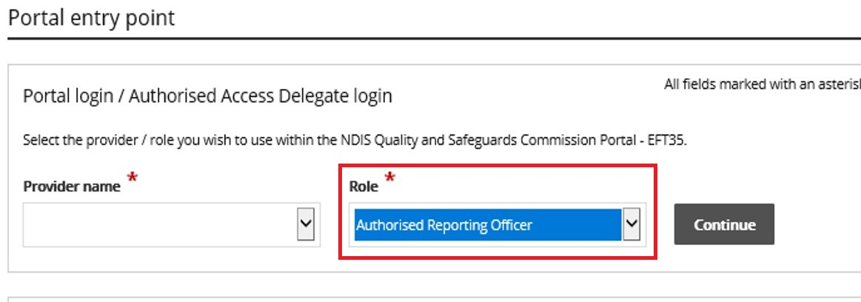

***Tip:*** *Any ARO can* ***activate*** *the plan by locating the plan through the* ***search*** *function, navigating to the implementing provider view, and clicking the* ***Activate*** *button (see ‘**Activating a behaviour support plan**’)*

***Tip:*** *Primary AROs receive tasks in the portal. This indicates when a behaviour support plan has been lodged.**If you don’t know who the Primary ARO is, or would like to nominate an ARO as the Primary ARO, email* [*nqsc.ictsupport@ndiscommission.gov.au*](mailto:nqsc.ictsupport@ndiscommission.gov.au) *with your provider registration ID and ABN.*

***Tip:*** *You may have multiple access roles in the NDIS Commission Portal. It is important that you are logged in as the ARO role when activating behaviour support plans and completing monthly reporting. If any of the buttons referred to in these instructions are not visible, you may be logged in under a different access role. Check this first before contacting the NDIS Commission for help.*

Behaviour Support Reporting **Admin** role

**Note**:

* This access role also allows a user to **activate** behaviour support plans and to enter monthly reports about the use of regulated restrictive practices outlined in the behaviour support plan.
* The Admin role cannot submit monthly reports; only the ARO role can do this.
* This role is approved by the **Authorised Access Delegate** within your organisation.

# Activating a behaviour support plan

Once the behaviour support plan is lodged in the NDIS Commission Portal by the specialist behaviour support provider, the implementing provider needs to

* Activate the plan,
* Lodge evidence of authorisation in the portal and
* Complete monthly reports on the use of the restrictive practices.

To do this, follow the steps below.

## View the plan

* 1. Select the **Behaviour Support plans** tab

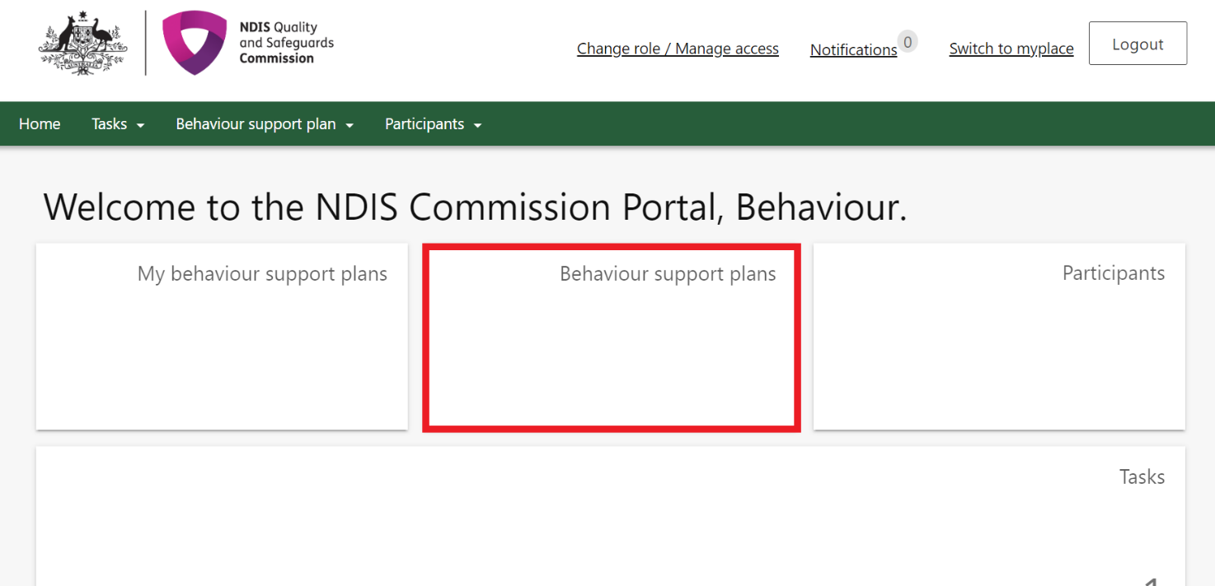

* 1. Search for the participant using the Plan ID or participant’s name and click **Run search.** The results will be displayed at the bottom of the screen. Select the plan and click **View**.

***Tip:*** *The search engine is sensitive, so it is important that the spelling of the person’s name is accurate.*

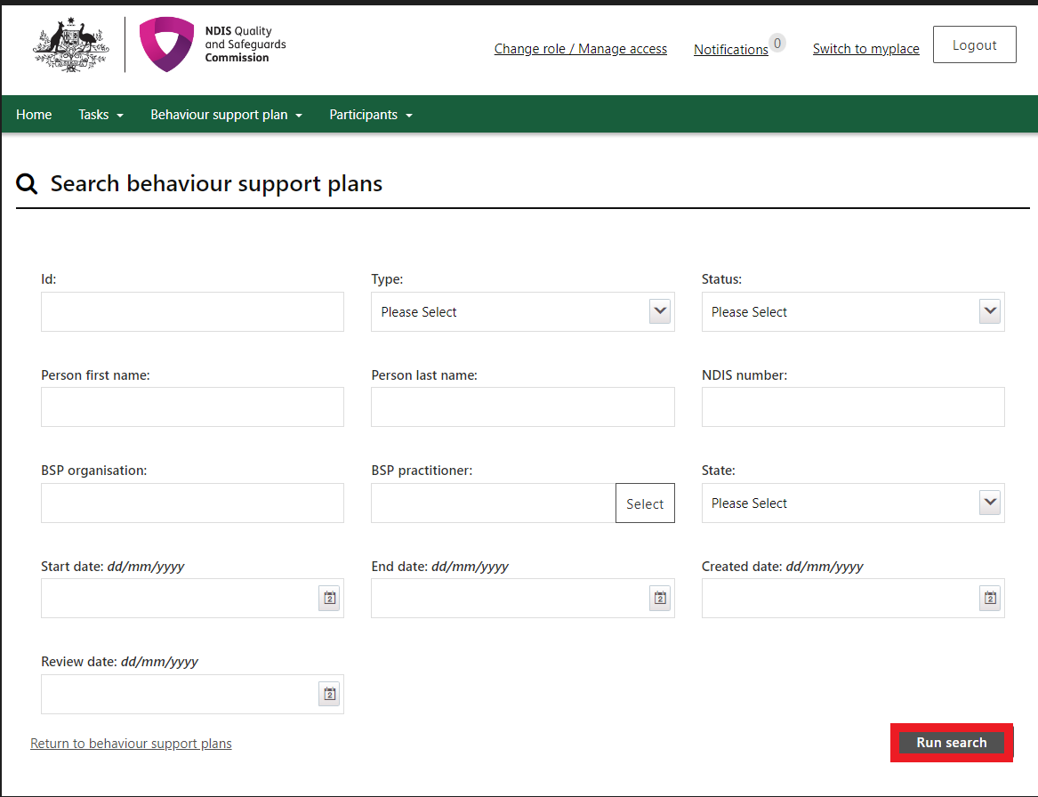

* 1. Click **Person details** and check it is the right person.
  2. Click **Details and** check the start and end date of the plan.
  3. Click **Schedule of restrictive practices** and check that all restrictive practices being used are listed accurately, including matching the information contained within the attached behaviour support plan. If they are not correct, **do not activate the plan** and contact the specialist behaviour support provider.
  4. Click **Attachments.** A copy of the behaviour support plan is located here. If there are no attachments, contact the specialist behaviour support provider. The specialist behaviour support provider is required to attach a copy of the plan as part of the lodgement for interim and comprehensive plans, and a copy of the functional behaviour assessment as part of the lodgement of the comprehensive behaviour support plan.

***Tip:*** *The behaviour support plan may be attached under the assessment section if it cannot be located under the attachments section.*

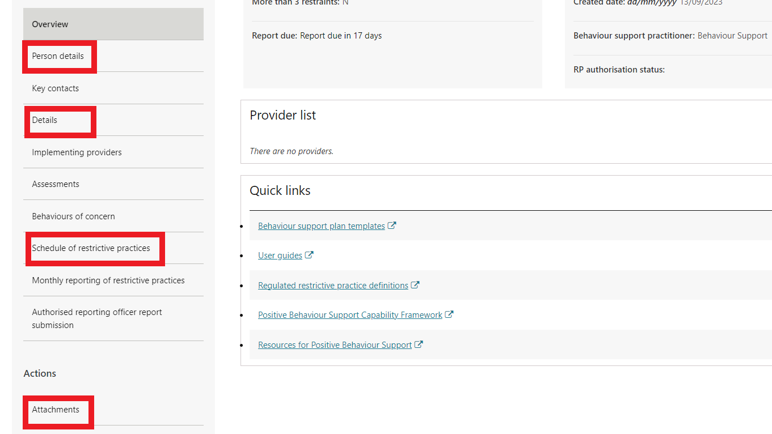

***Tip:*** *If there are any errors in the behaviour support plan,* ***do not activate the plan*** *and contact the specialist behaviour support provider.*

*If the plan status is ‘****Pending’*** *the specialist behaviour support provider is able to change the status back to* ***draft*** *and rectify the error.*

*Note: Once you click the* ***activate*** *button and the plan status is ‘****Active’****, changes cannot be made to the plan. Therefore, it is important that this stage is used as a check point, and the plan is reflective of your organisation’s use of the regulated restrictive practices.*

## 2. Attach evidence of authorisation (where applicable) and activate the plan

* 1. Click **Schedule of restrictive practices** from the left-hand side navigation menu.   
     For each restrictive practice, click the **Actions** button and then then click **Update.**

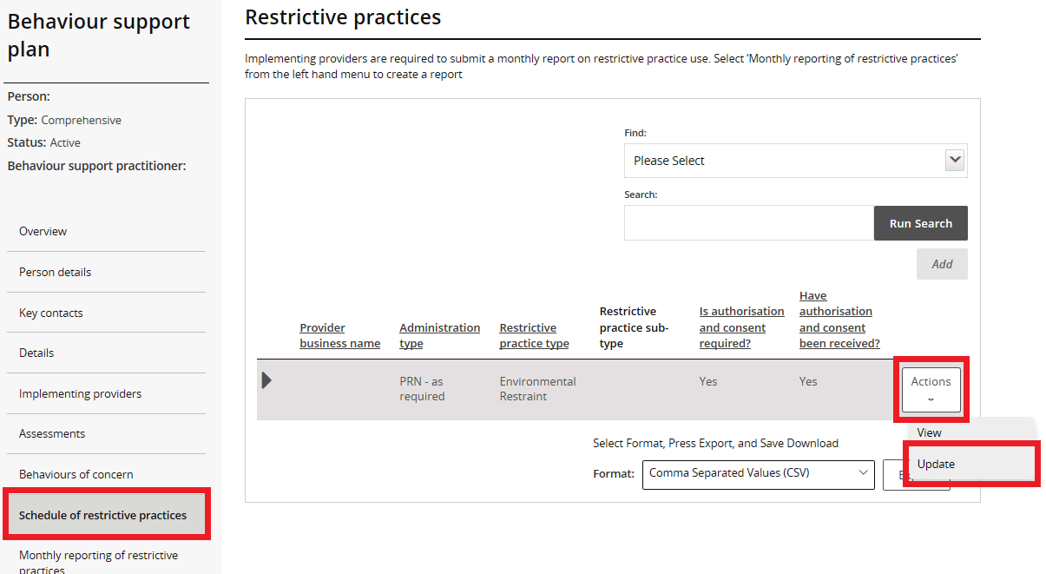

* 1. It is the role of the implementing provider to
* Obtain authorisation for the use of each restrictive practice.
* Update the authorisation information and,
* Attach the evidence of authorisation.

These fields can be updated by the ARO or the Behaviour Support Reporting Admin, even when the plan is active.

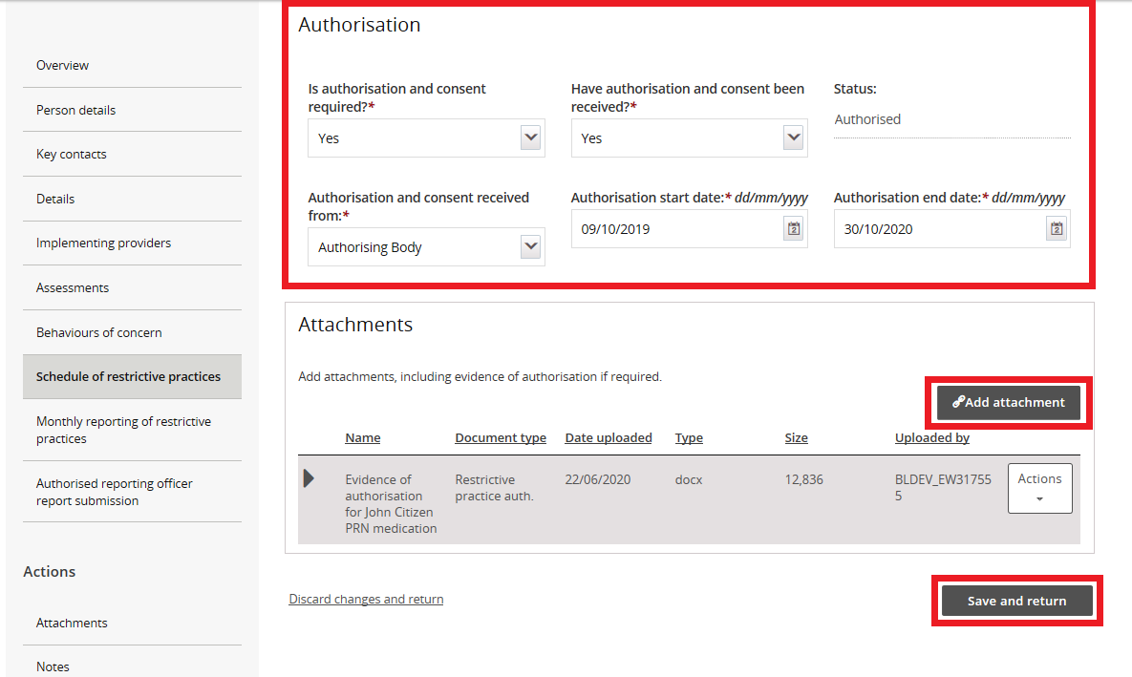

***Tip****: All States and Territories should use ‘Authorising Body’.   
QLD may select ‘Guardian’ as required in accordance with state authorisation process (however described).*

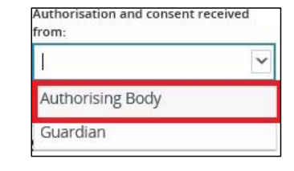

* 1. To lodge the evidence of authorisation, scroll down and click **Add attachment.**

***Tip:*** *If you have not yet received written evidence of authorisation you can come back and update these sections when you have received it.*

If authorisation has not been obtained, it is also a reportable incident (**unauthorised restrictive practice**). This means that if the plan has been activated, monthly reporting on the behaviour support portal will be required as well as URP reporting obligations.

* 1. Attach evidence of authorisation. Select **Restrictive practice auth. or Authorisation Document** as the ‘document type’ and click **save and close.** Attach evidence to each restrictive practice listed.   
     Note: the ‘Description’ field is not mandatory.

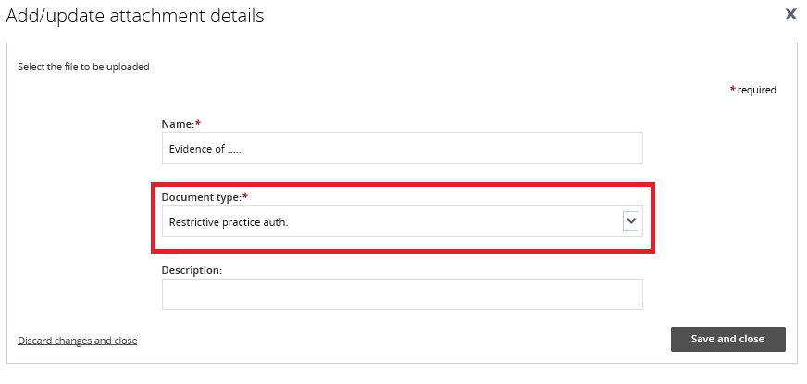

* 1. Once all details have been reviewed, click **Implementing Providers** in the left-hand side navigation menu and click **Activate**. The plan status will become active and is now ready for reporting.

***Tip:*** *if there are multiple Implementing providers, the behaviour support plan status may show as ‘****partially active****’ if the other provider/s has not yet activated the plan.*

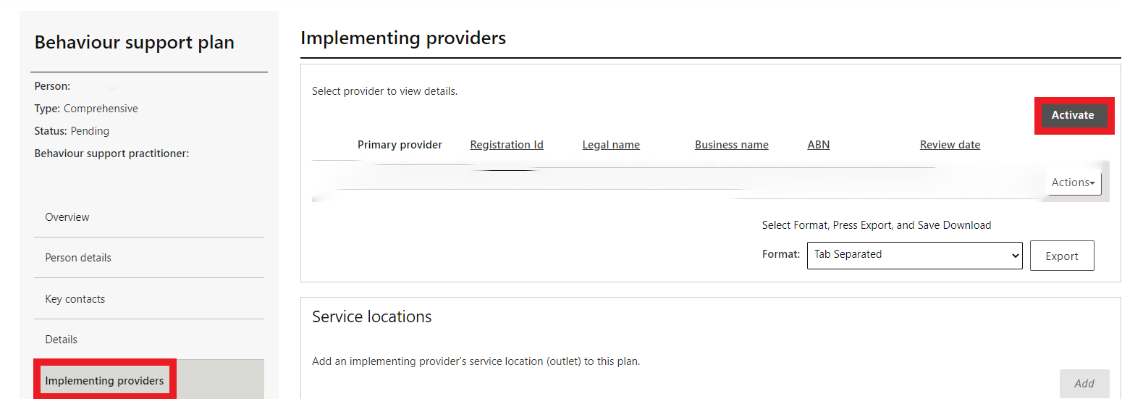

The provider must notify a specialist behaviour support provider if there has been a change in the participant’s circumstances that requires the behaviour support plan to be reviewed. Changes cannot be made to an active plan; a new plan will have to be lodged.

***Tip:*** *If authorisation is no longer required for a regulated restrictive practice that is detailed in the active plan (i.e., the restrictive practice has ceased, or the practice is not regulated due to evidence of primary purpose of medication), this can be updated under the schedule of restrictive practices. Select* ***Actions*** *and then click* ***Update****. Select* ***‘No’*** *from* ***‘Is authorisation and consent required’*** *and click* ***save and return****.* ***Attach evidence in Attachments.***

* 1. Refer to **NDIS Commission Quick Reference Guide: Monthly Reporting on the use of Regulated Restrictive Practices** for instructions on how to submit monthly reports.

## Plan status definitions

|  |  |
| --- | --- |
| Draft | This means that the behaviour support practitioner is developing the plan.  The Implementing Provider cannot view the plan when it is in draft status. When the practitioner clicks 'send draft' from the Details tab on the left-hand side of the page the status will change to 'pending'.  Best practice is for the practitioner to contact the implementing provider/s to advise the plan has been lodged on the Commission portal. |
| Pending | This means that the plan has been lodged by the behaviour support practitioner.  An implementing provider cannot complete monthly reporting when a plan has a status of ‘pending’. The plan must be ‘active’ to complete monthly reporting.  If changes need to be made when a plan has a status of ‘pending’, the practitioner can change the plan status back to ‘draft’, make the necessary amendments and then change the status back to ‘pending’. |
| Active | This means that the behaviour support plan has been activated by the implementing provider.  No changes can be made to an active plan. A new plan will have to be lodged. To save time, a copy of the plan can be made by going to the **Details** page and clicking the **Copy** button. |
| Partially Active | This means that there is more than one implementing provider.  The status will show as ‘partially active’ until ALL implementing providers have activated the plan. Implementing Providers that have activated the plan can commence monthly reporting |
| Closed | This means that the behaviour support plan has been closed and no changes can be made to the plan.  Behaviour support plans cannot be re-activated once they have been closed. If a plan has been closed in error, it will need to be re-lodged. A new behaviour support plan will need to be lodged if one is required.  Monthly reporting will also cease against this plan and any further reporting will need to be completed through the reportable incidents function on the portal until a new plan with authorisation is in place. |

|  |  |
| --- | --- |
| Expired | This means the end date of the behaviour support plan has been reached.  Monthly reporting can be completed on a plan with an ‘expired’ status. This function is useful when an implementing provider is awaiting a new plan to be uploaded onto the NDIS Commission Portal.  Comprehensive behaviour support plans must be developed within 6 months of being engaged and comprehensive behaviour support plans must be reviewed every 12 months or if there is a change in circumstances that requires the behaviour support plan to be amended |

# 

# Contact us

**Call: 1800 035 544** (free call from landlines). Our contact centre is open 9.00am to 4.30pm in the NT, 9.00am to 5.00pm in the ACT, NSW, QLD, SA, TAS and VIC Monday to Friday, excluding public holidays.

**Email:**  [behavioursupport@ndiscommission.gov.au](mailto:behavioursupport@ndiscommission.gov.au)

**Website:** [www.ndiscommission.gov.au](http://www.ndiscommission.gov.au)