**Specialist Behaviour Support Providers: How to lodge a Behaviour Support Plan**

**Quick Reference Guide**

This guide outlines how to use the **NDIS Quality and Safeguards Commission (NDIS Commission) Portal** to lodge a behaviour support plan.

Table of Contents

Specialist Behaviour Support Providers: How to lodge a Behaviour Support Plan 1

Accessing the NDIS Commission Portal (the Portal) 2

Step 1: Obtain a PRODA account 2

Step 2: Are you considered suitable as a NDIS behaviour support practitioner? 2

Step 3 – Self request access role for the Portal 2

General tips when lodging a behaviour support plan 3

Getting ready to lodge 4

1. Create behaviour support plan identification number (plan ID) 5

2. Add participant details 7

3. Add disability details 9

4. Add address details 11

5. Consent to share information 12

6. Add key contacts 14

7. Enter details about the behaviour support plan 16

8. Add implementing provider details 17

9. Add a functional behaviour assessment 21

10. Add behaviours of concern 24

11. Add restrictive practices 27

12. Attach the Behaviour Support Plan 32

13. Send draft behaviour support plan to implementing provider(s) 34

14. Fix an error in a plan 37

15. Closing a plan 40

Plan status definitions 43

Contact us 44

# Accessing the NDIS Commission Portal (the Portal)

## Step 1: Obtain a PRODA account

To access the Portal, you will need a PRODA account. For instructions, see the [Quick Reference Guide: Getting access to NDIS Commission Portal](https://www.ndiscommission.gov.au/document/1021).

## Step 2: Are you considered suitable as a NDIS behaviour support practitioner?

Under the National Disability Insurance Scheme (NDIS), a specialist behaviour support provider must engage behaviour support practitioners, who are persons that the NDIS Commissioner of the NDIS Quality and Safeguards Commission (NDIS Commission) considers suitable to undertake behaviour support assessments and to develop behaviour support plans that may contain the use of restrictive practices. There is [information about this requirement](https://www.ndiscommission.gov.au/providers/behaviour-support#02) on our website.

If you have not been considered suitable as an NDIS behaviour support practitioner, your access request will be rejected.

## Step 3 – Self request access role for the Portal

Behaviour Support Practitioner role

Once you have your PRODA account and have been considered suitable as a NDIS behaviour support practitioner, log in to the Portal and request access for ‘**Behaviour Support Practitioner’**. This role is approved by the NDIS Commission. You will be notified via email if your access has been approved within approximately two business days.

***Tip:*** *if you are requesting multiple user roles, ensure the behaviour support practitioner role is requested separately from any other roles. Do not request multiple roles at the same time as this may result in your request for the behaviour support practitioner role being rejected.*

Behaviour Support Practitioner **Admin** role

An administrative staff member or other non-behaviour support practitioner can assist in the lodging of behaviour support plans for the specialist behaviour support provider. However, a behaviour support practitioner must be added to the behaviour support plan in the Portal and is responsible for the information entered on the Portal and contained in the behaviour support plan.

The Behaviour Support Practitioner Admin can complete all steps required for lodgement; however, the behaviour support practitioner must complete the final step of clicking the ‘Send draft’ button.

### When is the behaviour support plan lodged?

The behaviour support plan is lodged when the ‘send draft’ button is pressed and the status of the plan changes to ‘pending’.

# General tips when lodging a behaviour support plan

***Tip:*** *Complete mandatory fields when entering information.   
These are identified by a red asterisk (*). Fields that are not marked with a red asterisk are not essential to complete the lodgement.*

***Tip:*** *When searching for providers, always use the provider’s ABN only. If you mistype the provider’s name, the Portal may return zero results, as it looks for an exact match. Using the ABN as the only search term is the most reliable way of finding providers in the Portal quickly.*

***Tip:*** *Ensure you add the implementing providers’ service location/outlet after adding the implementing provider. This is required to add the behaviours of concern and restrictive practices.*

|  |
| --- |
| Getting ready to lodge Prior to lodgement, it is a good idea to have the following items easily available and accessible:   1. **A completed behaviour support plan** in a document that contains at least one regulated restrictive practice. The plan can be written on your own template or on the NDIS Commission template. **Note - if there are no restrictive practices in the plan, lodgement is not required.** 2. **Implementing provider details**:    1. Each Implementing provider’s ABN    2. Service location outlet ID number or outlet name or outlet address 3. **Medication details** (if chemical restraint is included in the plan) e.g., medication chart with the names of the medications, dosage and frequency. 4. **A functional behaviour assessment**, if a comprehensive behaviour support plan is being lodged, as this must also be attached to the Portal.   ***Tip:*** *Select ‘Functional Behaviour Assessment’ as the document type when uploading.*  If you have multiple access roles, ensure you are logged in as behaviour support practitioner or Behaviour Support Practitioner Admin role. |

1. Create behaviour support plan identification number   
   (plan ID)
   1. Click on the behaviour support plan drop down menu and select **Behaviour support plan list.**

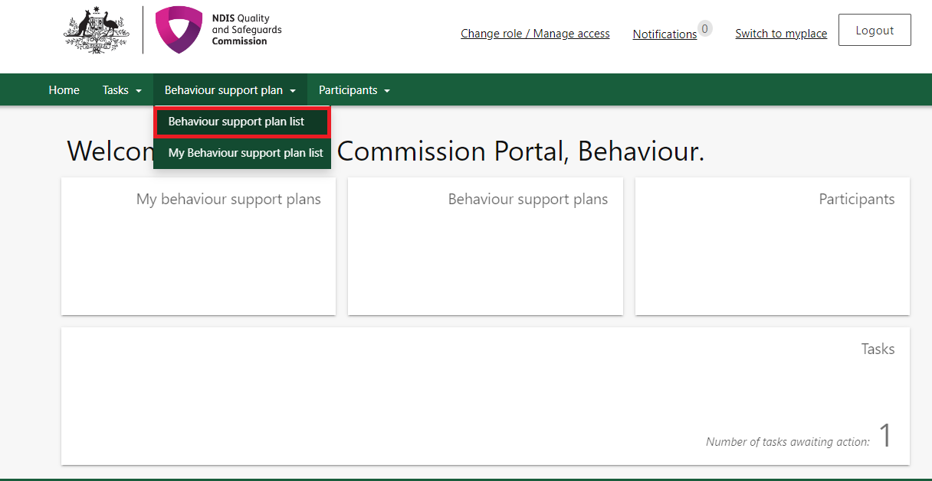

* 1. Click **Create plan**.

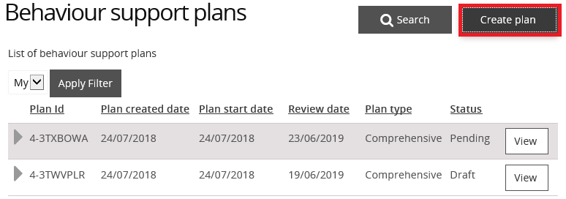

* 1. Select*Interim* or *Comprehensive* and then select **Save and continue.**

Only select *Comprehensive* if you have a completed a functional behaviour assessment ready to upload. Once you select either *Interim* or *Comprehensive*, a plan identification number (plan ID) is created for this plan type and cannot be changed. If you select the wrong plan type, you will need to go back to step 1.2 and create another plan.

***Tip:*** *Do not select ‘RP record (no BSP)’ plan type. If you are a practitioner uploading a behaviour support plan, then you should only choose between an interim plan and a comprehensive plan.*

***Tip:*** *If the wrong plan type is selected, go to step 15 to close the plan and select ‘created in error’ as reason for closure.*

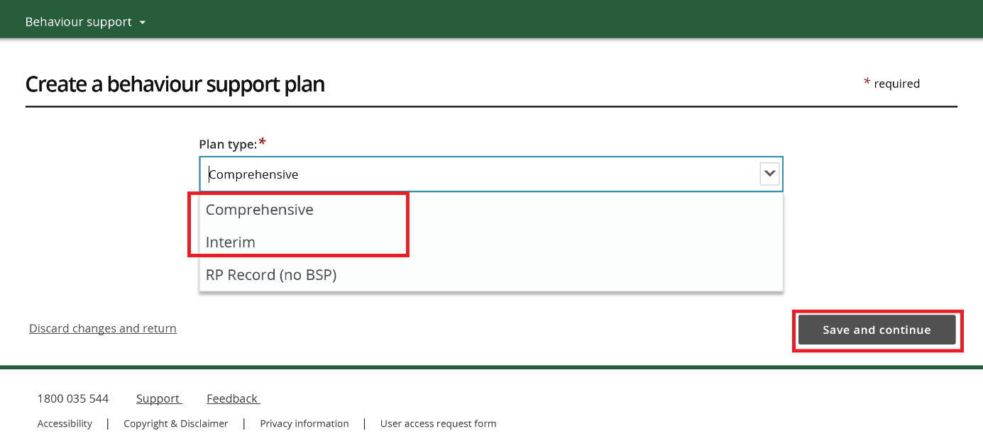

You have now created a draft behaviour support plan in the Portal.

**Note:** NSW/ACT practitioners need to provide the plan ID to implementing providers for the authorisation submission.

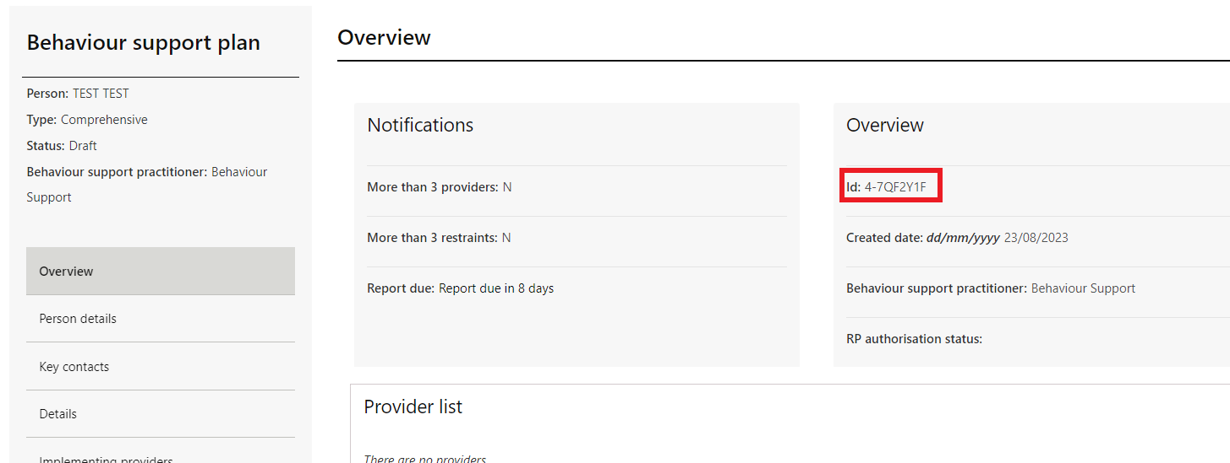

***Tip:*** *The* ***plan ID*** *is located in the ‘Behaviour support plan overview’ section on the right-hand side of the screen.*

## Add participant details

* 1. Click the **Person details** from the left-hand side menu then click **Select Add.**

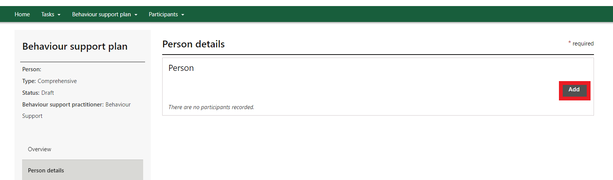

* 1. On the ‘Participant Search’ screen, enter the participant details and click **Search.**

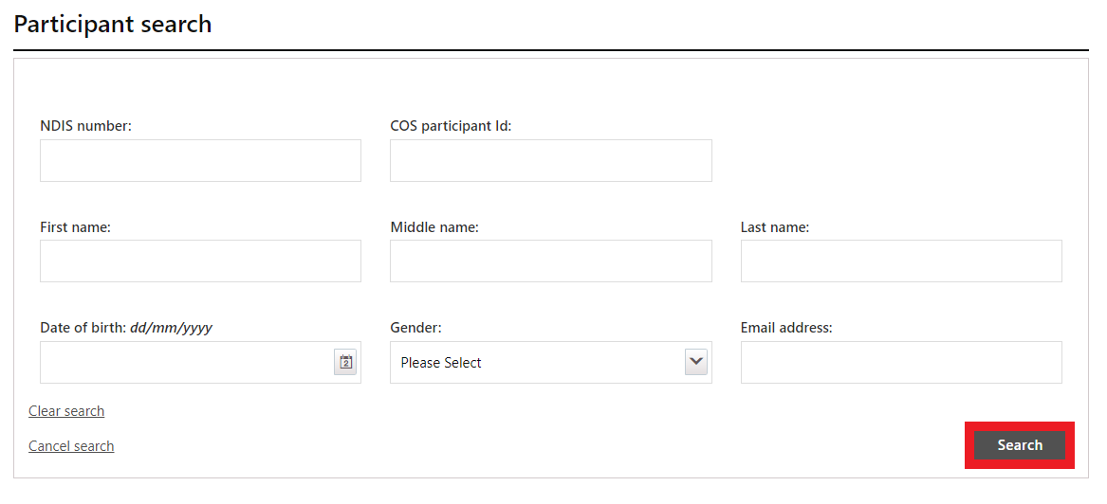

* 1. Select a **Participant record** to add then click **Select.**

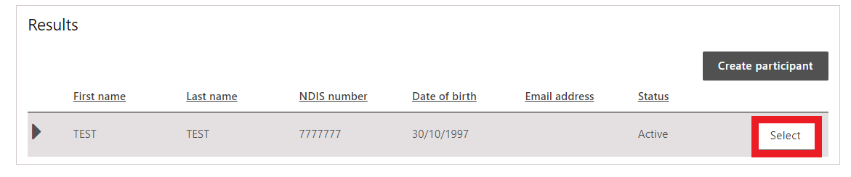

* 1. Check the participant details for accuracy. If they are incorrect, update the **person’s details**.   
     Go to step 3.1.

***Tip:*** *If numerous entries appear, cross check against the Date of Birth (DOB) on the behaviour support plan and NDIS participant number.*

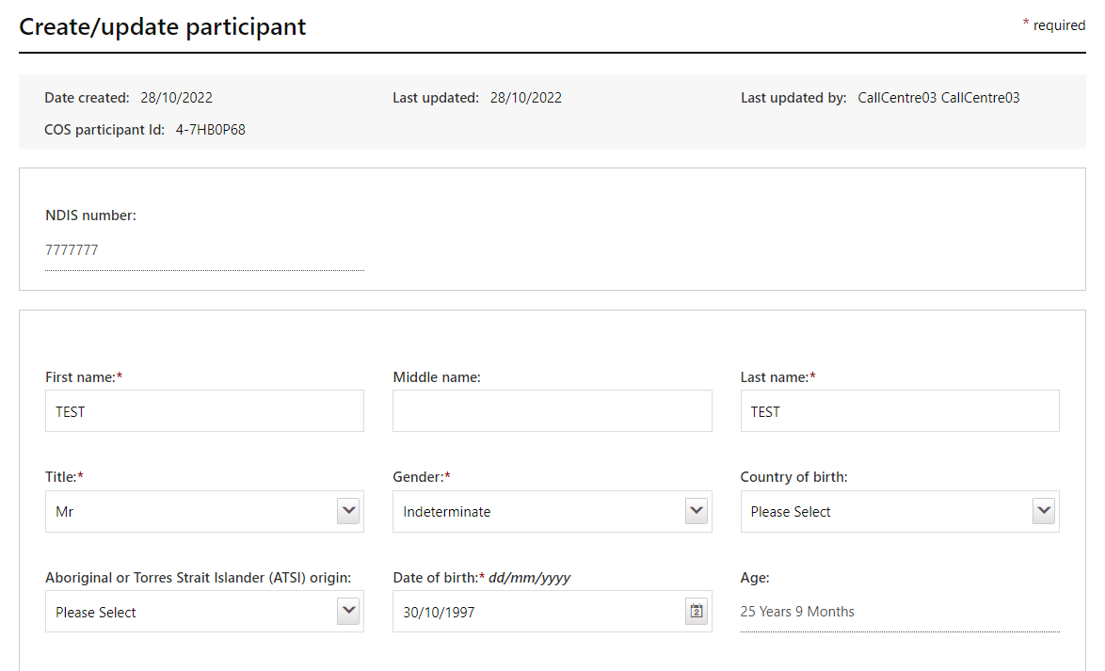

***Tip:*** *If you select an existing participant, this will auto populate their details in the plan, so you can move to the next section.*

* 1. If no participant records appear after searching, click **Create participant** and go to step 2.6.

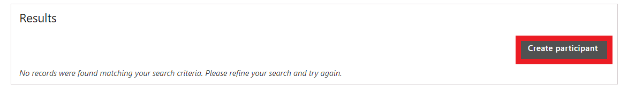

* 1. Enter the participant details and go to step **3.1**.

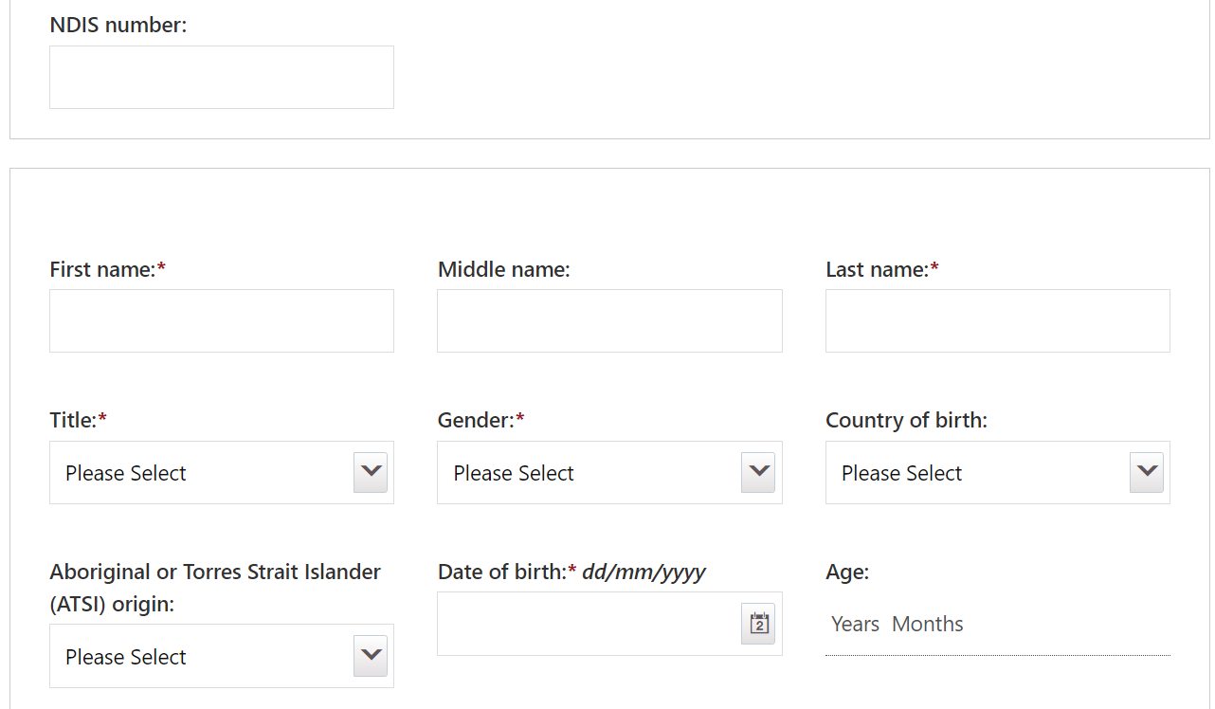

***Tip:*** *Once you have created the participant record for the first behaviour support plan, it will be available to use for any subsequent behaviour support plans for that participant.*

***Tip:*** *When lodging a behaviour support plan for a person that is funded under the* Disability Supports for Older Australians (DSOA) Program*, enter their health ID number under the section for NDIS participant number. If you do not know their health ID number put “COS”.* The NDIS Commission Portal will accept any number entered if the letters COS are placed in front.

1. Add disability details
   1. Scroll down to the **Disability details** tile then click **Add/update disability.**

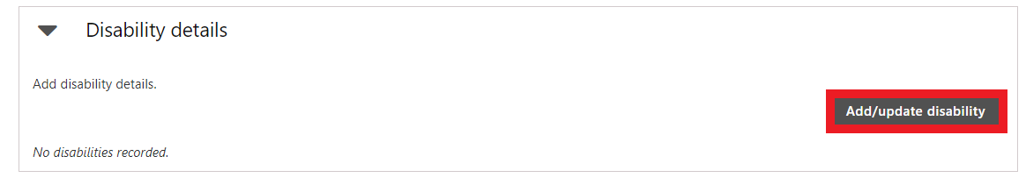

* 1. Select the **Disability type/s**, then click **Save and close.**

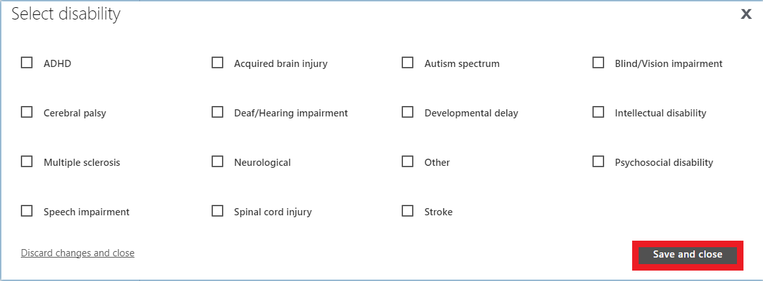

1. Add address details
   1. Scroll down to the **Addresses** tile then click **Add address.**

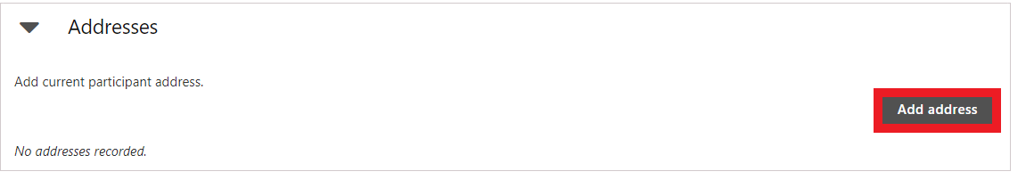

* 1. Type the **Address details** using no punctuation, then click **Save.**

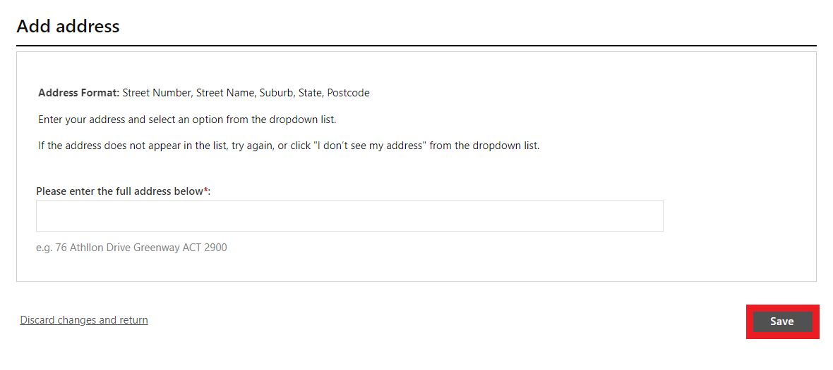

* 1. Then scroll down and click, **save and return.**

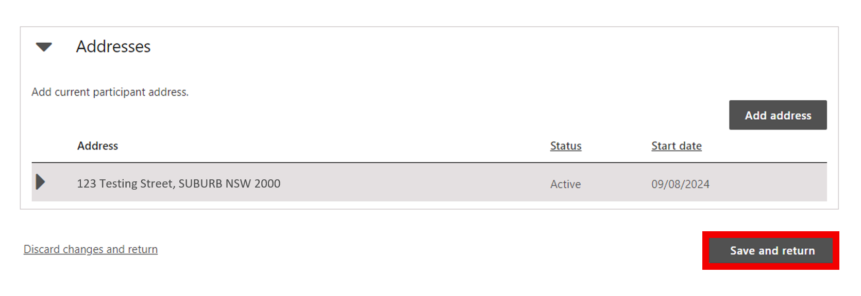

1. Consent to share information
   1. The consent to share information section is not mandatory.   
      Only complete this section if you have a copy of evidence of consent from the participant (or someone authorised to do so on their behalf). Click **update.**If you do not have a copy, go to step **6.1**.

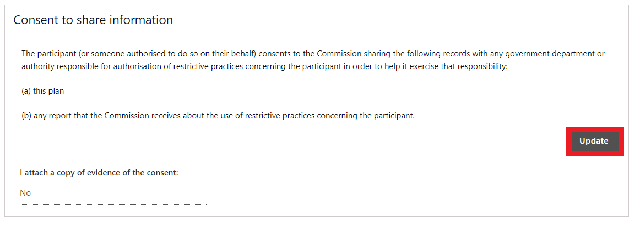

* 1. Select Yes, enter the details of the consent and click **save.**

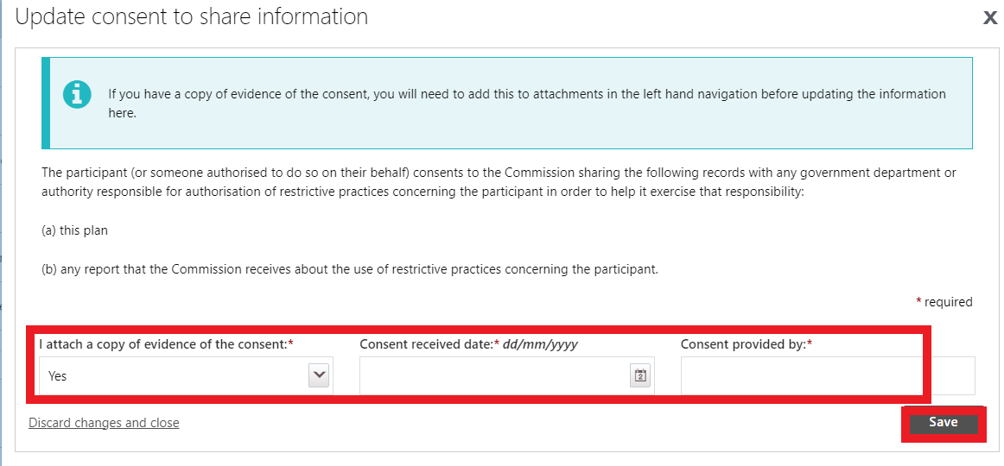

* 1. Go to the attachments tab on the left-hand side menu. **Click Add attachments**. Then upload a copy of the consent. Make sure you select **consent to share information** as the ‘document type’ from the drop-down options and click **save and close**.

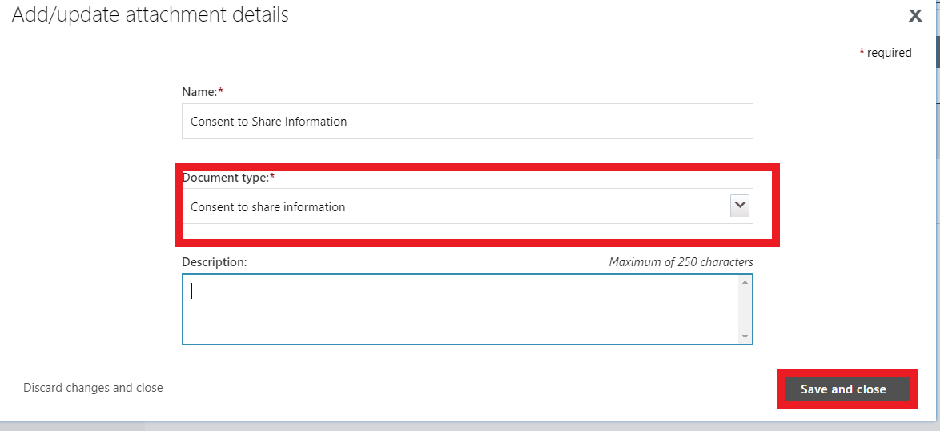

***Tip:*** *If you select ‘Yes’ to ‘attaching a copy of the consent’, and you do not add evidence of the consent in the attachments tab, it will not let you send the draft plan to ‘****pending****’ status.*

1. Add key contacts
   1. Click the **Key contacts** from left hand side menu then click **Add.**

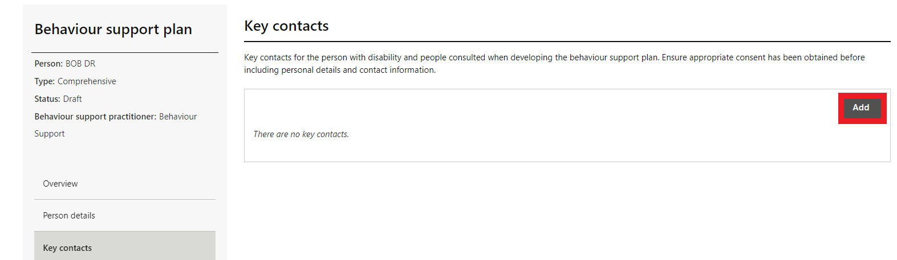

* 1. Click **Search.**

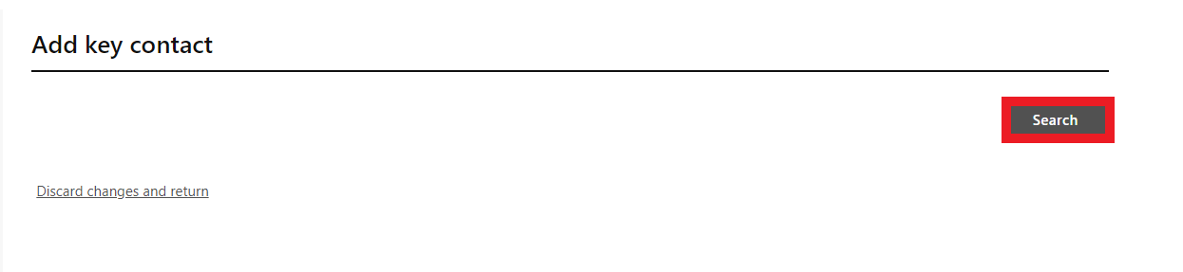

* 1. Type the **key contact’s search details** then click **Search.**

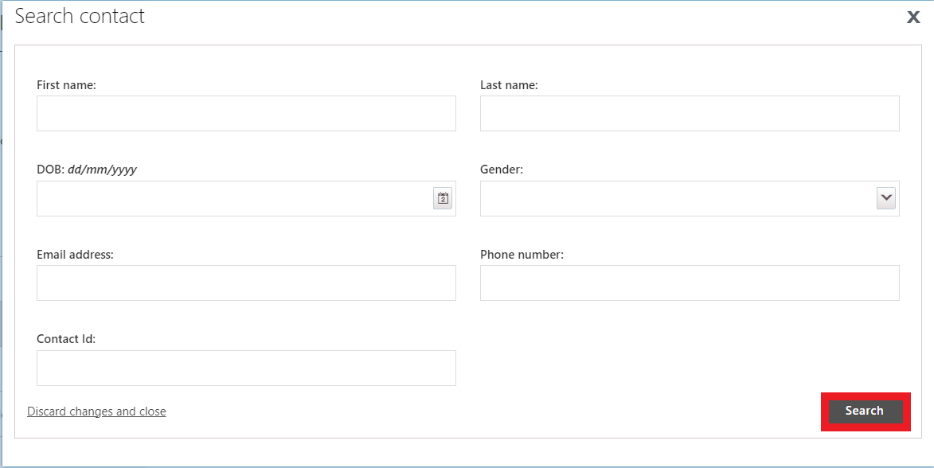

* 1. Select a **Key contact record to add then click Select and close.**

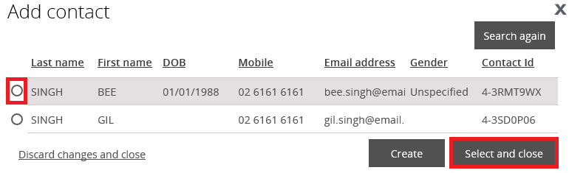

* 1. If the key contact you are searching for is not there, click on the **Create** button and enter their details.
  2. Check the **Key contact’s details for accuracy.**
  3. Update **Key contact’s details** if they are incorrect.
  4. Click **Save.**

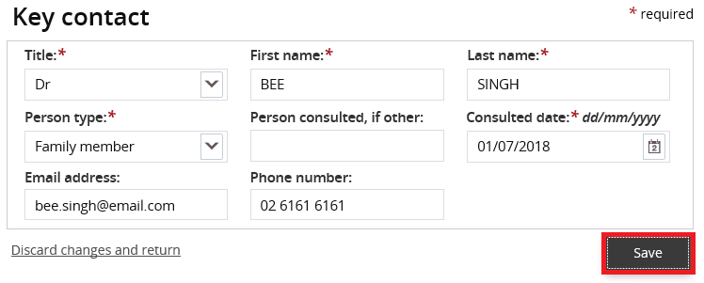

1. Enter details about the behaviour support plan
   1. Click **Details** from the left-hand side menu.   
      Click **Update**.   
      Click the **select** button next to the behaviour support practitioner box to select the practitioner that you are uploading the plan for.
   2. Enter the **start date, end date** and **review date**. The review date should be at least one month before the end date.

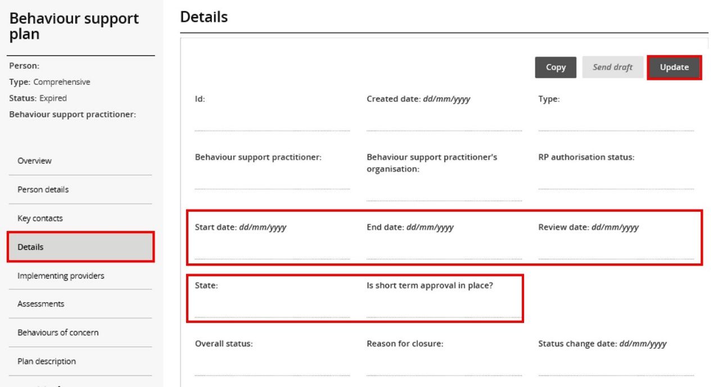

*****Tip:*** *Plan start dates in the portal should align with the dates on the attached behaviour support plan.*

Interim behaviour support plans are developed within 1 month and comprehensive behaviour support plans are developed with 6 months of being engaged.

A provider is considered ‘engaged’ from either the date of the service agreement, or the date specified in the service agreement (i.e. where a date is specified in the agreement by which the provider is to commence developing the plan)

* 1. Enter the **State** the participant is living in.  
       
     For Queensland only, indicate whether a short-term approval is in place.

***Tip:*** *After saving, check that the dates you have entered are correct. If they are incorrect, update and save again.*

## Add implementing provider details

The NDIS (Provider Registration and Practice Standards) Rules 2018 state “a person must be registered under section 73E of the Act to provide a class of supports to a participant if, during the provision of the supports, there is, or is likely to be, an interim or ongoing need to use a regulated restrictive practice in relation to the participant.”

This means any NDIS funded provider who implements (or is likely to implement) restrictive practices is required to be registered with the NDIS Commission for the type of support they are providing. This includes completing audit against Module 2A: Implementing Behaviour Support Plans. They do not need to be registered specifically for behaviour support registration group 0110.

### Unregistered implementing provider

If you are developing a behaviour support plan for a participant who is engaging unregistered providers and implementing regulated restrictive practices, please contact the NDIS Commission.

### No implementing provider

When there is no NDIS funded implementing provider using the regulated restrictive practice (e.g., family members, school) you will not be able to enter the behaviours of concern or regulated restrictive practices in the plan. The delivery of services to NDIS participants funded by the State or Territory Government, is an example of a non-NDIS provider and may include Forensic, Health and Mental Health Services or child protection agencies.

For these behaviour support plans:

* complete step 9 if it is a comprehensive plan - adding a functional behaviour assessment.
* complete step 12 – attach a copy of the plan.
* then go to step 15 and close the plan. Select the appropriate reason for closure e.g. **implemented by family** or **implemented by non-NDIS provider**.

For a behaviour support plan that is implemented by a registered NDIS provider(s), continue to follow each step in this guide.

* 1. Select **Implementing providers** and click **Add.**

***Tip:*** *Only add in NDIS providers who are implementing the restrictive practices.   
Do not add other providers to this section. Any other providers involved who are not implementing any restrictive practices can be added under* ***Key contacts*** *(see section 6).*

***Tip:***  *As the practitioner and the specialist behaviour support provider, you are automatically displayed on the* ***‘details’*** *view and do not need to be re-added here.*

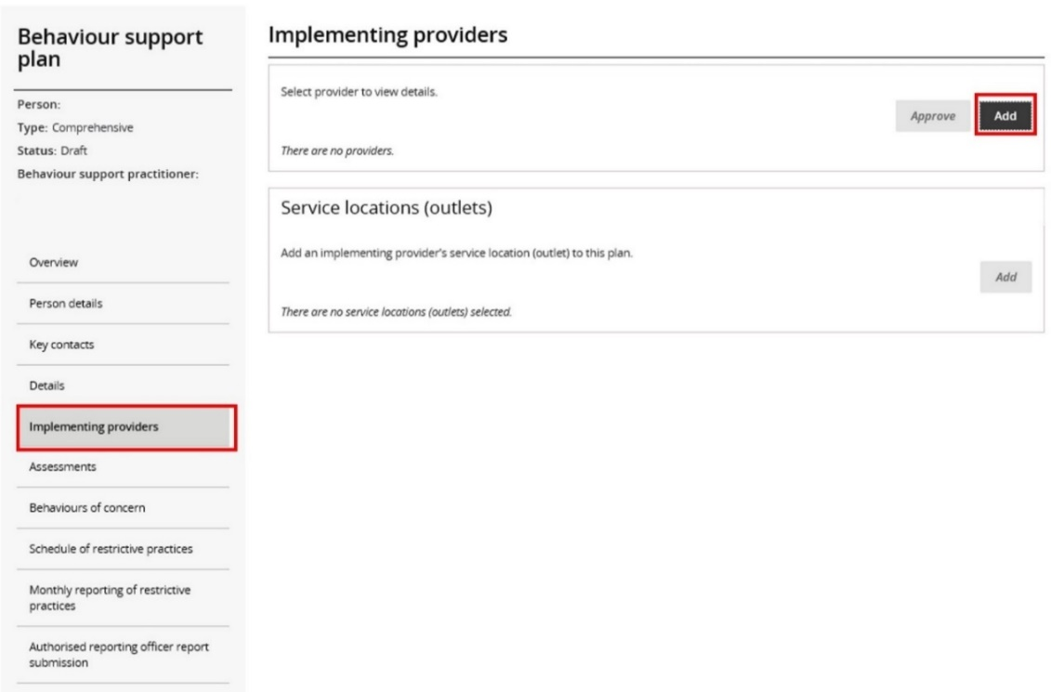

* 1. Type the **implementing** **provider ABN** then click **Search**.   
     You can also search by name, however it is easier to find the correct provider by using the ABN only. You should also verify both the ABN and provider name to ensure you have not selected another provider that is not involved with the participant.

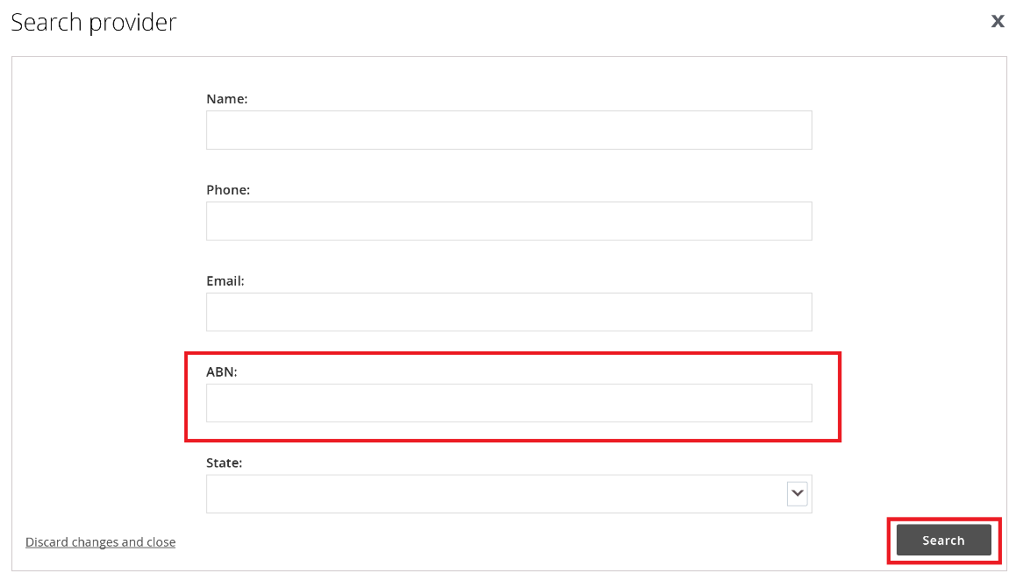

* 1. Select an **Implementing provider record** to add then click **Confirm.**

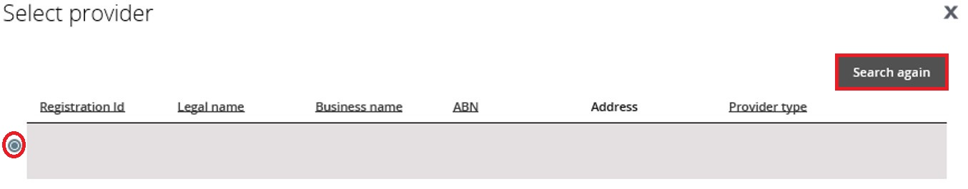

If there are more providers to add, **repeat steps 8.1 – 8.3.**

* 1. Where there are multiple providers, select a **primary provider**. This is the provider likely to be using the restrictive practices the most. Click the **Actions** button to change a primary provider.

***Tip:*** *When the plan status is in draft, the* ***Remove*** *button is available. If a provider is added in error, ensure it is not the primary provider, click the* ***Actions*** *button and click* ***Remove.***

***Tip:*** *The primary provider cannot be removed. Add the correct provider first, make them the primary provider by clicking the* ***make primary*** *button, and then remove the incorrect provider. Note: This will also remove any behaviours of concern or restrictive practices that have been attached to this provider.*

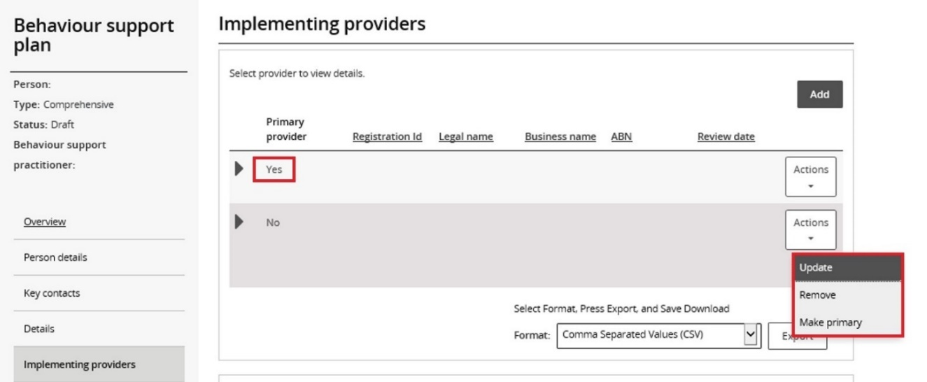

* 1. Click on the Provider name and, on the ‘Service locations (outlets) screen, click **Add.**

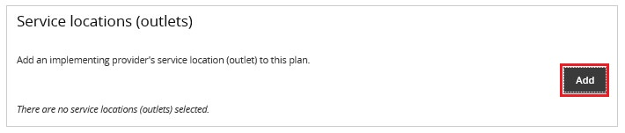

* 1. Type the **Service location (outlet) name or ID then click Add.**

If you are unsure of what outlet address to add, confirm with the implementing provider. You can also leave the fields blank, and click on the **Search locations** button. This will bring up a list of all available service locations to select from.

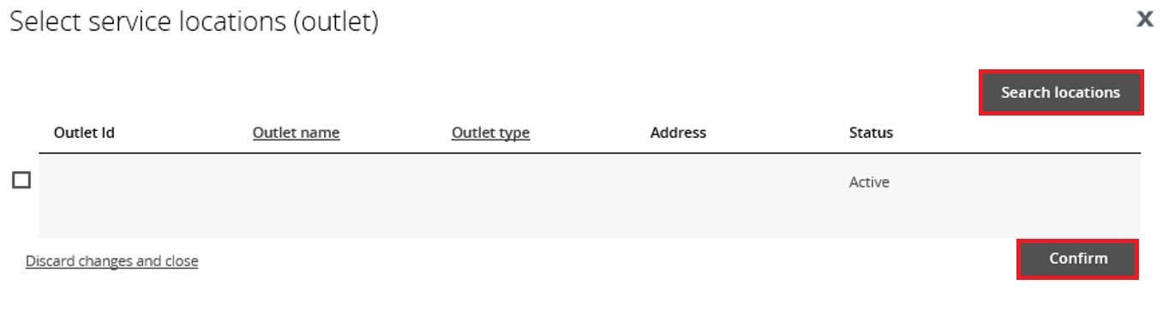

* 1. Select a **Service location record** to add then click **Confirm.**

***Tip:*** *You will not be able to add any behaviours of concern or regulated restrictive practices if a service location is not added.*

***Tip:*** *If there is more than one provider, you need to add a service location for each provider by* ***repeating steps 8.5 – 8.7.***

## Add a functional behaviour assessment

This is a mandatory field for comprehensive behaviour support plans. It is not required for interim plans.

* 1. Select **Assessments** and click **Add.**

This is a two-step process – first create a record of the assessment by clicking **Add**. Then upload a copy of the assessment under **Attachments**.

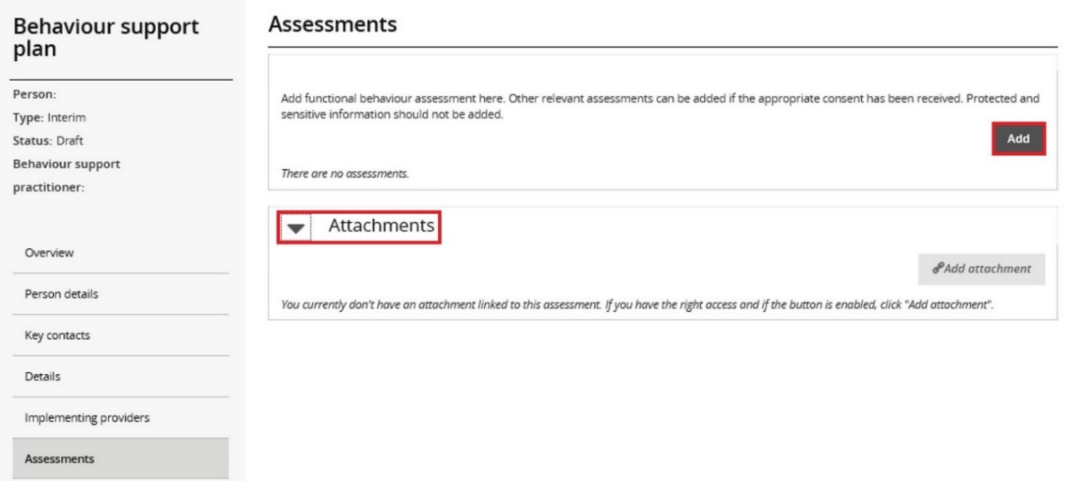

* 1. Enter the assessor’s name and report date and select *Functional Behaviour Assessment* then click **Save**.

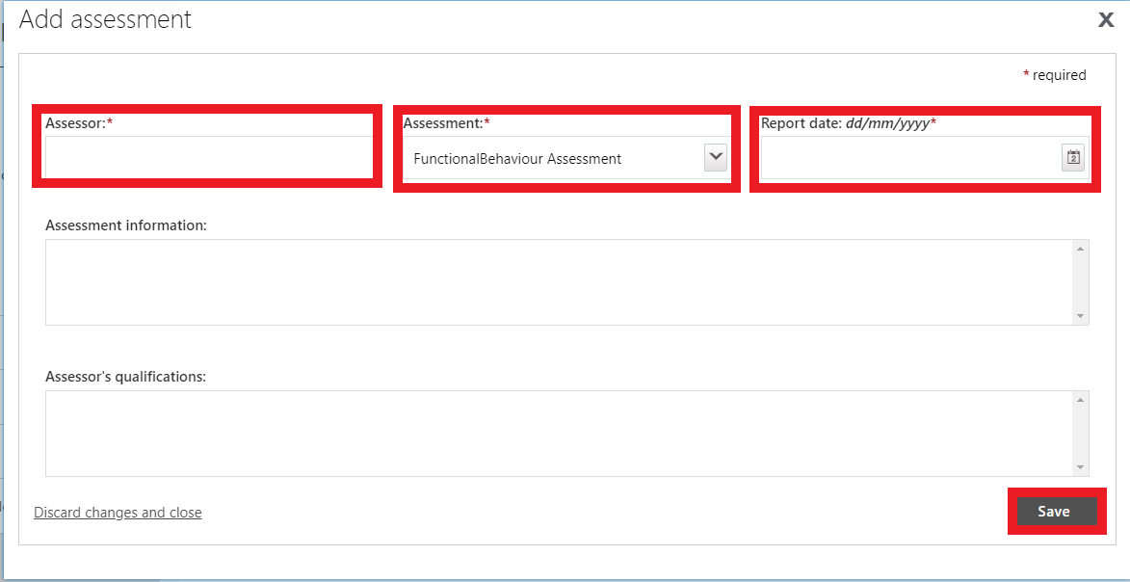

Note: **Assessment information** and **Assessor’s qualifications** are not mandatory fields.

***Tip:*** *Only the functional behaviour assessment is required to be attached. Other assessments do not need to be lodged with the NDIS Commission, but practitioners can attach other reports if useful.*

* 1. Click on the name of the assessment, then select the **Attachments** tile and click **Expand.**

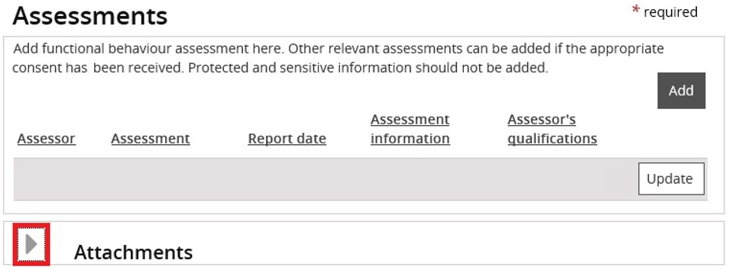

* 1. Click **Add attachment.**

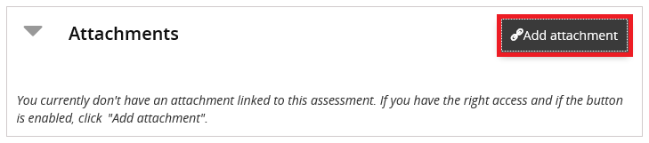

* 1. Choose a **File to Upload (attach)** then click **Open.**

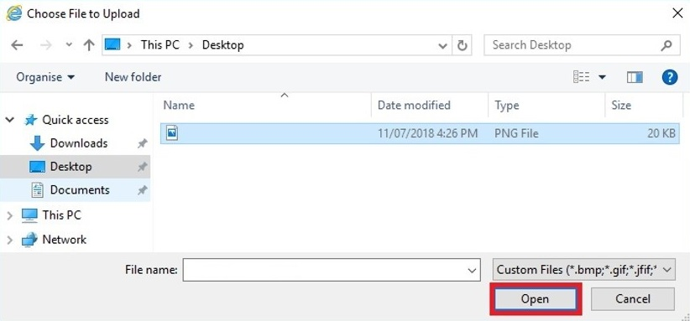

* 1. Select *Functional Behaviour Assessment* as the **Document type** then click **Save and close.**

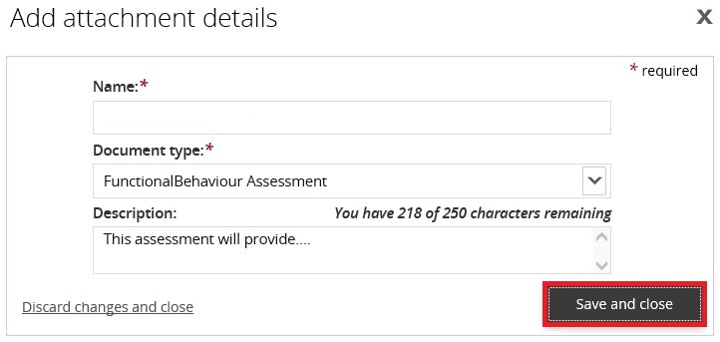

***Tip:*** *If the functional behaviour assessment is contained within the behaviour support plan, attach the behaviour support plan here as well as attaching it under* ***attachments****.*

***Tip:*** *Ensure that you have Functional Behaviour Assessment showing on the screen in two places, both at the top and underneath* ***Attachments****.*

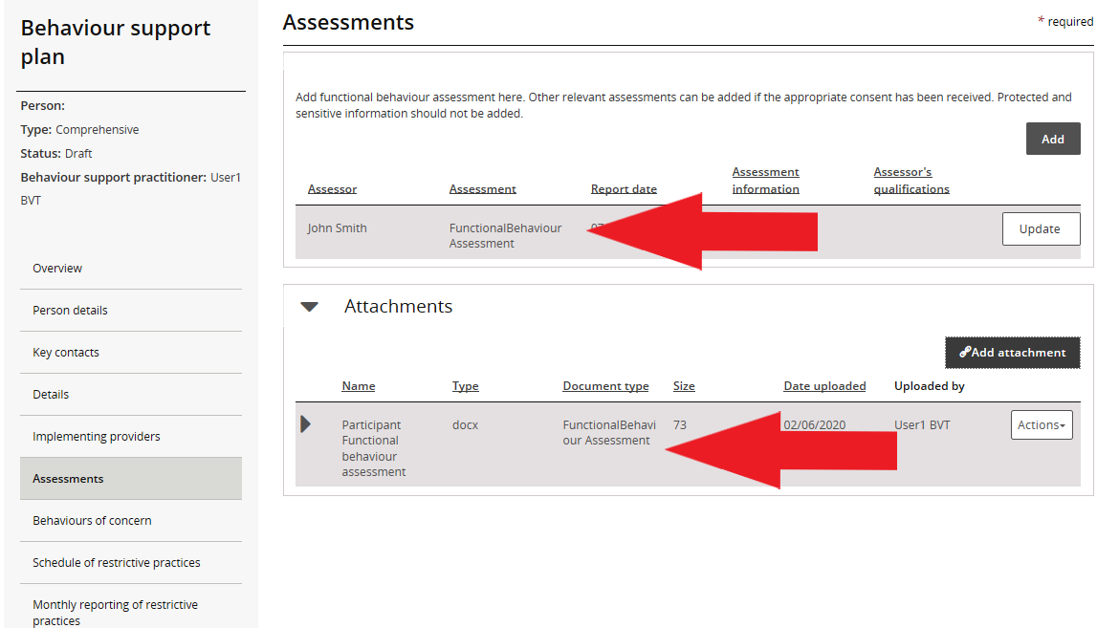

## Add behaviours of concern

* 1. Click **Behaviours of concern** from left-hand side menu and click **Add**.

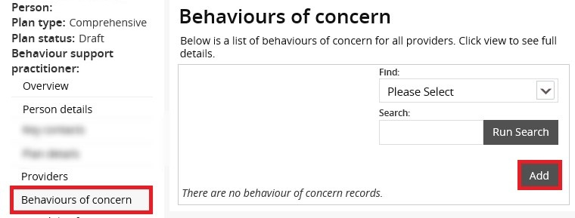

* 1. Select a **Behaviour of concern** from the **Behaviour of concern** drop down field. Select the **Provider Business name** and **Service location**, then click **Next**.

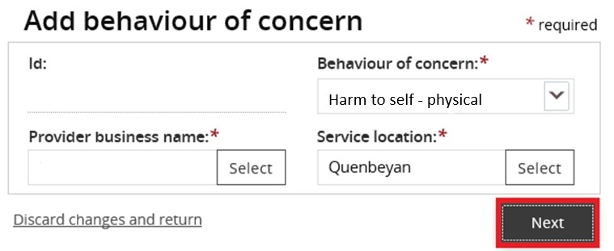

* 1. Do not enter the behaviour of concern details. Scroll down and Click **Save** **and return**.

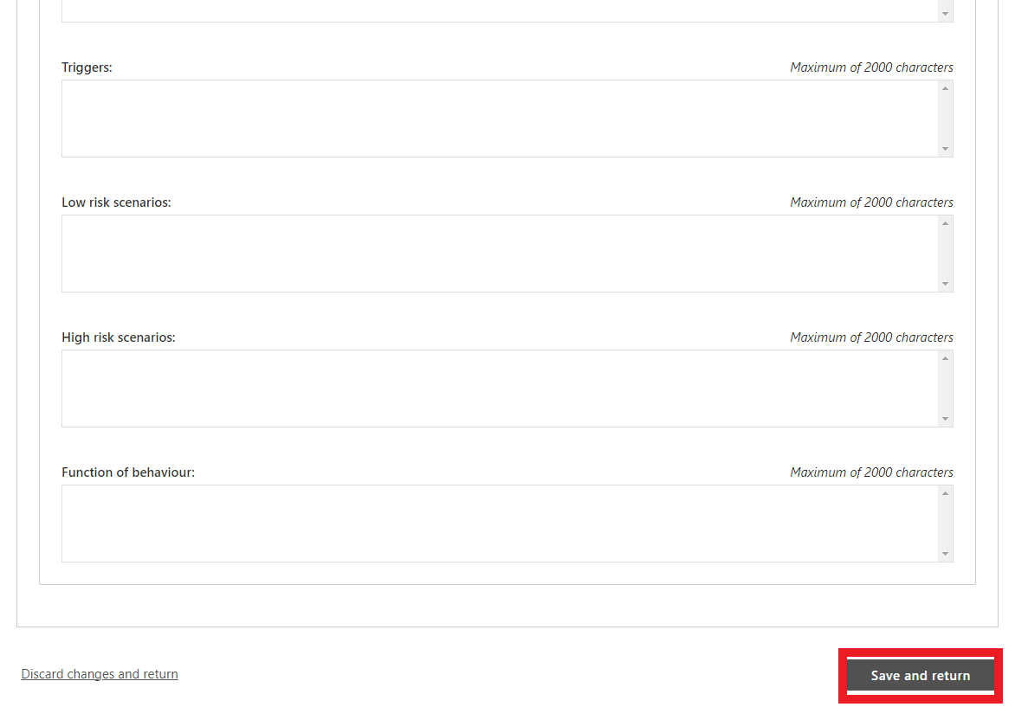

If there are more behaviours of concern to add, **repeat steps 10.1 – 10.3**.

* 1. If there are multiple providers, the behaviour of concern must be added against each provider where the behaviour occurs. To do this, select the behaviour of concern and click on the **copy** button. Change the **Provider business name** and **Service location** to reflect the different provider.

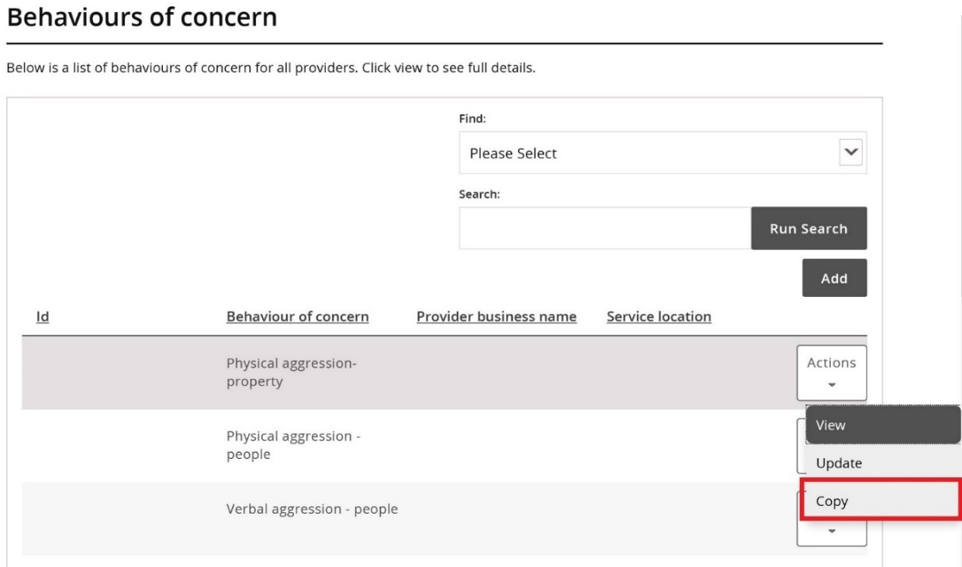

## Add restrictive practices

* 1. Click **Schedule of restrictive practices** from the left-hand side menu, and then click **Add.**

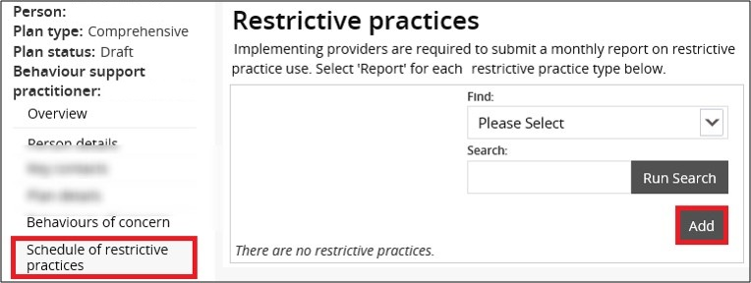

* 1. Complete the **restrictive practice** information from drop down fields then click **Next**.

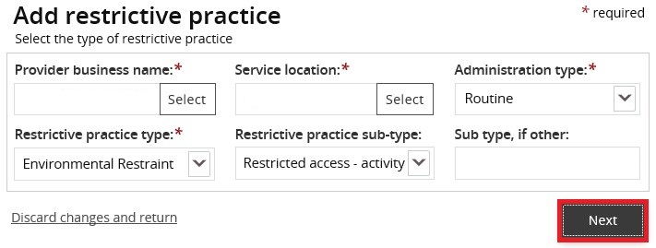

* 1. Enter the r**estrictive practice authorisation details. If you have not received a copy of authorisation select No and click save and return**

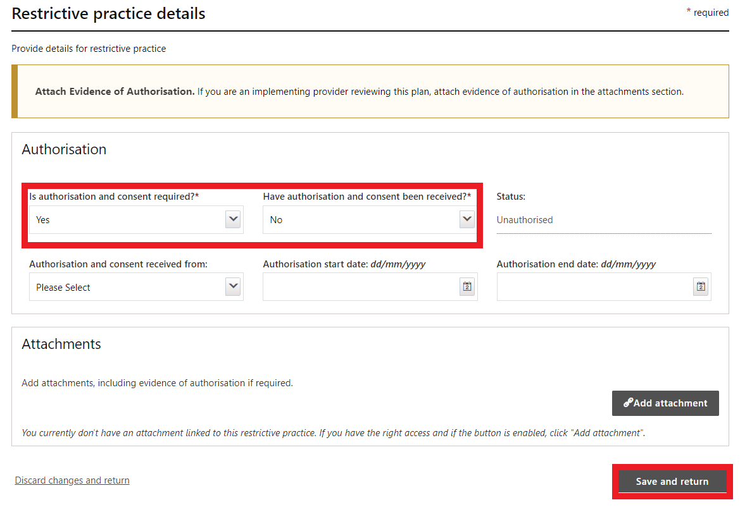

***Tip: It is the role of the Implementing provider(s) to lodge evidence of authorisation. Therefore, if authorisation is not yet obtained, the implementing provider (Authorised Reporting Officer role) can edit these fields and attach evidence of authorisation when they are activating the plan. (See NDIS Commission Quick Reference Guide – Activating Behaviour Support Plans and Lodging Evidence of Authorisation for additional information).***

***Tip: Restrictive Practice authorisation details can be edited, and evidence attached even when the plan is active.***

* 1. **If you have received evidence of authorisation, record these details under the authorisation section and attach this evidence at the bottom of the restrictive practice details page.** Then click **Save and return.**

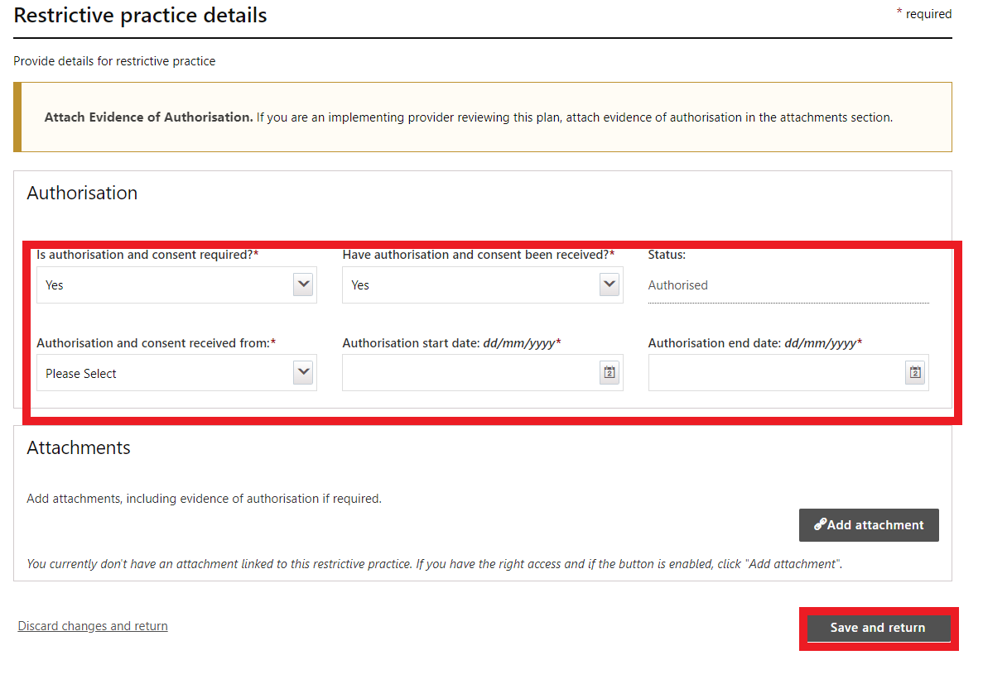

**Note:** The ‘Authorisation and consent received from’ should be **Authorising Body**, not **Guardian**. Queensland is the only exception to this.

* 1. For **chemical restraint**, different dosages or frequencies of the same medication can be combined and entered as a total daily dose. For example, 5mg in the morning and 10mg in the evening of the same medication can be entered in a total daily dose of 15mg. Where the frequency is less than daily, the frequency can be selected from the drop-down options.

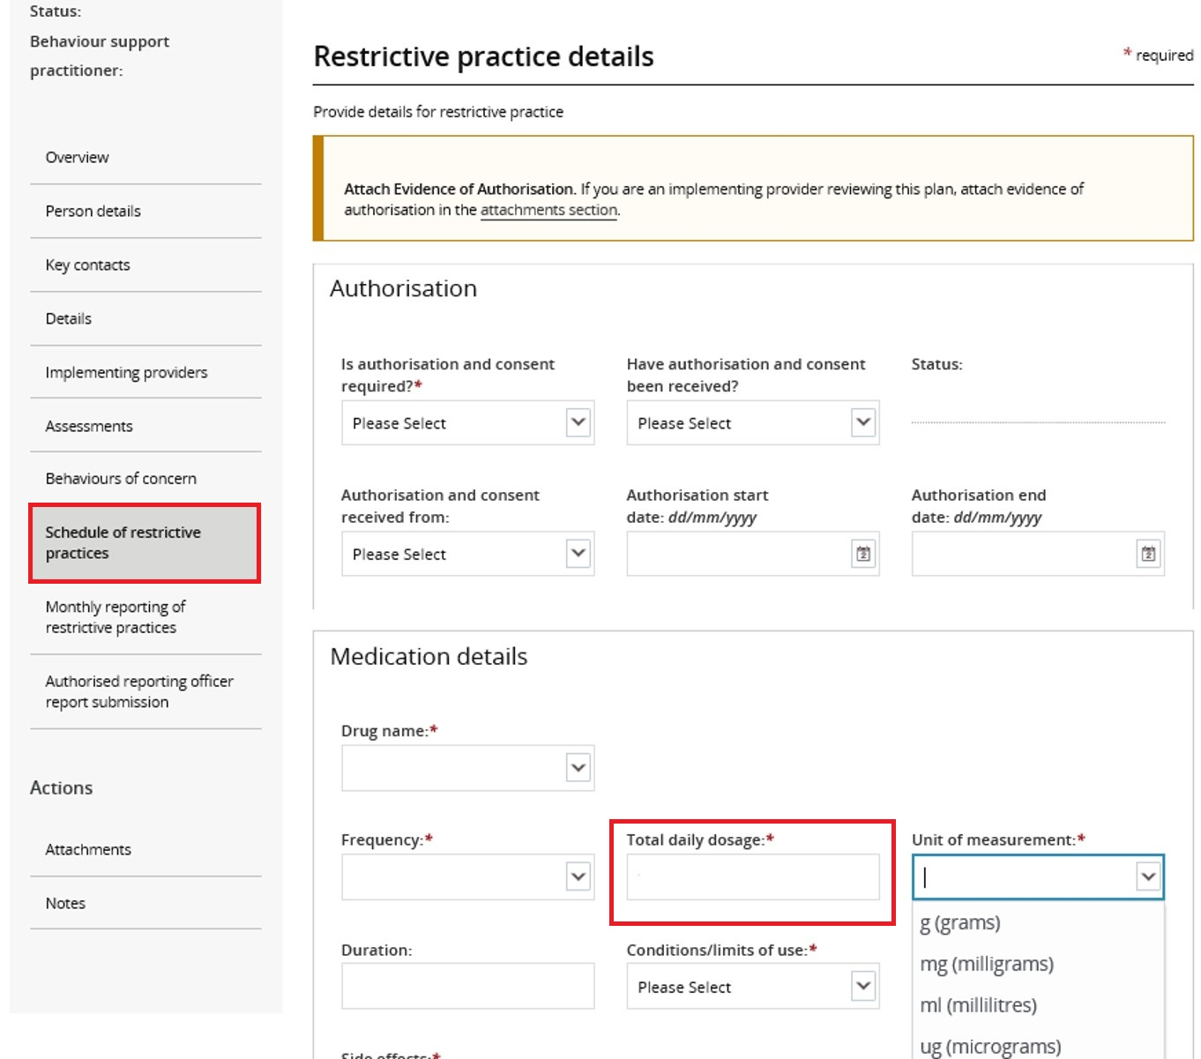

* 1. To enter additional restrictive practices, **repeat steps 11.1 – 11.5.**
  2. If there are multiple providers, the regulated restrictive practice must be added against each provider that will be using the practice. To do this, select the restrictive practice and click **Copy**. Then change the **Provider business name** and **Service location** to reflect the different provider.

|  |  |
| --- | --- |
| An image showing how to add multiple restrictive practices against different providers. | ***Tip:*** *Each implementing provider must have at least one   restrictive practice listed.*  ***Tip:*** *The regulated restrictive practices outlined in the behaviour support plan need to match the regulated restrictive practices entered into the schedule of restrictive practices.* |

## Attach the Behaviour Support Plan

* 1. From the left-hand side navigation menu select **Attachments.**

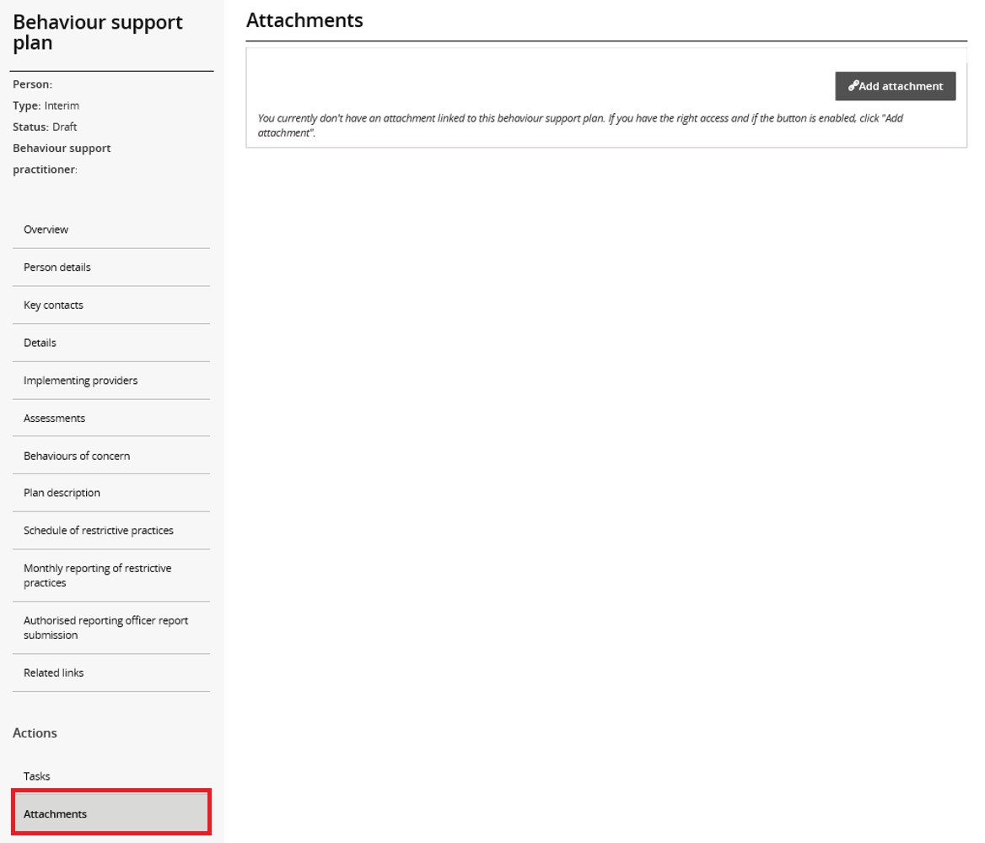

* 1. Click on **Add attachment.**

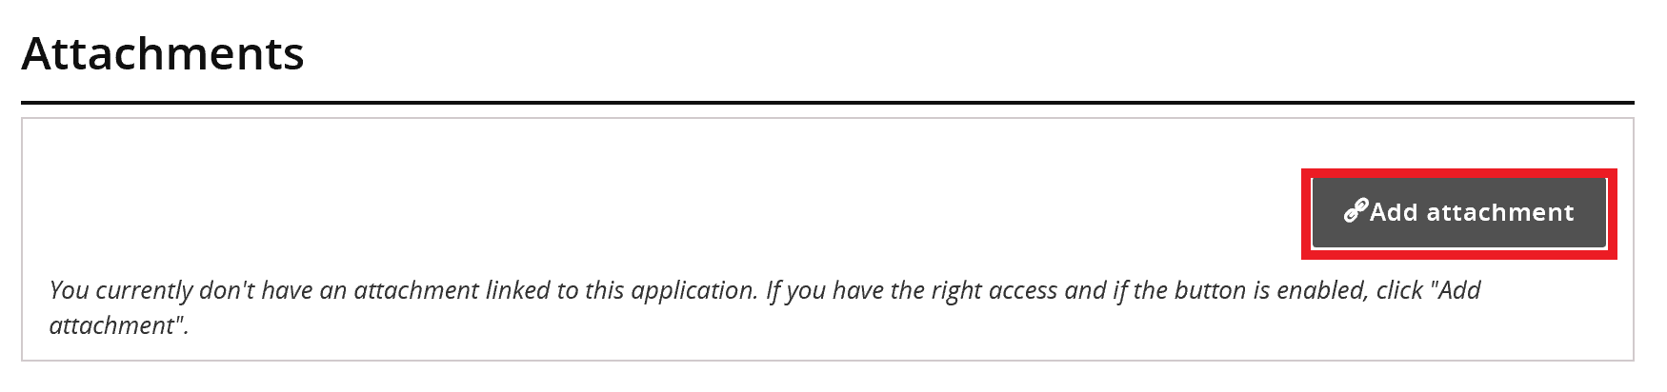

* 1. Once you have selected the file to attach, select *Behaviour support plan* from the document type drop-down list.
  2. Click **Save and close.**

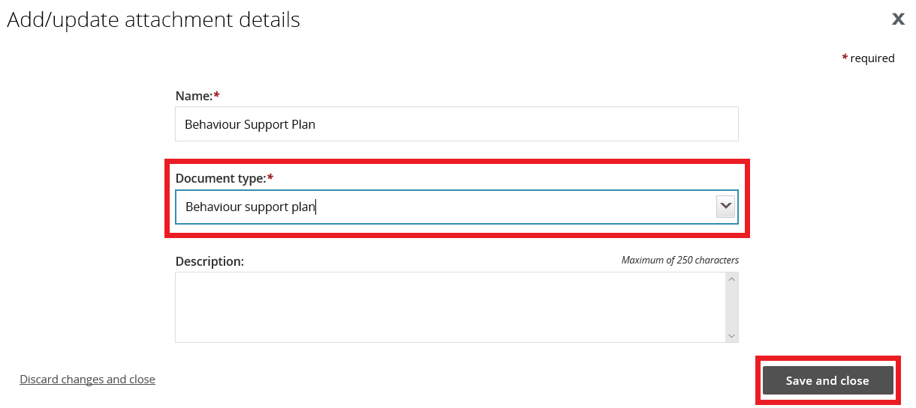

**Tip:** *Description is not a mandatory field*

## Send draft behaviour support plan to implementing provider(s)

**Tip:** Check all sections listed down the left-hand side menu to ensure that you have completed all the details required.

Behaviour Support Practitioner **Admin** role

* 1. Ensure that a behaviour support practitioner has been linked to the plan. Go to the **Details** view, click **update** and then click **select** to add a behaviour support practitioner.

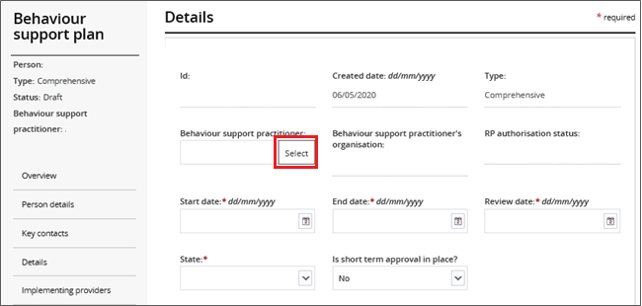

* 1. Click **Validate**. This will check that all mandatory fields have been completed. An error message will display to identify any missing information.

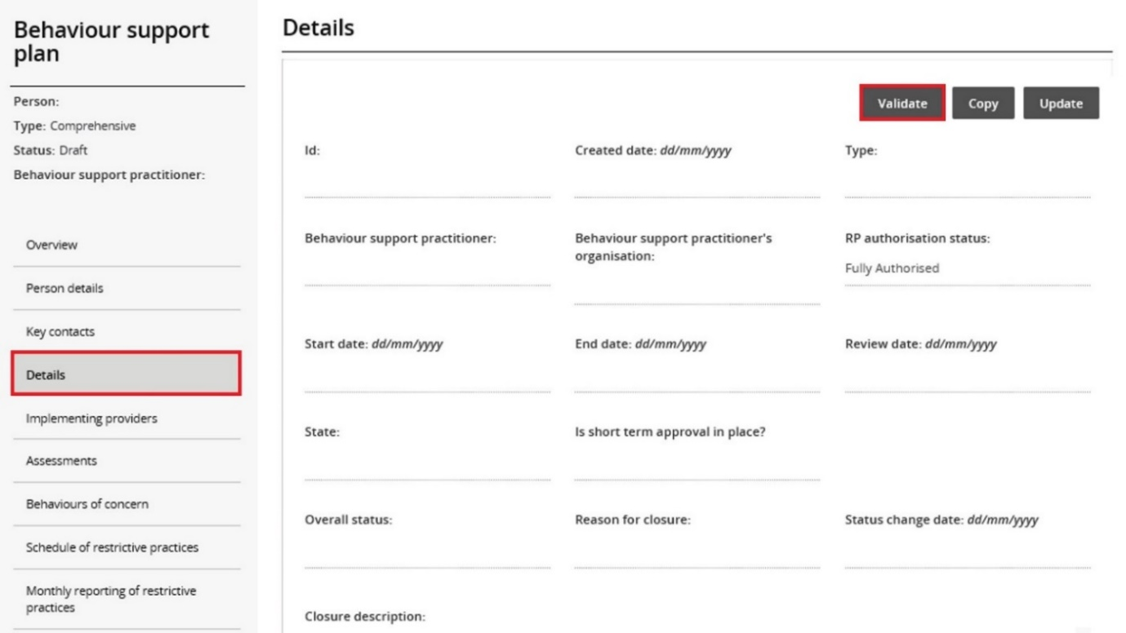

Behaviour Support Practitioner role

Only this role can send the plan to the implementing provider by clicking the **Send draft** button. This sends the plan to the implementing providers to activate it and commence monthly reporting.

The behaviour support practitioner is responsible for the information contained in the behaviour support plan and entered into the Portal. The practitioner should verify that the information has been entered correctly.

* 1. From the menu, select **Details**. Click **Send draft**. Please note, after you have clicked **Send draft**, the **Overall status** of the plan changes from **Draft** to **Pending**.

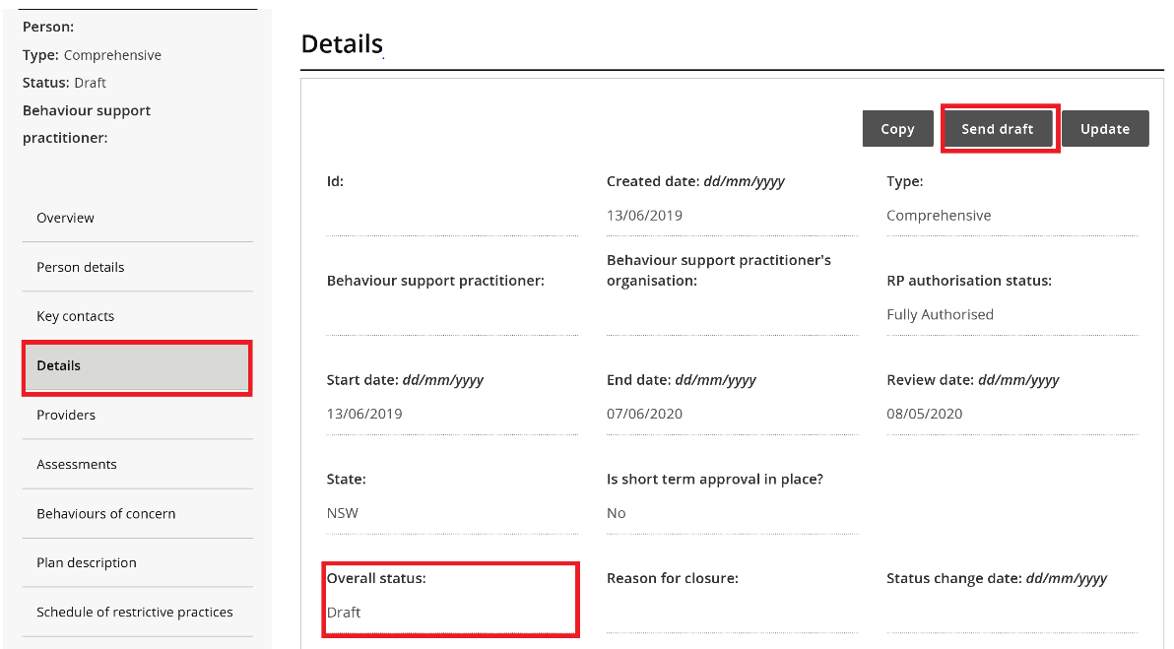

**Tip:** When the status changes to **pending**, a **task** is allocated to the primary authorised reporting officer (ARO) for the implementing provider. The primary ARO is the first person that became the ARO for the implementing provider. To find out who the primary ARO is, or to change the primary ARO, the provider can email [nqsc.ictsupport@ndiscommission.gov.au](mailto:nqsc.ictsupport@ndiscommission.gov.au) with their ABN.

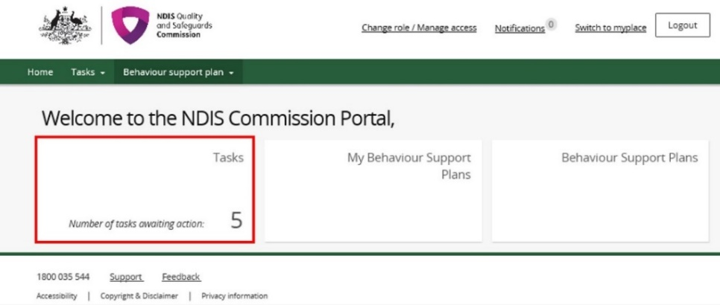

***Tip:*** Any ARO can still activate the plan by locating the plan through search, navigating to the implementing provider view, and clicking the **Activate** button (NDIS Commission Portal Quick Reference Guide: Activating Behaviour Support Plans and Lodging Evidence of Authorisation).

Once the implementing provider has activated the plan, the status of the plan will change to ‘active’. No changes can be made to the plan once it is active.

Once the end date has passed, the status of the plan will automatically change to ‘expired’.

## Fix an error in a plan

### Draft plans

* 1. When the plan status is ‘draft’, a **Remove** button is available under the **Actions** button.

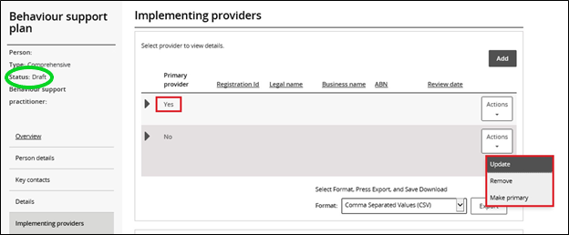

To remove an implementing provider added in error, click **Remove**. This will also remove all associated behaviours of concern and restrictive practices.

**Tip:** The primary provider cannot be removed. Add the correct provider first and make them the primary by clicking the **make primary** button, and then remove the incorrect provider. For more information, see paragraph 8.4.

The **remove** button is also available under **Behaviours of concern** and **Schedule of restrictive practices**, allowing individual behaviours of concern and restrictive practices to be removed.

Implementing Providers cannot view behaviour support plans when they are in draft status.

### Pending plans

* 1. An error identified when the plan status is ‘pending’ can be fixed by changing the status back to ‘draft’.

In draft, edits can be made – see step 14.1 for how to remove providers, behaviours of concern or restrictive practices added in error.

To change the status back to ‘draft’, go to the **Details** view, click **Update** and then click the **Status** drop‑down box and select *Draft*.

A behaviour support plan is considered lodged with the NDIS Commission when the status is ‘pending’.

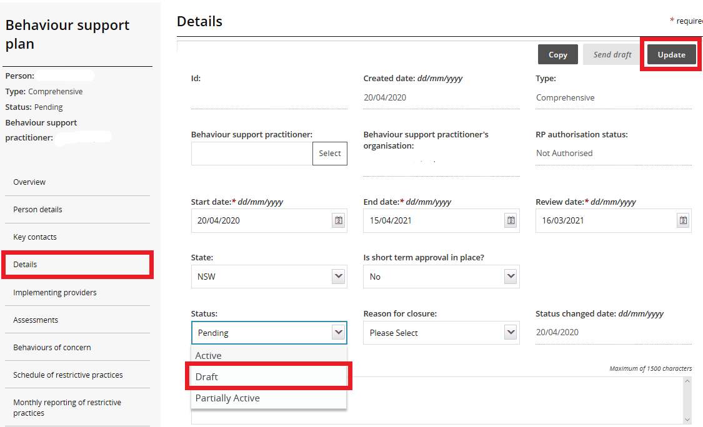

### Active Plans

***Tip:*** *If there is a small variation in the way a restrictive practice is being used, for example a change in dosage of a medication or change in the way an environmental restraint is being used, the implementing provider can report this variation monthly by selecting* ***report variation*** *when they complete the monthly report. The amendments can be made when the behaviour support plan is reviewed.*

*****Tip:*** *If you have lodged a plan that has been activated by the Implementing Provider but have entered the dosage or frequency of a medication incorrectly for a chemical restraint, this can be changed by NDIS Commission Staff. Contact* [*behavioursupport@ndiscommission.gov.au*](mailto:behavioursupport@ndiscommission.gov.au) *and attach evidence to the Plan ID.*

If there is a change in circumstances which requires a plan containing regulated restrictive practices to be amended, a NDIS behaviour support practitioner must review the plan as soon as practicable after the change occurs. In any event, a plan containing regulated restrictive practices should be reviewed every 12 months while the plan is in force.

* 1. When the plan status is active, no changes can be made to the plan.
  2. A new plan will have to be lodged. To save time, a copy of the plan can be made by going to the **Details** page and clicking the **Copy** button.

This will create a new plan in draft with a new plan ID that will contain some of the existing information in the original plan. The required changes can now be made.

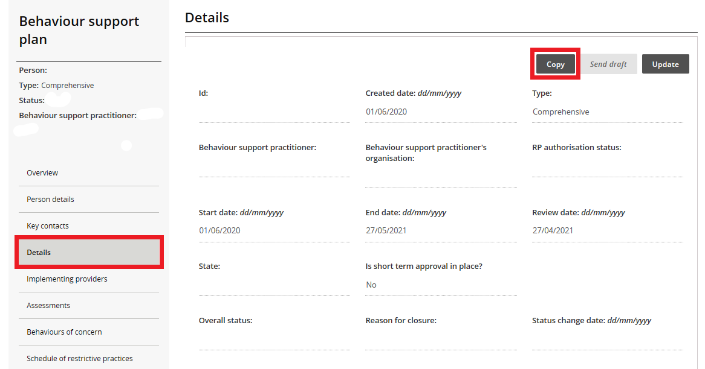

Before clicking the ‘send draft’ button and making the new plan ‘pending’, you will need to close the original active plan. See section 15: closing a plan.

## Closing a plan

***Tip:*** *Specialist Behaviour Support Providers should consult with Implementing Provider(s) before closing plans. Monthly reporting of restrictive practices cannot be submitted once a plan has been closed.*

***Tip:*** *If a plan has been closed but is being replaced with a new plan and the regulated restrictive practice/s are the same, the Implementing Provider can continue their monthly reporting requirements once the new plan is activated. This is regardless of the start date of the new plan.*

***Tip:*** *Behaviour Support Plans cannot be re-activated once the status has been changed to closed, even when this has been done in error. If the plan is closed in error, it will need to be re-lodged.*

***Tip:*** *Behaviour Support Plans with a status of ‘active’ or ‘expired’ should not be closed due to the cessation of Specialist Behaviour Support Services. These plans will be superseded (as required) when a new Specialist Behaviour Support provider is engaged. The Implementing Provider(s) is still required to implement and report monthly against an active or expired behaviour support plan.*

***Tip****: A specialist behaviour support provider should only close a plan when:*

* The plan has been created in error.
* There is no NDIS funded implementing provider e.g. family.
* An implementing provider is no longer supporting a participant.
* A plan has been superseded due to:
  + A restrictive practice has ceased or been added.
  + A new implementing provider has been engaged.
  + There has been a change of circumstance for the participant.

In all other situations, the behaviour support plan will remain ‘active’ on the portal until a specialist behaviour support provider registers a new plan with the NDIS Commission, or the existing plan expires.

* 1. In the **Details** view, click **Update**

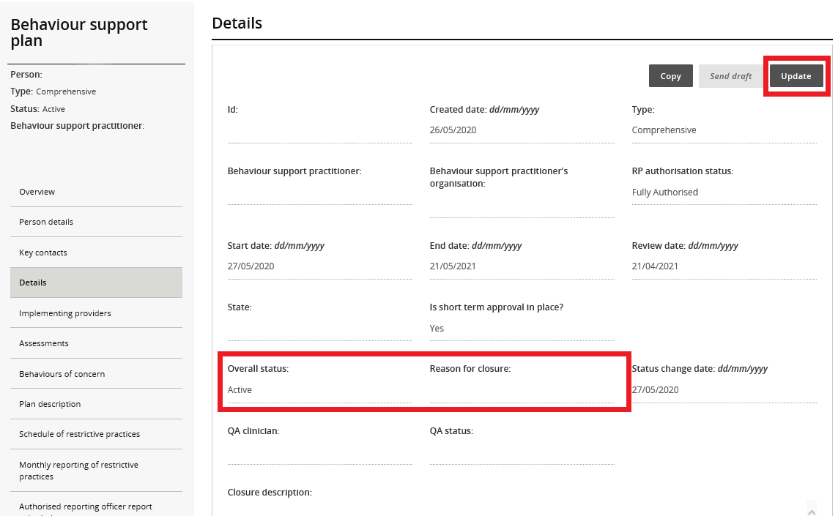

* 1. 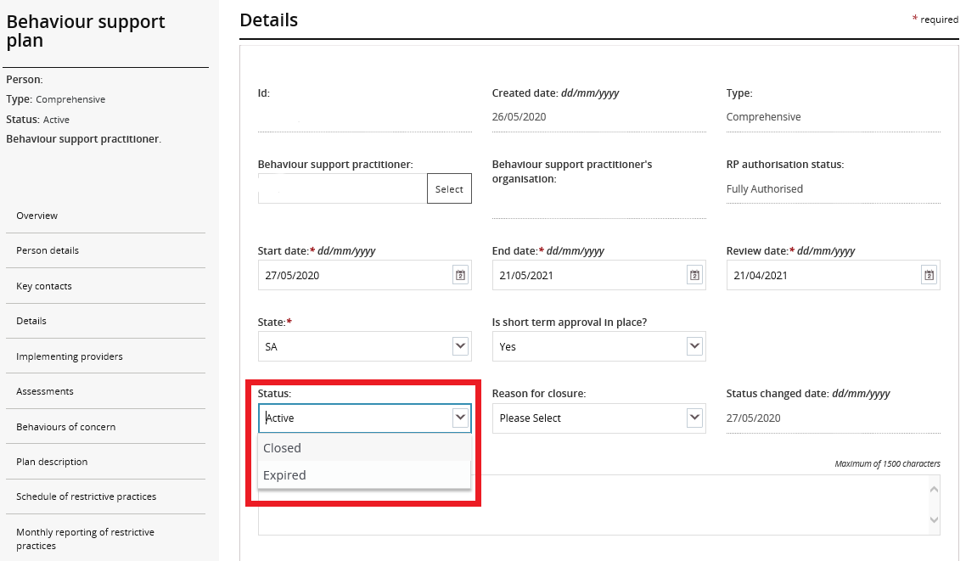Select*Closed* from the **Status** drop down box
  2. Select a reason for closure from the **Reason for closure** drop-down menu and then click **Save**.

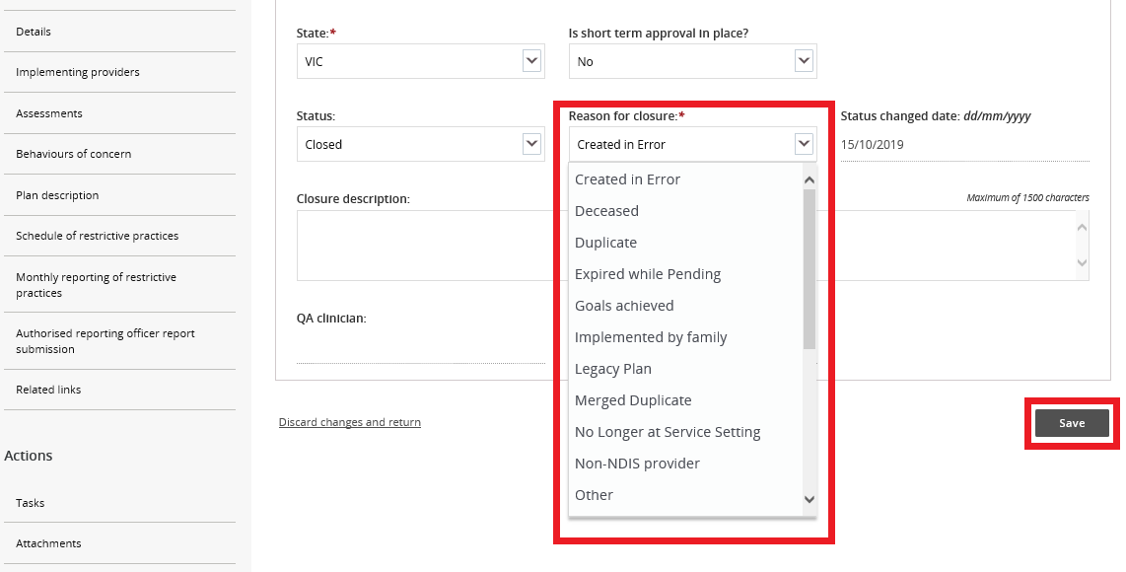

***Tip:*** *If Other is selected as a reason for closure, additional information is required in the* ***Closure description*** *box.*

## Plan status definitions

|  |  |
| --- | --- |
| Draft | This means that the behaviour support practitioner is developing the plan.  The Implementing Provider cannot view the plan when it is in draft status. When the practitioner clicks 'send draft' from the Details tab on the left-hand side of the page the status will change to 'pending'.  Best practice is for the practitioner to contact the implementing provider/s to advise the plan has been lodged on the Commission portal. |
| Pending | This means that the plan has been lodged by the behaviour support practitioner.  An implementing provider cannot complete monthly reporting when a plan has a status of ‘pending’. The plan must be ‘active’ to complete monthly reporting.  If changes need to be made when a plan has a status of ‘pending’, the practitioner can change the plan status back to ‘draft’, make the necessary amendments and then change the status back to ‘pending’. |
| Active | This means that the behaviour support plan has been activated by the implementing provider.  No changes can be made to an active plan. A new plan will have to be lodged. To save time, a copy of the plan can be made by going to the **Details** page and clicking the **Copy** button. |
| Partially Active | This means that there is more than one implementing provider.  The status will show as ‘partially active’ until ALL implementing providers have activated the plan. Implementing Providers that have activated the plan can commence monthly reporting |
| Closed | This means that the behaviour support plan has been closed and no changes can be made to the plan.  Behaviour support plans cannot be re-activated once they have been closed. If a plan has been closed in error, it will need to be re-lodged. A new behaviour support plan will need to be lodged if one is required.  Monthly reporting will also cease against this plan and any further reporting will need to be completed through the reportable incidents function on the portal until a new plan with authorisation is in place. |

|  |  |
| --- | --- |
| Expired | This means the end date of the behaviour support plan has been reached.  Monthly reporting can be completed on a plan with an ‘expired’ status. This function is useful when an implementing provider is awaiting a new plan to be uploaded onto the NDIS Commission Portal.  Comprehensive behaviour support plans must be developed within 6 months of being engaged and comprehensive behaviour support plans must be reviewed every 12 months or if there is a change in circumstances that requires the behaviour support plan to be amended |

## Contact us

**Call: 1800 035 544** (free call from landlines). Our contact centre is open 9.00am to 4.30pm in the NT, 9.00am to 5.00pm in the ACT, NSW, QLD, SA, TAS and VIC Monday to Friday, excluding public holidays.

**Email:** [behavioursupport@ndiscommission.gov.au](mailto:behavioursupport@ndiscommission.gov.au)

**Website:** [www.ndiscommission.gov.au](http://www.ndiscommission.gov.au)