**Implementing Providers: Monthly Reporting on the use of Regulated Restrictive Practices**

**Quick Reference Guide**

This guide outlines how to use the **NDIS Commission Portal** to submit monthly reports on the use of regulated restrictive practices.

See our other Quick Reference Guide:

* Implementing Providers: Activating a behaviour support plan and lodging evidence of authorisation

## In this guide

Accessing the NDIS Commission Portal

Reporting on regulated restrictive practices in a lodged behaviour support plan

Report when a regulated restrictive practice is not used

Report the use of a routine regulated restrictive practice

Report the use of a PRN (as needed) regulated restrictive practice

Remove a report entered in error

Reporting when no behaviour support plan is lodged

Plan status definitions

# Accessing the NDIS Commission Portal

## Step 1: Obtain a PRODA account

To access the NDIS Commission Portal, you will need a PRODA account. For instructions, see the [Quick Reference Guide: Getting access to NDIS Commission Portal](https://www.ndiscommission.gov.au/document/1021).

## Step 2: Self-request access role

Authorised Reporting Officer (ARO) role

Once you have your PRODA account, login to the NDIS Commission Portal and request access for ‘**Authorised Reporting Officer’ (ARO)**. This role is approved by the Authorised Access Delegate role within your organisation.

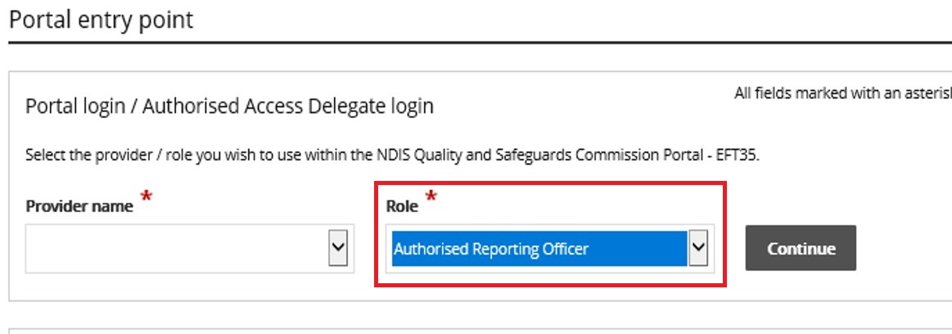

***Tip:*** *Any ARO can activate behaviour support plans by locating the plan through search, navigating to the implementing provider view, and clicking the* ***Activate*** *button (see ‘Implementing Providers: Activating a behaviour support plan and lodging evidence of authorisation’)*

***Tip:*** *Primary ARO’s receive tasks. This indicates when a behaviour support plan has been lodged. If you don’t know who this is or would like to nominate an ARO as the Primary ARO, email* [*nqsc.ictsupport@ndiscommission.gov.au*](mailto:nqsc.ictsupport@ndiscommission.gov.au) *with your registration ID and ABN.*

***Tip:*** *You may have multiple access roles in the NDIS Commission Portal, so it is important that you are logged in as the ARO role when completing monthly reporting. If any of the buttons referred to in these instructions are not visible, you may be logged in under a different access role.* ***Check this first before contacting the NDIS Commission for help.***

Behaviour Support Reporting **Admin** role

* This access role also allows a user to **activate** behaviour support plans and to enter monthly reports about the use of regulated restrictive practices outlined in the behaviour support plan.
* The Admin role cannot submit monthly reports; only the ARO role can do this.
* This role is approved by the **Authorised Access Delegate** within your organisation.

# Reporting on regulated restrictive practices in a lodged behaviour support plan

When a behaviour support plan is lodged, the specialist behaviour support provider creates a list of the regulated restrictive practices. The implementing provider is required to report monthly on the use of these practices.

***Tip:*** *Monthly reports can be submitted against plans with a status of* ***active****,* ***expired or partially active*** (*Note: only the provider that has activated the plan in partially active status can submit reports).**If a plan is* ***closed*** *(even in error) it cannot be re-activated, and monthly reports cannot be submitted.*

***Tip:*** *If a plan has been closed by the Specialist Behaviour Support Provider because a new plan is being lodged, the implementing provider can continue their monthly reporting requirements against the new plan when it is lodged and activated. This is regardless of the start date of the new plan.*

***Tip:*** *If a plan has been closed in error that was being actively implemented and reported on and a new plan is not being lodged, the Implementing Provider should contact the Specialist Behaviour Support Provider as it cannot be re-activated and will need to be re-lodged.*

## Report when a regulated restrictive practice is not used

Monthly reporting must be completed for all regulated restrictive practices in a behaviour support plan, including reporting if they are not used. Monthly reporting should be completed within 5 business days of the following month.

* 1. 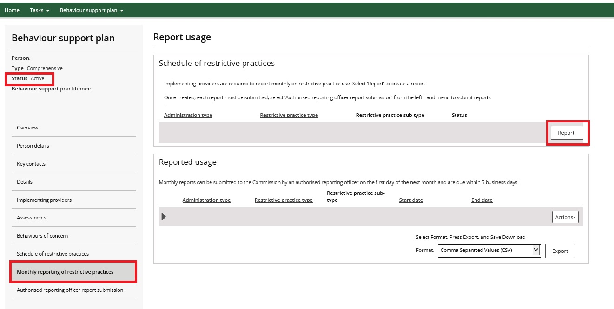From the left-hand side navigation menu, click **Monthly reporting of restrictive practices**. When the plan status is 'Active’, the **Report** button becomes available. Click the **Report** button to enter a monthly report.
  2. 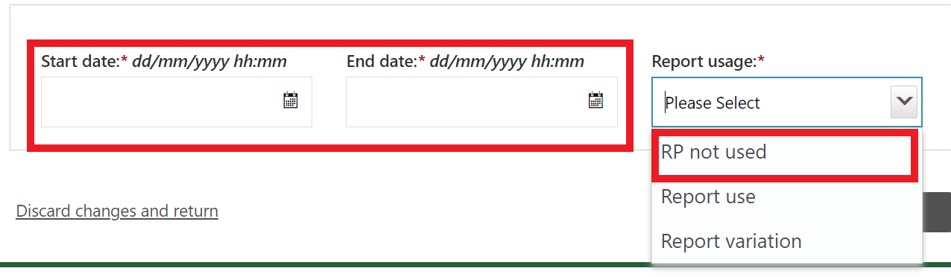Enter the dates the regulated restrictive practice was not in place and then select **‘RP not used’** option from the drop-down list and click **Save.**

***Tip:*** *The ‘RP not used’ option is selected when the regulated restrictive practice/s was not used at all by the Implementing Provider during the period of the full calendar month that is being reported on.*

The provider must notify a specialist behaviour support provider if there has been a change in circumstances that requires the behaviour support plan to be reviewed.

* 1. 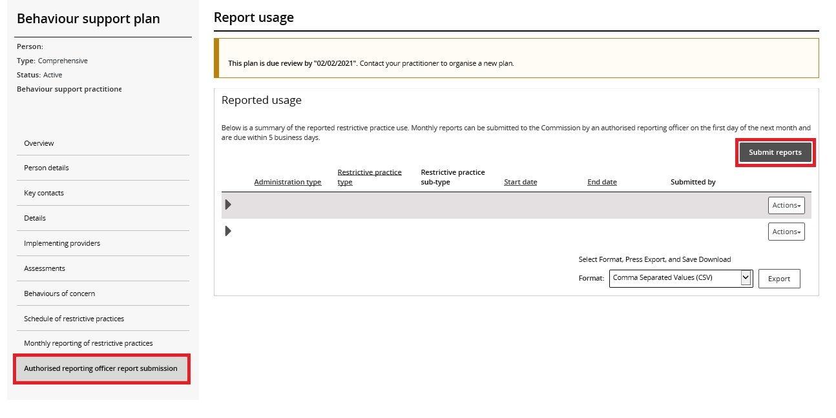After the reports are entered, select the ‘Authorised reporting officer’ tab. Click **Submit reports.**

Only the **ARO** role can submit the reports.

***Tip:*** *A*ll reports can be submitted at the same time using the **Submit reports** button, or they can be submitted individually by clicking the **Actions** button.

## Report the use of a routine regulated restrictive practice

### Reporting where the use was in accordance with the behaviour support plan

* 1. Enter the dates the routine regulated restrictive practice was in place, select **report use** from the drop-down options, select the behaviour of concern the practice was used to manage and click **Save.**

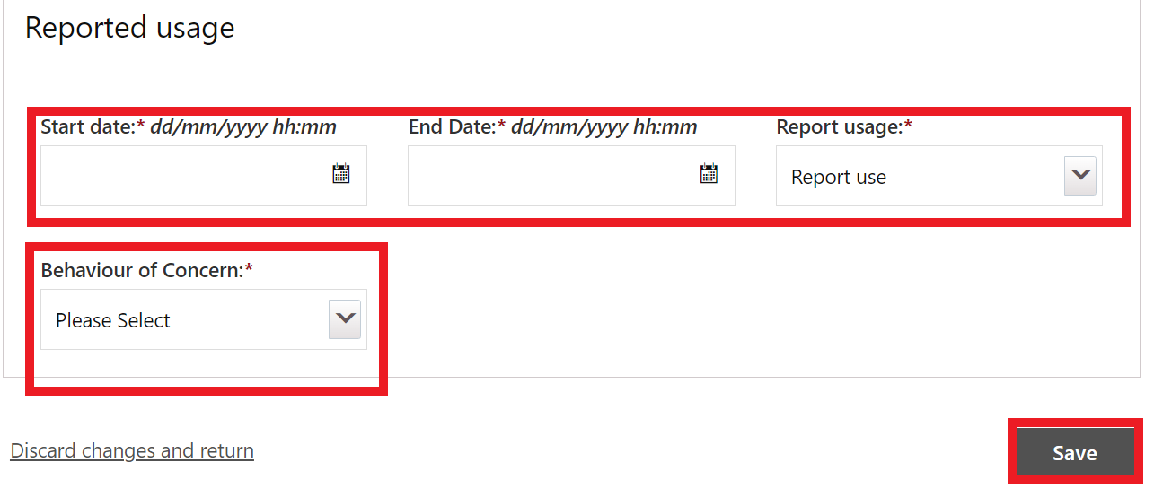Note: If there was a change in the way the routine regulated restrictive practice is used, select **Report** **variation** instead and move to step **2.2**.

***Tip:*** *The ‘Report use’ option is selected when the use of a routine regulated restrictive practice/s is used at any time by the Implementing Provider during the period of the full calendar month that is being reported on.*

### Reporting a variation in the use of the regulated restrictive practice

The report variation option can be selected when (for example):

* A change in medication dosage or frequency that does not require re-authorisation in the state or territory where the practice is used; or
* A participant’s medication is being changed due to the prescriber trialling different dosages or medications, resulting in multiple variations to medications over a period specified by the prescribing medical practitioner; or
* The implementation of a regulated restrictive practice changes from routine to PRN due to fade out strategies and re-authorisation is not required in the state or territory where the practice is used.

Note:

* Any change to the implementation of regulated restrictive practices that is not strictly in accordance with the behaviour support plan is considered a reportable incident.
* Any changes to a regulated restrictive practice that requires re-authorisation in accordance with State/Territory requirements would also be considered a reportable incident.
* The implementing provider should engage the behaviour support practitioner to review the plan where there are changes to the way regulated restrictive practices are being used.
  1. 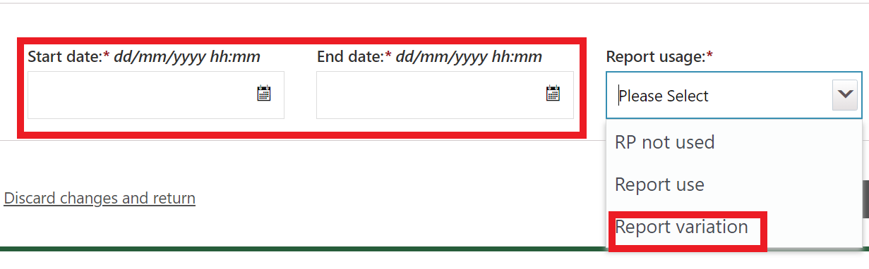For the **routine** use of a practice, enter the dates when the variation applied and select the **Report variation** option from the drop-down menu.
  2. 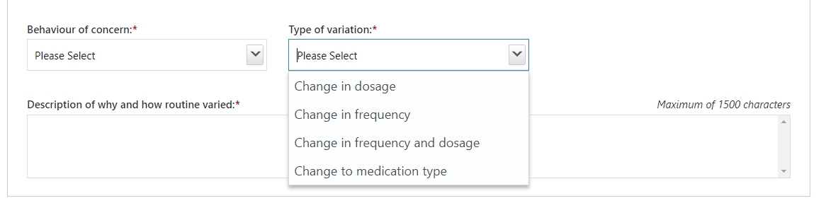Select the behaviour of concern the practice was used to manage, the type of variation from the drop options and a description of why and how the practice varied. Click **Save.**
  3. To report a variation to the way a **PRN practice** is used, select the ‘report use’ option and detail the changes in the comments section.

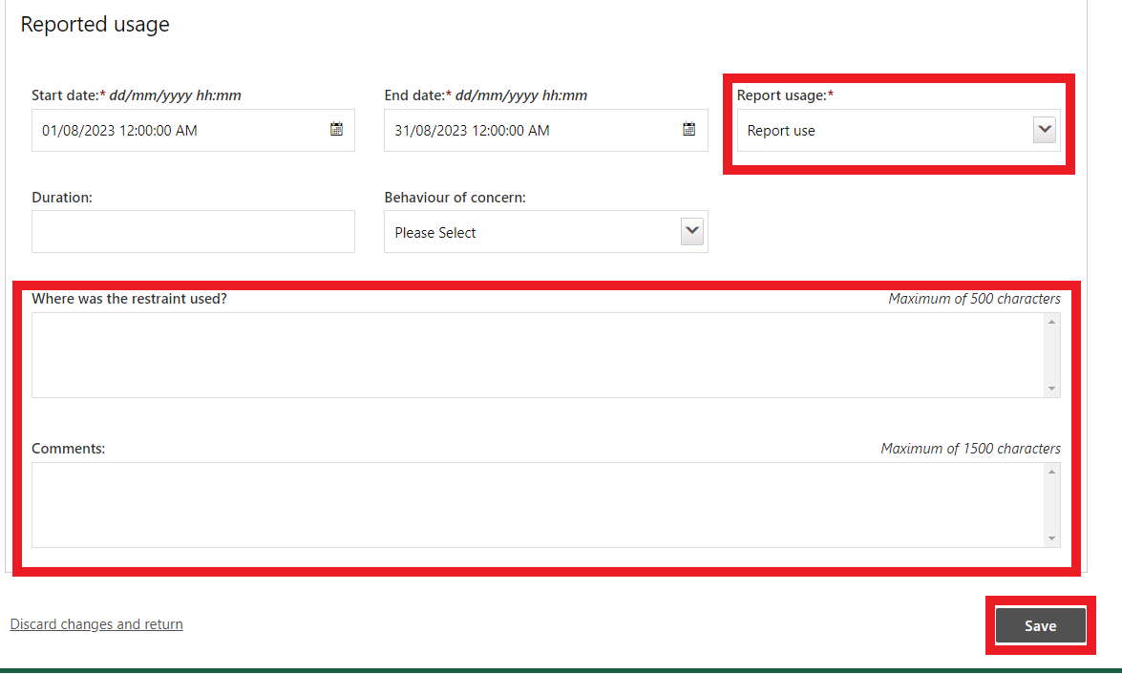

* 1. After entering the reports, select the ‘Authorised reporting officer’ tab. Click **Submit reports**.

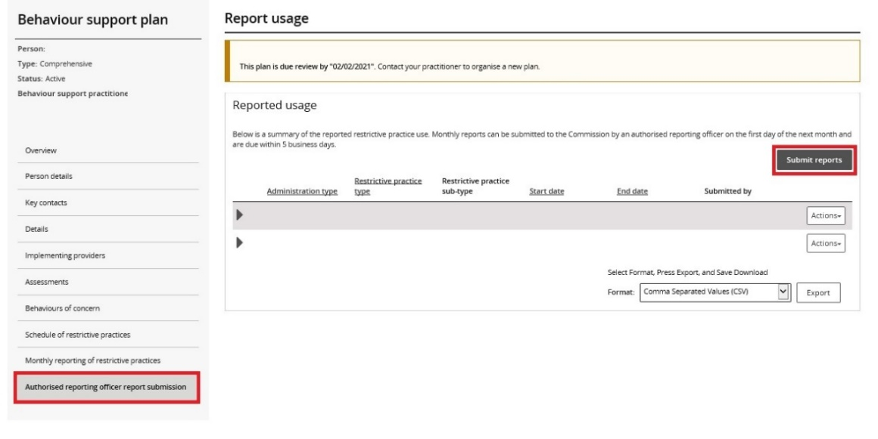

Note: only the **ARO** role can submit the reports.

## Report the use of a PRN (as needed) regulated restrictive practice

* 1. For a PRN practice, **each use** of the practice must be reported.   
     For a chemical restraint PRN, the end date can be left blank, just complete the date and time the PRN was used in the Start date field.   
     For seclusion, physical restraint, environmental restraint or a mechanical restraint that is used as needed, include the start date/time and the end date/time.

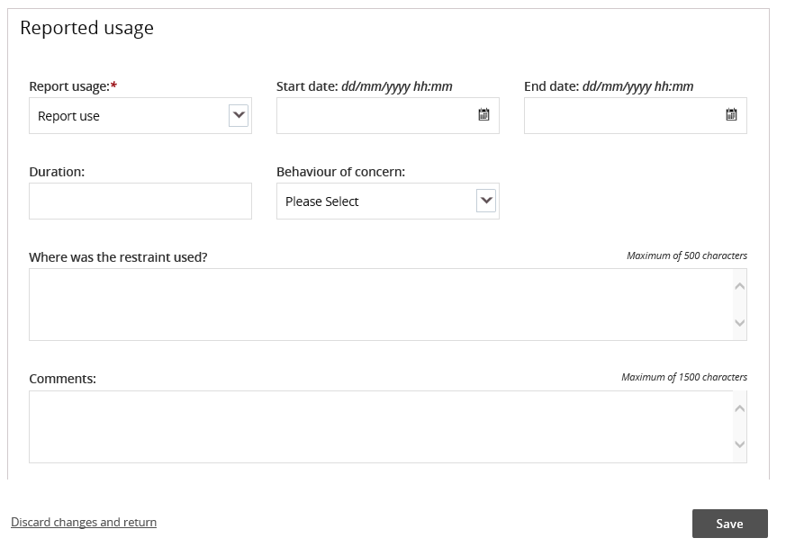

* 1. To enter multiple uses of PRN regulated restrictive practices, click **Monthly reporting of restrictive practices,** and click the **Report** button to report a second use.

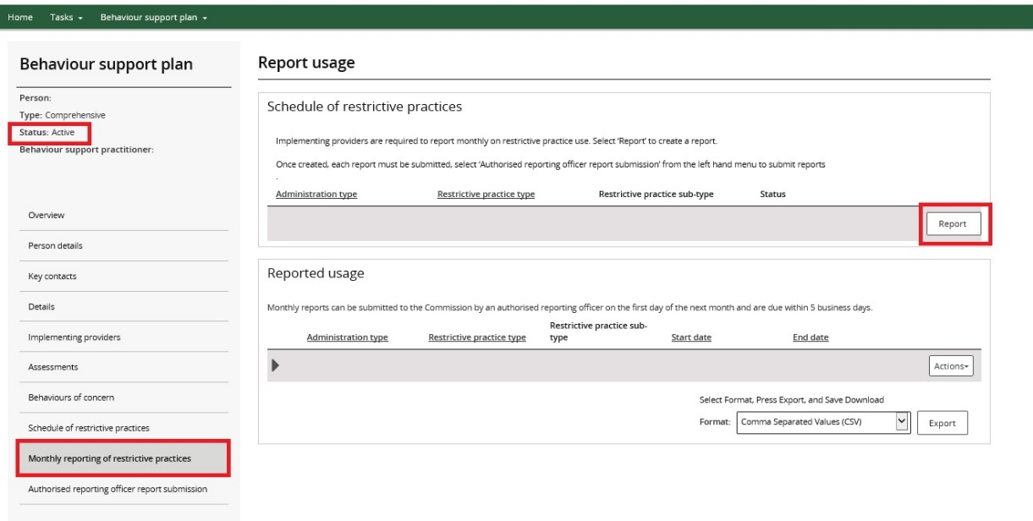

***Tip:*** *PRN uses of regulated restrictive practices can be reported any time after the use.*

* 1. After the reports are entered, select the ‘Authorised reporting officer’ tab and click **Submit reports**.



Only the **ARO** role can submit the reports.

## Remove a report entered in error

* 1. To remove a report entered in error, Click the **Actions** button and then click **Remove**

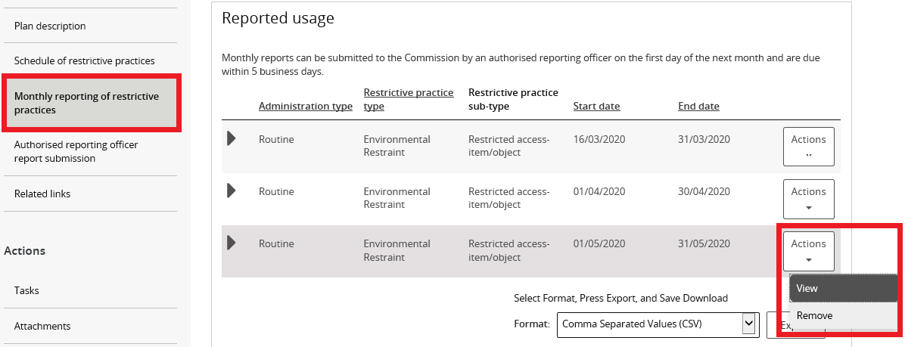

## RP Record (no BSP)

Please do not use the “RP Record (no BSP)” function in the NDIS Commission Portal.

**Monthly reporting must be completed on a behaviour support plan lodged in the portal by a behaviour support practitioner**. If you are implementing a behaviour support plan but it is not lodged in the portal, please follow-up with the specialist behaviour support provider.

**Reportable incidents must be submitted for the use of any unauthorised regulated restrictive practices.** If the restrictive practice being used is not in a behaviour support plan and/ or authorised in accordance with the State/ Territory authorising process (however described), this is a reportable incident.

1. **Plan status d****efinitions**

|  |  |
| --- | --- |
| Draft | This means that the behaviour support practitioner is developing the plan.  The Implementing Provider cannot view the plan when it is in draft status. When the practitioner clicks 'send draft' from the Details tab on the left-hand side of the page the status will change to 'pending'.  Best practice is for the practitioner to contact the implementing provider/s to advise the plan has been lodged on the Commission portal. |
| Pending | This means that the plan has been lodged by the behaviour support practitioner.  An implementing provider cannot complete monthly reporting when a plan has a status of ‘pending’. The plan must be ‘active’ to complete monthly reporting.  If changes need to be made when a plan has a status of ‘pending’, the practitioner can change the plan status back to ‘draft’, make the necessary amendments and then change the status back to ‘pending’. |
| Active | This means that the behaviour support plan has been activated by the implementing provider.  No changes can be made to an active plan. A new plan will have to be lodged. To save time, a copy of the plan can be made by going to the **Details** page and clicking the **Copy** button. |

|  |  |
| --- | --- |
| Partially Active | This means that there is more than one implementing provider.  The status will show as ‘partially active’ until ALL implementing providers have activated the plan. Implementing Providers that have activated the plan can commence monthly reporting |
| Closed | This means that the behaviour support plan has been closed and no changes can be made to the plan.  Behaviour support plans cannot be re-activated once they have been closed. If a plan has been closed in error, it will need to be re-lodged. A new behaviour support plan will need to be lodged if one is required.  Monthly reporting will also cease against this plan and any further reporting will need to be completed through the reportable incidents function on the portal until a new plan with authorisation is in place. |
| Expired | This means the end date of the behaviour support plan has been reached.  Monthly reporting can be completed on a plan with an ‘expired’ status. This function is useful when an implementing provider is awaiting a new plan to be uploaded onto the NDIS Commission Portal.  Comprehensive behaviour support plans must be developed within 6 months of being engaged and comprehensive behaviour support plans must be reviewed every 12 months or if there is a change in circumstances that requires the behaviour support plan to be amended |

# Contact us

**Call: 1800 035 544** (free call from landlines). Our contact centre is open 9.00am to 4.30pm in the NT, 9.00am to 5.00pm in the ACT, NSW, QLD, SA, TAS and VIC Monday to Friday, excluding public holidays.

**Email:**  [behavioursupport@ndiscommission.gov.au](mailto:behavioursupport@ndiscommission.gov.au)

**Website:** [www.ndiscommission.gov.au](http://www.ndiscommission.gov.au)