NDIS Commission Policy
Behaviour Support and Restrictive Practices
Version 1.0 (May 2024)
NDIS Quality and Safeguards Commission
PO Box 210, Penrith NSW 2750
Copyright
© Commonwealth of Australia (NDIS Quality and Safeguards Commission) 2024
The NDIS Quality and Safeguards Commission encourages the dissemination and exchange of information provided in this policy. The material in this policy is licensed under a Creative Commons Attribution 4.0 International licence, with the exception of:
- the Commonwealth Coat of Arms
- the NDIS Quality and Safeguards Commission logo
- any third party material
- any material protected by a trademark
- any illustration, diagram, photograph or graphic over which the NDIS Quality and Safeguards Commission does not hold copyright, but which may be part of or contained within this policy.
More information on this CC BY licence is set out at the creative commons website: www.creativecommons.org. Enquiries about this licence and any use of this policy can be sent to: communications@ndiscommission.gov.au
Attribution
Use of all or part of these guidelines must include the following attribution:
© Commonwealth of Australia (NDIS Quality and Safeguards Commission) 2024.
Using the Commonwealth Coat of Arms
Terms of use for the Coat of Arms are available at this website: https://www.pmc.gov.au/government/commonwealth-coat-arms
Important notice
The information in this policy is for general guidance only. It does not constitute legal or other professional advice, and should not be relied on as a statement of a law in any jurisdiction. You should obtain professional advice if you have any specific concern.
The NDIS Quality and Safeguards Commission has made every reasonable effort to provide current and accurate information, but it does not make any guarantees regarding the accuracy, currency or completeness of that information.
Parties wishing to re-publish or otherwise use the information in this policy must check this information for currency and accuracy prior to publication. This should be done prior to each publication edition, as NDIS Quality and Safeguards Commission guidance and relevant legislation may change. Any queries should be addressed to communications@ndiscommission.gov.au.

Table of contents
NDIS Commission Policy 1
Definitions 4
Purpose 6
Policy scope 6
Relevant legislative provisions 6
Policy statements 6
Safeguarding 7
Compliance 7
Capability Building 8
Evidence-informed practice 8
Co-regulation 8
Monitoring and evaluation 9

Definitions
The meaning of key terms and abbreviations in this policy are set out in the table below.
Table 1 – Definitions, key terms and abbreviations used in this document.
Term or Abbreviation | Description
Behaviour support | Behaviour Support, also referred to as Positive Behaviour Support (PBS), is a human rights and values led approach. It includes an ongoing process of assessment, intervention, and data-based decision making. Behaviour Support focuses on skill building, creating supportive contexts through ecological and systemic change and reducing the likelihood and impact of behaviours of concern. It relies on person-centred, proactive and evidence informed strategies that are respectful of a person’s dignity and aim to enhance the person’s quality of life. Behaviour Support draws primarily from behavioural, educational, and social sciences, although other evidence-based strategies may be incorporated. It can be applied within a multi-tiered framework at the level of the individual and at the level of larger systems. (Adapted from Kincaid et al. 2016 and Leif et al. 2023)
Behaviour support plan | A behaviour support plan (BSP) is a document prepared in consultation with the person with disability, their family, carers, and other support people. The BSP contains person-centred, proactive, and evidence-informed strategies to enhance the person’s quality of life. It addresses the needs of the person and reduces the likelihood and impact of behaviours of concern.
Behaviour Support Rules | National Disability Insurance Scheme (Restrictive Practices and Behaviour Support) Rules 2018 (Cth).
Evidence-informed practice | Evidence-informed practice means integrating the rights and perspectives of the person with disability, with the best available research, professional expertise and information from the implementing or practice contexts.
High risk practice | A practice that places a person with disability at high risk of harm and is associated with adverse and/or catastrophic outcomes, such as long-term psychological or physical injury and/or death.
NDIS behaviour support practitioner | A person who is considered suitable by the NDIS Commissioner following an assessment undertaken pursuant to section 181D (2) of the NDIS Act to undertake behaviour support assessments (including functional behaviour assessments) and to develop behaviour support plans for NDIS participants that may contain regulated restrictive practices. A NDIS behaviour support practitioner is also a NDIS worker.
NDIS Commission | The National Disability Insurance Scheme Quality and Safeguards Commission is a federal government agency established by section 181A of the National Disability Insurance Scheme Act 2013 (Cth) to improve the quality and safety of supports and services delivered to people with disability.
NDIS Commissioner | NDIS Commissioner means the Commissioner of the NDIS Quality and Safeguards Commission as referred to in section 181C of the National Disability Insurance Scheme Act 2013 (Cth).
NDIS provider | A person, entity, business or organisation that receives NDIS funding or who is a NDIS provider as prescribed by the NDIS rules.
NDIS worker | A person who is employed or otherwise engaged by a NDIS Provider to provide NDIS supports and services to people with disability. A NDIS behaviour support practitioner is also a NDIS worker.
Participant | A person with disability who is a participant in the National Disability Insurance Scheme (NDIS). They have a NDIS plan and use the funding in that plan to purchase supports and services.
Person-centred practice | An approach underpinned by recognition of the fundamental human right to equality and self-determination, and the recognition and facilitation of what matters to that person. It is a holistic approach that prioritises wellbeing and quality of life directed at the person’s will and by the person’s needs and preferences in the context of the person’s world (including environments and relationships), individual expression, values and beliefs.
Prohibited practice | Practices that are prohibited by law in the relevant State or Territory in which a registered NDIS provider provides supports or services to a person with disability.
Restrictive practice | Any practice or intervention that has the effect of restricting the rights or freedom of movement of a person with disability.
Regulated restrictive practice | A restrictive practice is a regulated restrictive practice if it is or involves any of the five types of restrictive practices that are subject to regulation and oversight by the NDIS Commission: (1) seclusion; (2) chemical restraint, (3) mechanical restraint, (4) physical restraint, and (5) environmental restraint.
Unauthorised restrictive practice | Where a regulated restrictive practice is used without authorisation by the relevant State or Territory (however described) or is not used in accordance with a behaviour support plan for the person with disability.

Purpose
- This policy outlines the NDIS Commission’s leadership role in relation to behaviour support, and in the reduction and elimination of the use of restrictive practices.
- Behaviour support under the NDIS is an evidence-informed practice based on the principles of positive behaviour support. It aims to improve the quality of life of the person with disability by developing and implementing individualised strategies that are responsive to the person’s needs, reduce the likelihood and impact of behaviours of concern, and minimise the use of restrictive practices.
- NDIS participants can access behaviour support from registered NDIS providers of specialist behaviour support and NDIS behaviour support practitioners. Supports and services may also be delivered by NDIS providers and workers who implement behaviour support plans that may contain the use of regulated restrictive practices. NDIS providers and workers must adhere to National Disability Insurance Scheme Act 2013 (Cth) (NDIS Act), and associated Rules.
- The NDIS Commission’s role is to uphold the rights of, and promote the health, safety and wellbeing of, people with disability and promote progressively higher standards of NDIS behaviour support services.

Policy scope
- This document applies to the NDIS Commission’s role in regulating the quality and safety of behaviour support services and the use of regulated restrictive practices by NDIS providers, workers and NDIS behaviour support practitioners. The document does not provide policy principles in relation to NDIS behaviour support practitioner suitability or capability (see the Positive Behaviour Support Capability Framework document). This policy should be considered in conjunction with the Positive Behaviour Capability Framework (PBS Capability Framework).

Relevant legislative provisions
- This policy is in furtherance of part of the NDIS Commissioner’s behaviour support function as set out in section 181H of the NDIS Act. The PBS Capability Framework addresses sections 181H (a)(i) and (ii) of the NDIS Act, which are not covered in this document.
- This policy also provides additional information about the requirements outlined in the NDIS (Code of Conduct) Rules 2018 (Cth), NDIS (Provider Registration and Practice Standards) Rules 2018 (Cth) and the NDIS (Restrictive Practices and Behaviour Support) Rules 2018 (Cth).

Policy statements
- The NDIS Commission’s Practice Quality Division provides leadership in behaviour support, and in the reduction and elimination of the use of restrictive practices.
- The Practice Quality Division works to fulfil the functions vested in the NDIS Commissioner under section 181H of the NDIS Act and apply the NDIS Commission Regulatory Strategy in relation to behaviour support and the reduction and elimination of restrictive practices. This includes undertaking capability building and operational activities that engage the full suite of regulatory levers (diagram 1).
Diagram 1. NDIS Quality and Safeguards Commission High Level Regulatory Strategy, December 2022. Regulatory Levers and Tools (pg. 13).
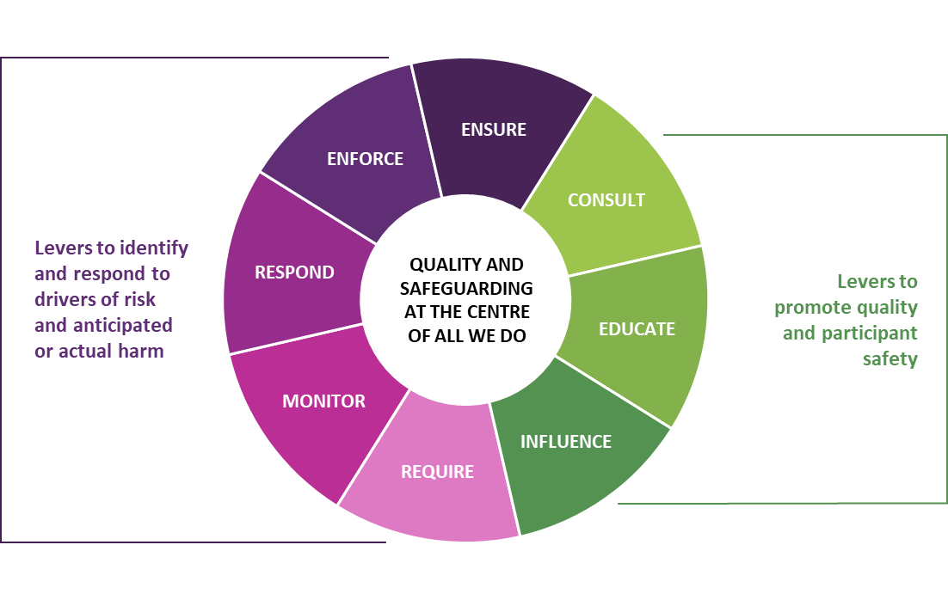
- The NDIS Commission’s approach to uplift and regulate the quality and safety of behaviour support and reduce and eliminate the use of restrictive practices is guided by five principles: Safeguarding, Compliance, Capability Building, Evidence-informed practice and Co-regulation. The regulatory levers are embedded throughout the principles and are applied together with other relevant NDIS Commission policies.

Safeguarding
- Where it is identified that the quality of behaviour support or the use of regulated restrictive practices, high risk, and/or prohibited practices pose a safety risk to a person with disability, a timely response is delivered to uphold their rights and quality of life. The response takes appropriate regulatory action to:
  - remove or minimise the risk of harm to the person with disability.
  - secure NDIS provider and worker compliance with the NDIS Act.

Compliance
- The NDIS Commission takes a risk informed and proportionate approach to monitoring behaviour support and the use of regulated restrictive practices.
- Consistent with the NDIS Commission’s approach to compliance and enforcement, all available regulatory levers are used to:
- ensure compliance with the NDIS Act and relevant Rules.
- improve the quality and implementation of behaviour support plans.
- reduce the use of regulated restrictive practices, including the use of unauthorised restrictive practices.
- eliminate the use of high risk and prohibited practices
- NDIS providers and workers who do not comply with legislative obligations are held to account through the NDIS Commission’s compliance and enforcement activities.

Capability Building
- Best-practice leadership, policy, guidance, and education on behaviour supports and the reduction and elimination of the use of restrictive practices is delivered. This includes the provision of advice and subject matter expertise across Commission functions.
- Capability and operational activities consider other service and support systems connected to people with disability, NDIS providers, NDIS workers, and other stakeholders (including those internal and external to the NDIS Commission).
- Practice Quality advice is rights-based, evidence-informed and, person centred.
- Resources, guidance materials and engagement activities about behaviour support and restrictive practices are co-designed or developed in consultation with people with disability, NDIS providers, and relevant stakeholders as appropriate.
- Accessibility needs are considered and addressed in the preparation and delivery of resources and guidance.

Evidence-informed practice
- Strategies to promote and evaluate the quality of behaviour support and the reduction and elimination of restrictive practices are:
- evidence- informed and data-driven.
- outcome focussed and measurable.
- collaborative, coordinated and developed in consultation with subject matters experts including within the NDIS Commission and external partners (for example, participants, NDIS providers, peak bodies, universities).

Co-regulation
- The NDIS Commission promotes a nationally consistent regulatory framework, including nationally consistent minimum standards for the use of restrictive practices. This involves undertaking work with state and territory authorising bodies to promote national consistency, in line with the principles of the National Framework for Reducing and Eliminating the Use of Restrictive Practices in the Disability Service Sector.

Monitoring and evaluation
- The implementation of this policy will be monitored and evaluated to facilitate continuous improvement. Practice Quality Division recognises the role of data driven approaches to regulation, and the timely and efficient collection, analysis and dissemination of information relating to behaviour support and the use of restrictive practices.
- The Practice Quality Division reviews effectiveness and impact through:
- A range of quantitative and qualitative measures
- routine reporting and analysis of the number of people with disability subject to regulated restrictive practices and unauthorised restrictive practices
- review of changes in regulated restrictive practices use over time
- identification of risks to people with disability, and changes in this over time
- regular review of the quality and compliance of behaviour support plans.

