Compliance and Enforcement Policy

Version 2.0 September 2024

NDIS Quality and Safeguards Commission

PO Box 210, Penrith NSW 2750

**Copyright**

© Commonwealth of Australia (NDIS Quality and Safeguards Commission) 2024

CC-By logo

The NDIS Quality and Safeguards Commission encourages the dissemination and exchange of information provided in this policy. The material in this policy is licensed under a Creative Commons Attribution 4.0 International licence, with the exception of:

* the Commonwealth Coat of Arms
* the NDIS Quality and Safeguards Commission logo
* any third-party material
* any material protected by a trademark
* any illustration, diagram, photograph or graphic over which the NDIS Quality and Safeguards Commission does not hold copyright, but which may be part of or contained within this policy.

More information on this CC BY licence is set out at the creative common’s website: www.creativecommons.org. Enquiries about this licence and any use of this policy can be sent to: [communications@ndiscommission.gov.au](mailto:communications@ndiscommission.gov.au)

**Attribution**

Use of all or part of these guidelines must include the following attribution:

© Commonwealth of Australia (NDIS Quality and Safeguards Commission) 2024.

**Using the Commonwealth Coat of Arms**

Terms of use for the Coat of Arms are available at this website: <https://www.pmc.gov.au/government/commonwealth-coat-arms>

**Important notice**

The information in this policy is for general guidance only. It does not constitute legal or other professional advice and should not be relied on as a statement of a law in any jurisdiction. You should obtain professional advice if you have any specific concern.

The NDIS Quality and Safeguards Commission has made every reasonable effort to provide current and accurate information, but it does not make any guarantees regarding the accuracy, currency or completeness of that information.

Parties wishing to re-publish or otherwise use the information in this policy must check this information for currency and accuracy prior to publication. This should be done prior to each publication edition, as NDIS Quality and Safeguards Commission guidance and relevant legislation may change. Any queries should be addressed to [communications@ndiscommission.gov.au](mailto:communications@ndiscommission.gov.au).

Table of contents

Compliance and Enforcement Policy 1

Definitions 4

Purpose 5

Policy scope 5

Relevant legislative provisions 5

Our compliance and enforcement principles 6

Human rights approach 6

Risk-based, proportionate and intelligence led 6

Fair, transparent and accountable 7

Our regulatory levers 7

Our key regulatory approaches 9

Our compliance and enforcement tools 10

Non-statutory tools 10

Statutory tools 10

How we choose our tools 11

Protecting and disclosing information about our enforcement actions 11

Reviewable decisions 12

Monitoring and evaluation 12

Governance 13

Version history 13

Approval 13

## Definitions

The meaning of key terms and abbreviations in this policy are set out in the table below.

| **Term or Abbreviation** | **Description** |
| --- | --- |
| Authorised person | A person appointed by the NDIS Commissioner as an inspector and/or investigator under section 73ZR of the NDIS Act |
| Complaints Rules | National Disability Insurance Scheme (Complaints Management and Resolution) Rules 2018 |
| Compliance | Adhering to the legal requirements and obligations of the NDIS Act, including the NDIS Code of Conduct and the Rules |
| Compliance action | Using the NDIS Commission’s functions to influence, educate and ensure NDIS providers, their key personnel and workers comply with their obligations under the NDIS Act |
| Enforcement | The use of statutory powers under the NDIS Act, NDIS Rules and the Regulatory Powers Act to compel compliance and/or sanction for non-compliance |
| Harm | Includes physical, psychological, emotional and financial harm arising from abuse, exploitation and neglect |
| Investigation | The process of seeking information about alleged, apparent or possible non-compliance. It involves an authorised person gathering evidence in support of sanctions for non-compliance |
| Investigation powers | The powers in Division 8, Part 3A of Chapter 4 of the NDIS Act and Part 3 of the Regulatory Powers Act that can be used by an authorised person to investigate alleged contraventions of civil penalty provisions in the NDIS Act, the *Crimes Act 1914* or the *Criminal Code Act 1995* |
| Monitoring | Regulatory activity involving collecting, analysing and evaluating information to monitor providers or workers to determine compliance with the requirements and obligations of the NDIS Act, including the NDIS Code of Conduct and the Rules |
| NDIS | National Disability Insurance Scheme |
| NDIS Act | The *National Disability Insurance Scheme Act 2013* |
| NDIS Code of Conduct | The National Disability Insurance Scheme (Code of Conduct) Rules 2018, which applies to all NDIS providers regardless of registration |
| NDIS Rules | All Rules made pursuant to the NDIS Act |
| Participants | People receiving supports and services under the NDIS |
| Person | A natural person and a body corporate |
| Personal information | Personal information includes a broad range of information, or an opinion, which could identify an individual, including a body corporate |
| Providers | Registered and unregistered NDIS Providers, key personnel, and workers |
| Regulatory Powers Act | The *Regulatory Powers (Standard Provisions) Act 2014* |
| Reportable Incident Rules | National Disability Insurance Scheme (Incident Management and Reportable Incidents) Rules 2018 |

## Purpose

1. The NDIS Commission gives the highest priority to enforcing the laws designed to uphold and protect the rights of participants and the integrity and sustainability of the NDIS. We educate, influence, enforce and monitor NDIS providers, workers and key personnel to ensure they are aware of and recognise their obligations. We also secure compliance through the use of the compliance actions, monitoring, enforcement and investigations powers. We act to enforce the law if NDIS providers, workers and key personnel do not comply with the law.
2. This policy sets out how we will secure compliance with and enforce the law. It informs participants, providers, our staff, and the public about how the NDIS Commission may use its compliance and enforcement powers and the key reasons behind its approaches. It covers:

* our regulatory approaches and how we promote and direct compliance,
* the principles we apply to our compliance and enforcement decision making, and
* the powers, tools and levers we use to secure compliance and enforce the law and the factors we consider in using them.

## Policy scope

1. This policy applies to all our functions and staff that undertake compliance and enforcement activities. Together with our Regulatory Approach and Human Rights Principles, it sets the platform for how we fulfil our role as the national regulator for disability supports and services.
2. This policy complements the law enforcement policies of other Australian Government regulators.
3. It should also be read alongside our published annual Regulatory Priorities.

## Relevant legislative provisions

1. The NDIS Act and NDIS Rules provide a framework of the protections for NDIS participants and the NDIS. These establish the legal obligations of providers, their key personnel and workers and promote continuous improvement in quality and safeguards in disability supports and services.
2. The NDIS Act, NDIS Rules and the Regulatory Powers Act provide the NDIS Commission with our compliance and enforcement powers, including powers to monitor, detect, remedy and address non-compliance.
3. The compliance and enforcement strategies in the NDIS Act and Rules include:

* registration and permissions to ensure that only suitable providers and workers operate in the NDIS market,
* strong investigative and enforcement powers to identify and take tough action against unscrupulous and negligent providers, workers and key personnel including powers to remove dishonest or unsuitable individuals and organisations from the NDIS market, issuing banning orders, seeking injunctions and civil penalties,
* monitoring of providers to examine whether they are complying with their legal obligations, including their conditions of registration and obligations to screen workers,
* periodic, independent auditing of providers to assesses their performance against practice standards and quality indicators,
* encouraging best practice and quick actions to achieve compliance through educating providers about their obligations and the value of compliance,
* information sharing with partner regulators and bodies supporting people with disability,
* capability to work closely with the NDIA on dishonest and fraudulent use of funds for people with disability, and
* powers to investigate and monitor matters relating to registered and unregistered providers and workers, including site visits.

## Our compliance and enforcement principles

1. As an Australian Government regulator, the NDIS Commission is guided by the Australian government’s principles for best practice regulation as well as the purposes of the NDIS Act. We apply the [Australian Government Investigations Standards](https://www.ag.gov.au/integrity/publications/australian-government-investigations-standards) to our investigations practice.
2. We also apply the following principles in conducting compliance and enforcement actions:

* we take a human-rights approach,
* our actions will be intelligence led and risk-based, proportionate to the risk,
* we are fair, transparent, and accountable,
* we use all our regulatory powers, tools and levers.

### Human rights approach

1. Our priority is people with disability’s safety and wellbeing and their rights to be free from harm and discrimination. We aim to find the right balance between compliance and consumer independence.
2. We emphasise engagement with people with disability and their supporters, in hearing their accounts and by being clear and transparent about our processes.
3. We provide progress reports without compromising rights to privacy and effective enforcement.
4. We educate and empower participants in self-advocacy, consumer awareness and self-determination.

### Risk-based, proportionate and intelligence led

1. To ensure participant safety and scheme sustainability, the NDIS Commission is a strong and proportionate regulator. We actively balance our risk-based approach with the needs and expectations of our stakeholders, applying the strongest and fastest actions to the most serious issues and breaches. Our key stakeholders are participants, their supporters and advocates, providers, disability workers, our Minister and partner agencies.
2. We regularly review our information to detect emerging and systemic risks in the provision of disability supports and services. Our annually published Regulatory Priorities state the issues we will target in our compliance and enforcement activities. We use our compliance and enforcement powers and capabilities proactively and in response to identified risks and known harms. We promote voluntary compliance and maximise deterrence for non-compliant conduct across the NDIS market.
3. We work at multiple levels on quality and safeguarding. In taking compliance and enforcement action, we think about the whole NDIS system and act to address systemic risks in the provision of NDIS supports and services. We think and act at the level of individual participants and consider their experiences and actions, as well as at the level of individual workers, key personnel, and providers.
4. We are intelligence led, using our knowledge of the sector, and on data and information provided to us by partner agencies and the greater community. We carry out targeted intelligence operations to collect new information.

### Fair, transparent and accountable

1. We are fair to providers and individuals that we take action against, ensuring we act impartially and objectively, and avoid conflicts of interest. We ensure our staff are identifiable.
2. We allow a person to be heard before making a decision that affects their interests, unless there is an imminent danger to the health, safety, or wellbeing of a person with disability. We give reasons for our decisions.
3. We recognise that many providers comply, and want to comply, with their legal obligations. Without compromising our responsibilities to protect personal information, we work to ensure providers have access to the same information we use in our decisions and tools needed to support compliance.

### Our regulatory levers

1. We know that having a range of regulatory options is effective in deterring non-compliance and supports responsible, robust compliance and enforcement activities. We have REACTIVE levers to identify and respond to risks and harms, and PROACTIVE levers to promote quality and safety.
2. We use all our regulatory levers to achieve our purpose as a contemporary and agile regulator. These levers are almost always used in combination, having considered all the circumstances and with proportionality in mind.

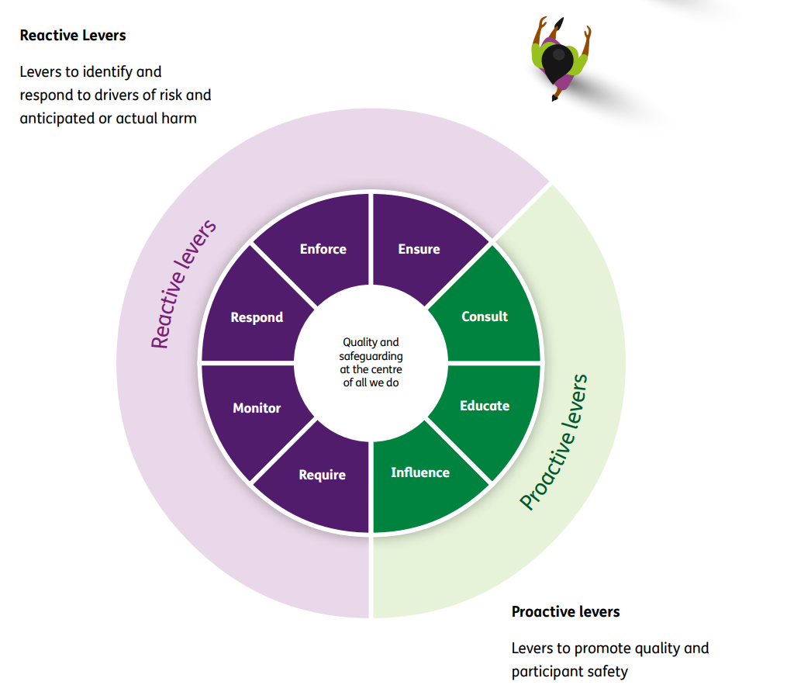

1. We ENSURE providers understand and respond to key risks and comply with the law. We investigate and take action against those who don’t comply with the law.
2. We ENFORCE the law by using our powers to sanction offenders, partnering with the NDIA and other regulators and agencies at all levels of government, to ensure enforcement activity has the greatest possible effect.
3. We RESPOND to all complaints and incident reports in a manner that aligns to the risk, while considering participant impact and views.
4. We MONITOR the quality of services and the treatment of people with disability, paying particular attention to monitoring restrictive practices.
5. We REQUIRE providers to meet a certain standard of quality and safety. We control who can and cannot provide certain services and supports.
6. We CONSULT with impacted participants and/or their families when we plan to commence court proceedings against providers, and we keep them informed throughout those proceedings.
7. We EDUCATE providers and workers to understand good practice and their legal obligations and work to build their capabilities. We educate participants to know their rights.
8. We INFLUENCE by example, embedding our compliance and enforcement activities and a culture of quality, innovation, and continuous improvement. We promote best practice and work hard to establish trust with people with disability and their supporters, and within the regulated community.

## Our key regulatory approaches

1. We focus on three key regulatory approaches – high intensity responses, targeted campaigns, and regulatory activities. We aim to direct substantial effort into targeted campaigns to reduce the effort required for high intensity responses and regulatory activities over time.

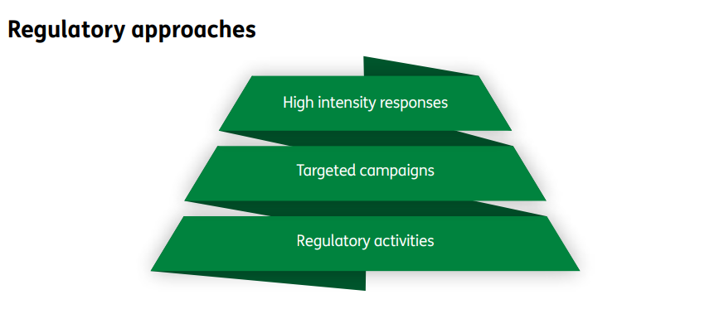

1. Our **High Intensity** responses are immediate responses to participants at extreme risk of serious harm, to significant incidents, or to emerging critical risks identified through data and intelligence. We work with emergency services and partner agencies to remove the critical risk and take follow up action against providers doing the wrong thing using our strong enforcement tools.
2. Our **Targeted Campaigns** address emerging sector issues and may target location based or service specific interventions to drive quality, safeguarding and consumer independence.
3. **Regulatory activities** are the largest part of our compliance and enforcement work and includes actions arising through managing provider registration, monitoring provider operations, and resolving and investigating complaints relating to the quality and safety of supports and services.
4. Routine monitoring may include reviewing intelligence and data, reportable incidents and complaints made to the NDIS Commission. We may conduct site visits and compliance audits to ensure providers are adhering to the conditions of their registration and to identify any non-compliance.
5. Where allegations or intelligence indicates possible non-compliance, we may make preliminary enquiries with providers, workers, participants and their supports and co-regulators. We may also seek expert advice.
6. We may progress to an investigation, including using our statutory tools to gather information. Our investigations may lead us to take compliance and enforcement action.

## Our compliance and enforcement tools

1. Our most serious tools to enforce the law are in the NDIS Act and Regulatory Powers Act. Our broad powers to ensure compliance also enable us to use non-statutory regulatory tools.

### Non-statutory tools

1. Where the nature of non-compliance is non-critical and presents no ongoing or uncontrolled risk of harm to a participant or the integrity of the NDIS, a **corrective action request** may be issued to a provider, requesting they take action to address it.
2. A **warning letter** sets out brief details of one or more contraventions of the NDIS Act by a provider. It warns them that we may take more formal regulatory action in the future if we are satisfied, they have breached their obligations.

### Statutory tools

1. A **compliance notice** is a written direction to a provider requiring them to take or not take certain action, to address identified non-compliance or possible non-compliance. It can require the provider to produce evidence that it has met the conditions of the notice. We can commence civil penalty proceedings if a provider does not meet the conditions of a compliance notice.
2. We may issue an **infringement notice** where we have a reasonable belief that a civil penalty provision of the NDIS Act has been breached. It is an opportunity for the recipient to respond by paying the penalty amount rather than face court proceedings.
3. An **enforceable undertaking** is a written commitment by a person to us that they will take or not take specific action to prevent or respond to a breach of the NDIS Act. It can help the person comply with their current and future obligations. We will only commence an enforceable undertaking where there has been a breach or alleged breach of the NDIS Act. We may commence legal proceedings if the person does not meet their commitments.
4. An **injunction** is a court order used to compel a person to take or not take certain action. We may seek an injunction from a court to ensure a provider complies with the NDIS Act. We most commonly seek injunctions as an interim and preventative measure while investigations are finalised.
5. A **civil penalty** is a financial penalty imposed by a court for breaching a civil penalty provision. The aim of a civil penalty is deterrence. Whilst civil penalty proceedings are not criminal proceedings, and do not result in a person being convicted of an offence, a court determines culpability and imposes the penalty, which can be significant.
6. We have a range of **information gathering powers** to compel providers to provide information or documents where we have identified non-compliance or possible non-compliance with the NDIS Act. This includes monitoring and investigations warrants.
7. The NDIS Commission may make a **banning order** prohibiting or restricting a provider, either permanently, temporarily or conditionally, from engaging in specified activities related to providing supports or services to a person with disability. We use a banning order as a safeguarding tool to protect people with disability from being harmed by fraudulent, dishonest, and unsafe supports and services. We also have powers to **vary** or **revoke** a banning order.
8. For providers to deliver supports and services to participants whose plans are managed by the NDIA, they must be **registered** with the NDIS Commission. Providers that deliver specialist disability accommodation, use restrictive practices, or develop behaviour support plans, must also be registered with the NDIS Commission. The NDIS Commission has powers to **vary**, **suspend** or **revoke** a registration to address non-compliance with the NDIS Act.

### How we choose our tools

1. We make timely, appropriate and reasonable use of all our monitoring, investigations and enforcement powers and tools. In deciding how to use them, some of our considerations include:

* whether there is an applicable contravention and the likelihood it occurred,
* the seriousness and the likelihood of past and future harm to any participant, including considering any personal risk factors, the number of people with disability affected, and the types of services provided,
* the gravity of the non-compliance and how far below acceptable standards it falls,
* the deterrence value and longer-term impact of a successful action on quality services and safeguarding for people with disability, and
* public expectations that we respond strongly when the dignity and safety of people with disability is disregarded, and the integrity of the NDIS is threatened.

1. We also consider the attitude, knowledge, and actions by a provider, including:

* whether and how quickly they acted to support participants and remedy the non-compliance,
* whether they understand the non-compliance and have been proactive in making positive changes,
* whether they have cooperated with us and promptly advised us of any difficulties they are facing in achieving compliance,
* their track record of past incidents and enforcement history,
* whether the non-compliance was intentional, reckless, or negligent or a mistake, and
* if they gained any commercial advantage by not complying.

### Protecting and disclosing information about our enforcement actions

1. We collect, store, and use a wide range of personal information to inform compliance and enforcement activities. Participants, providers, and others have the right to expect we will only share their personal information for good reason and in accordance with the law.
2. There are circumstances in which we may disclose information about enforcement action undertaken or where we are required to do so.
3. Our **provider register** informs participants and the public about all registered NDIS providers including the supports they are registered to provide and enforcement actions we have taken. We put the information about all current and historical statutory enforcement actions such as current and expired banning orders and suspensions of registration in [Part 2 of the NDIS Provider Register](https://www.ndiscommission.gov.au/about/compliance-and-enforcement/compliance-actions-against-providers-and-individuals). We also publish this information on our [website](https://www.ndiscommission.gov.au/about/compliance-and-enforcement/ndis-provider-register-and-compliance-and-enforcement-actions) unless publication is not in a participant or the public’s interest.
4. Where we have been asked to review, revoke, or withdraw the enforcement action, the information will remain on the NDIS Commission’s website until a decision is made by us or by a court or tribunal. If an enforcement action is revoked, set aside or withdrawn, we will generally remove any information about the action from the NDIS Provider Register and the NDIS Commission website.
5. Sharing information forms part of our approach to identifying, mitigating and responding to risk of harm for NDIS participants and the scheme. This includes sharing information with government partners to lessen a threat to the life, health or safety of a person with disability and publishing outcomes from court decisions on our website in the public interest.
6. We do not release any information that might prejudice a person’s right to a fair hearing or compromise the safety of people involved in an investigation.
7. We explore ways to share information about enforcement actions to build NDIS market understanding of provider behaviours that are unsafe or do not contribute to participant wellbeing.

### Reviewable decisions

1. If a provider is directly affected by a **reviewable decision**, they may ask us to review it. This process is known as **internal review** of a decision. A reviewable decision includes a decision about registration or the issuing of a compliance notice or banning order. At the end of the internal review process, the reviewer may confirm or vary the reviewable decision, or set it aside and substitute it with a new decision.
2. If a provider is not satisfied with our internal review decision, they may apply to the Administrative Review Tribunal to review it. A review by the Administrative Review Tribunal is known as an **external review**.
3. More information about reviewable decisions is available on our [internal review webpage](https://www.ndiscommission.gov.au/about/compliance-and-enforcement/internal-review-decisions#paragraph-id-7444).

## Monitoring and evaluation

1. We work to continuously improve our compliance and enforcement activities, through monitoring, evaluating and reporting on their effectiveness.
2. We use data and intelligence available to us to determine our annual Regulatory Priorities. We then monitor and evaluate our activities and outcomes to inform an assessment of our effectiveness. We reflect on what we learn from reviews of our decisions and investigations, from court outcomes and stakeholder engagement, and feed those learnings into continuous improvement of our activities.
3. We collate, review and publish data on the use of our regulatory tools in our publicly available Quarterly Performance Reports. We also have several internal, senior leadership committees dedicated to monitoring and evaluating the effectiveness of compliance and enforcement activities against our purpose and Regulatory Approach.
4. Our regulatory outcomes are available in the NDIS Commission’s Annual Report. Our reports are published on our [corporate documents webpage](https://www.ndiscommission.gov.au/about/corporate-documents).
5. We explore ways to share compliance and enforcement data with participants and providers to inform consumer independence and promote continuous improvement in provider practice and behaviour.
6. Changes in the NDIS as well as within the NDIS Commission may affect this policy. We will review this policy annually or sooner to ensure it reflects internal and external changes.