Quick Reference Guide (QRG) for Approved Quality Auditors

Recording the closure of minor non-conformities post-Verification audit for providers with a condition of registration imposed.

## Overview

Registered NDIS providers are subject to conditions under the [*National Disability Insurance Scheme Act 2013*](https://www.legislation.gov.au/Series/C2013A00020) (NDIS Act) and the [*National Disability Insurance Scheme (Provider Registration and Practice Standards) Rules 2018*](https://www.legislation.gov.au/Details/F2021C01137) (Registration Rules).

Information for providers regarding conditions of registration is available on the [NDIS Commission website](https://www.ndiscommission.gov.au/providers/registered-ndis-providers/registered-provider-obligations-and-requirements).

The NDIS Quality and Safeguards Commission (NDIS Commission) provides information and guidance to support registered providers meet their registration obligations under the NDIS Act and Registration Rule*s*, and monitors providers compliance with their conditions of registration.

A failure to comply with a condition of registration is subject to a civil penalty of 250 penalty units. In addition, the NDIS Commission can take other compliance or enforcement action including imposing a (further) condition of registration or suspending, varying or revoking a registered NDIS provider’s registration.

## Condition of Registration

Registered NDIS providers that undertook a verification audit and have open minor non-conformities at the close of audit, may have had a condition imposed on their registration as follows:

***‘A condition imposed under Section 73G of the NDIS Act for minor non-conformities identified at the time of audit to be assessed and closed out by an approved quality auditor no later than 18 months after registration.’***

To monitor a provider’s adherence to this condition, the NDIS Commission requests that Approved Quality Auditors notify the NDIS Commission when the minor non-conformities have been addressed (closed), using the Commission Operating System (COS).

Notification is to be made by:

* Attaching a copy of the completed Corrective Action Plan to the provider’s **application** record in COS, indicating closure of minor non-conformities (where possible) and;
* Adding a *Task* to the provider’s **registration** record in COS.

**Note: This QRG is only applicable to provider’s that have the above condition imposed.**

### Part A – Locate a provider’s registration record

1. Log in to the NDIS Commission Operation System (COS) via the [Quality Auditor Portal.](https://www.ndiscommission.gov.au/portal/quality-auditors-portal-login)
2. Select **Registration** from the menu bar then click **Registration search.**

A screenshot of a computer image of the Registration Search tab 


1. Enter the **Registration Id** and click **Run search.**

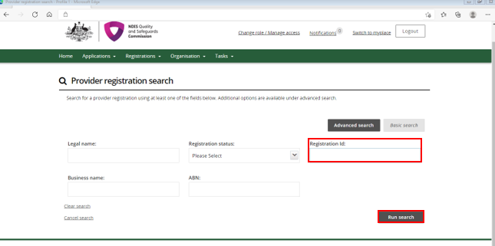

1. Select **View** from the result list.

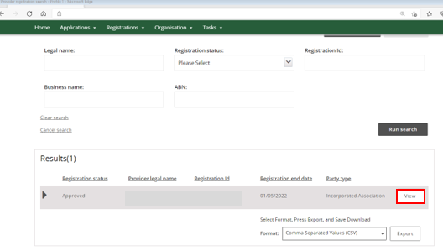

Please continue to page 4 for Part B – Create a task in COS.

### Part B – Create a Task in COS

1. Scroll down the left-hand tabs and under the **Actions** heading select **Tasks.**

This will open the Tasks box.

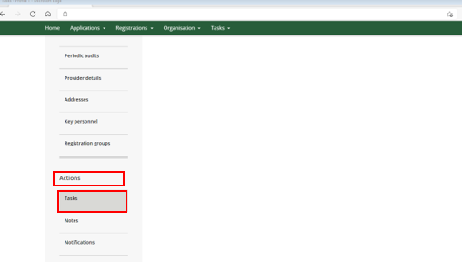

1. In the Task box select, **Add.**

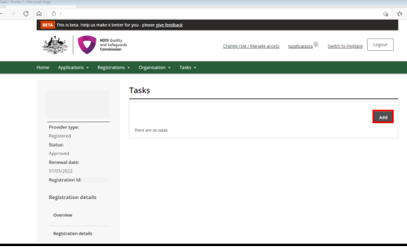

1. Complete the below Task fields in **red**, using the **exact** wording below.

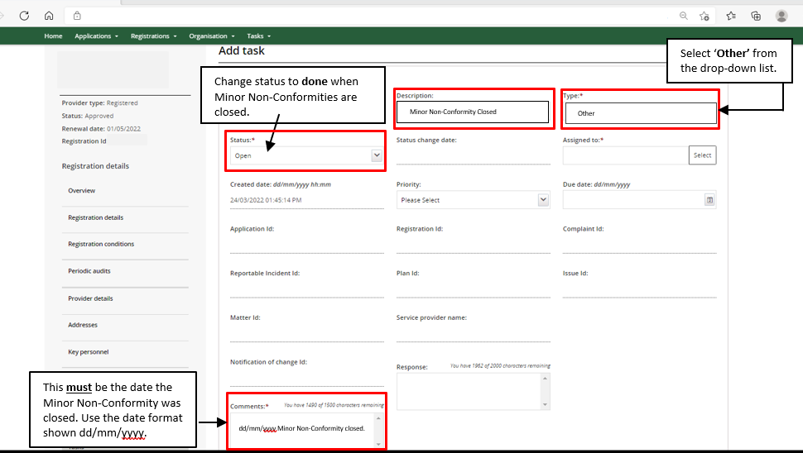

1. Once completed, select **Save and return.**

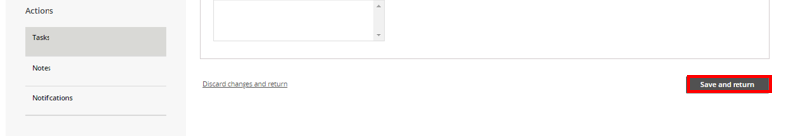

### Part C – Attach the completed Corrective Action Plan to COS

1. Attach a copy of the completed Corrective Action Plan to the provider’s **application** record in COS, indicating closure of minor non-conformities (where possible).

End of document.